U24AI034 | OS Assignment 03 | Manav Dhamecha

1. Write a Shell Script to find,

a) Largest of N numbers

#!/bin/bash
echo "Enter how many numbers:"
read n

echo "Enter numbers:"
read max

for ((i=2; i<=n; i++))
do
read num
if [ $num -gt $max ]
then
max=$num
fi
done

echo "Largest number is $max"

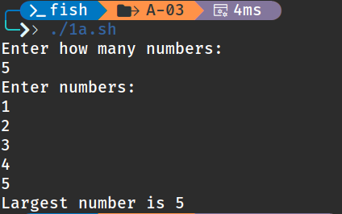

b) Swap two values

#!/bin/bash

echo "Enter first number:"
read a
echo "Enter second number:"
read b
temp=$a
a=$b
b=$temp
echo "After swapping:"
echo "a = $a"
echo "b = $b"

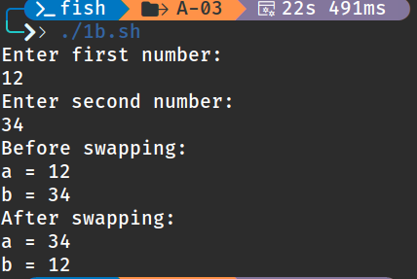

c) Odd or Even

#!/bin/bash

echo "Enter a number:"
read n

if [ $((n % 2)) -eq 0 ]
then
echo "Even number"
else
echo "Odd number"
fi

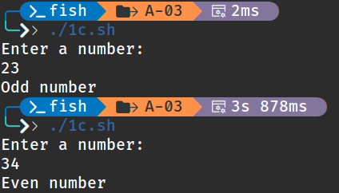

d) Sum of three numbers

#!/bin/bash
echo "Enter three numbers:"
read a b c
sum=$((a + b + c))
echo "Sum = $sum"
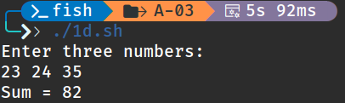

2. Write a shell script to check to see if the file “file_path” exists. If it does exist, display “file_path passwords are enabled.” Next, check to see if you can write to the file. If you can, display “You have permissions to edit “file_path.””If you cannot, display “You do NOT have permissions to edit “file_path”.

#!/bin/bash

echo "Enter file path:"
read file_path

if [ -e "$file_path" ]
then
echo "$file_path passwords are enabled."

if [ -w "$file_path" ]
then
echo "You have permissions to edit $file_path."
else
echo "You do NOT have permissions to edit $file_path."
fi
else
echo "File does not exist."
fi

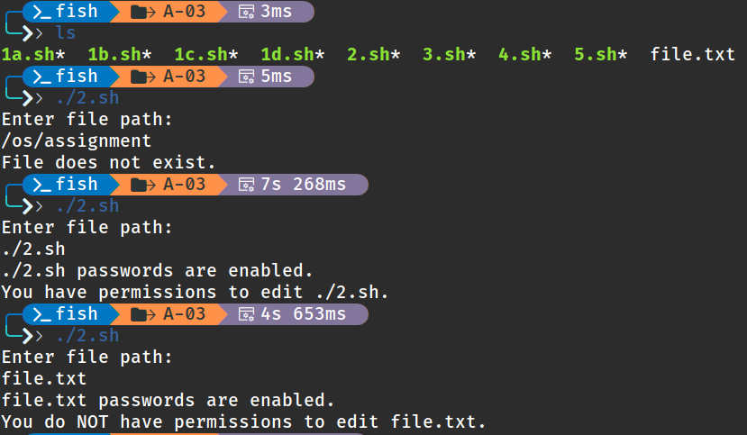

3. Write a shell script that asks the user to type a number of words as input to shell script Store the input words by user into an array. Print how long each word is.

#!/bin/bash

echo "Enter number of words:"
read n

for ((i=0; i<n; i++))
do
read words[$i]
done

for ((i=0; i<n; i++))
do
echo "Length of ${words[$i]} is ${#words[$i]}"
done
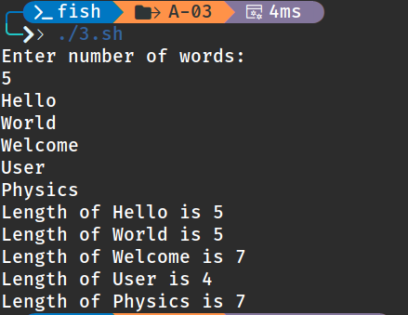

4. Write a shell program to reverse the five-digit integer.

#!/bin/bash
echo "Enter a five-digit number:"
read num
rev=0
while [ $num -gt 0 ]
do
rem=$((num % 10))
rev=$((rev * 10 + rem))
num=$((num / 10))
done
echo "Reversed number is $rev"

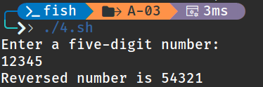

5. Write a shell program to search for a given number from the list of numbers using
binary search.

#!/bin/bash

echo "Enter number of elements:"
read n

echo "Enter sorted elements:"
for ((i=0; i<n; i++))
do
read arr[$i]
done

echo "Enter element to search:"
read key

low=0
high=$((n - 1))
found=0

while [ $low -le $high ]
do
mid=$(((low + high) / 2))

if [ ${arr[$mid]} -eq $key ]
then
echo "Element found at position $((mid + 1))"
found=1
break
elif [ ${arr[$mid]} -lt $key ]
then
low=$((mid + 1))
else
high=$((mid - 1))
fi
done

if [ $found -eq 0 ]
then
echo "Element not found"
fi

