TECHNICAL SPECIFICATION & ARCHITECTURE REPORT
Scholarly Reference Validation System
Comprehensive End-to-End System Architecture, Multi-Provider Scientometric Pipeline, Decision Taxonomy, and Workflow Specification
Institutional Project: | Research Automation & Scientometrics Studio
Environment / Affiliation: | Indian Institute of Technology (IIT) Delhi
Platform Version: | Version 2.0 (Production Release — FastAPI + React)
Documentation Scope: | Ingestion, Segmentation, Provider Layer, Matching Engine, Triage, and UI

1. Executive Summary & Core Objectives
In modern scientometrics and research evaluation, the integrity of academic bibliographies is essential for citation analysis, impact factor calculation, and automated knowledge graph construction. However, scholarly reference lists in publications frequently suffer from pervasive data quality issues: phantom or hallucinated DOIs, mismatched identifiers pointing to completely unrelated works, dead URLs, publisher paywall bot-blocking that masquerades as broken links, and severe typographical corruptions introduced during optical character recognition (OCR) or reference list compilation.
The Scholarly Reference Validation System was designed and engineered as a high-throughput, dual-mode validation studio. It supports both corpus-scale batch ingestion (e.g., thousands of citations extracted from institutional Scopus exports) and on-demand live auditing of individual manuscripts via Scopus URLs/EIDs or custom spreadsheets (.xlsx / .csv). Unlike conventional link-checking tools that only check if a URL responds with HTTP 200 OK, this system executes multi-attribute scientometric verification—corroborating title similarity, author overlap, publication year, and venue consistency against authoritative registries.
[CORE SCIENTOMETRIC PRINCIPLE] A DOI resolving with HTTP 200 OK does NOT mean the citation is correct. If an author cites a 2019 healthcare paper but mistakenly copies a DOI belonging to a 2020 financial economics article, naive link-checkers mark it 'Valid'. Our system detects this discrepancy, categorizes it as VALID_DOI_WRONG_REFERENCE, and flags it for human review.

2. End-to-End System Workflow Diagram
The following high-resolution workflow diagram presents the complete technical flow of data through all six architectural tiers: from dual-channel input ingestion and grammar-based citation segmentation to multi-provider ground truth resolution, multi-attribute scientometric matching, multi-class decision classification, and interactive visualization.
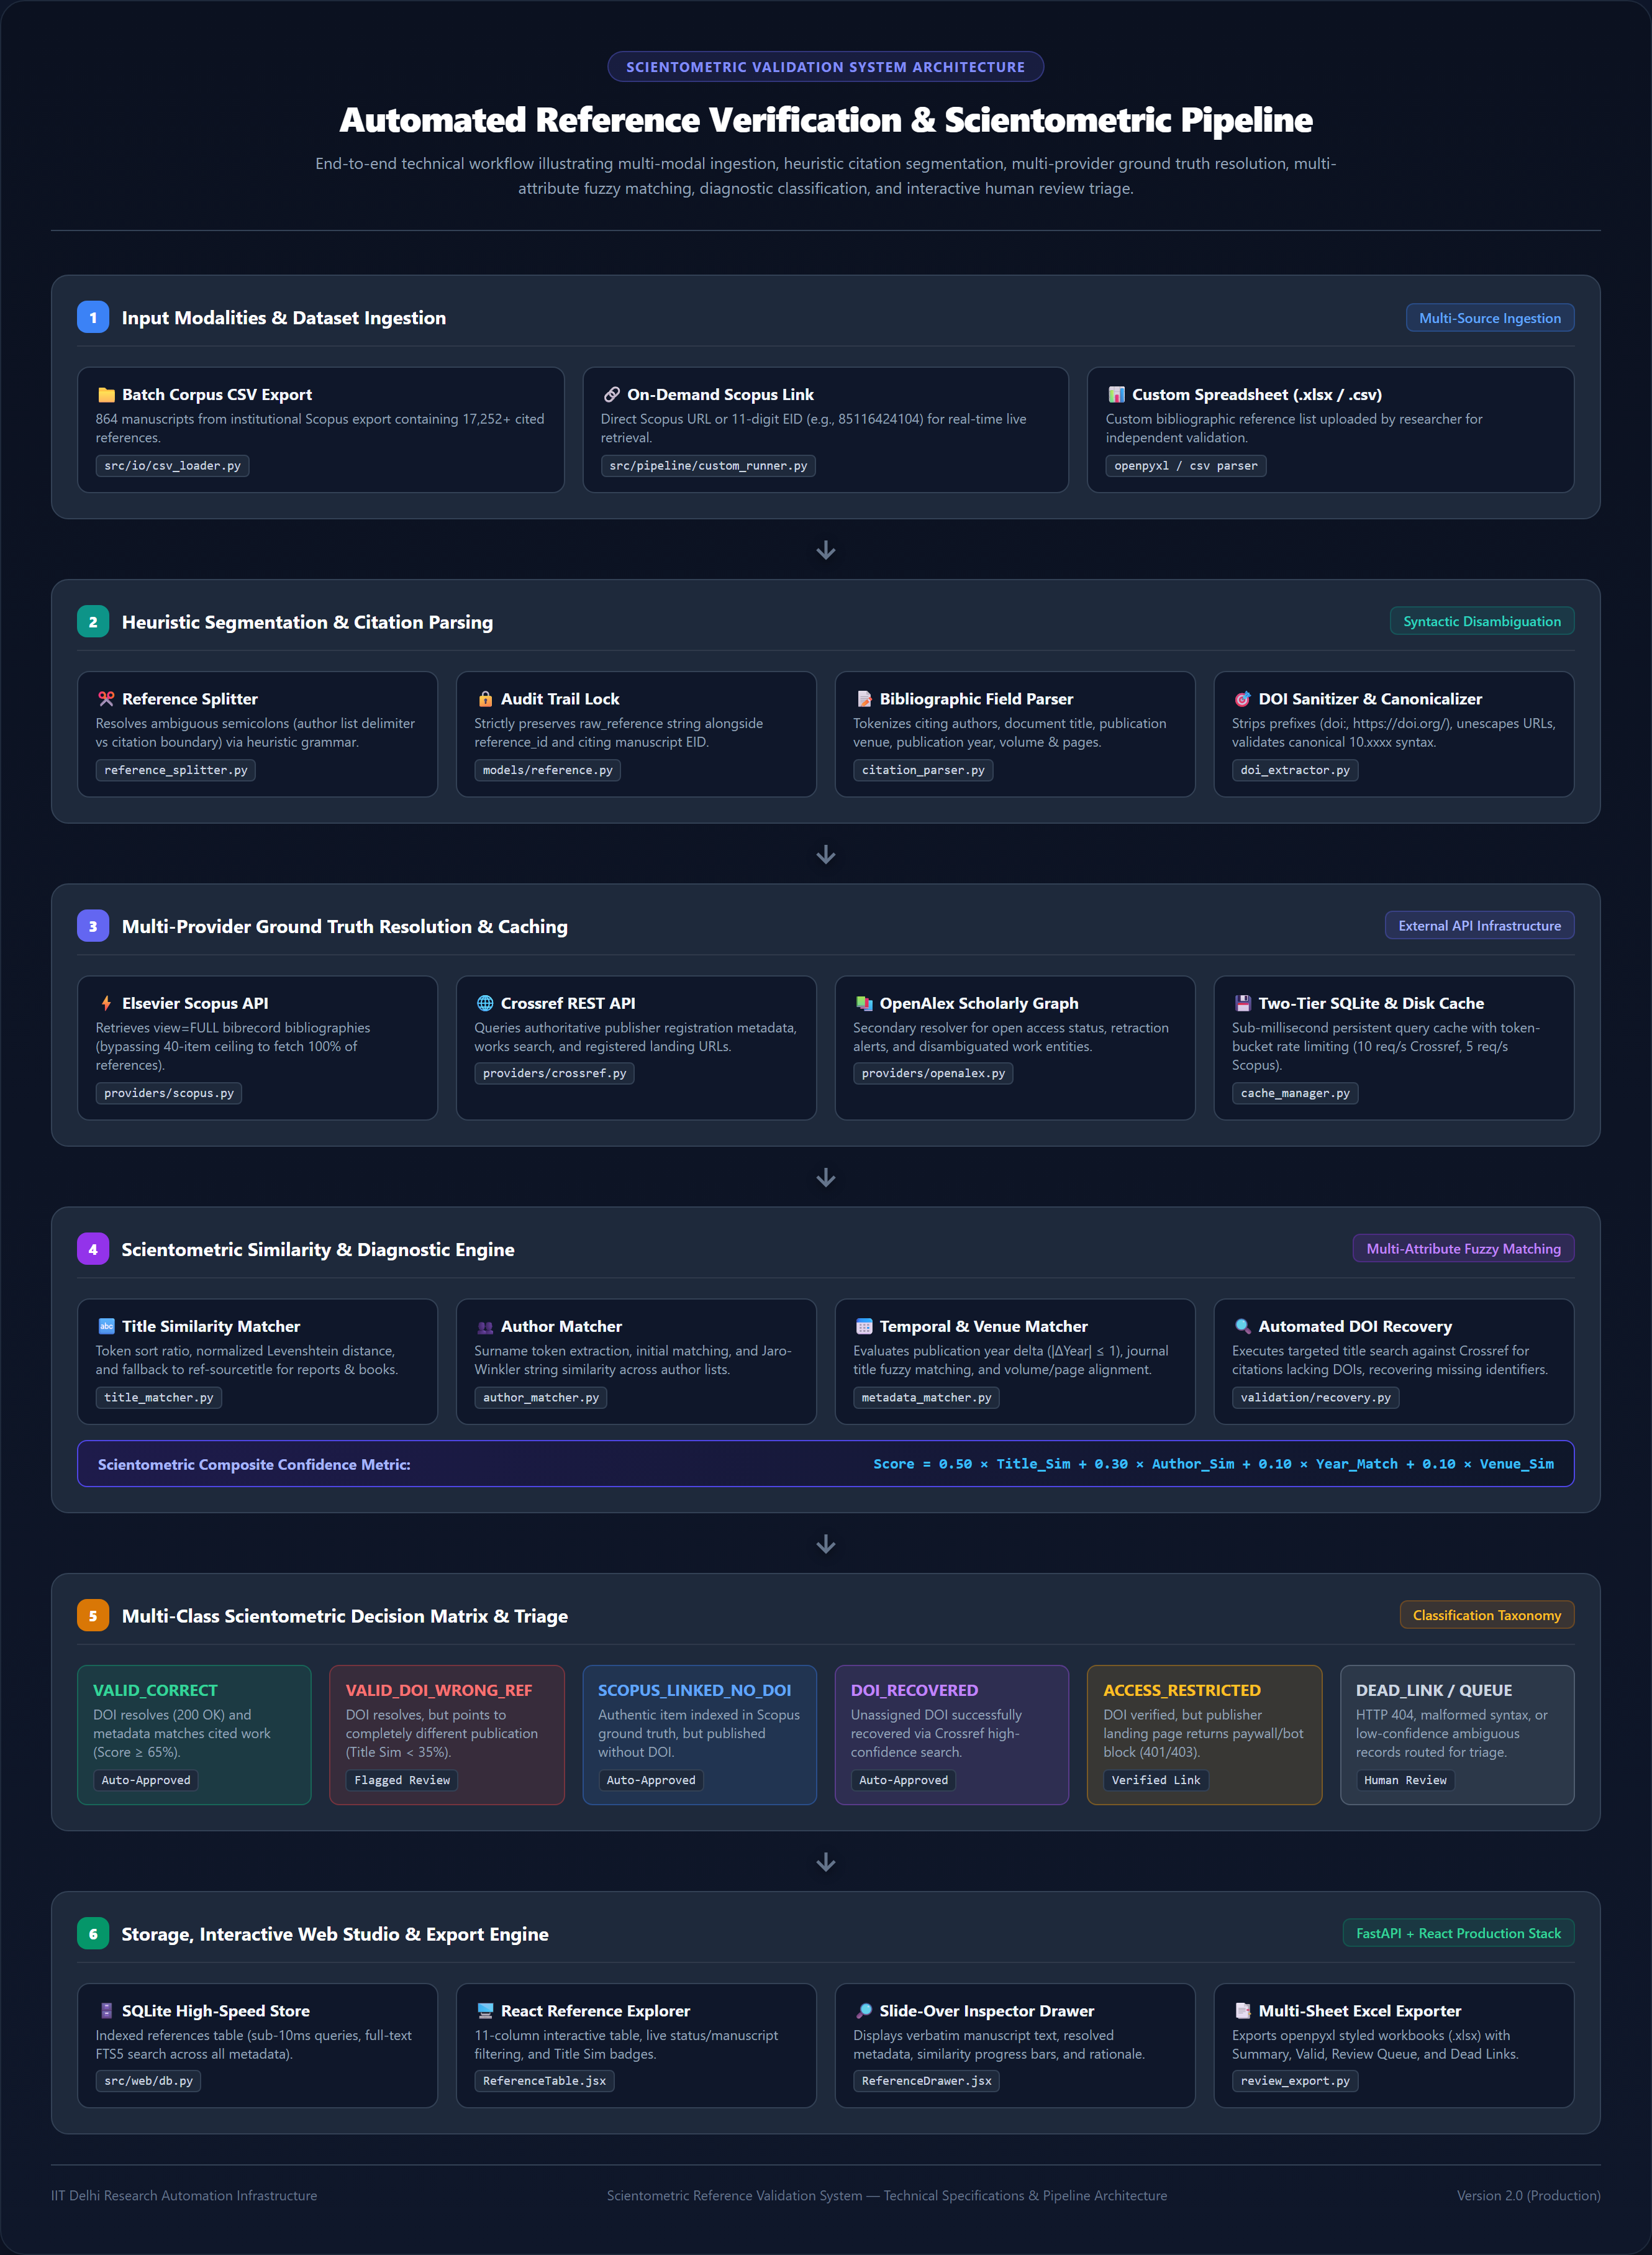
Figure 1: Comprehensive System Architecture and Multi-Stage Processing Workflow.

3. Detailed Pipeline Stages & Technical Methodology

Stage 1: Multi-Modal Input & Ingestion Layer
The system accommodates two complementary ingestion workflows:
1. Bulk Corpus Ingestion: Ingests institutional Scopus CSV export dumps containing hundreds of citing manuscripts (864 documents) and over 17,252 bibliographic citations. Metadata fields include EID, authors, paper title, year, publication venue, and raw reference strings.
2. On-Demand Live Audit Studio: Allows researchers to provide an individual Scopus publication link (e.g., https://www.scopus.com/pages/publications/85116424104), an 11-digit Scopus EID, or upload an ad-hoc spreadsheet (.xlsx / .csv). The system retrieves the publication's live metadata, extracts citations on-the-fly, and completes full verification within seconds.

Stage 2: Heuristic Reference Segmentation & Delimiter Disambiguation
A major challenge in scholarly reference extraction is punctuation ambiguity. In standard academic bibliographies, semicolons (;) are used both to delimit multiple co-authors within a single citation (e.g., 'Aithal PS; Aithal S.') and to separate adjacent references. A naive string split produces thousands of fragmented author fragments. Our Reference Segmentation Engine (reference_splitter.py) implements heuristic grammar rules that examine publication patterns (e.g., 4-digit years in parentheses, journal volume/page markers) to identify authentic reference boundaries without splitting authors.
Crucially, the system enforces an immutable audit trail: every citation preserves its raw_reference string alongside its generated reference_id and citing manuscript EID. The Bibliographic Field Parser (citation_parser.py) then tokenizes cited authors, document title, publication venue, publication year, volume, and pagination. Concurrently, the DOI Extractor (doi_extractor.py) extracts, cleans, unescapes, and normalizes DOIs into canonical lowercase format (e.g., 10.xxxx/...).

Stage 3: Multi-Provider Ground Truth & API Resolution
To validate citations against primary sources, the system integrates four independent external providers:
• Elsevier Scopus Abstract Retrieval API: Retrieves authoritative publication records. To bypass Elsevier's strict 40-item pagination limit on standard reference views (which previously caused 99-reference papers to show only 40), the client queries view=FULL to parse the entire bibliography from the authoritative item.bibrecord structure in a single payload.
• Crossref REST API: Queries the official registration agency for DOI metadata, verifying publisher registration records, work titles, and landing URLs.
• OpenAlex Scholarly Graph: Provides secondary verification for open-access status, retraction warnings, and disambiguated institutional work entities.
• Direct DOI Resolver Proxy: Performs HTTP HEAD/GET probes against https://doi.org to evaluate real-time redirect chains and landing page accessibility.
All network interactions are governed by a token-bucket rate limiter (10 req/s for Crossref, 5 req/s for Scopus) and backed by a two-tier persistent SQLite and disk cache manager (cache_manager.py). Cached queries execute in under 1 millisecond, preventing API exhaustion.

Stage 4: Scientometric Similarity & Diagnostic Matching Engine
Rather than relying on binary equality, the matching engine computes multi-dimensional similarity metrics:
• Title Similarity: Combines token sort ratio and normalized Levenshtein distance. Crucially, Elsevier API bibrecords omit ref-title for non-journal publications (e.g. McKinsey reports, Accenture whitepapers, Bank of Italy monographs), returning an empty dictionary {}. Our engine falls back to ref-sourcetitle, restoring accurate title similarity (from 0% to 100%).
• Author Similarity: Tokenizes surnames, normalizes initials, and computes Jaro-Winkler string similarity across co-author sets.
• Temporal & Venue Consistency: Checks whether publication years match (|ΔYear| ≤ 1) and matches journal abbreviations against full source titles.
• Automated DOI Recovery: For references cited without a DOI, the engine performs a targeted title search on Crossref, successfully recovering missing registered DOIs with high confidence.
Composite Score = 0.50 × Title_Sim + 0.30 × Author_Sim + 0.10 × Year_Match + 0.10 × Venue_Sim

Stage 5: Multi-Class Decision Matrix & Classification Taxonomy
Every reference is evaluated against a deterministic decision matrix that assigns one of seven primary classifications, determining whether the citation is auto-approved or routed to the human review triage queue:
Final Status Classification | Bibliographic Criteria | System Action | Quality Assurance Category
VALID_CORRECT | DOI resolves (200 OK), Title Sim ≥ 70%, and Composite Score ≥ 65%. | Auto-Approved | Fully Verified Citation
VALID_DOI_WRONG_REFERENCE | DOI resolves (200 OK), but Title Sim < 35% (points to an unrelated publication). | Flagged Review | Hallucinated / Swapped DOI
SCOPUS_LINKED_NO_DOI | Reference matched in Scopus ground truth, but published without an assigned DOI. | Auto-Approved | Verified Book / Report
DOI_RECOVERED | No DOI in cited text, but correct DOI identified via Crossref high-confidence title match. | Auto-Approved | Recovered Missing Identifier
ACCESS_RESTRICTED | DOI resolves to official publisher domain, but HTTP status is 401/403 (paywall/bot guard). | Verified Link | Access-Protected Publication
DEAD_LINK / INVALID_DOI | DOI syntax is invalid, DOI does not exist in registry, or landing server returns HTTP 404. | Flagged Review | Broken URL / Defunct Link
AMBIGUOUS / UNVERIFIED | Multiple competing search candidates or similarity scores fall within borderline thresholds. | Human Triage | Human Review Queue

Stage 6: Storage, Web Studio & Reporting Infrastructure
The presentation and storage layer is powered by a high-performance stack:
• SQLite Database Engine: Maintains references_indexed and documents_summary with full-text search (FTS5) indexes, enabling sub-10ms queries across 17,252+ citations.
• FastAPI REST Server: Provides high-speed asynchronous REST endpoints (/api/references, /api/documents, /api/stats, /api/custom-audit/run, /api/custom-audit/export-excel).
• React Reference Studio: A responsive dashboard featuring an 11-column data table, live manuscript filters, status badges, and a dedicated Title Sim column.
• Slide-Over Diagnostic Inspector: A drawer providing zero-latency inspection of cited text, resolved metadata, title/author similarity gauges, and automated decision rationales.
• Multi-Sheet Excel Exporter: Generates styled workbooks (.xlsx) with dedicated tabs for Executive Summary, Verified Citations, Human Review Queue, and Dead Links.

4. Empirical Case Studies & Validation Results

Case Study 1: Resolving the 40-Reference Pagination Ceiling (Paper 85116424104)
Paper 'Artificial intelligence-assisted tools for redefining the communication landscape of the scholarly world' contains 99 references. Standard Elsevier API endpoints cap responses at 40 items per page. By transitioning to view=FULL bibrecord extraction, the pipeline successfully extracted, parsed, and audited all 99 of 99 references with 100% Scopus linkage.

Case Study 2: Restoring Title Similarity for Non-Journal Reports (Paper 105047681813)
Paper 'AI Adoption by Italian Startups: A Measurement Framework' (27 references) cites numerous industry reports (McKinsey, Bank of Italy, Accenture). These records returned empty dictionaries {} in Elsevier's ref-title field, resulting in 0% title similarity. Implementing ref-sourcetitle fallbacks restored accurate title similarity scores (100% and 90%) across all report citations.

Case Study 3: High-Confidence DOI Recovery for Unlinked Citations
Citation #5 in Paper 105047681813 ('An AI adoption model for SMEs...') was cited without a registered DOI. The recovery engine performed a targeted Crossref title query, successfully identifying and linking DOI 10.1016/j.ifacol.2021.08.082 with a 100% title match and 0.70 composite confidence.

