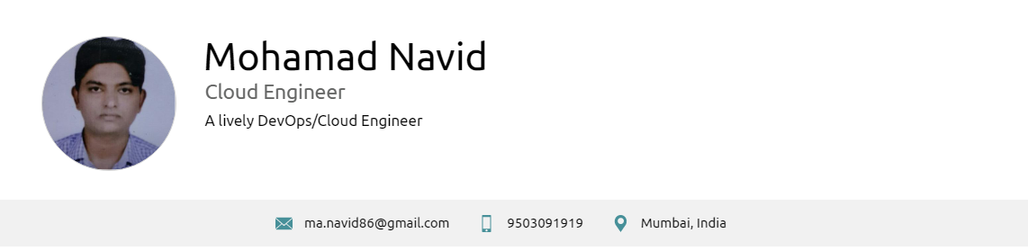

**WORK EXPERIENCE**

**Cloud Engineer**

ASM Enterprise Solutions Private Limited. | Navi Mumbai | www.altencalsoftlabs.com

Client: Reliance Corporate Park (Project: JIO) Client Designation : Team Lead

*01/2019 – Present (Mumbai, India)*

*Responsibilities*

- Work as part of a team, to design and develop cloud data solutions

- Manage and support full application stacks from the OS through custom applications using Amazon cloud based computing environments

- Manage a continuous integration/continuous deployment methodology for our server based technologies

**Sr. System Engineer**

Cybage Software Pvt. Ltd

*04/2015 – 01/2019 (Pune, India)*

*Responsibilities*

- Building, installation and configuration of Linux operating systems on servers

- Provide System Administration for servers based on Redhat

- Providing Primary/Secondary On call Support for Servers spread across multiple Sites

- Configuration of LVM on Linux servers

**CERTIFICATES**

- AWS Certified Solutions Architect - Associate (*10th July 2018)*

- ITIL® Foundation Certificate in IT Service Management (*30th Dec'2013)*

- Microsoft Certified Professional (MCP) – (Exam: 070-270 and 070-290) (*13th Dec'2008)*

- Certified Engineer (RHCE) Red Hat Enterprise Linux 5 (*14th May 2008)*

**SKILLS**

**LANGUAGES**

English

*Native or Bilingual Proficiency*

Hindi

*Native or Bilingual Proficiency*

Marathi

*Native or Bilingual Proficiency*

**EDUCATION**

**Study Program**

Swami Ramanand Teerth Marathwada University Nanded, Maharashtra

*2003 – 2006 Nanded, India*

*Courses*

Bachelor of Science in Computer Science Degree (BCS),