Dockers and Containers
Virtualization:
Virtualization is the ability to run multiple operating systems on a single physical system and share the underlying hardware resources.
It is the process by which one server hosts the appearance of many computers.
Virtualization is used to improve IT throughput and costs by using physical resources as a pool from which virtual resources can be allocated.
Different types of virtualizations:
Bare metal hypervisor ex: Vmware ESX, IBM PowerVM, Xen
Hosted Hypervisor ex: KVM
Software partitioning: Dockers, WPARs
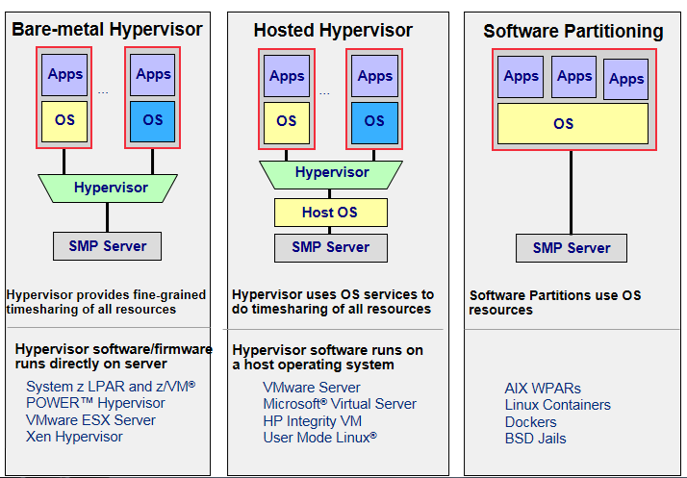
SMP – Symmetric multi processing

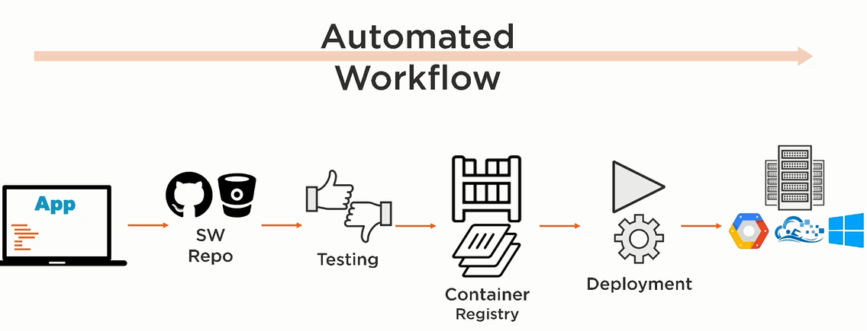

LXC (Linux Containers) is an operating-system-level virtualization method for running multiple isolated Linux systems (containers) on a control host using a single Linux kernel
Uses kernel features calls cgroups (Linux Kernel control groups)– that allows limitation and prioritization of resources like CPU/memory, /i/o, network
Namespace isolation – that allows complete isolation of an application view of Operating system environment including process trees. networking ,user ids and mounted file system
LXC combines kernel's cgroups and support for isolated namespaces to provide an isolated environment for applications
Note: LXC is a Linux technology. It does not work on Windows or Mac.
Dockers are useful in:
To avoid having too much software on the machine
To try deploying a web app
To try provisioning scripts on fake machine first them try on actual machine

Dockers leverage LXC – Lightweight alternative to full virtualization such as provided by traditional hypervisors like KVM VMware Xen or ESXi

Installing docker:

Steps for RHEL:

Execute below command on the node

sudo yum-config-manager --add-repo https://docs.docker.com/engine/installation/linux/repo_files/centos/docker.repo
sudo yum -y install docker-engine
sudo systemctl start docker
service docker status

Ensure the below file is created in /etc/yum.repos.d

cat /etc/yum.repos.d/docker.repo

root@reviewb ~]# cd /etc/yum.repos.d/
[root@reviewb yum.repos.d]# ls
iso.repo
[root@reviewb yum.repos.d]# cat /docker
cat: /docker: Is a directory
[root@reviewb yum.repos.d]# cat /docker.repo
[docker-main]
name=Docker Repository
baseurl=https://yum.dockerproject.org/repo/main/centos/7/
enabled=1
gpgcheck=1
gpgkey=https://yum.dockerproject.org/gpg

[docker-testing]
name=Docker Repository
baseurl=https://yum.dockerproject.org/repo/testing/centos/$releasever/
enabled=0
gpgcheck=1
gpgkey=https://yum.dockerproject.org/gpg

[docker-beta]
name=Docker Repository
baseurl=https://yum.dockerproject.org/repo/beta/centos/7/
enabled=0
gpgcheck=1
gpgkey=https://yum.dockerproject.org/gpg

[docker-nightly]
name=Docker Repository
baseurl=https://yum.dockerproject.org/repo/nightly/centos/7/
enabled=0
gpgcheck=1
gpgkey=https://yum.dockerproject.org/gpg

docker --help
--config=~/.docker Location of client config files
-D, --debug Enable debug mode
-H, --host=[] Daemon socket(s) to connect to
-h, --help Print usage
-l, --log-level=info Set the logging level
--tls Use TLS; implied by --tlsverify
--tlscacert=~/.docker/ca.pem Trust certs signed only by this CA
--tlscert=~/.docker/cert.pem Path to TLS certificate file
--tlskey=~/.docker/key.pem Path to TLS key file
--tlsverify Use TLS and verify the remote
-v, --version Print version information and quit

Commands:
attach Attach to a running container
build Build an image from a Dockerfile
commit Create a new image from a container's changes
cp Copy files/folders between a container and the local filesystem
create Create a new container
diff Inspect changes on a container's filesystem
events Get real time events from the server
exec Run a command in a running container
export Export a container's filesystem as a tar archive
history Show the history of an image
images List images
import Import the contents from a tarball to create a filesystem image
info Display system-wide information
inspect Return low-level information on a container, image or task
kill Kill one or more running container
load Load an image from a tar archive or STDIN
login Log in to a Docker registry.
logout Log out from a Docker registry.
logs Fetch the logs of a container
network Manage Docker networks
node Manage Docker Swarm nodes
pause Pause all processes within one or more containers
port List port mappings or a specific mapping for the container
ps List containers
pull Pull an image or a repository from a registry
push Push an image or a repository to a registry
rename Rename a container
restart Restart a container
rm Remove one or more containers
rmi Remove one or more images
run Run a command in a new container
save Save one or more images to a tar archive (streamed to STDOUT by default)
search Search the Docker Hub for images
service Manage Docker services
start Start one or more stopped containers
stats Display a live stream of container(s) resource usage statistics
stop Stop one or more running containers
swarm Manage Docker Swarm
tag Tag an image into a repository
top Display the running processes of a container
unpause Unpause all processes within one or more containers
update Update configuration of one or more containers
version Show the Docker version information
volume Manage Docker volumes
wait Block until a container stops, then print its exit code

Run 'docker COMMAND --help' for more information on a command.

Steps:
1. Install docker using yum
yum install docker

2. download the image using docker pull
docker pull ubuntu
docker pull rhel6

3. List dockers available
docker ps → to list running containers
docker ps -a → lists all containers including killed ones

4. start a docker using
docker run -t -i ubuntu

5. To stop a docker
docker stop <container_id>

6. to start a docker
docker start <container_id>

7.to login
docker attach <>

Commands:

Docker pull is to pull images
Docker ps to display running containers
Docker ps -a to display all running containers including the dead ones
Docker inspect is to show all values
Docker stop/start – is to stop or start a container
Docker attach/detach is to attach or detach to a container
Docker run is to run the container, if image is not available docker pulls from docker hub repository

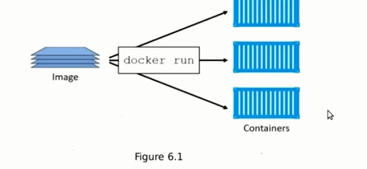
Examples:

[root@rscthydnet1 ~]# docker images
REPOSITORY TAG IMAGE ID CREATED SIZE
ubuntu latest 1967d889e07f 2 weeks ago 167.9 MB

- sudo docker run -t -i ubuntu:latest ➔ downloads Ubuntu docker
checks local machine first, it not available downloads the image from net

[root@rscthydnet1 LINUX]# sudo docker run -t -i ubuntu
Unable to find image 'ubuntu:latest' locally
latest: Pulling from ubuntu
0847857e6401: Pull complete
f8c18c152457: Pull complete
8643975d001d: Pull complete
d5802da4b3a0: Pull complete
fe172ed92137: Pull complete
Digest: sha256:5349f00594c719455f2c8e6f011b32758dcd326d8e225c737a55c15cf3d6948c
Status: Downloaded newer image for ubuntu:latest
root@d47c9e2cbf15:/#

it will login to docker

root@d47c9e2cbf15:/# id
uid=0(root) gid=0(root) groups=0(root)
root@d47c9e2cbf15:/# cat /etc/*release
DISTRIB_ID=Ubuntu
DISTRIB_RELEASE=16.04
DISTRIB_CODENAME=xenial
DISTRIB_DESCRIPTION="Ubuntu 16.04.1 LTS"
NAME="Ubuntu"
VERSION="16.04.1 LTS (Xenial Xerus)"
ID=ubuntu
ID_LIKE=debian
PRETTY_NAME="Ubuntu 16.04.1 LTS"
VERSION_ID="16.04"
HOME_URL="http://www.ubuntu.com/"
SUPPORT_URL="http://help.ubuntu.com/"
BUG_REPORT_URL="http://bugs.launchpad.netubuntu/"
VERSION_CODENAME=xenial
UBUNTU_CODENAME=xenial
root@d47c9e2cbf15:/#

We can download the docker and load it
docker load -i centos_docker_image.tar

run apt-get update to work with apt-get
root@d47c9e2cbf15:/# apt-get update
Get:1 http://ports.ubuntu.comubuntu-ports xenial InRelease [247 kB]
Get:2 http://ports.ubuntu.comubuntu-ports xenial-updates InRelease [95.7 kB]
Get:3 http://ports.ubuntu.comubuntu-ports xenial-security InRelease [94.5 kB]
Get:4 http://ports.ubuntu.comubuntu-ports xenial/main Sources [1103 kB]
Get:5 http://ports.ubuntu.comubuntu-ports xenial/restricted Sources [5179 B]
Get:6 http://ports.ubuntu.comubuntu-ports xenial/universe Sources [9802 kB]
Get:7 http://ports.ubuntu.comubuntu-ports xenial/main x86_64el Packages [1470 kB]
Get:8 http://ports.ubuntu.comubuntu-ports xenial/universe x86_64el Packages [9485 kB]
Get:9 http://ports.ubuntu.comubuntu-ports xenial-updates/main Sources [256 kB]
Get:10 http://ports.ubuntu.comubuntu-ports xenial-updates/restricted Sources [1872 B]
Get:11 http://ports.ubuntu.comubuntu-ports xenial-updates/universe Sources [136 kB]
Get:12 http://ports.ubuntu.comubuntu-ports xenial-updates/main x86_64el Packages [487 kB]
Get:13 http://ports.ubuntu.comubuntu-ports xenial-updates/universe x86_64el Packages [395 kB]
Get:14 http://ports.ubuntu.comubuntu-ports xenial-security/main Sources [54.7 kB]
Get:15 http://ports.ubuntu.comubuntu-ports xenial-security/restricted Sources [1872 B]
Get:16 http://ports.ubuntu.comubuntu-ports xenial-security/universe Sources [13.8 kB]
Get:17 http://ports.ubuntu.comubuntu-ports xenial-security/main x86_64el Packages [171 kB]
Get:18 http://ports.ubuntu.comubuntu-ports xenial-security/universe x86_64el Packages [55.7 kB]
Fetched 23.9 MB in 1min 2s (382 kB/s)
Reading package lists... Done

Install packages
apt-get install vim
apt-get install openssh
apt-get install vim
apt-get install iputils-ping
apt-get install net-tools
apt-get install ksh

To come out of docker without stopping it
control+pq

docker run – every time it creates a new container.

To get the container id

root@rscthydnet1 ~]# docker ps -a
CONTAINER ID IMAGE COMMAND CREATED STATUS PORTS NAMES
docker stop container_ID
docker start container_ID

docker run -d --name ubuntu-docker1 ubuntu
[root@rscthydnet1 ~]# docker ps
CONTAINER ID IMAGE COMMAND CREATED STATUS PORTS NAMES
20354b3035a3 ubuntu "/bin/bash" 6 seconds ago Up 3 seconds romantic_booth

docker attach 20354b3035a3

[root@rscthydnet1 ~]# docker ps
CONTAINER ID IMAGE COMMAND CREATED STATUS PORTS NAMES
20354b3035a3 ubuntu "/bin/bash" 8 minutes ago Up 18 seconds romantic_booth

[root@rscthydnet1 ~]# docker stop 20354b3035a3
20354b3035a3
[root@rscthydnet1 ~]# docker start 20354b3035a3
20354b3035a3

[root@rscthydnet1 ~]# docker ps -a
CONTAINER ID IMAGE COMMAND CREATED STATUS PORTS NAMES
20354b3035a3 ubuntu "/bin/bash" 9 minutes ago Up 57 seconds romantic_booth
5f3e16925382 ubuntu "/bin/bash" 9 minutes ago Exited (127) 9 minutes ago admiring_montalcini
24eedbddd026 ubuntu "/bin/bash" 11 minutes ago Exited (0) 11 minutes ago ubuntu-docker1
d47c9e2cbf15 ubuntu "/bin/bash" 3 hours ago Exited (127) 11 minutes ago sleepy_elion
[root@rscthydnet1 ~]#

[root@rscthydnet1 ~]# docker attach d47c9e2cbf15
You cannot attach to a stopped container, start it first
[root@rscthydnet1 ~]# docker start d47c9e2cbf15

d47c9e2cbf15
[root@rscthydnet1 ~]#
[root@rscthydnet1 ~]# docker attach d47c9e2cbf15
root@d47c9e2cbf15:/#
root@d47c9e2cbf15:/#
root@d47c9e2cbf15:/#
root@d47c9e2cbf15:/# ls -lrt
total 828
drwxr-xr-x. 2 root root 6 Apr 12 2016 home
drwxr-xr-x. 2 root root 6 Apr 12 2016 boot
drwxr-xr-x. 10 root root 97 Nov 1 08:20 usr
drwxr-xr-x. 2 root root 6 Nov 1 08:20 srv
drwxr-xr-x. 2 root root 6 Nov 1 08:20 opt
drwxr-xr-x. 2 root root 6 Nov 1 08:20 mnt
drwxr-xr-x. 2 root root 6 Nov 1 08:20 media
drwxr-xr-x. 2 root root 22 Nov 1 08:21 lib64
drwxr-xr-x. 11 root root 4096 Nov 1 08:21 var
dr-xr-xr-x. 12 root root 0 Nov 14 04:07 sys
drwxr-xr-x. 2 root root 6 Nov 16 08:25 rsctfvt
drwxr-xr-x. 9 root root 4096 Nov 16 08:31 lib
-rw-r-----. 1 root root 809234 Nov 16 08:34 sg3_utils-1.41-3.fc24.x86_64.rpm
drwxrwxrwx. 2 root root 8192 Nov 16 08:36 _linux_2
drwxr-xr-x. 5 root root 74 Nov 16 08:38 run
drwxr-xr-x. 2 root root 4096 Nov 16 08:40 bin
drwxr-xr-x. 2 root root 4096 Nov 16 08:40 sbin
drwxr-xr-x. 72 root root 4096 Nov 16 08:45 etc
drwxrwxrwt. 2 root root 6 Nov 16 08:45 tmp
drwx------. 4 root root 94 Nov 16 10:32 root
dr-xr-xr-x. 583 root root 0 Nov 16 10:44 proc
drwxr-xr-x. 5 root root 380 Nov 16 10:44 dev
root@d47c9e2cbf15:/#
root@d47c9e2cbf15:/#
root@d47c9e2cbf15:/#

To make container running always

docker run -d <docker name> sh /script.sh

this script,sh should be a never ending loop, something like:
while true
do
sleep 1
done

Port forwarding:
Start a container from host
And we can map the host and container’s ports
Container ‘s app can be accessed from host machine using port forwarding concept
Example:
Create a docker and do a mapping between host port 8080 to container 8080
docker run -p 8080:8080 jenkins:latest

docker run -d -p 8080:8080 jenkins:latest -> to run in the background

docker rm <name of the container> to remove the container, first stop the container and remove.
Detaching/attaching – we can do on a running container
Attaching/detaching a shell
Stop/start – stoping a service .
Docker rmi – to remove image
Docker pull xyz:latest
Docker run -it xyz /bin/bash
Install software
Apt-get update
Apt-get install <>
Customize the image
Exit the container

To create the image to push it to Docker Hub:
docker commit -m “customized image name” -a “authorname” <containerid> <nameofaccount>/<nameof the image>:tag

example -

docker commit -m "ubuntupython" -a "santosh" f56be454c884 santoshdevops/ubuntupython:v1
sha256:7f093647f35a39965d101859c269da63884fef22bc574829786408513efbe7b8
docker commit -m "jenkinscustomzed3" -a "santosh" fd4e1be10bd2 santoshdevops/jenkinscustomzed3:v200

docker login

Note:
We need to create a login in docker hub, and use the same for pushing images
Give account name and password
Docker push nameofdockerimage
example - docker push santoshdevopsubuntupython

then try to delete the image from local machine
and try to pull same image

Docker File:
To automate the image creation
Create docker file
touch Dockerfile
Add the instructions to file

Command Description
ADD Copies a file from the host system onto the container
CMD The command that runs when the container starts
ENTRYPOINT
ENV Sets an environment variable in the new container
EXPOSE Opens a port for linked containers
FROM The base image to use in the build. This is mandatory and must be the first command in the file.
MAINTAINER An optional value for the maintainer of the script
ONBUILD A command that is triggered when the image in the Docker file is used as a base for another image
RUN Executes a command and save the result as a new layer
USER Sets the default user within the container
VOLUME Creates a shared volume that can be shared among containers or by the host machine
WORKDIR Set the default working directory for the container

cat Dockefile

FROM ubuntu:latest
MAINTAINER Visualpath
RUN apt-get update && apt-get install -y ruby

Docker build -t newdockerimage:v3 .
Creates image
Do all the stuff
Create a new container
Remove the old container
ADD
CMD similar to run,
Run gets executed while building
CMD gets executed while running the container
USER to set user id
VOLUME – attach a directory from a host machine

WORKDIR – launch into default dir
Docker bridge ip 172.17.0.1 – advanced switch
This is the gateway for containers

Example of building image from Dockerfile:
docker build -t myimage_t .
docker run --name my_first_instance -t myimage_t

To stop all the docker containers
docker stop $(docker ps -a -q)

to remove all the docker images
docker rm $(docker ps -a -q)

Docker images are stored in - /var/lib/docker/devicemapper/
(based on the device used, here device used is devicemapper)

Can we directly copy the image from one machine to other?

Yes:

save the docker image as a tar file:
docker save -o <save image to path> <image name>
Then copy your image to a new system with regular file transfer tools such as cp or scp. After that you will have to load the image into docker:docker load -i <path to image tar file>
docker load -i <path to image tar file>

Can we control the cpu /memory running for a container?

Yes:
If we have 2 containers, one for the database and one more for the web server

sudo docker run -c 614 -dit --name db postgres /postgres.sh
sudo docker run -c 410 -dit --name web nginx /nginx.sh
Will give 60% to the db container (614 is 60% of 1024) and 40% to the web container.

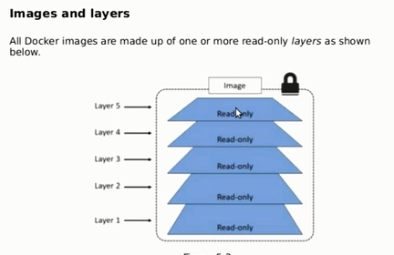
Docker image has layers
If any data is added, after a container is created on top of image it will create a new layer.
Every layer will have id.
Docker inspect is command to give info about docker.

To share volumes between 2 containers:
[root@reviewb ~]# cd /vol2
[root@reviewb vol2]# ls -lrt
total 4
-rw-r--r--. 1 root root 92 Mar 4 10:10 Dockerfile
[root@reviewb vol2]# cat Dockerfile
FROM ubuntu:latest
RUN mkdir /myvol
RUN echo "hello world" > /myvol/greeting
VOLUME /myvol
docker build -t vol2 . ➔ build the image with directory /myvol
docker run -it vol2 /bin/bash → creates container1
docker run -it --volumes-from <1st container id> ubuntu:latest bash → creates container2 with shared directory /myvol

file /myvol will be shared across 2 dockers

Sharing file between Host and Container:
on host:
docker volume create --name DataVolume1 --> creates a docker volume

docker run -ti --rm -v DataVolume1:/datavolume1 ubuntu --> creates container, upon exit docker will be deleted
on docker:

echo "Example1" > /datavolume1/Example1.txt

on host:
docker volume inspect DataVolume1

output
[
{
"Name": "DataVolume1",
"Driver": "local",
"Mountpoint": "/var/lib/docker/volumes/datavolume1/_data",
"Labels": null,
"Scope": "local"
}
]

we can start a new docker with same data volume
docker run --rm -ti -v DataVolume1:/datavolume1 ubuntu

to create volume that persists when container is removed.
docker run -ti --name=Container2 -v DataVolume2:/datavolume2 ubuntu

Docker logs:
On RHEL
cat /var/log/messages | grep docker
or
journalctl -u docker.service

Docker logs based on OS:

Ubuntu (old using upstart ) - /var/log/upstart/docker.log
Ubuntu (new using systemd ) - journalctl -u docker.service
Boot2Docker - /var/log/docker.log
Debian GNU/Linux - /var/log/daemon.log
CentOS - /var/log/daemon.log | grep docker
CoreOS - journalctl -u docker.service
Fedora - journalctl -u docker.service
Red Hat Enterprise Linux Server - /var/log/messages | grep docker
OpenSuSE - journalctl -u docker.service
OSX - ~/Library/Containers/com.docker.docker/Data/com.docker.driver.amd64-linux/log/d‌​ocker.log

Database Use case:
docker run --name db -d -e MYSQL_ROOT_PASSWORD=123 -p 3306:3306 mysql:latest
docker ps
docker exec -it db /bin/bash
mysql -uroot -p123
show databases;
exit
steps to build image:
1. docker pull ubuntu ==> downloads image
2. docker run -it ubuntu => creates container, logs into container
3. do customization, apt-get update, apt-get install python
4. exit from the container using exit
5. docker commit
6. docker login (need to sign up with docker hub first)
7. docker push

this can be automated using dockerfile
docker build -t <image name> .

Create nginx container using docker image:

docker run --name mynginx-P -d nginx
creates a container with name mynginx and runs in the detached mode
container will be running until it is stopped.
Nginx exposes the ports 80 and 443 in the container
-P tells dockers to map those ports to ports in the docker host.

Nginx (pronounced as engine-x) is open source software for web serving, caching load balancing.
Its designed for max performance and stability
Apache webserver is slow, developed in 1995, there are some issues with respect to multi tasking
Nginx was developed in 2004.

FROM nginx

RUN rm /etc/nginx/conf.d/default.conf

RUN rm /etc/nginx/conf.d/examplessl.conf

COPY content /usr/share/nginx/html

COPY conf /etc/nginx
Create the image by running

docker build -t mynginximage1 .

nginx content will be from
/usr/share/nginx/html
Dockerfile to create image with customized code:
FROM nginx
RUN rm /usr/share/nginx/html/index.html
COPY content /usr/share/nginx/html

Docker Swarm:
docker swarm is cluster of machines running docker which provides scalable and reliable platform to run many containers.
Manages all the containers.
Single faced manager where user can interact with.
Docker swarm is for
load balancing: load is balanced across the containers/machines
high availability/fail-over: Webserver will be up, even if one of the node goes down
reliability: load will be shared even if the node goes down.

How to convert 4 machines to docker swarm machines:
Pre-req:
Machines are running with Docker version 1.12
Machines are in the same subnet
With ports 2377,4789 7946 open.
Login to 1st machine and make it manager:
docker swarm init --listen-addr 192.168.0.104:2377 --advertise-addr 192.168.0.104
docker node ls → to check nodes in the swarm.
Login to 2^{nd,} 3rd , 4th nodes and make them workers
docker swarm join --token SWMTKN-1-0fywejkjqfpvnmivezc5biirlqe1dkaxqbdiuv3642v4jsdkbs-0lamc59edwsqzdmqkh1gtnrwj 192.168.0.104:2377

docker node ls → will show 4 nodes

Running service on swarm:

Swarm manages individual containers, we work at higher level
Service is abstract created on top of the containers.
Service is independent function/task/application running inside the container.

Create a service with nginx server:
docker service create --name website --publish 80:80 sixeyed/docker-swarm-walkthrough

make it more scalable:
scale up to 10 instances:

docker service inspect website --pretty
docker service update --replicas 20 website
containers can run on manager or workers
docker service list

even without running the container, using second node we can access website.

Reliability:
If the node goes down, manager knows, node list shows node as down.
The containers will be moved to another node.

Dockerfile example:

#select the base image
FROM ubuntu
#author name
MAINTAINER ubuntu
#copies the contents from docker host to docker container
ADD /host /var/www/html
# execute a command
RUN apt-get update
RUN apt-get install -y python
# define environment variable
ENV var 1
# expose a port
EXPOSE 80
#mount
VOLUME ["/host1"]

Example2:
FROM ubuntu
ENTRYPOINT ["/bin/ping"]
CMD ["localhost"]

docker run -i -t test ➔pings local host
docker run -i -t test google ➔pings google
The ENTRYPOINT specifies a command that will always be executed when the container starts.
The CMD specifies arguments that will be fed to the ENTRYPOINT.
To mount a directory from host to container
docker run -i -t -v /host1:/mnt new:v1 "bin/bash"

