**Jenkins**

**Master-slave**

Jenkins supports the "master/slave" mode, where the workload of building projects are delegated to multiple "slave" nodes, allowing a single Jenkins installation to host a large number of projects, or to provide different environments needed for builds/tests. Sometimes you might also need several different environments to test your builds. In this case using a slave to represent each of your required environments is almost a must.

**Node**

A slave is a computer that is set up to offload build projects from the master and once setup this distribution of tasks is fairly automatic. The exact delegation behavior depends on the configuration of each project; some projects may choose to "stick" to a particular machine for a build, while others may choose to roam freely between slaves.

Since each slave runs a separate program called a "slave agent" there is no need to install the full Jenkins (package or compiled binaries) on a slave. There are various ways to start slave agents, but in the end the slave agent and Jenkins master needs to establish a bi-directional communication link (for example a TCP/IP socket.) in order to operate.

**Steps to create a node**

**Step-1** Go to the Manage Jenkins section and scroll down to the section of Manage Nodes.

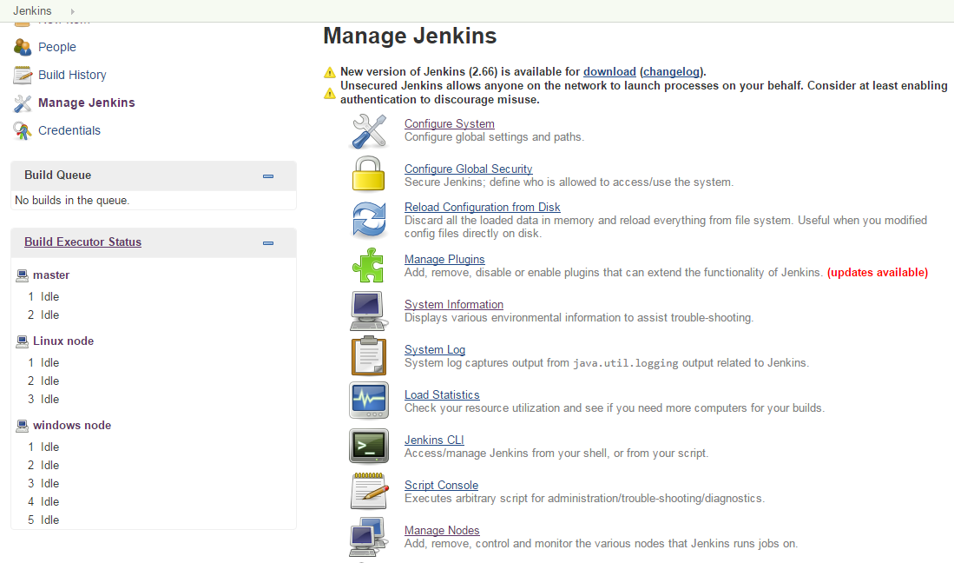

**Step-2** Click on new node

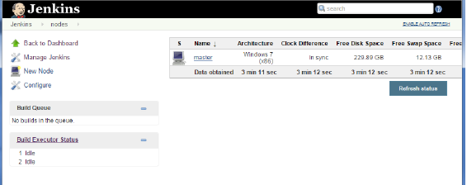

**Step 3** − Give a name for the node, choose the Dumb slave option and click on Ok.

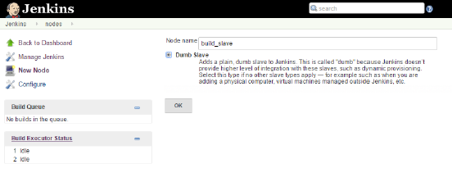

**Step -4**

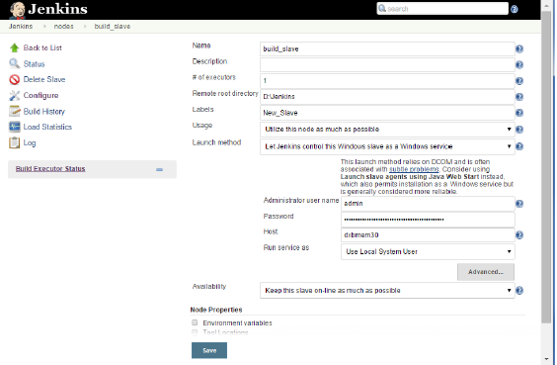

**Step-5** Once the above steps are completed, the new node machine will initially be in an offline state, but will come online if all the settings in the previous screen were entered correctly. One can at any time make the node slave machine as offline if required.

