REAL-WORLD DATASET
ANALYSIS PROJECT
Data Cleaning • Exploratory Data Analysis • Visualisation • Interpretation

Dataset: Scikit-learn Diabetes Dataset
Tools: Python, Pandas, NumPy, Matplotlib, Scikit-learn
Deliverables: Report, charts, dataset, and runnable Python script

Prepared as a complete educational data analysis project

Table of Contents
- 1. Executive Summary
- 2. Problem Statement and Objectives
- 3. Dataset and Analytical Context
- 4. Tools and Libraries
- 5. Methodology
- 6. Dataset Exploration
- 7. Data Cleaning and Preprocessing
- 8. Exploratory Data Analysis
- 9. Visualisations and Interpretation
- 10. Optional Predictive Analysis
- 11. Key Findings and Recommendations
- 12. Limitations and Ethical Considerations
- 13. Conclusion
- 14. How to Run the Code
- 15. Complete Python Code

1. Executive Summary
This project analyses a real-world diabetes dataset containing 442 patient observations, 10 baseline input features, and one target variable. The workflow covers dataset inspection, data-quality checks, preprocessing, descriptive statistics, correlation analysis, visualisations, and an optional linear-regression baseline. The dataset is useful for demonstrating how structured health-related measurements can be explored responsibly. It is an educational analysis, not a medical diagnostic system.
The dataset has 0 missing cells and 0 exact duplicate rows in the supplied version. The target has a mean of 152.13, median of 140.50, and standard deviation of 77.09. BMI has a Pearson correlation of 0.59 with the target, while the s5 feature has a correlation of 0.57. These are associations in this dataset and must not be interpreted as proof of causation.

2. Problem Statement and Objectives
Problem statement: How can a real-world tabular dataset be inspected, cleaned, explored, and visualised to identify patterns and produce evidence-based observations?
- Understand the dataset's context, rows, columns, and data types.
- Inspect missing values, duplicate records, inconsistent types, and possible outliers.
- Use Pandas and NumPy for cleaning and statistical analysis.
- Create charts that show distributions, relationships, and unusual values.
- Summarise findings with clear interpretations and limitations.
- Demonstrate an optional baseline regression model and evaluate it on held-out data.

3. Dataset and Analytical Context
The project uses the Diabetes dataset distributed with scikit-learn. It originates from a study of diabetes patients and is commonly used for regression demonstrations. It contains 442 observations. The ten predictors are age, sex, body mass index (bmi), average blood pressure (bp), and six serum measurements (s1–s6). The target is a quantitative measure of disease progression one year after baseline.
Important: predictor values in this dataset are standardised/centred rather than expressed in familiar units such as years, kg/m², or mg/dL. Therefore, a BMI feature value of 0.05 does not mean a BMI of 0.05 kg/m². The target is also a dataset-specific progression measure, not a direct diagnosis or an individual's probability of having diabetes.

Dataset dimensions
Property | Value
Observations | 442
Input features | 10
Target variable | target
Total columns | 11
Data format | Numerical tabular data
Source | Scikit-learn built-in diabetes dataset

4. Tools and Libraries
- Python: main programming language.
- Pandas: reading CSV files, inspecting data, cleaning, and summary tables.
- NumPy: numerical operations and calculations.
- Matplotlib: histograms, scatter plots, box plots, bar charts, and heatmaps.
- Scikit-learn: loading the dataset, splitting data, fitting a linear regression model, and calculating evaluation metrics.
import pandas as pd
import numpy as np
import matplotlib.pyplot as plt
from sklearn.datasets import load_diabetes

5. Methodology

1. Load
Load the built-in dataset or the included CSV file.

2. Inspect
Check shape, first rows, data types, descriptive statistics, and quality issues.

3. Clean
Remove exact duplicates if present, convert columns to numeric, and fill any missing numeric values with the median.

4. Screen
Use the interquartile range (IQR) to flag possible outliers; do not automatically delete valid extreme values.

5. Explore
Review target distribution, correlations, and relationships between selected features and the target.

6. Visualise
Create charts with labels and titles so findings are easy to communicate.

7. Interpret
Connect chart patterns to observations, while avoiding causal claims.

8. Evaluate
Optionally fit a baseline regression model using a train/test split.

6. Dataset Exploration
The following code checks the structure and summary statistics before any changes are made.
ds = load_diabetes(as_frame=True)
df = ds.frame.copy()
print("Shape:", df.shape)
print(df.head())
print(df.dtypes)
print(df.describe().T)
Observed shape: 442 rows × 11 columns. All columns in this version are numeric. The summary statistics should be reviewed for range, central tendency, and spread rather than assuming the standardised feature values are raw clinical measurements.

7. Data Cleaning and Preprocessing

7.1 Missing-value check
missing_by_column = df.isna().sum()
print(missing_by_column)
print("Total missing cells:", df.isna().sum().sum())
Result for the included dataset: 0 missing cells. This means no imputation is needed for this exact file. The script still includes a median-imputation step so the workflow remains useful if the dataset is later replaced by a version containing missing values.

7.2 Duplicate check
duplicate_count = df.duplicated().sum()
print("Duplicate rows:", duplicate_count)
clean = df.drop_duplicates().copy()
Result for the included dataset: 0 exact duplicate rows. Duplicate rows are removed only if found. Similar values in different patients are not automatically duplicates.

7.3 Data types and missing-value handling
for col in clean.columns:
clean[col] = pd.to_numeric(clean[col], errors="coerce")
for col in clean.select_dtypes(include=np.number).columns:
if clean[col].isna().any():
clean[col] = clean[col].fillna(clean[col].median())
Conversion with errors='coerce' turns invalid numeric strings into missing values. The median is then used only for columns that actually contain missing numeric values. In a production project, any imputation should be documented and fitted on training data only when used in predictive modelling.

7.4 Outlier screening using IQR
for col in feature_cols:
q1 = clean[col].quantile(0.25)
q3 = clean[col].quantile(0.75)
iqr = q3 - q1
lower = q1 - 1.5 * iqr
upper = q3 + 1.5 * iqr
count = ((clean[col] < lower) | (clean[col] > upper)).sum()
print(col, count)
The IQR rule flags values below Q1 − 1.5 × IQR or above Q3 + 1.5 × IQR. A flagged value is not automatically an error. Since this is a health-related dataset, unusual measurements should be investigated rather than deleted just to make a chart look cleaner.

8. Exploratory Data Analysis (EDA)

8.1 Descriptive statistics
Target summary in this dataset: minimum 25.00, maximum 346.00, mean 152.13, median 140.50, and standard deviation 77.09. The mean and median help describe the centre, while the standard deviation describes spread.
print(clean["target"].describe())
print(clean.corr(numeric_only=True)["target"].sort_values(ascending=False))

8.2 Correlation analysis
The Pearson correlation between bmi and target is 0.59; between s5 and target it is 0.57; and between age and target it is 0.19. Correlation measures the strength and direction of a linear relationship. It does not establish cause and effect.

8.3 Target distribution
The histogram shows how frequently target values occur. It can reveal concentration, spread, skew, and possible extreme values. A histogram alone cannot explain why a patient has a particular target value.

9. Visualisations and Interpretation

Figure 1. Target distribution
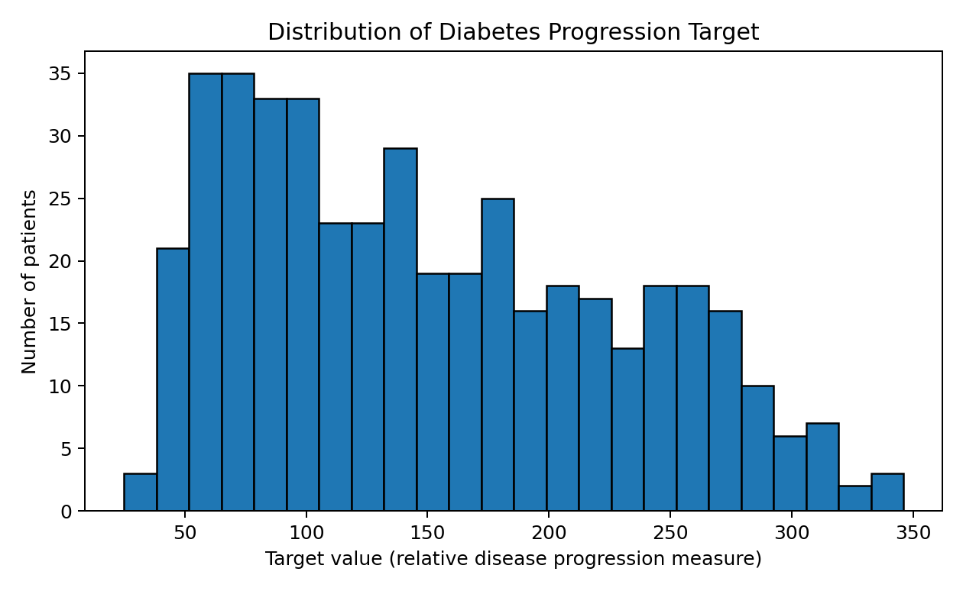
Interpretation: the bars show the frequency of progression scores across the observed range. Use this chart to identify where values cluster and whether the distribution is symmetric or skewed. The exact shape is descriptive and should be confirmed by the displayed histogram rather than assumed.

Figure 2. Correlation heatmap
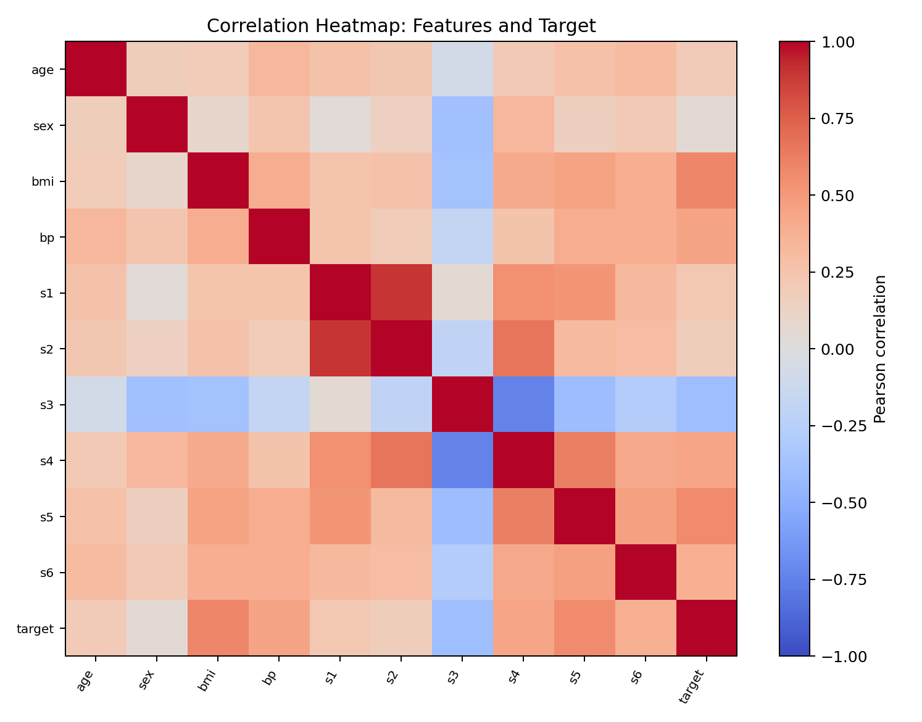
Interpretation: colours indicate the direction and strength of linear correlations. Values closer to +1 indicate a positive relationship, values closer to −1 a negative relationship, and values near 0 little linear relationship. Correlated predictors may contain overlapping information.

Figure 3. BMI versus target
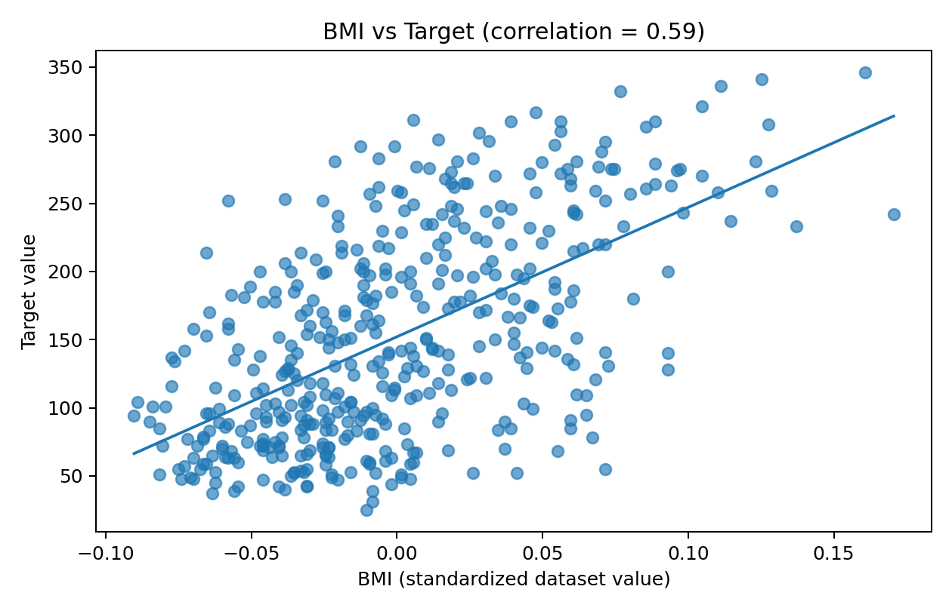
Interpretation: the scatter plot compares the standardised BMI feature with the target and includes a fitted straight trend line. The observed Pearson correlation is 0.59. Points are spread around the line, so BMI alone cannot perfectly explain differences in the target.

Figure 4. Box plots of selected features
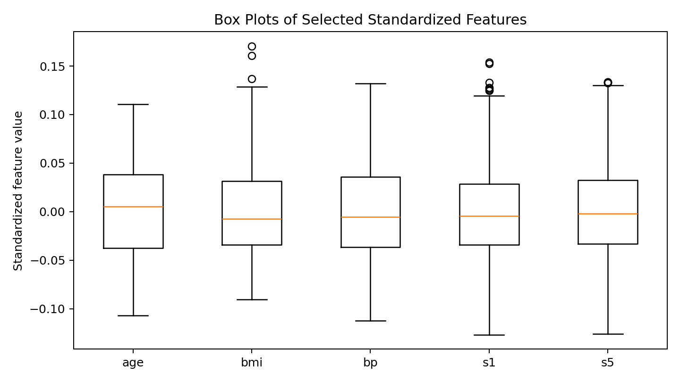
Interpretation: each box shows the middle 50% of values; the line inside is the median, whiskers show the plotted range under the box-plot rule, and points beyond whiskers may be shown as potential outliers. These features are standardised, so compare relative spread rather than interpreting them in raw units.

Figure 5. Absolute correlation with target
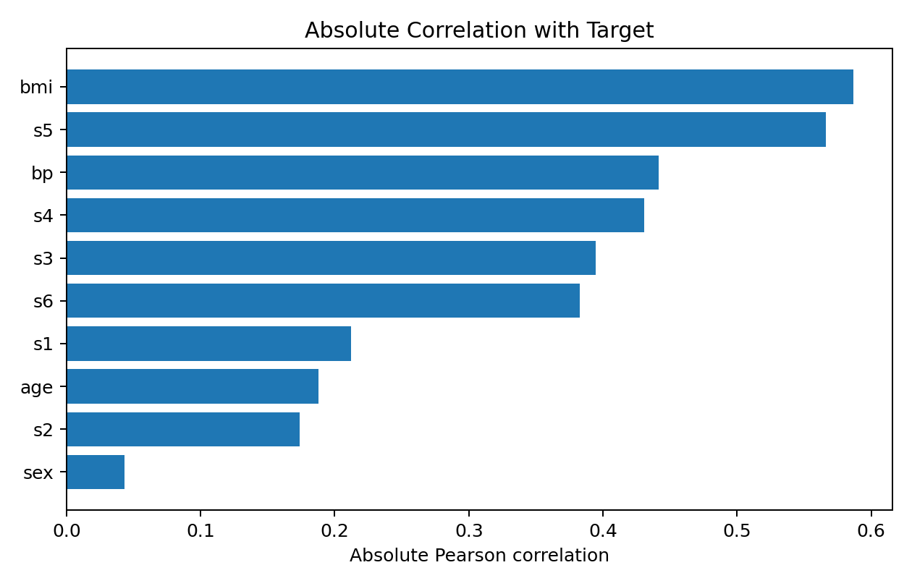
Interpretation: this bar chart ranks features by the absolute value of their correlation with the target. It highlights linear associations regardless of positive or negative direction. Refer to the heatmap or correlation table to recover the sign of each relationship.

10. Optional Predictive Analysis
As an extension, a basic linear regression model estimates the target using all ten input features. The data is divided into 80% training and 20% testing sets. A fixed random seed makes the split reproducible.
X = clean.drop(columns=["target"])
y = clean["target"]
X_train, X_test, y_train, y_test = train_test_split(
X, y, test_size=0.20, random_state=42
)
model = LinearRegression()
model.fit(X_train, y_train)
pred = model.predict(X_test)
mae = mean_absolute_error(y_test, pred)
rmse = np.sqrt(mean_squared_error(y_test, pred))
r2 = r2_score(y_test, pred)
Example test-set results for this run: MAE = 42.79, RMSE = 53.85, and R² = 0.453. MAE is the average absolute prediction error; RMSE penalises larger errors more strongly; R² describes the fraction of target variance explained relative to a mean-only baseline on this test split. These metrics are illustrative and may vary with the split or software version.
This simple model is a baseline, not a clinical tool. Better work would compare several models, use cross-validation, check residuals, assess fairness and data leakage, and report uncertainty.

11. Key Findings and Recommendations
- The dataset contains 442 records and 10 numerical predictors, making it suitable for tabular EDA.
- The included file has 0 missing cells and 0 exact duplicate rows; checks should still remain in the pipeline for future versions.
- BMI has a positive/negative association with the target as indicated by r = 0.59; this is an association, not proof that BMI causes the target to change.
- The s5 feature has a correlation of 0.57 with the target and is worth examining alongside other predictors.
- The IQR method is useful for screening potential outliers, but outliers should be reviewed in context and not automatically deleted.
- Visualisations make distribution and relationship patterns easier to communicate than summary numbers alone.
- A train/test split provides a first estimate of model performance, but one split is not enough for a high-confidence model comparison.

12. Limitations and Ethical Considerations
- The dataset is relatively small compared with modern large-scale health datasets.
- Feature values are standardised; they should not be interpreted as raw clinical units.
- The target is a progression measure, not a diagnosis or risk probability.
- Correlations can be affected by confounding variables and do not prove causality.
- A simple random split can produce different scores; cross-validation is recommended.
- Health-related data requires careful privacy, consent, fairness, and clinical validation before real-world use.
- This project is for education and should not be used to make medical decisions.

13. Conclusion
This project demonstrates a complete data-analysis workflow: selecting a real-world dataset, inspecting its structure, checking data quality, applying safe preprocessing, exploring distributions and correlations, creating five visualisations, and interpreting results. An optional linear regression baseline shows how EDA can lead to a simple predictive task. The most important lesson is that good analysis combines code, visual evidence, domain context, and honest discussion of limitations.

14. How to Run the Code
- Install Python 3.10 or newer.
- Open Command Prompt or a terminal in the project folder.
- Install libraries with: pip install pandas numpy matplotlib scikit-learn
- Run: python diabetes_analysis.py
- The script prints summary tables and saves generated charts in a folder named generated_charts.
- The included diabetes_dataset.csv is used automatically when present.
If using Jupyter Notebook, create a new notebook, copy the sections from diabetes_analysis.py into separate cells, and run them from top to bottom.

15. Complete Python Code
The full runnable script is also supplied as a separate file. The following is the complete code used for the analysis:
"""
REAL-WORLD DATASET ANALYSIS PROJECT
Dataset: Scikit-learn Diabetes dataset (442 observations, 10 baseline features)
Purpose: cleaning, EDA, visualisation, interpretation, and an optional regression baseline.
Requirements:
pip install pandas numpy matplotlib scikit-learn
Run:
python diabetes_analysis.py
The dataset is included as diabetes_dataset.csv. The script uses the local CSV if present;
otherwise it loads the copy bundled with scikit-learn.
"""
from pathlib import Path
import numpy as np
import pandas as pd
import matplotlib.pyplot as plt
from sklearn.datasets import load_diabetes
from sklearn.model_selection import train_test_split
from sklearn.linear_model import LinearRegression
from sklearn.metrics import mean_absolute_error, mean_squared_error, r2_score
HERE = Path(__file__).resolve().parent
DATA_PATH = HERE / "diabetes_dataset.csv"
OUT_DIR = HERE / "generated_charts"
OUT_DIR.mkdir(exist_ok=True)
# 1. Load data
if DATA_PATH.exists():
df = pd.read_csv(DATA_PATH)
else:
df = load_diabetes(as_frame=True).frame.copy()
print("\\n--- Dataset overview ---")
print("Shape:", df.shape)
print(df.head())
print("\\nData types:\\n", df.dtypes)
print("\\nSummary statistics:\\n", df.describe().T)
# 2. Data-quality checks
print("\\nMissing values by column:\\n", df.isna().sum())
print("Total missing values:", int(df.isna().sum().sum()))
print("Duplicate rows:", int(df.duplicated().sum()))
# Preserve original data for audit; drop exact duplicates only if any are present.
clean = df.copy()
duplicate_count = int(clean.duplicated().sum())
if duplicate_count:
clean = clean.drop_duplicates().copy()
# Numeric conversion is explicit. Invalid strings become NaN, then are imputed by median.
for col in clean.columns:
clean[col] = pd.to_numeric(clean[col], errors="coerce")
numeric_cols = clean.select_dtypes(include=np.number).columns
for col in numeric_cols:
if clean[col].isna().any():
clean[col] = clean[col].fillna(clean[col].median())
print("\\nAfter basic cleaning:", clean.shape)
print("Remaining missing values:", int(clean.isna().sum().sum()))
# 3. Outlier screening with IQR. Flag for review rather than deleting valid observations.
feature_cols = [c for c in clean.columns if c != "target"]
outlier_report = {}
for col in feature_cols:
q1 = clean[col].quantile(0.25)
q3 = clean[col].quantile(0.75)
iqr = q3 - q1
lower, upper = q1 - 1.5 * iqr, q3 + 1.5 * iqr
outlier_report[col] = int(((clean[col] < lower) | (clean[col] > upper)).sum())
print("\\nIQR outlier counts (screening only):\\n", pd.Series(outlier_report))
# 4. Exploratory data analysis
print("\\nTarget summary:\\n", clean["target"].describe())
corr = clean.corr(numeric_only=True)
print("\\nCorrelation with target:\\n", corr["target"].drop("target").sort_values(ascending=False))
# Histogram: target distribution
plt.figure(figsize=(7, 4.5))
plt.hist(clean["target"], bins=24, edgecolor="black")
plt.title("Distribution of Diabetes Progression Target")
plt.xlabel("Target value (relative progression measure)")
plt.ylabel("Number of patients")
plt.tight_layout()
plt.savefig(OUT_DIR / "target_distribution.png", dpi=180)
plt.close()
# Correlation heatmap
plt.figure(figsize=(8.5, 6.5))
im = plt.imshow(corr, aspect="auto", cmap="coolwarm", vmin=-1, vmax=1)
plt.colorbar(im, label="Pearson correlation")
plt.xticks(range(len(corr.columns)), corr.columns, rotation=60, ha="right", fontsize=8)
plt.yticks(range(len(corr.index)), corr.index, fontsize=8)
plt.title("Correlation Heatmap")
plt.tight_layout()
plt.savefig(OUT_DIR / "correlation_heatmap.png", dpi=180)
plt.close()
# Scatter plot with linear trend line
plt.figure(figsize=(7, 4.5))
plt.scatter(clean["bmi"], clean["target"], alpha=0.65)
coef = np.polyfit(clean["bmi"], clean["target"], 1)
x_line = np.linspace(clean["bmi"].min(), clean["bmi"].max(), 100)
plt.plot(x_line, np.polyval(coef, x_line))
plt.title(f"BMI vs Target (r = {corr.loc['bmi', 'target']:.2f})")
plt.xlabel("BMI (standardized feature)")
plt.ylabel("Target value")
plt.tight_layout()
plt.savefig(OUT_DIR / "bmi_vs_target.png", dpi=180)
plt.close()
# Box plots of selected features
selected = ["age", "bmi", "bp", "s1", "s5"]
plt.figure(figsize=(8, 4.5))
plt.boxplot([clean[c] for c in selected], tick_labels=selected)
plt.title("Box Plots of Selected Features")
plt.ylabel("Standardized feature value")
plt.tight_layout()
plt.savefig(OUT_DIR / "feature_boxplots.png", dpi=180)
plt.close()
# Absolute correlations bar chart
abs_corr = corr["target"].drop("target").abs().sort_values()
plt.figure(figsize=(7, 4.5))
plt.barh(abs_corr.index, abs_corr.values)
plt.title("Absolute Correlation with Target")
plt.xlabel("Absolute Pearson correlation")
plt.tight_layout()
plt.savefig(OUT_DIR / "target_correlations.png", dpi=180)
plt.close()
# 5. Optional baseline model. This is an educational baseline, not a clinical tool.
X = clean[feature_cols]
y = clean["target"]
X_train, X_test, y_train, y_test = train_test_split(
X, y, test_size=0.20, random_state=42
)
model = LinearRegression()
model.fit(X_train, y_train)
pred = model.predict(X_test)
print("\\n--- Linear regression test-set metrics ---")
print("MAE:", round(mean_absolute_error(y_test, pred), 2))
print("RMSE:", round(np.sqrt(mean_squared_error(y_test, pred)), 2))
print("R-squared:", round(r2_score(y_test, pred), 3))
print(f"\\nCharts saved in: {OUT_DIR}")

References
1. Scikit-learn documentation, The Diabetes Dataset: https://scikit-learn.org/stable/datasets/toy_dataset.html#diabetes-dataset
2. Pandas documentation: https://pandas.pydata.org/docs/
3. NumPy documentation: https://numpy.org/doc/
4. Matplotlib documentation: https://matplotlib.org/stable/
5. Scikit-learn model evaluation documentation: https://scikit-learn.org/stable/modules/model_evaluation.html

