DATA SCIENCE CAPSTONE PROJECT
Diabetes Progression Prediction Using Machine Learning

End-to-end data science workflow
Dataset • Data cleaning • EDA • Machine learning • Evaluation • Insights
Tools: Python, Pandas, NumPy, Matplotlib, Seaborn and Scikit-learn
Student Name: ______________________________
Course / Semester: __________________________
College: ____________________________________
Submission Date: ____________________________

Abstract
This capstone demonstrates an end-to-end Data Science workflow using the diabetes regression dataset distributed with Scikit-learn. The objective is to estimate a quantitative measure of disease progression one year after baseline from ten baseline variables. The work covers problem definition, data inspection, cleaning checks, exploratory data analysis, model development, evaluation, interpretation, recommendations and limitations. Linear Regression and Random Forest Regression are compared using a fixed 80:20 hold-out split and five-fold cross-validation. The target is a research outcome score, not a diagnosis or a direct prediction of whether a person has diabetes. Results are educational and must not be used for clinical decisions.

Executive Summary
The dataset contains 442 records and 10 predictor variables. The hold-out test set contains 89 records. The model with the lower test RMSE is Linear Regression (RMSE 53.85, MAE 42.79, R² 0.453). These scores summarize performance on this split only; cross-validation and external validation are needed before generalizing.

Table of Contents
- 1. Introduction and Problem Definition
- 2. Objectives, Scope and Expected Outcomes
- 3. Dataset Description and Data Collection
- 4. Data Understanding and Preparation
- 5. Exploratory Data Analysis (EDA)
- 6. Methodology and Machine Learning
- 7. Model Evaluation and Comparison
- 8. Interpretation and Data-Driven Insights
- 9. Recommendations
- 10. Limitations, Ethics and Risk
- 11. Conclusion and Future Scope
- 12. Complete Python Implementation
- 13. References

1. Introduction and Problem Definition
Diabetes is a long-term health condition that requires ongoing research and monitoring. Data Science can help researchers explore relationships between baseline measurements and later outcomes. In this project, the task is framed as a supervised regression problem: use baseline measurements to estimate a continuous disease-progression score recorded one year later in the dataset.

Problem statement
Given ten baseline variables for a participant, build and evaluate machine-learning models that estimate the dataset's quantitative diabetes progression target.

Why this problem matters
- It demonstrates how multiple measurements can be analysed together rather than in isolation.
- A regression model provides a numeric estimate, allowing prediction errors to be measured.
- The workflow teaches reproducible preparation, visual analysis, model comparison and responsible interpretation.

2. Objectives, Scope and Expected Outcomes
- Load and describe a genuine, documented dataset.
- Check data types, missing values, duplicate rows and unusual values.
- Explore distributions, correlations and relationships using charts.
- Train a Linear Regression baseline and a Random Forest regression model.
- Compare models with MAE, MSE, RMSE and R², plus five-fold cross-validation.
- Translate patterns into cautious research insights and practical recommendations.
Scope: this is a retrospective educational analysis of the bundled research dataset. It does not establish causation, diagnose diabetes, estimate an individual's medical risk, or recommend treatment.

3. Dataset Description and Data Collection
The dataset is the diabetes dataset included in Scikit-learn's public educational datasets (load_diabetes). It contains 442 observations, ten baseline features and one continuous target. The target represents a quantitative measure of disease progression one year after baseline. Feature values are preprocessed/standardized by the dataset provider; they are not raw clinical measurements in familiar units.
Item | Description
Source | Scikit-learn built-in diabetes dataset; original research data commonly attributed to Efron et al. (2004).
Observations | 442
Predictor variables | 10
Target | Continuous disease progression measure one year after baseline
Task type | Supervised regression
Data format | Numeric tabular data
Missing values detected | 0
Duplicate rows detected | 0

Feature dictionary
Feature | Meaning (dataset documentation)
age | Age (standardized dataset value)
sex | Sex indicator (standardized dataset value)
bmi | Body mass index (standardized dataset value)
bp | Average blood pressure (standardized dataset value)
s1 | Serum measurement 1 (total serum cholesterol)
s2 | Serum measurement 2 (low-density lipoproteins)
s3 | Serum measurement 3 (high-density lipoproteins)
s4 | Serum measurement 4 (total cholesterol / HDL)
s5 | Serum measurement 5 (possibly log of triglycerides level)
s6 | Serum measurement 6 (blood sugar level)

The s1–s6 columns are compact variable labels used by the dataset. Their interpretation should follow the dataset documentation; do not infer units from the standardized values.

4. Data Understanding and Preparation
The data was loaded into a Pandas DataFrame. Initial checks examined shape, column names, data types, summary statistics, missing values and duplicate rows. The built-in dataset has 0 missing values and 0 exact duplicate rows in this run. Because the source dataset is already numeric and preprocessed, no categorical encoding or unit conversion was required.

Preparation steps
- Separate predictors (X) from the target (y).
- Check null values and duplicates before modelling.
- Use an 80:20 train-test split with random_state=42 for reproducibility.
- Fit StandardScaler only inside the Linear Regression pipeline, so scaling parameters are learned from training data only.
- Keep the test set untouched until final evaluation to reduce data leakage.

Code: load and inspect the dataset
from sklearn.datasets import load_diabetes
import pandas as pd
diabetes = load_diabetes(as_frame=True)
df = diabetes.frame.copy()
print(df.head())
print(df.shape)
print(df.info())
print(df.isnull().sum())
print("Duplicates:", df.duplicated().sum())
print(df.describe().round(2))

5. Exploratory Data Analysis (EDA)
EDA is used to understand the target distribution, identify relationships and guide model development. Correlation describes linear association, not cause and effect.
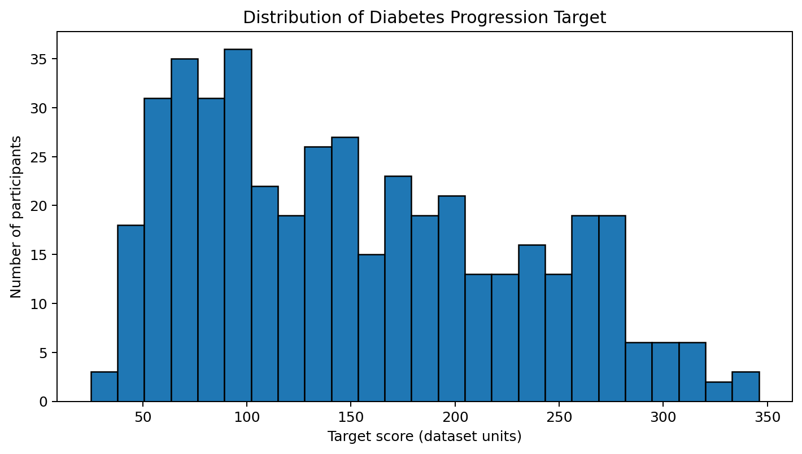
Figure 1. Distribution of the continuous diabetes progression target.
The target has a mean of 152.13, median of 140.50 and standard deviation of 77.09. The histogram shows how the outcome values are distributed and whether the sample is concentrated around a central range or has a long tail.
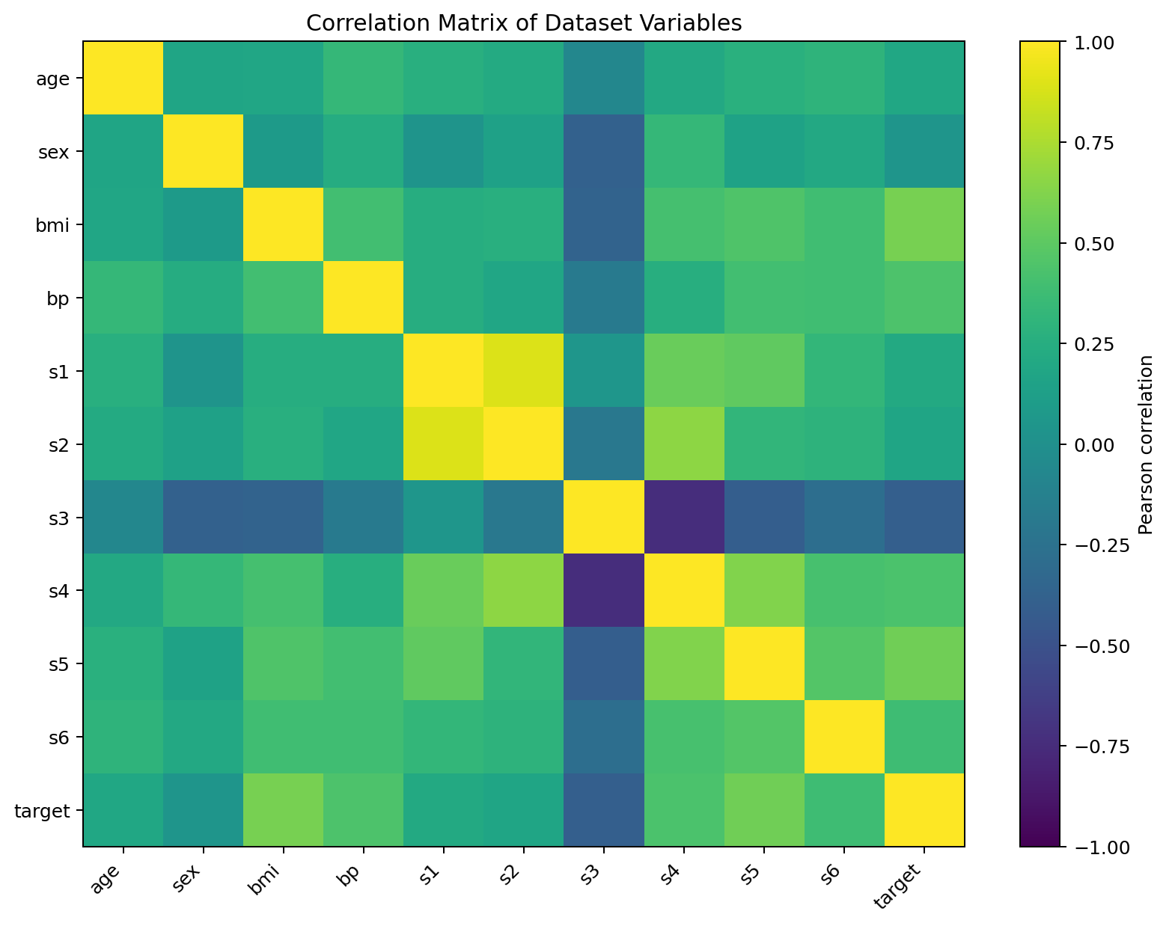
Figure 2. Pearson correlation matrix for predictors and target.
The heatmap gives a quick view of pairwise linear relationships. The strongest absolute feature-to-target correlations in this dataset are shown below. Correlation is useful for exploration, but it does not prove that a feature causes progression.
Feature | Correlation with target
bmi | 0.586
s5 | 0.566
bp | 0.441
s4 | 0.430
s3 | -0.395
s6 | 0.382

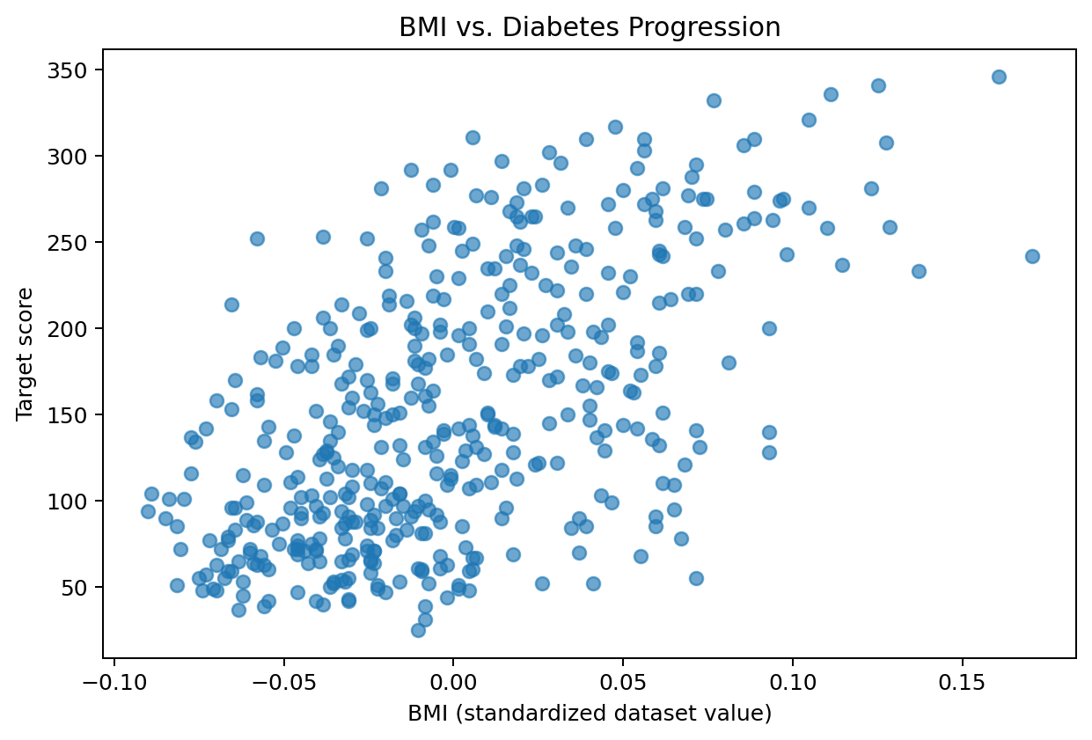
Figure 3. Relationship between the standardized BMI feature and the target.
The scatter plot checks whether a simple upward or downward pattern is visible and whether observations vary widely around that pattern. Each point represents one participant.

6. Methodology and Machine Learning
Two regression algorithms were selected to provide a simple, interpretable baseline and a more flexible non-linear model.
Algorithm | How it works | Reason for inclusion
Linear Regression | Fits a linear relationship between predictors and the continuous target. | Interpretable baseline; coefficients can summarize linear associations.
Random Forest Regressor | Combines predictions from many decision trees trained on bootstrapped samples and feature subsets. | Can represent non-linear patterns and feature interactions.

Training design
- Training data: 80% of observations.
- Test data: 20% of observations.
- Random seed: 42.
- Linear Regression: StandardScaler + LinearRegression pipeline.
- Random Forest: 400 trees, min_samples_leaf=2, random_state=42.
- Cross-validation: five shuffled folds on the full dataset for a stability check.

Code: split and train models
from sklearn.model_selection import train_test_split
from sklearn.pipeline import Pipeline
from sklearn.preprocessing import StandardScaler
from sklearn.linear_model import LinearRegression
from sklearn.ensemble import RandomForestRegressor
X = df.drop(columns=["target"])
y = df["target"]
X_train, X_test, y_train, y_test = train_test_split(
X, y, test_size=0.20, random_state=42
)
linear_model = Pipeline([
("scaler", StandardScaler()),
("model", LinearRegression())
])
rf_model = RandomForestRegressor(
n_estimators=400,
min_samples_leaf=2,
random_state=42,
n_jobs=-1
)
linear_model.fit(X_train, y_train)
rf_model.fit(X_train, y_train)
pred_lr = linear_model.predict(X_test)
pred_rf = rf_model.predict(X_test)

7. Model Evaluation and Comparison
The models are evaluated on the same held-out test observations. MAE is the average absolute prediction error; MSE is the average squared error; RMSE is the square root of MSE and is expressed in target units; R² measures the fraction of target variance explained relative to predicting the test-set mean. Higher R² is generally better, while lower MAE, MSE and RMSE are better.
Model | MAE | MSE | RMSE | R²
Linear Regression | 42.79 | 2900.19 | 53.85 | 0.453
Random Forest | 44.04 | 2958.30 | 54.39 | 0.442

On this particular test split, Linear Regression has the lower RMSE. This does not automatically mean it will perform better on every sample or in a different population. The scores should be interpreted together rather than selecting a model from one metric alone.
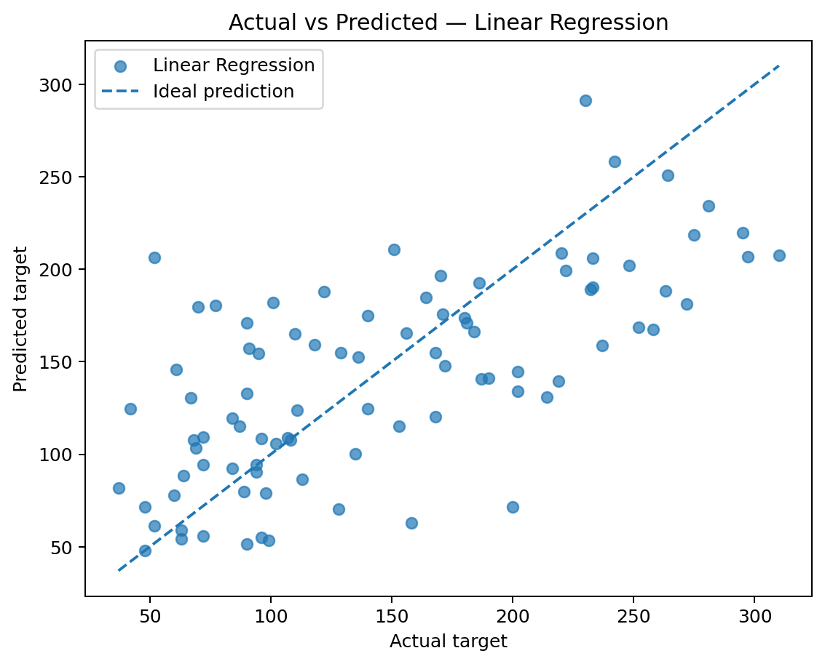
Figure 4. Linear Regression predictions compared with actual test targets.
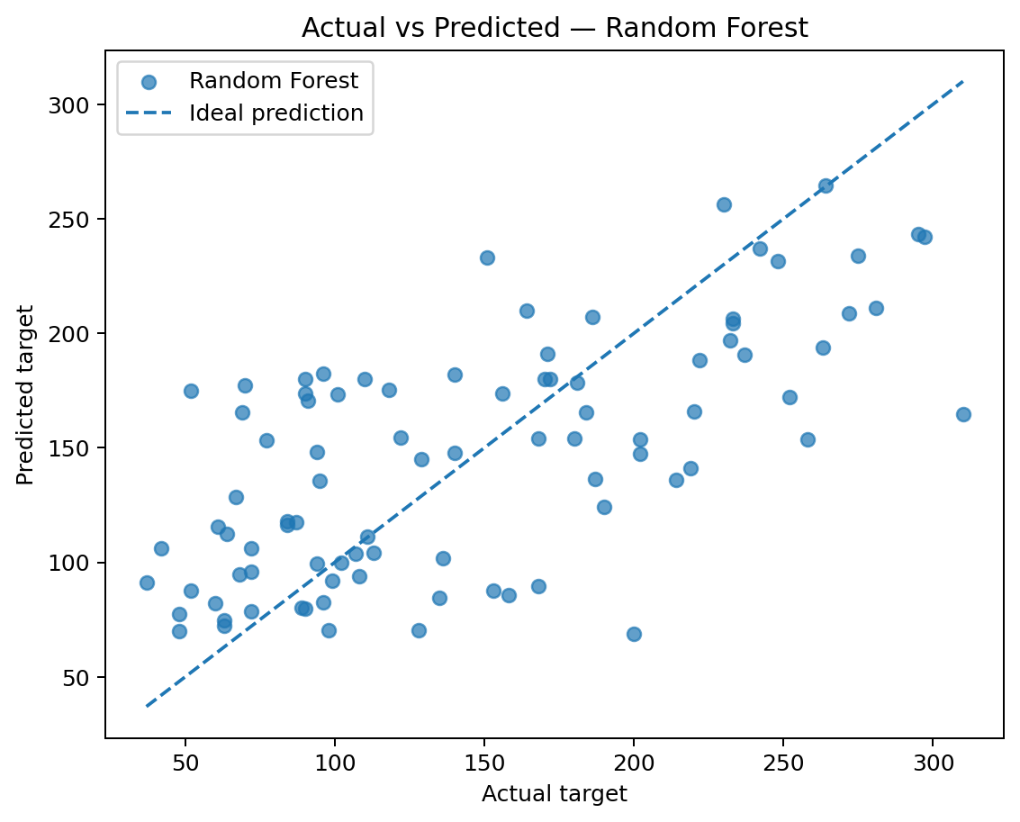
Figure 5. Random Forest predictions compared with actual test targets.
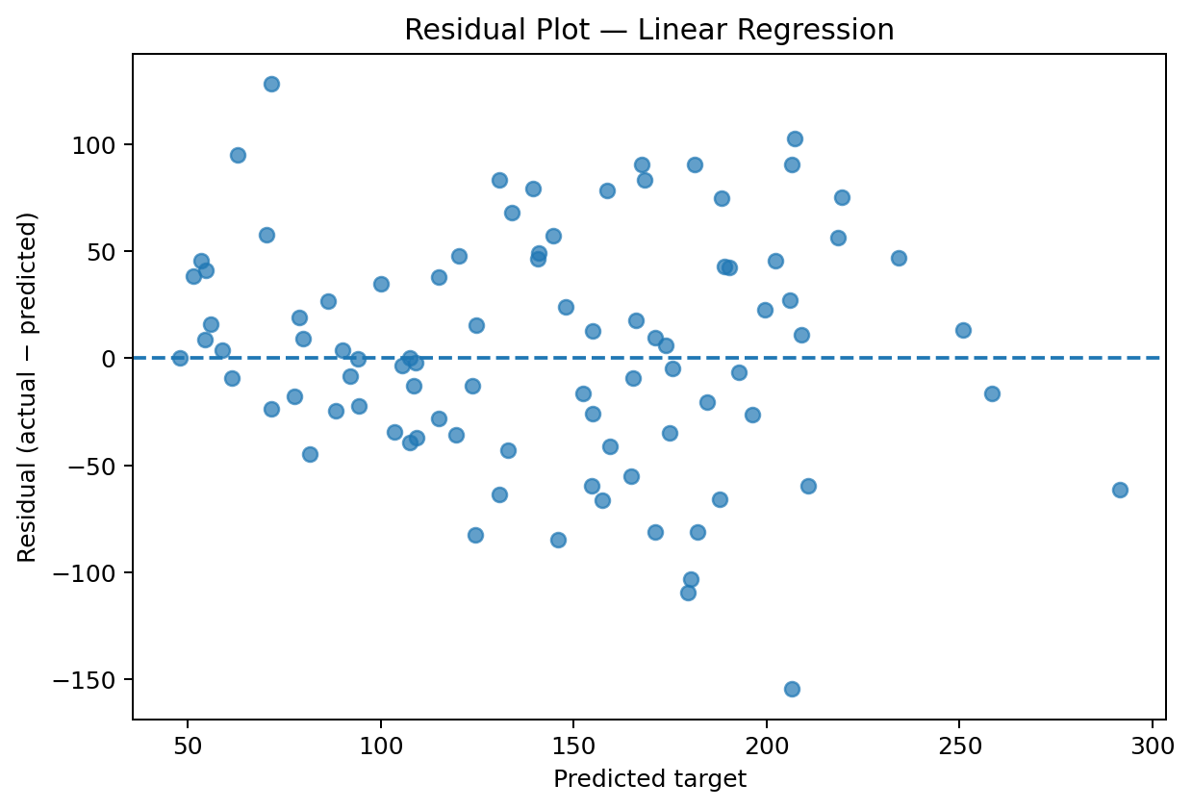
Figure 6. Linear Regression residuals; random scatter around zero is generally desirable.

Five-fold cross-validation
Linear Regression mean cross-validated R² = 0.478 (standard deviation 0.085); Random Forest mean cross-validated R² = 0.428 (standard deviation 0.096). Variation across folds indicates that performance depends on which observations are held out.

Code: evaluate models
from sklearn.metrics import mean_absolute_error, mean_squared_error, r2_score
import numpy as np
def evaluate_model(name, actual, predicted):
mse = mean_squared_error(actual, predicted)
return {
"Model": name,
"MAE": mean_absolute_error(actual, predicted),
"MSE": mse,
"RMSE": np.sqrt(mse),
"R2": r2_score(actual, predicted)
}
print(evaluate_model("Linear Regression", y_test, pred_lr))
print(evaluate_model("Random Forest", y_test, pred_rf))

8. Interpretation and Data-Driven Insights
The model comparison indicates how well the selected methods estimate the dataset target for unseen rows from the same source. A prediction close to the diagonal in the actual-vs-predicted charts is more accurate. Larger vertical distances indicate larger errors. Residual plots help identify systematic overprediction, underprediction or changing error spread.

Feature importance
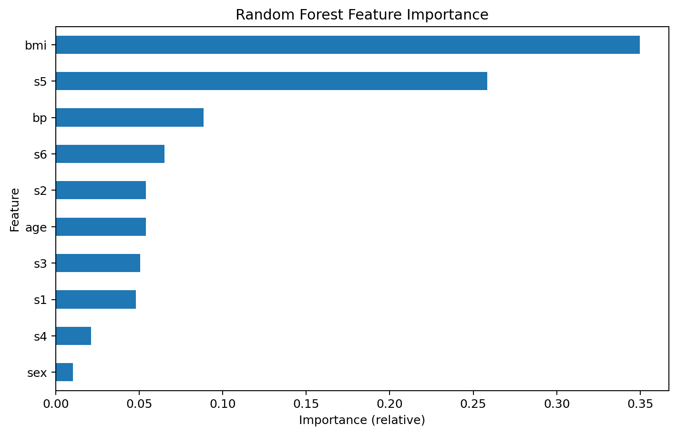
Figure 7. Random Forest impurity-based feature importance.
Random Forest feature importance describes how much each feature contributes to reductions in split impurity across the fitted trees. It is not a causal effect, can be biased toward certain feature types, and may distribute importance across correlated variables. It should be treated as a model diagnostic rather than a medical explanation.

Examples of interpretation
- If two participants have similar feature values, the model may produce similar estimated target scores; this is a model output, not a clinical judgement.
- If the actual-vs-predicted point is far from the diagonal, the model made a larger error for that observation.
- If residuals show a curved pattern, a linear model may be missing a non-linear relationship.
- If feature importance is concentrated in a small number of variables, those variables were useful for this fitted model, but they are not proven causes.

9. Recommendations
- For educational research, report both a transparent baseline and a flexible model rather than presenting one score in isolation.
- Use repeated or nested cross-validation and an external dataset before claiming that performance generalizes.
- Document data provenance, feature definitions, preprocessing and random seeds so results can be reproduced.
- Consult domain experts before assigning clinical meaning to patterns or model outputs.
- If a model is ever considered for healthcare use, require fairness assessment, privacy protection, prospective validation, clinical oversight and regulatory review.

10. Limitations, Ethics and Risk
- Small dataset: 442 observations may not represent current or diverse populations.
- Historical data: patterns in an older research cohort may not transfer to present-day care.
- Target meaning: the target is a progression score, not a diabetes diagnosis, prevalence estimate or treatment outcome recommendation.
- Preprocessed features: standardized values make coefficients and scatter axes less intuitive than raw clinical units.
- Correlation and feature importance do not establish causality.
- Potential bias: subgroup performance and fairness were not comprehensively evaluated.
- No external validation: a single random hold-out split is not enough for deployment.
Ethical statement: This project uses a public educational dataset and does not contain personally identifying information in the distributed version. The model must not be used to make decisions about an individual's diagnosis, medication, insurance, employment or care.

11. Conclusion and Future Scope
This project completed the main stages of a Data Science capstone: problem definition, data loading and inspection, exploratory analysis, preprocessing, regression modelling, evaluation, visualization and recommendation development. The two models provide a useful comparison between a linear baseline and a tree-based ensemble. The results demonstrate the importance of a held-out test set, multiple metrics and cautious interpretation.

Future scope
- Test Gradient Boosting, HistGradientBoosting, Elastic Net and Support Vector Regression.
- Tune hyperparameters using nested cross-validation without touching the final test set.
- Use permutation importance and SHAP-style explanations to examine model behaviour.
- Validate on a larger, newer and independent dataset with clearly documented consent and governance.
- Evaluate error and calibration-like behaviour across relevant demographic subgroups where ethically and legally appropriate.
- Build a simple dashboard for research exploration, with clear warnings that outputs are not clinical advice.

12. Complete Python Implementation
The following script reproduces the core analysis, model training, evaluation and visualizations. Install dependencies first using: pip install pandas numpy matplotlib seaborn scikit-learn
# DATA SCIENCE CAPSTONE: DIABETES PROGRESSION REGRESSION
# Install: pip install pandas numpy matplotlib seaborn scikit-learn
import numpy as np
import pandas as pd
import matplotlib.pyplot as plt
import seaborn as sns
from sklearn.datasets import load_diabetes
from sklearn.model_selection import train_test_split, KFold, cross_val_score
from sklearn.pipeline import Pipeline
from sklearn.preprocessing import StandardScaler
from sklearn.linear_model import LinearRegression
from sklearn.ensemble import RandomForestRegressor
from sklearn.metrics import (
mean_absolute_error, mean_squared_error, r2_score
)
# 1. LOAD DATA
dataset = load_diabetes(as_frame=True)
df = dataset.frame.copy()
print("Shape:", df.shape)
print(df.head())
print(df.info())
print("Missing values:\n", df.isnull().sum())
print("Duplicate rows:", df.duplicated().sum())
print(df.describe())
# 2. DATA PREPARATION
X = df.drop(columns=["target"])
y = df["target"]
X_train, X_test, y_train, y_test = train_test_split(
X, y, test_size=0.20, random_state=42
)
# 3. DEFINE MODELS
linear_model = Pipeline([
("scaler", StandardScaler()),
("model", LinearRegression())
])
rf_model = RandomForestRegressor(
n_estimators=400,
min_samples_leaf=2,
random_state=42,
n_jobs=-1
)
# 4. TRAIN
linear_model.fit(X_train, y_train)
rf_model.fit(X_train, y_train)
# 5. PREDICT
pred_lr = linear_model.predict(X_test)
pred_rf = rf_model.predict(X_test)
# 6. EVALUATE
def evaluate(name, actual, predicted):
mse = mean_squared_error(actual, predicted)
return {
"Model": name,
"MAE": mean_absolute_error(actual, predicted),
"MSE": mse,
"RMSE": np.sqrt(mse),
"R2": r2_score(actual, predicted)
}
results = pd.DataFrame([
evaluate("Linear Regression", y_test, pred_lr),
evaluate("Random Forest", y_test, pred_rf)
])
print("\nTest results:\n", results.round(3))
# 7. FIVE-FOLD CROSS-VALIDATION
cv = KFold(n_splits=5, shuffle=True, random_state=42)
for name, model in [
("Linear Regression", linear_model),
("Random Forest", rf_model)
]:
scores = cross_val_score(model, X, y, cv=cv, scoring="r2")
print(name, "CV R2 mean:", scores.mean(),
"std:", scores.std())
# 8. EXPLORATORY VISUALIZATIONS
plt.figure(figsize=(8, 5))
sns.histplot(y, bins=25, kde=True)
plt.title("Distribution of Target")
plt.xlabel("Diabetes progression target")
plt.tight_layout()
plt.show()
plt.figure(figsize=(9, 7))
sns.heatmap(df.corr(), cmap="coolwarm", center=0, annot=False)
plt.title("Correlation Matrix")
plt.tight_layout()
plt.show()
plt.figure(figsize=(7, 5))
sns.scatterplot(data=df, x="bmi", y="target")
plt.title("BMI vs Target")
plt.tight_layout()
plt.show()
# 9. ACTUAL VS PREDICTED
plt.figure(figsize=(6, 5))
plt.scatter(y_test, pred_lr, alpha=0.7)
low = min(y_test.min(), pred_lr.min())
high = max(y_test.max(), pred_lr.max())
plt.plot([low, high], [low, high], "r--")
plt.xlabel("Actual")
plt.ylabel("Predicted")
plt.title("Linear Regression: Actual vs Predicted")
plt.tight_layout()
plt.show()
plt.figure(figsize=(6, 5))
plt.scatter(y_test, pred_rf, alpha=0.7)
low = min(y_test.min(), pred_rf.min())
high = max(y_test.max(), pred_rf.max())
plt.plot([low, high], [low, high], "r--")
plt.xlabel("Actual")
plt.ylabel("Predicted")
plt.title("Random Forest: Actual vs Predicted")
plt.tight_layout()
plt.show()
# 10. RESIDUAL ANALYSIS
residuals = y_test - pred_lr
plt.figure(figsize=(7, 5))
plt.scatter(pred_lr, residuals, alpha=0.7)
plt.axhline(0, color="red", linestyle="--")
plt.xlabel("Predicted target")
plt.ylabel("Residual")
plt.title("Residual Plot - Linear Regression")
plt.tight_layout()
plt.show()
# 11. FEATURE IMPORTANCE
importance = pd.Series(
rf_model.feature_importances_, index=X.columns
).sort_values()
importance.plot(kind="barh", figsize=(8, 5))
plt.title("Random Forest Feature Importance")
plt.xlabel("Relative importance")
plt.tight_layout()
plt.show()
# 12. SAVE PREDICTIONS
prediction_output = pd.DataFrame({
"actual_target": y_test,
"linear_prediction": pred_lr,
"random_forest_prediction": pred_rf
})
prediction_output.to_csv("test_predictions.csv", index=False)
print("Saved test_predictions.csv")

13. References
- Scikit-learn documentation — Diabetes dataset: https://scikit-learn.org/stable/datasets/toy_dataset.html#diabetes-dataset
- Scikit-learn documentation — Model evaluation: https://scikit-learn.org/stable/modules/model_evaluation.html
- Scikit-learn documentation — Linear models: https://scikit-learn.org/stable/modules/linear_model.html
- Scikit-learn documentation — Random Forests: https://scikit-learn.org/stable/modules/ensemble.html#forest
- Efron, B., Hastie, T., Johnstone, I. and Tibshirani, R. (2004). Least Angle Regression. Annals of Statistics, 32(2), 407–499.
Note: The Scikit-learn dataset is supplied for learning and reproducible demonstrations. Consult the official documentation for dataset details, licensing and provenance.

