MongoDB Assignment A

- Create a new database called student_management.

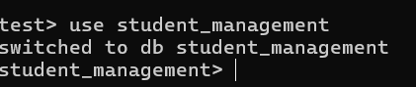

- Create a collection called students in the student_management database.

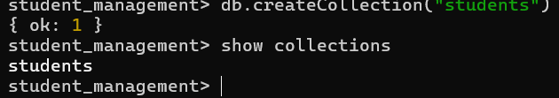

- Insert at least five student records into the students collection. Each record should have the following fields:
- student_id (integer)
- name (string)
- age (integer)
- department (string)
- courses (array of strings)
- grade (string)
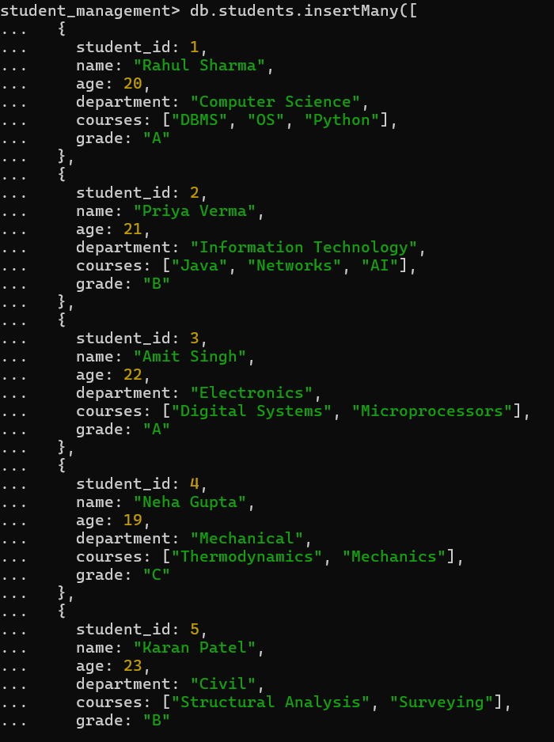

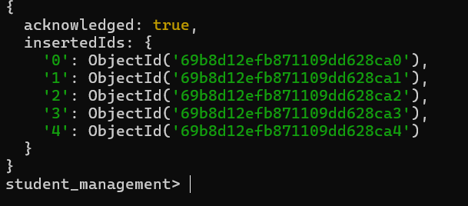

- Query the Collection:
Write queries to perform the following tasks:
- Retrieve all students who are in the "Computer Science" department.
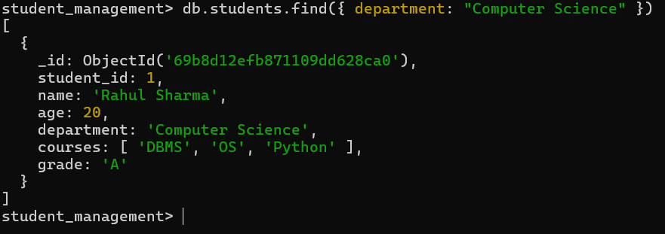

- Retrieve students who have an age greater than 21.

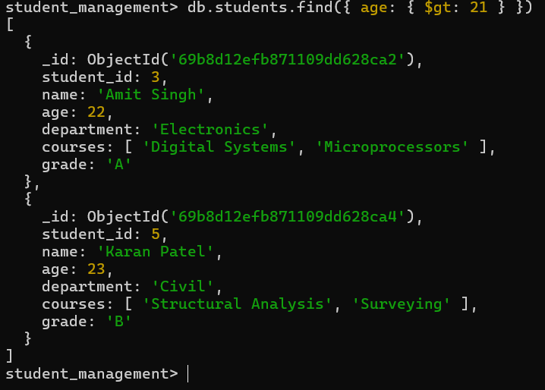

- Retrieve students who are taking the "Database Systems" course.

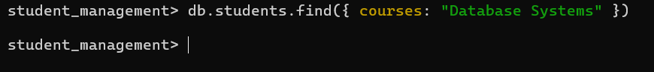

- Retrieve students with a grade of "A".
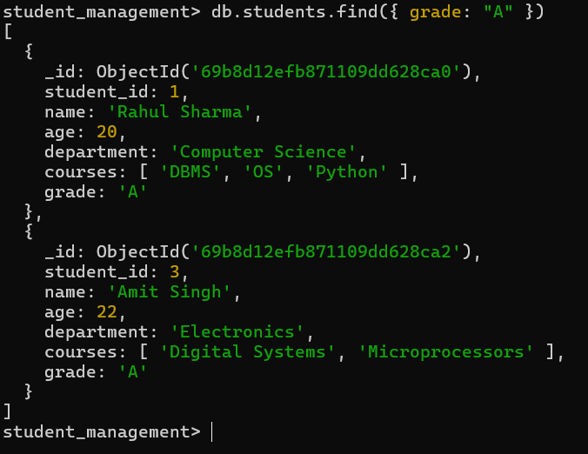

- Update Documents:
- Update the age of a student with student_id 101 to 21.
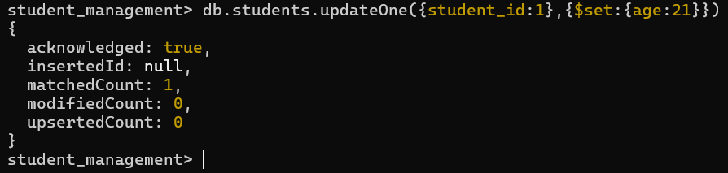

- Add a new course, "Machine Learning", to the courses array for students in the "Computer Science" department.
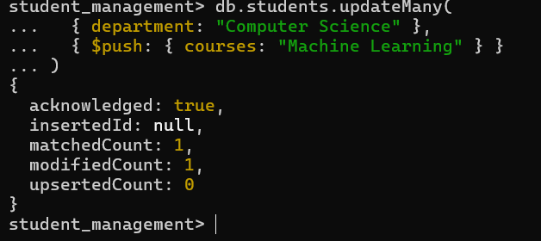

- Delete Documents:
- Delete a student record with student_id 105.
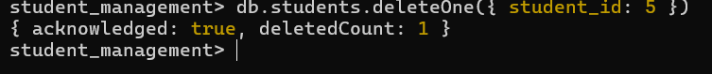

- Delete all students who have a grade lower than "C".

