🕵️‍♂️ Algorithm 7: K-Means Clustering
(The Organizer)

1. Concept (Understanding it)
- What is it? An Unsupervised algorithm. It does not need labels (answers).
- Goal: To group similar data points together into $K$ clusters.
- Analogy: Organizing a messy closet into piles (Shirts, Pants, Socks) without knowing beforehand what piles you need.

2. Key Terms (For Interviews)
- Centroid: The center point of a cluster.
- Inertia: How tightly the data points are packed around their centroid. (Lower is better).
- Elbow Method: The technique to find the best $K$ by plotting Inertia vs. $K$.

3. The Math (Logic) 📏
- It uses Euclidean Distance to find which centroid is closest to each point.
- It iteratively moves the centroids to the Average (Mean) position of the points in the cluster.

4. Scikit-Learn Code Template 💻
Python
from sklearn.cluster import KMeans

# 1. Create Model (Let's say we want 3 groups)
model = KMeans(n_clusters=3)

# 2. Train (Notice: We only give X, no y!)
model.fit(X)

# 3. Get Results
groups = model.predict(X) # Which group does each point belong to?
centroids = model.cluster_centers_ # Where are the centers?

5. Pros & Cons
- ✅ Pros: Fast and simple. Great for customer segmentation.
- ❌ Cons: You have to guess $K$ first. It struggles with weird shapes (like spirals or rings).

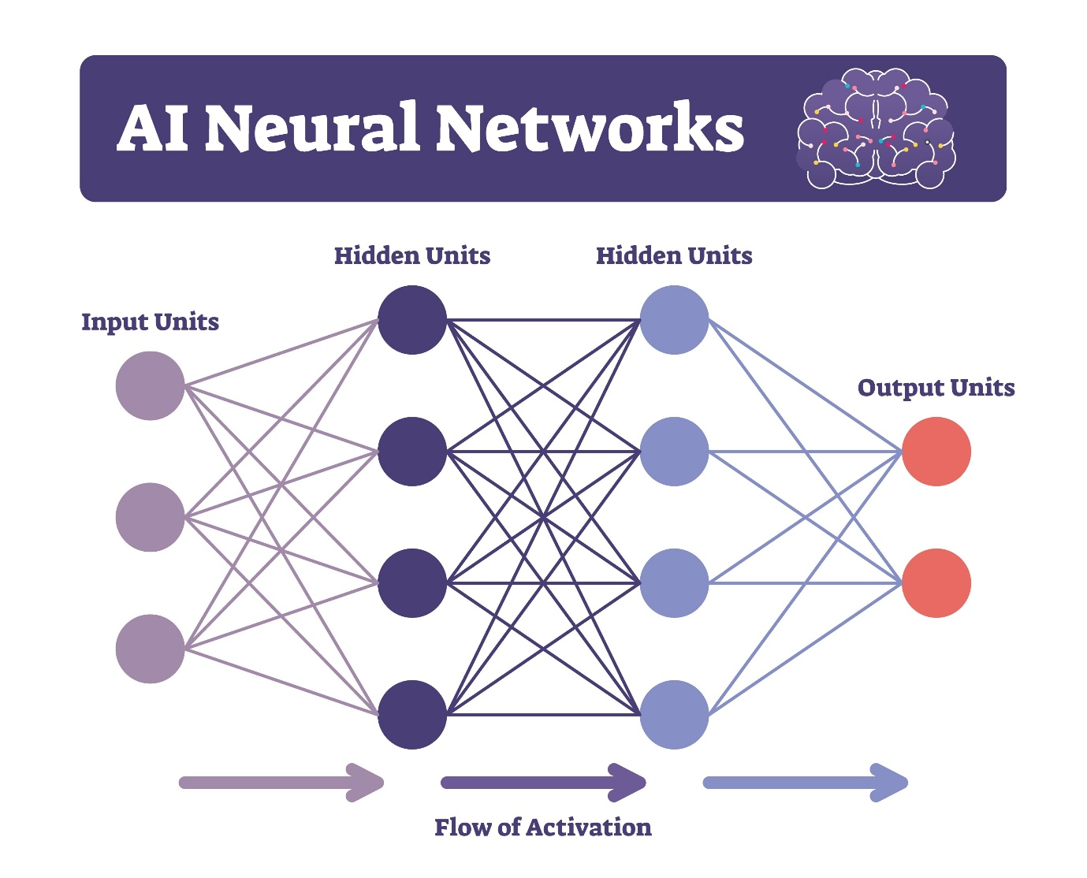
Shutterstock
Explore
- The 3 Layers:
  - Input Layer: Receives raw data (e.g., raw pixels of an image). It does no math.
  - Hidden Layers: The layers in the middle. They extract Features.
    - Hierarchy of Learning: Simple features (lines) $\rightarrow$ Complex features (shapes) $\rightarrow$ Objects.
  - Output Layer: Gives the final prediction (e.g., Probabilities for Digits 0-9).

Chapter 3: How Machines Learn (Training Loop)
- The Goal: To find the perfect values for the Weights ($w$). We cannot change the Input, so we must change the Weights.
- The 3 Steps of Training:
  - Forward Propagation: The network makes a guess.
  - Loss Calculation: We compare the guess with the actual answer to calculate the Error.
  - Backpropagation: The most important step. We go backward and update the weights to reduce the error.
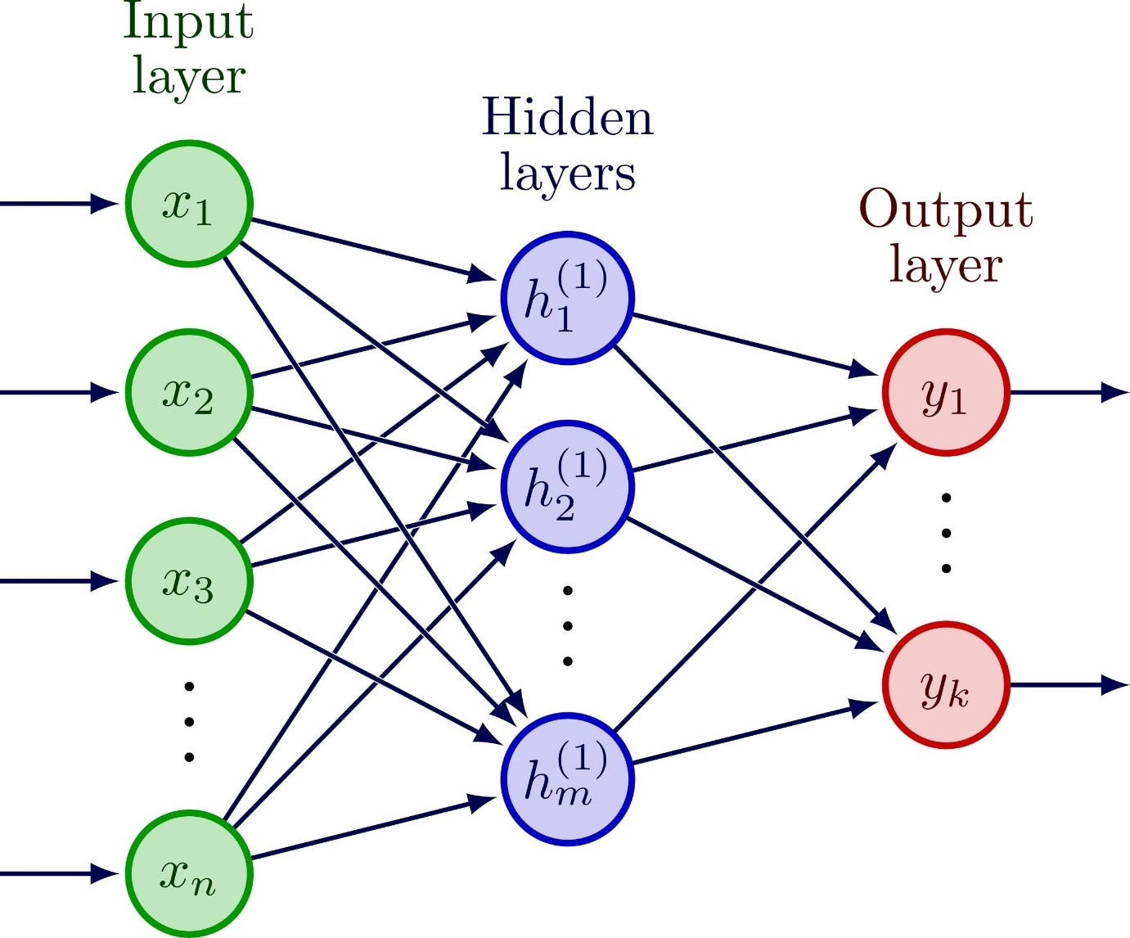
Shutterstock
Explore
- Key Terms:
  - Loss Function: Calculates how wrong the model is.
  - Optimizer: The tool that updates weights (e.g., Adam, SGD).
  - Epoch: One complete pass through the entire dataset. (We need many epochs to learn effectively).

🧠 Level 3: Deep Learning (Cheat Sheet)

1. The Perceptron (The Atom) ⚛️
- Concept: A single artificial neuron inspired by the human brain
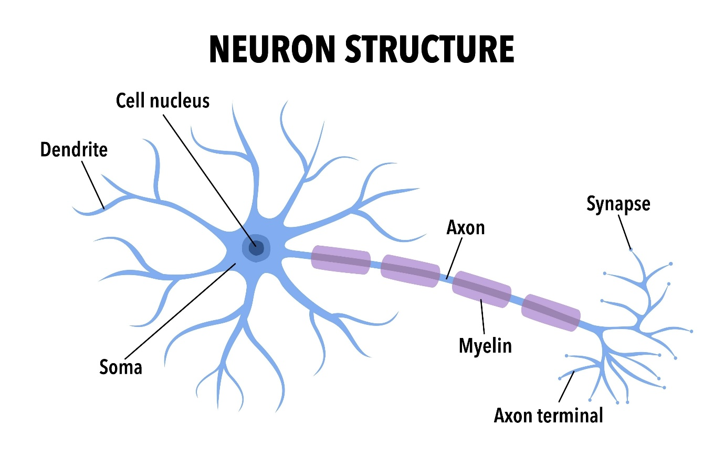
Shutterstock
Explore
.
- Logic: It calculates a Weighted Sum of inputs and uses an Activation Function to decide the output.
- Formula: $z = (x_1 \times w_1) + (x_2 \times w_2) + b$
  - If $z > \text{Threshold} \rightarrow 1$ (Fire)
  - Else $\rightarrow 0$ (Don't Fire)

2. Artificial Neural Networks (ANN) 🕸️
- Structure: Multiple neurons connected in layers

Shutterstock
Explore
.
* Input Layer: Receives raw data (pixels).
* Hidden Layers: Finds patterns.
* Output Layer: Gives the final prediction (Probability).
- Problem: It requires Flattening (2D image $\rightarrow$ 1D line), which destroys spatial patterns (shapes).

3. Training Process (How it Learns) 🛠️
- Forward Propagation: The network guesses the answer.
- Loss Function: Calculates the error (Difference between Guess and Actual).
- Backpropagation: The algorithm goes backward to update weights ($w$) to reduce error
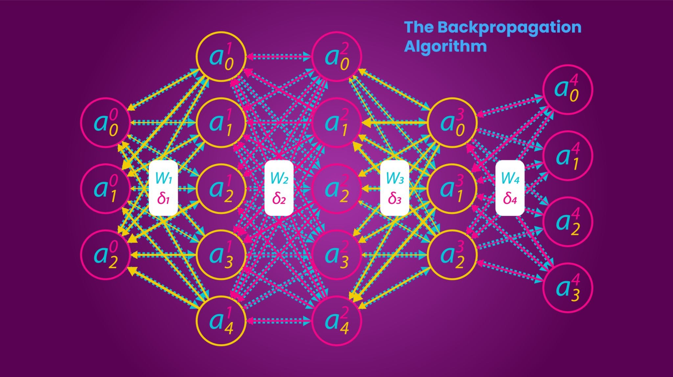
Getty Images
.
- Epoch: One complete cycle of training through the entire dataset.

4. Convolutional Neural Networks (CNN) 📸
- Best For: Images / Computer Vision.
- Key Concept: It does not flatten the image initially.
- Layers:
  - Conv2D (Scanner): Uses filters to detect features (Edges $\rightarrow$ Shapes $\rightarrow$ Objects).
  - MaxPooling (Compressor): Reduces image size to focus on important features.
- Result: High accuracy on image data (e.g., MNIST ~98%).

5. Recurrent Neural Networks (RNN) 🔄
- Best For: Sequence Data (Text, Audio, Time Series).
- Key Concept: It has a Loop. It remembers the previous input while processing the current input.
- Problem: Short-term Memory (Vanishing Gradient). It forgets the beginning of long sentences.

6. LSTM (Long Short-Term Memory) 🧠📔
- Solution: An advanced RNN with a "Diary" (Cell State) to keep long-term memories.
- Gates:
  - Forget Gate: Deletes irrelevant info.
  - Input Gate: Saves new important info.
  - Output Gate: Decides what to reveal now.

🤖 Level 4: Transfer Learning & NLP (Cheat Sheet)

1. Transfer Learning (The Smart Way) 🎓
- Concept: Instead of training a model from scratch (Baby), use a pre-trained model (PhD Student) developed by Google/Facebook.
- Benefit: Requires less data, less time, and gives higher accuracy (99%+).
- Analogy: Don't reinvent the wheel. Use an existing engine and build your car.

2. Transformers (The Engine) ⚙️
- Concept: The modern architecture behind ChatGPT, BERT, and Gemini.
- BERT (Bidirectional Encoder Representations from Transformers):
  - Reads text from both directions (Left $\leftrightarrow$ Right) at once.
  - Understands Context (e.g., "Bank" of a river vs. "Bank" for money).

3. Hugging Face (The Library) 🤗
- What is it? The "GitHub" for AI Models. A platform to download thousands of pre-trained models.
- Library: transformers
- Pipeline: A simple function to use models instantly without complex code.
  - pipeline("sentiment-analysis")

4. NLP Basics (Natural Language Processing) 🗣️
- Tokenization: Converting words into numbers (Vectors) so computers can understand.
  - "I love AI" $\rightarrow$ [101, 2034, 4567]
- Multilingual Models: Models trained on 100+ languages (e.g., XLM-RoBERTa). They can understand Hindi, English, and Hinglish.

Level 5: Generative AI & Prompt Engineering (Cheat Sheet)

Chapter 1: Generative AI (The Creator) 🎨
1. Discriminative vs. Generative AI
- Discriminative AI (Old): यह पहचानने (Identify) या फैसला लेने (Decide) का काम करता है।
  - Example: क्या यह बिल्ली है? क्या यह स्पैम है? (यह एक जज या आलोचक है)।
- Generative AI (New): यह कुछ नया बनाने (Create) का काम करता है।
  - Example: एक बिल्ली की पेंटिंग बनाओ, कविता लिखो, कोड लिखो। (यह एक कलाकार या लेखक है)।
2. LLMs (Large Language Models) 🧠
- Full Form: Large Language Models.
- Examples: ChatGPT, Gemini, Llama.
- Training: इन्हें अरबों किताबों और इंटरनेट डेटा पर ट्रेन किया गया है।
- Core Logic: ये कोई "सोचते" नहीं हैं। ये असल में "Next Word Prediction Machine" (अगला शब्द बताने वाली मशीन) हैं।
  - Example: "The sky is..." $\rightarrow$ (High probability: Blue).
3. Temperature (The Creativity Knob) 🌡️
- यह AI की "रचनात्मकता" (Creativity) को कंट्रोल करता है।
- Low Temperature (e.g., 0.1): AI सेफ खेलता है। जवाब सटीक (Precise) और फेक्चुअल होता है। (कोडिंग/मैथ्स के लिए अच्छा)।
- High Temperature (e.g., 0.8): AI रिस्क लेता है और कम कॉमन शब्द चुनता है। जवाब क्रिएटिव (Creative) होता है। (कहानियों/कविताओं के लिए अच्छा)।

Chapter 2: Prompt Engineering (The Art of Talking to AI) 🗣️
1. The Golden Formula ✨
एक परफेक्ट प्रॉम्प्ट लिखने का सूत्र:
$$Prompt = \text{Role (किरदार)} + \text{Task (काम)} + \text{Context (विवरण)} + \text{Format (तरीका)}$$

- Example: "Act as a Teacher (Role). Explain For Loop (Task) to a 5-year-old (Context) using a funny story (Format)."
2. Key Techniques (तकनीकें) 🛠️
- A. Zero-Shot Prompting:
  - बिना किसी उदाहरण के सीधा सवाल पूछना।
  - Use: आसान कामों के लिए (e.g., "Translate this to Hindi").
- B. Few-Shot Prompting (Examples का जादू):
  - AI को पहले कुछ उदाहरण (Examples) देना ताकि वह पैटर्न समझ सके।
  - Example:
Input: Good $\rightarrow$ Output: Bad
Input: Up $\rightarrow$ Output: Down
Input: Hot $\rightarrow$ Output: ?? (Cold)
- C. Chain of Thought (CoT) - "सोच-विचार करना":
  - AI को मजबूर करना कि वह Step-by-Step सोचे (खासकर मैथ्स/लॉजिक के लिए)।
  - Magic Phrase: "Let's think step by step." (चलो एक-एक करके सोचते हैं)।
  - Benefit: AI जल्दबाजी में गलत जवाब नहीं देता, पहले कैलकुलेशन करता है।

Chapter 3: GenAI APIs (Application Programming Interface)

1. Concept: What is an API?
- Definition: An API is a bridge that allows your code (Python) to talk to an external server (Google/OpenAI).
- The Problem: You cannot run massive models like Gemini or GPT-4 on your personal laptop. They run on supercomputers in the cloud.
- The Solution: You send a message (Prompt) to the cloud via an API, and the cloud sends back the answer.
- Analogy: The Restaurant 🍽️
  - You (User): The Python Code.
  - Kitchen (Server): Where the AI Model lives and cooks the answer.
  - Waiter (API): Takes your order (Prompt) to the kitchen and brings back the food (Response).

2. Security: The API Key 🔑
- What is it? A unique password string (e.g., AIzaSy...) that grants access to the server.
- The Rule: NEVER share your API Key publicly or upload it to GitHub.
- Best Practice: Use Environment Variables.
  - Create a .env file to store the key: GOOGLE_API_KEY=xyz...
  - Add .env to .gitignore so Git ignores it.
  - Use python-dotenv library to load it in code.

3. Python Implementation (Gemini Example) 💻
Python
import os
import google.generativeai as genai
from dotenv import load_dotenv

# 1. Load the Key securely
load_dotenv()
api_key = os.getenv("GOOGLE_API_KEY")

# 2. Setup the Model
genai.configure(api_key=api_key)
model = genai.GenerativeModel('gemini-2.0-flash')

# 3. Generate Content
response = model.generate_content("Write a python function to add two numbers.")
print(response.text)

📚 Chapter 4: RAG (Retrieval-Augmented Generation)

1. The Problem: LLM Hallucinations 😵
- Knowledge Cutoff: Models only know what they were trained on. They do not know your private data (PDFs, Company Emails, Notes).
- Hallucination: If you ask about private data, the AI might make up a fake answer.
- Context Window: You cannot paste a 1000-page book into the prompt; it's too big.

2. The Solution: RAG (The Open Book Exam) 📖
- Concept: Instead of asking the AI to memorize your data, we give it the ability to look up relevant information before answering.
- Analogy: A Smart Librarian. It finds the exact page you need and gives it to the AI to read.

3. The RAG Workflow (5 Steps) ⚙️
- Chunking (Slicing):
  - Break large documents (PDFs) into smaller pieces or paragraphs (e.g., 500 words each).
- Embeddings (Translation to Math): 🔢
  - Convert text chunks into Vectors (Lists of numbers) using an Embedding Model.
  - Logic: "King" and "Queen" will have similar numbers; "Apple" will have different numbers.
- Vector Database (Storage): 🗄️
  - Store these vectors in a special database (e.g., FAISS, ChromaDB, Pinecone).
  - This DB acts like a "High-Speed Search Engine."
- Retrieval (The Search): 🔍
  - When a user asks a question, convert the question into a Vector.
  - Use KNN (K-Nearest Neighbors) to find the chunks in the database that are mathematically closest to the question.
- Generation (The Answer): ✍️
  - Feed the User Question + Retrieved Chunks to the LLM.
  - Prompt: "Using these chunks [Context], answer this question [Query]."

4. Key Terms for Interviews 🗣️
- Embeddings: The numerical representation of text that captures meaning.
- Vector DB: A database optimized for storing and searching embeddings.
- Context Window: The limit on how much text an LLM can process at once (RAG solves this by only sending relevant text).

