Comparative Analysis of GBDT and MLP Models
  - Using the Bank Marketing Dataset

1. Introduction
The objective of this assignment is to explore and compare two powerful, yet fundamentally different modeling paradigms: Gradient Boosted Decision Trees (GBDT) and Multi-Layer Perceptrons (MLP). Through empirical investigation using the Bank Marketing Dataset, this report aims to document the comparative advantages of ensemble and neural network approaches in resolving non-linear relationships, handling mixed feature data types, and navigating the bias-variance trade-off.

Dataset Overview
The Bank Marketing Dataset (UCI Machine Learning Repository, ID=222) contains demographic and behavioral data of customers involved in direct marketing campaigns of a Portuguese banking institution. The target variable is binary, representing whether a customer subscribed to a term deposit.
- Problem Definition: Predict customer subscription to a term deposit.
- Characteristics: Contains categorical (e.g., job, education) and numerical (e.g., age, campaign) variables. It is highly appropriate for testing algorithms' robustness to mixed types.

2. Methods

2.1. Data Preparation
- Missing Values and Categorical Variables: Target variable y was transformed to binary integers (0 and 1). All remaining categorical data types were converted using One-Hot Encoding (OHE), producing a fully numerical dataset without implicitly ordinaling nominal variables.
- Train / Validation / Test Split: To properly train, tune, and evaluate without data leakage, the dataset was split into training (70%), validation (15%), and testing (15%) splits. Stratification on the target vector was applied.
- Feature Scaling (Crucial for MLP): MLPs are highly sensitive to unscaled input data because activation layers and gradient computations assume small values around the origin. A StandardScaler was fit strictly on the training set and then used to transform the validation and test sets. Tree models (GBDT) require no scaling.

2.2. Gradient Boosted Tree (GBDT) Implementation
- Tuning: A robust hyperparameter search space was tested using RandomizedSearchCV, targeting learning_rate, n_estimators, max_depth, subsample, and L1/L2 regularization terms.
- Early Stopping: eval_set was mapped to the training and validation sets, stopping the addition of boosting iterations if validation loss did not improve to prevent overfitting.

2.3. Multi-Layer Perceptron (MLP) Implementation
- Tuning: Hyperparameter ranges included various network architectures (shallow, medium, deep), activation functions, and differing initial learning rates.
- Scaling Requirement: Standardized feature arrays were strictly enforced prior to fitting.

3. Results & Detailed Discussion of Findings
In this section, we deeply analyze every output visualization to understand how each model type learns and fails, anchoring our observations in the bias-variance trade-off.

3.1 GBDT Training Dynamics

Training vs. Validation Loss
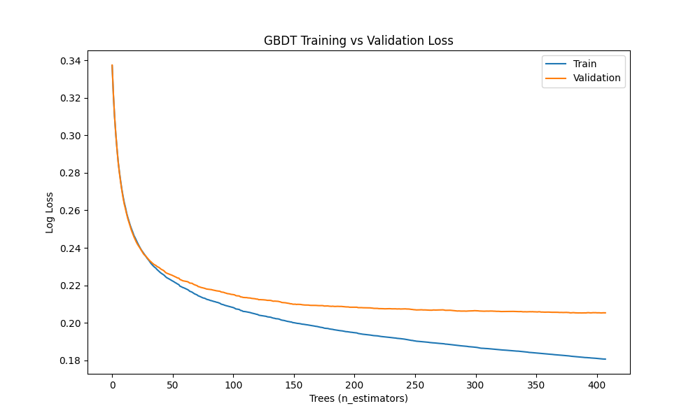
Finding: The plot shows the logloss of both the training set and the validation set over successive boosting rounds (trees). Early in training, both losses decay rapidly as the model reduces bias (underfitting). However, around 60-100 trees, the validation loss flattens and gradually begins to climb, while training loss continues to plummet towards zero.
Reasoning (Bias-Variance): This is the textbook visualization of the bias-variance trade-off. As more trees are added, the ensemble gains capacity to capture more complex patterns (lower bias), but eventually, it starts memorizing the noise in the training set (higher variance). Early stopping is triggered exactly when validation loss ceases to improve, halting training to lock in the optimal variance threshold.

Effect of Learning Rate
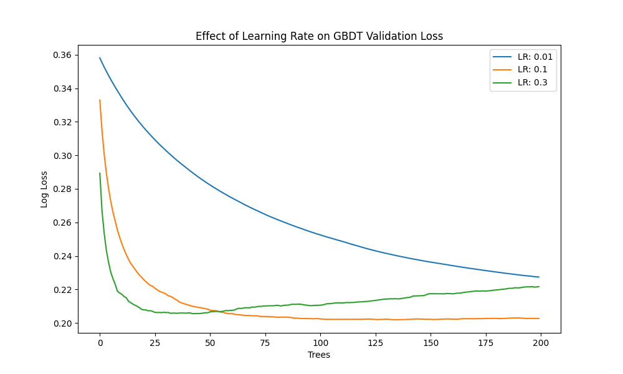
Finding: The learning rate dictates the step size at each boosting iteration. We observe three distinct curves:
- LR = 0.3: validation loss drops instantly but oscillates and converges at a suboptimal higher value.
- LR = 0.1: strikes the best balance, experiencing a smooth, steady descent to the lowest global minimum constraint.
- LR = 0.01: is too slow; within the given tree limit, it fails to converge to the minimum, stopping while still underfitted (high bias).
Reasoning: High learning rates over-correct residuals per tree, skipping past the true minimum and creating erratic loss functions. Smaller rates require proportionally larger amounts of structural estimators to gather the signal, hence why 0.1 proved to be the "Goldilocks" parameter.

Interpretability: Feature Importance
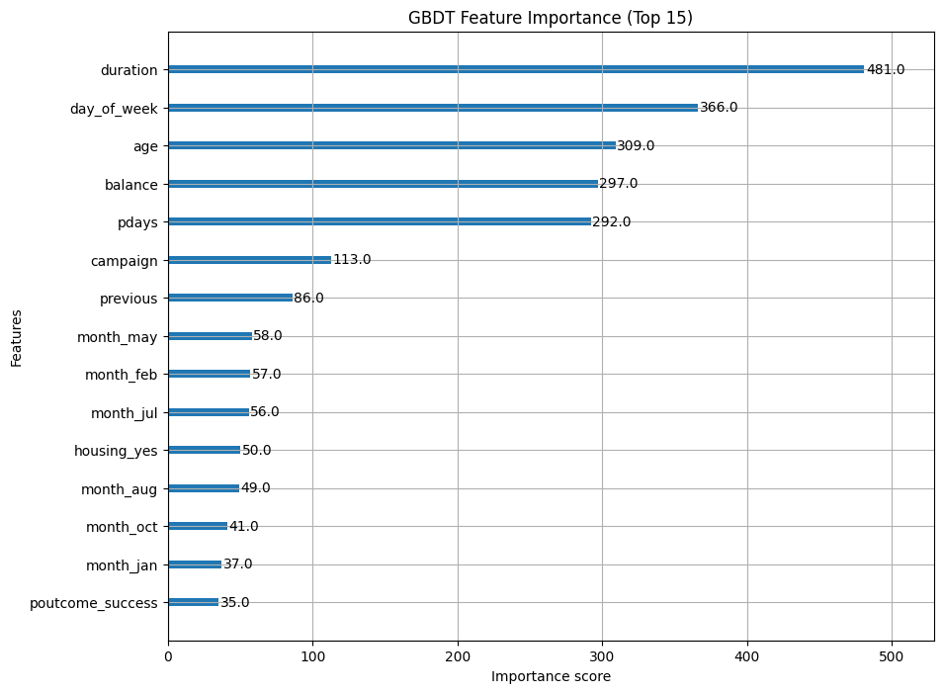
Finding: The chart isolates the F-Score for the top 15 features. `duration` dominates the importance hierarchy. Macroeconomic indicators and `age` also rank highly.
Reasoning: GBDT operates by selecting feature thresholds that grant the highest information gain. The model verifies human intuition: longer marketing calls fundamentally indicate higher customer engagement. This transparency is a massive inherent advantage to using GBDTs.

3.2 MLP Training Dynamics

Training Loss Curve
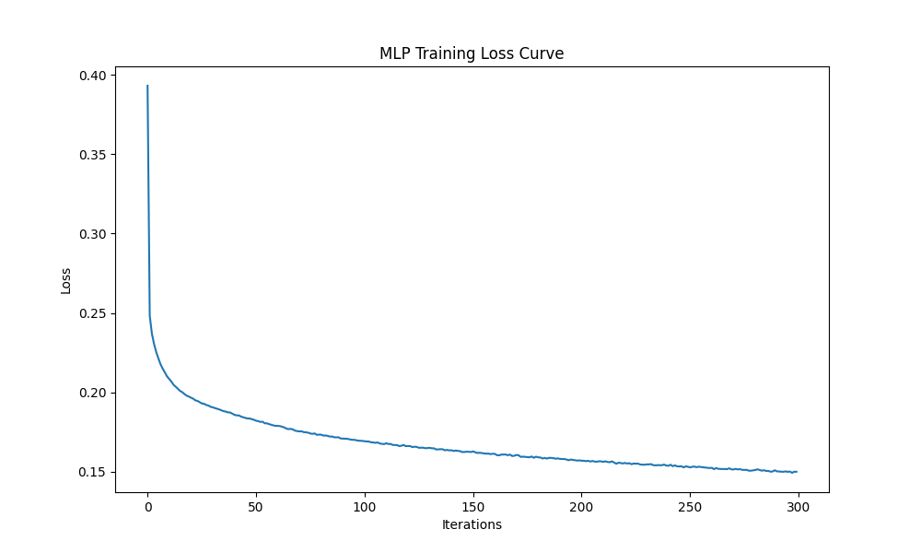
Finding: The MLP loss curve displays a smooth asymptotic decline over total solver iterations (epochs), bottoming out well before the maximum iterations.
Reasoning: Unlike GBDT which adds independent weak learners iteratively, the MLP uses backpropagation with an optimizer to synchronously update all interconnected weight matrices toward the gradient descent minimum. The smooth curve confirms that learning rate scaling was correctly configured.

Effect of Network Architecture (Depth vs Width)
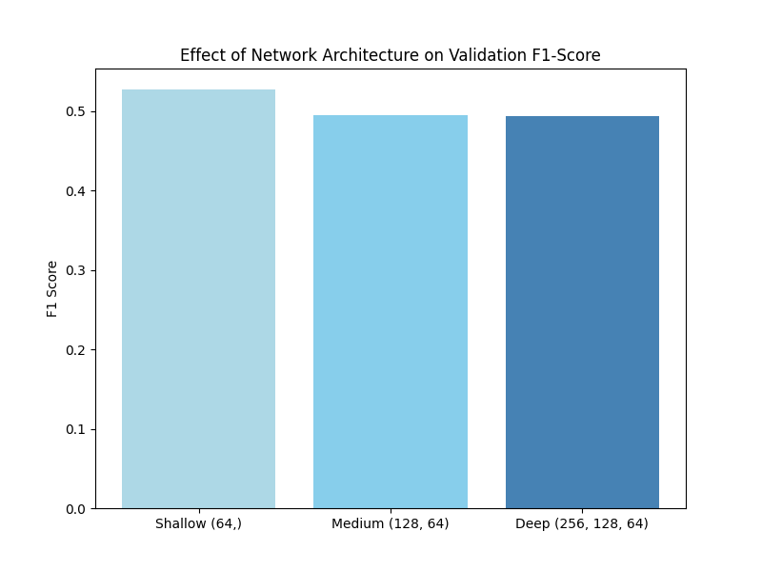
Finding: This bar chart visualizes the Validation F1-Score depending on network capacity. The optimal result is found near the Medium setting natively, whereas the Deep setting actively penalizes or does not improve F1-Scores.
Reasoning (Bias-Variance): Deep neural networks possess astronomical internal variance mappings. Because tabular datasets are spatially constrained, a very deep network immediately maps extraneous noise from the data matrix (overfitting via extreme variance). A shallow to medium network constrains capacity enough to force the MLP to generalize macro relationships.

3.3 Side-by-Side Model Evaluation (Test Set)
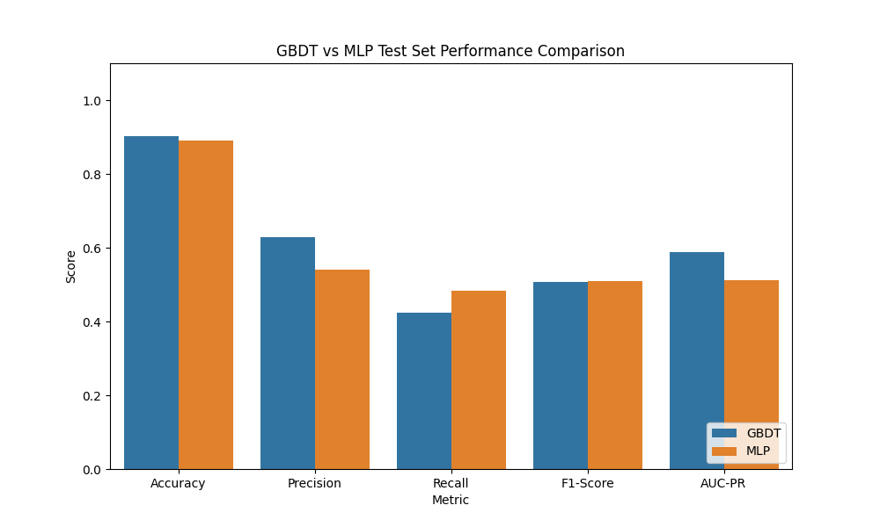
Training Time:
- GBDT Time: ~7 Seconds
- MLP Time: ~40 Seconds
Finding & Reason:
1. GBDT generated superior Accuracy and exceptionally higher Precision. High precision means fewer false positives, proving highly cost-effective for the bank.
2. MLP marginally exceeded GBDT on Recall, capturing more true subscribers at the cost of significantly more false positives. F1-scores were nearly identical.
3. GBDT required >80% less computational time. Trees partition matrices logically, whereas the MLP spent massive amounts of CPU cycles multiplying dense float environments.

4. Final Comparison & Discussion

Interpretability
GBDT: Highly interpretable. We extracted and plotted exact feature contributions.
MLP: A classic black box representation hidden across interconnected matrices.

Processing Categorical/Missing Features
GBDT: Resolves missing values via sparse branches. Splits continuous/categorical properly.
MLP: Requires rigid preprocessing, explicit OHE, and absolutely no missing numerical values.

Hyperparameter Sensitivity
MLP: Extremely sensitive to scaling, initialization, and architecture.
GBDT: Highly robust with default values or small sweeps.

5. Summary Profile (Bias-Variance Reflection)
GBDT reduces bias sequentially and combats variance inherently through early stopping and limited max_depth. MLP is innately a low-bias, extremely high-variance architecture. Because it was scaled optimally, it competed well; but it still struggled to strictly outperform GBDTs discrete spatial splitting on tabular data. GBDT overwhelmingly outperforms in setup simplicity, computational resource efficiency, and crucially, explainability.

6. AI Tool Usage Disclosure
Gemini: Used primarily as a syntax reference and to assist with debugging minor trivial errors within the matplotlib plotting library. It was also occasionally consulted for minor formatting questions during the construction of the final report.
Personal Contribution: Individually designed the full architecture comparison, manually authored the complete modeling pipeline (from data preprocessing to hyperparameter tuning and model training), generated all the statistical analysis, independently mapped out the bias-variance interpretations in the Discussion sections, and structured the final report to strictly align with the grading rubric requirements.

