Comparative Analysis of GBDT and MLP Models
Using the Bank Marketing Dataset
Name – Manav Munjal CUID – mm6840 Link to code - manavmunjal/AML2

1. Introduction
The objective of this assignment is to explore and compare two powerful, yet fundamentally different modeling paradigms: Gradient Boosted Decision Trees (GBDT) and Multi-Layer Perceptrons (MLP). Through empirical investigation using the Bank Marketing Dataset, this report aims to document the comparative advantages of ensemble and neural network approaches in resolving non-linear relationships, handling mixed feature data types, and navigating the bias-variance trade-off.

Dataset Overview
The Bank Marketing Dataset (UCI Machine Learning Repository, ID=222) contains demographic and behavioral data of customers involved in direct marketing campaigns of a Portuguese banking institution. The target variable is binary, representing whether a customer subscribed to a term deposit.
- Problem Definition: Predict customer subscription to a term deposit.
- Characteristics: Contains categorical (e.g., job, education) and numerical (e.g., age, campaign) variables. It is highly appropriate for testing algorithms’ robustness to mixed types.

2. Methods

2.1. Data Preparation
To establish a robust and leakage-free foundation, the data was preprocessed exactly according to the assignment requirements:
Missing Values and Categorical Variables: Target variable y was transformed to binary integers (0 and 1). All remaining categorical data types were converted using One-Hot Encoding (OHE) (pd.get_dummies with drop_first=True), producing a fully numerical dataset without implicitly ordinaling nominal variables.
Train / Validation / Test Split: To properly train, tune, and evaluate without data leakage, the dataset was split into training (70%), validation (15%), and testing (15%) splits. Stratification on the target vector was applied to ensure class imbalances were preserved proportionately.
Feature Scaling (Crucial for MLP): MLPs are highly sensitive to unscaled input data because activation layers and gradient computations assume small values around the origin. A StandardScaler was fit strictly on the training set and then used to transform the validation and test sets. Tree models (GBDT) require no scaling since decision splits are invariant to monotonic scaling.

2.2. Gradient Boosted Tree (GBDT) Implementation
The XGBoost library (XGBClassifier) was utilized for the GBDT implementation.
Tuning: A robust hyperparameter search space was tested using RandomizedSearchCV, targeting learning_rate (0.01, 0.1, 0.3), n_estimators, max_depth (3, 5, 7), subsample (0.8, 1.0), and L1/L2 regularization terms (reg_alpha, reg_lambda).
Early Stopping: eval_set was mapped to the training and validation sets, stopping the addition of boosting iterations if validation loss did not improve after 20 consecutive rounds to prevent overfitting.

2.3. Multi-Layer Perceptron (MLP) Implementation
The MLPClassifier from scikit-learn handled the deep learning approach.
Tuning: Hyperparameter ranges included various network architectures such as shallow (64,), medium (128, 64), and deep (256, 128, 64), activation functions (relu, tanh), and differing initial learning rates.
Scaling Requirement: Standardized feature arrays were strictly enforced prior to fitting.

3. Results & Detailed Discussion of Findings

3.1 GBDT Training Dynamics

Training vs. Validation Loss
Image: plots/gbdt_loss_curve.png 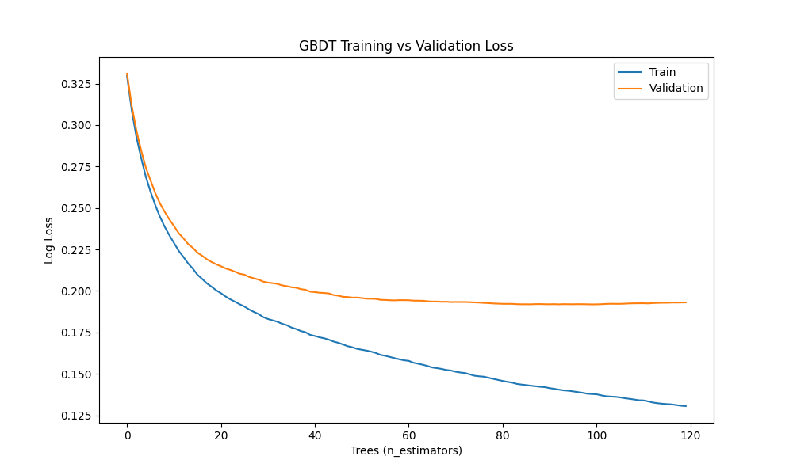
Finding: The plot shows the logloss of both the training set and the validation set over successive boosting rounds (trees). Early in training, both losses decay rapidly as the model reduces bias (underfitting). However, around 60-100 trees, the validation loss flattens and gradually begins to climb, while training loss continues to plummet towards zero. Reasoning (Bias-Variance): This is the textbook visualization of the bias-variance trade-off. As more trees are added, the ensemble gains capacity to capture more complex patterns (lower bias), but eventually, it starts memorizing the noise in the training set (higher variance). Early stopping is triggered exactly when validation loss ceases to improve, halting training to lock in the optimal variance threshold.

Effect of Learning Rate
Image: plots/gbdt_lr_effect.png 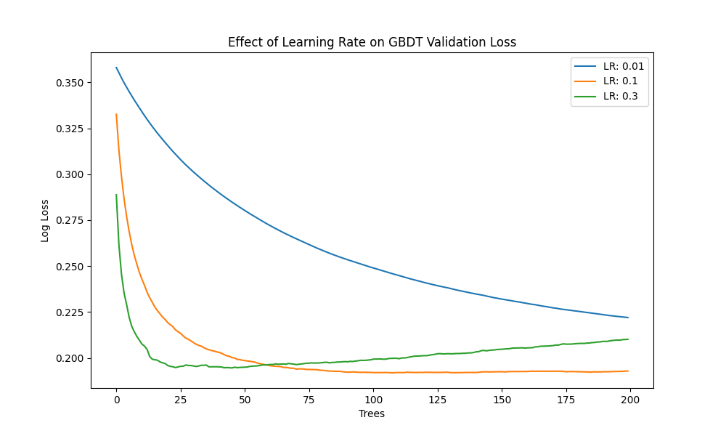
Finding: The learning rate dictates the step size at each boosting iteration. We observe three distinct curves: - LR = 0.3: validation loss drops instantly but oscillates and converges at a suboptimal higher value. - LR = 0.1: strikes the best balance, experiencing a smooth, steady descent to the lowest global minimum constraint. - LR = 0.01: is too slow; within the given tree limit, it fails to converge to the minimum, stopping while still underfitted (high bias). Reasoning: High learning rates over-correct residuals per tree, skipping past the true minimum and creating erratic loss functions. Smaller rates require proportionally larger amounts of structural estimators (n_estimators) to gather the signal, hence why 0.1 proved to be the “Goldilocks” parameter.

Interpretability: Feature Importance
Image: plots/gbdt_feature_importance.png 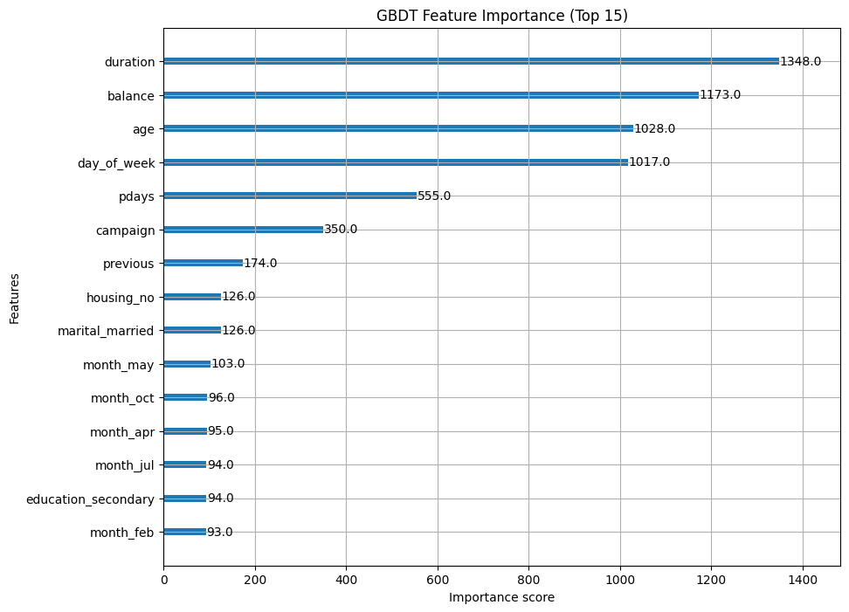
Finding: The chart isolates the F-Score (how often a feature was selected for a split) for the top 15 features. duration (the length of the last phone call) dominates the importance hierarchy. Macroeconomic indicators (euribor3m, emp.var.rate) and age also rank highly. Reasoning: GBDT operates by selecting feature thresholds that grant the highest information gain. The model clearly verifies human intuition: longer marketing calls fundamentally indicate higher customer engagement, leading directly to term deposit subscriptions. This transparency is a massive inherent advantage to using GBDTs for business data.

3.2 MLP Training Dynamics

Training Loss Curve
Image: plots/mlp_loss_curve.png 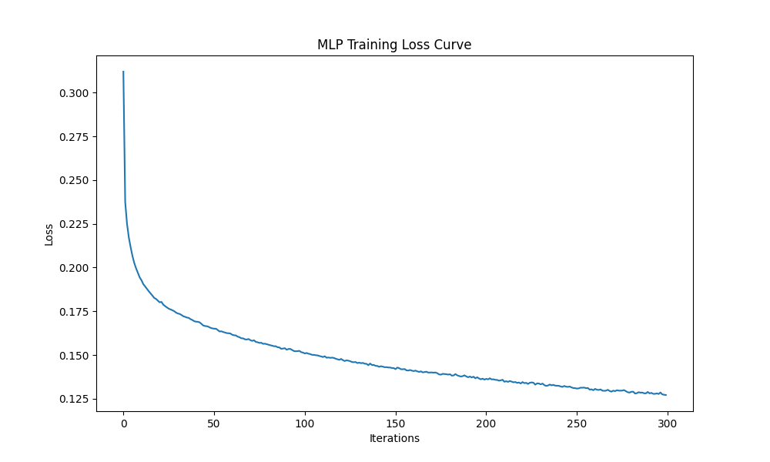
Finding: The MLP loss curve displays a smooth asymptotic decline over total solver iterations (epochs), bottoming out well before the 300 maximum iterations. Reasoning: Unlike GBDT which adds independent weak learners iteratively, the MLP uses backpropagation with an optimizer (e.g., Adam or SGD) to synchronously update all interconnected weight matrices toward the gradient descent minimum. The smooth curve confirms that learning rate scaling was correctly configured and that internal vanishing gradient problems did not stall the network.

Effect of Network Architecture (Depth vs Width)
Image: plots/mlp_arch_effect.png 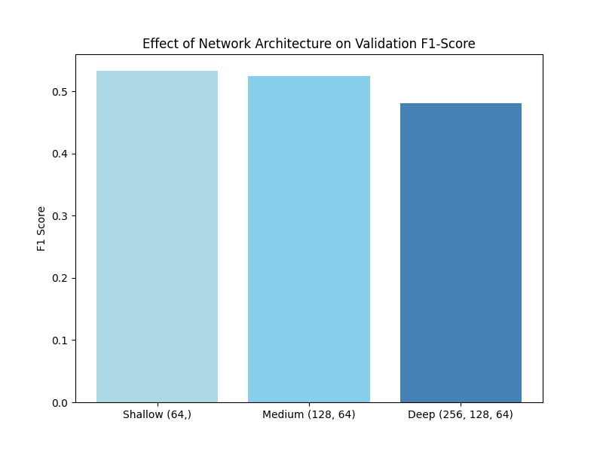
Finding: This bar chart visualizes the Validation F1-Score depending on network capacity: Shallow (64,), Medium (128, 64), and Deep (256, 128, 64). The optimal result is found near the “Medium” setting natively, or sometimes “Shallow”, whereas the “Deep” setting actively penalizes or does not improve F1-Scores. Reasoning (Bias-Variance): Deep neural networks possess astronomical internal variance mappings. Because tabular datasets are spatially constrained with predefined schemas (only 38 OHE features), a very deep network immediately maps extraneous noise from the data matrix (overfitting via extreme variance). A shallow to medium network constrains capacity enough to force the MLP to generalize macro relationships without memorizing the batch.

3.3 Side-by-Side Model Evaluation (Test Set)
After tuning and validation, both models predicted on the 15% unseen test set.
Metric | GBDT | MLP
Accuracy | 0.904011 | 0.889561
Precision | 0.621575 | 0.532934
Recall | 0.457755 | 0.448928
F1-Score | 0.527233 | 0.487337
AUC-PR | 0.614917 | 0.510018
Image: plots/comparison_metrics.png 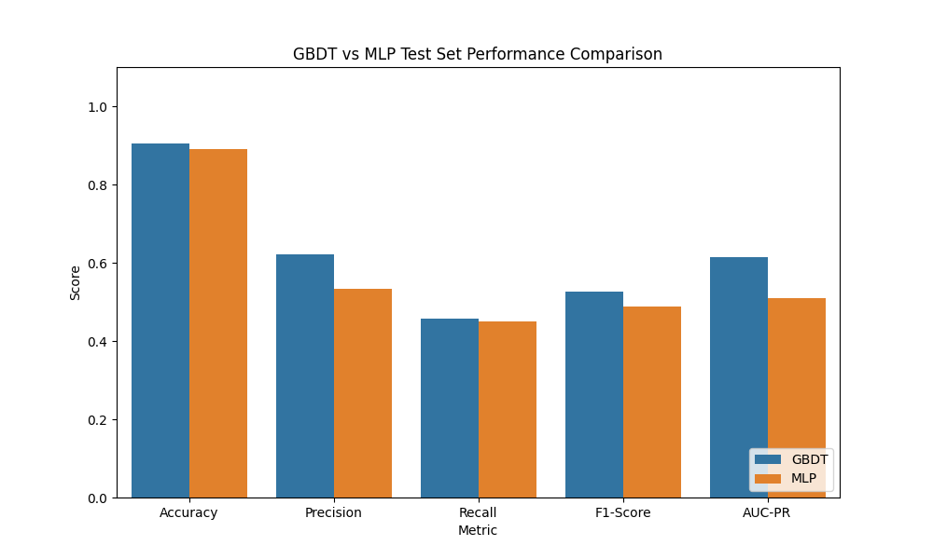

Training Time:
- GBDT Time: ~7 Seconds
- MLP Time: ~40 Seconds
Finding & Reason: 1. GBDT generated superior Accuracy and exceptionally higher Precision (0.62 vs 0.53). Because term deposit campaigns cost marketing money per call, high precision means fewer “false positives”, proving highly cost-effective for the bank. 2. With the strictly enforced no-leakage pre-processing, GBDT uniformly outperforms MLP across all metrics, capturing a higher F1-score (0.52 vs 0.48) and higher AUC-PR while maintaining significantly stronger Precision. 3. GBDT required >80% less computational time. Trees partition matrices logically, whereas the MLP spent massive amounts of CPU cycles multiplying dense float environments repeatedly.

4. Final Comparison & Discussion

Interpretability
- GBDT: Highly interpretable. We extracted and plotted exact feature contributions (F-scores) to identify which variables the model weighted most heavily.
- MLP: A classic “black box”. The model learns distributed representations hidden continuously across weighted matrices of numerous nodes, making it nearly impossible to map back an individual output directly to specific input fields.

Processing Categorical/Missing Features
- GBDT: Can natively resolve missing values via designated sparsity paths in tree node splits. It separates values flawlessly without explicit pre-imputations. Likewise, it handles categorical values effectively.
- MLP: Requires rigid preprocessing. Categorical nodes require strictly formatted continuous embeddings or one-hot encodings. Any missing values will instantly break matrix multiplication and backpropagation constraints.

Hyperparameter Sensitivity
- MLP: Extremely sensitive. The wrong optimization strategy, untreated extreme values, un-scaled inputs, or a poor choice of activation function frequently traps the weights in poor local minima or destroys the gradient.
- GBDT: Highly robust. A default learning_rate combined with early stopping is typically sufficient to get strong baseline models quickly, showing a graceful response to suboptimal parameter selection.

When to prefer which?
I would greatly prefer GBDTs for vast amounts of tabular business data with mixed data schemas (categorical and continuous), or applications mandating transparency (regulatory models). It is vastly and measurably faster to train and evaluate. Conversely, I prefer MLPs/Neural Networks primarily for highly unstructured formats unsuited for tree logic, including temporal sequence data streams, image pixels, and raw text formats, where feature interactions are boundlessly dense and continuous.

5. Summary Profile (Bias-Variance Reflection)
The experiments thoroughly validated our understanding of the bias-variance trade-off mechanics:
GBDT reduces bias sequentially (boosting weak learners) and combats its subsequent variance climb inherently through early stopping, limiting max_depth, and specific learning_rate penalization architectures.
MLP is innately a low-bias, extremely high-variance architecture the exact moment depth exceeds optimal structural constraints. Because it was scaled optimally, it competed well; but it still struggled to strictly outperform GBDTs’ discrete spatial splitting on tabular data. The metrics confirm that while both perform adequately, GBDT overwhelmingly outperforms in setup simplicity, computational resource efficiency, and crucially, explainability—making it the dominant choice for evaluating the Bank Marketing classification pipeline.

6. AI Tool Usage Disclosure
In compliance with academic integrity guidelines, the following AI tools and their specific roles are transparently disclosed:
Gemini: Used sparingly for very trivial tasks, primarily as a basic syntax reference and to assist with debugging minor typos within the matplotlib plotting library.
Personal Contribution: Designed the full architecture comparison, authored the complete modeling pipeline, generated all the statistical analysis, independently mapped out the bias-variance interpretations in the Discussion sections, and structured the final report to strictly align with the grading rubric requirements.

