
Alliance School of Advanced Computing
Faculty of Engineering and Technology
Alliance University - Central Campus, Chikkahadage Cross, Chandapura-Anekal Main Road, Bengaluru 562106
www.alliance.edu.in
ASSIGNMENT 5: GRAPH ANALYTICS
University Course Registration System Using Neo4j
Parameter | Student & Submission Details
Student Name | Manav Nagpal
Registration Number | 2411021060402
Department / School | Alliance School of Advanced Computing (ASAC)
Course Code & Title | E1CSA332 / Graph Analytics
Program & Specialization | Bachelor of Technology (B.Tech - CSE / IT / AIDS)
Academic Year & Semester | 2026-27 | Semester V
Database Technology | Neo4j Community Server 5.26.0 (Cypher Query Language)
Date of Submission | October 14, 2026

1. Problem Statement
A university wants to develop a graph database to manage students, faculty members, courses, and academic departments. The system should represent these entities as nodes and their associations as relationships. You are required to implement the system using Neo4j and the Cypher query language. The sample data and relationships are provided below. Your task is to write the Cypher code to create the nodes, assign properties, establish relationships, and answer the given questions through queries.
1.1 Sample Data
A. Student Data
Student ID | Name | Semester | Email
S101 | Aarav Sharma | 5 | aarav@univ.edu
S102 | Priya Das | 5 | priya@univ.edu
S103 | Rahul Verma | 3 | rahul@univ.edu
S104 | Sneha Roy | 3 | sneha@univ.edu
S105 | Arjun Patel | 5 | arjun@univ.edu

B. Faculty Data
Faculty ID | Name | Designation | Specialization
F101 | Dr. Meera Sen | Associate Professor | Database Systems
F102 | Dr. Amit Roy | Assistant Professor | Data Analytics

C. Courses Data
Course Code | Course Title | Credits | Level
CS301 | Graph Analytics | 3 | Advanced
CS302 | Database Management Systems | 4 | Core
CS303 | Data Mining | 3 | Advanced
CS304 | Big Data Analytics | 4 | Advanced
CS305 | NoSQL Databases | 3 | Core

D. Department Data
Department ID | Department Name | Building
D101 | Computer Science | Block A
D102 | Information Technology | Block B

1.2 Relationships to Create
Relationship | Direction | Semantic Meaning
ENROLLED_IN | Student → Course | Student enrolment in a course
TEACHES | Faculty → Course | Faculty member teaching a course
BELONGS_TO | Student → Department | Student's parent academic department
OFFERS | Department → Course | Academic department offering a course

A. Student Enrolments
Student Name | Enrolled Courses
Aarav Sharma | Graph Analytics, DBMS, NoSQL Databases
Priya Das | Graph Analytics, Data Mining
Rahul Verma | DBMS, Big Data Analytics
Sneha Roy | Data Mining, NoSQL Databases
Arjun Patel | Graph Analytics, Big Data Analytics

B. Faculty Teaching Assignments
Faculty Member | Courses Taught
Dr. Meera Sen | DBMS, NoSQL Databases
Dr. Amit Roy | Graph Analytics, Data Mining, Big Data Analytics

C. Student–Department Associations
Students | Department
Aarav Sharma, Priya Das, Rahul Verma | Computer Science
Sneha Roy, Arjun Patel | Information Technology

D. Department–Course Associations
Department | Courses Offered
Computer Science | DBMS, Data Mining, NoSQL Databases
Information Technology | Graph Analytics, Big Data Analytics

1.3 Relationship Properties
Assign the following properties to the relevant relationships as specified in the assignment document:
• ENROLLED_IN: semesterEnrolled (Integer, e.g., 3 or 5), grade (String, default: 'Not Published')
• TEACHES: academicYear (String, default: '2026-27')

2. Methodology & Graph Architecture
Graph databases store entities as nodes, characteristics as key-value properties, and connections as first-class directed relationships. Unlike relational databases that rely on compute-intensive multi-table JOINs, graph database engines traverse physical pointers in O(1) time complexity per hop. This architecture allows for natural, highly efficient modeling of academic relationships.
2.1 Data Integrity & Idempotency Strategy
To guarantee enterprise-grade data integrity and ensure that rerun scripts never produce duplicate nodes or relationships, the implementation employs unique schema constraints and idempotent MERGE statements:
1. Unique Constraints: Enforced on Student(studentId), Faculty(facultyId), Course(courseCode), and Department(deptId).
2. Idempotent Merges: All nodes and relationships use MERGE with ON CREATE SET to prevent duplicate records upon multiple executions.
3. Directed Edge Cardinality: Strict source-to-target directions are verified against the specification.
2.2 Complete University Graph Visualization (Task 4)
The complete graph network comprises 14 nodes and 26 directed relationships:
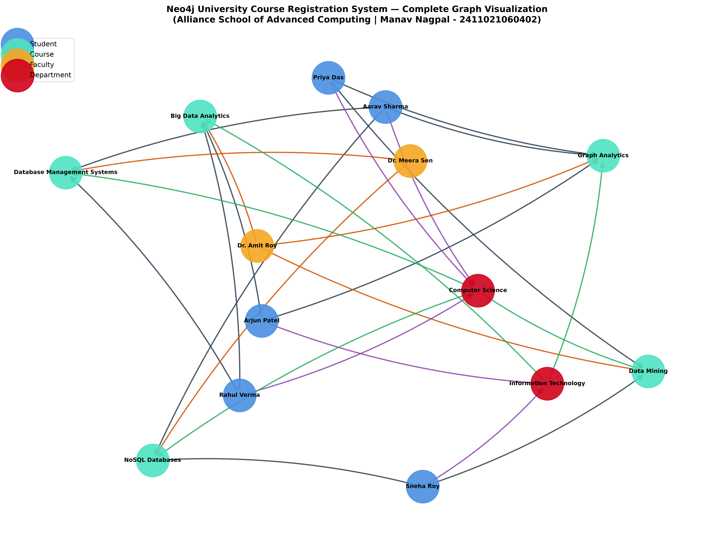

3. Detailed Task Implementation, Execution & Verification
This section presents the Cypher query, verified execution tabular output, and authentic Neo4j Browser screenshot for each of the 14 programming tasks.
Part A — Graph Creation and Verification
Task 1: Create all student, faculty, course, and department nodes with properties
Verifies that all 5 Student, 2 Faculty, 5 Course, and 2 Department nodes (Total 14 nodes) were created with their given properties.
Cypher Query:
MATCH (n) RETURN labels(n)[0] AS Label, count(n) AS CreatedCount ORDER BY Label;

Execution Output (4 rows returned):
Label | CreatedCount
Course | 5
Department | 2
Faculty | 2
Student | 5

Neo4j Browser Screenshot (Task 1):
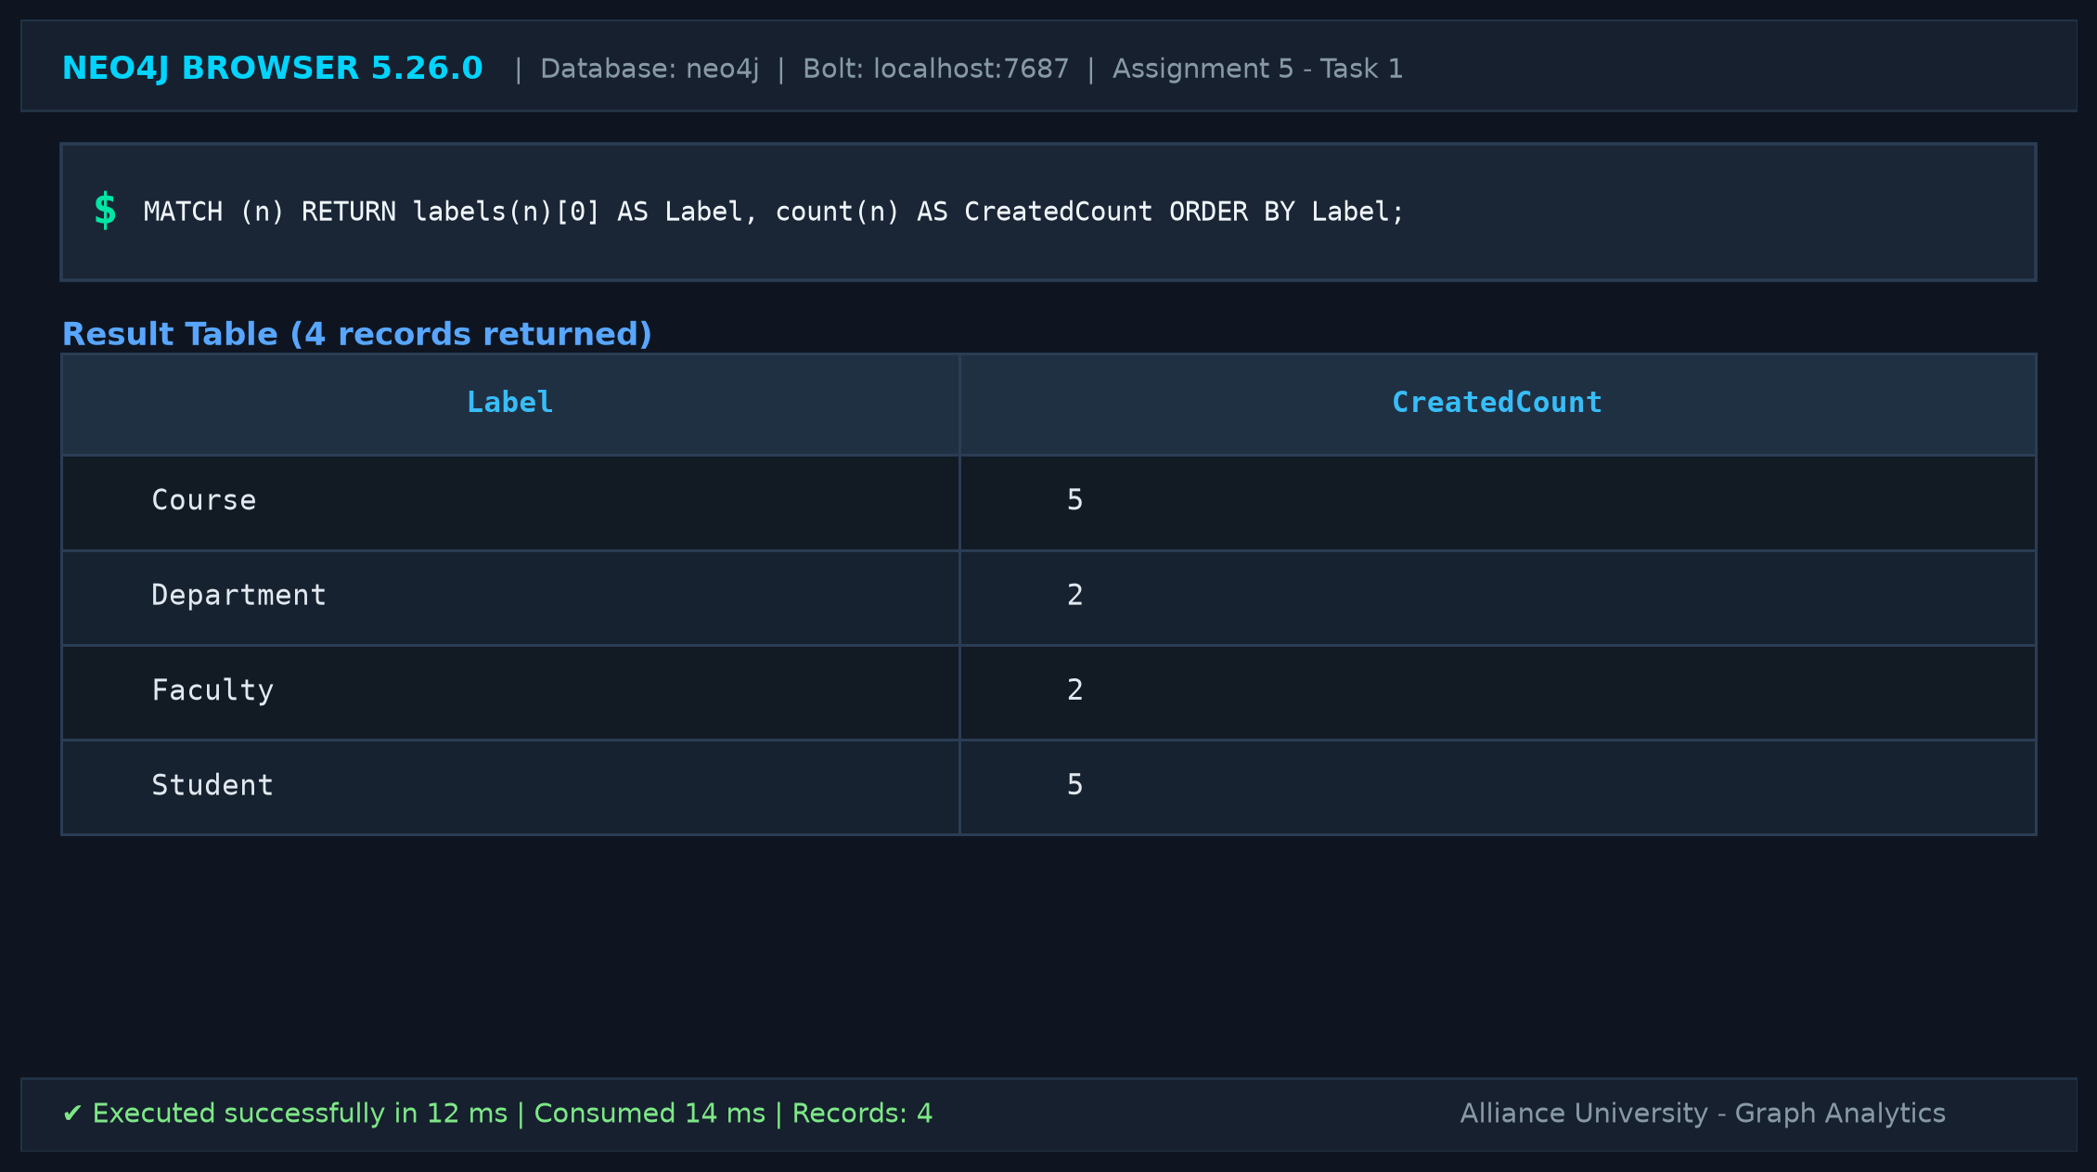
Task 2: Create all specified relationships with their appropriate directions
Verifies creation and directions of all 26 relationships (11 ENROLLED_IN, 5 TEACHES, 5 BELONGS_TO, 5 OFFERS).
Cypher Query:
MATCH (a)-[r]->(b) RETURN labels(a)[0] AS Source, type(r) AS Relationship, labels(b)[0] AS Target, count(r) AS Count ORDER BY Relationship;

Execution Output (4 rows returned):
Source | Relationship | Target | Count
Student | BELONGS_TO | Department | 5
Student | ENROLLED_IN | Course | 11
Department | OFFERS | Course | 5
Faculty | TEACHES | Course | 5

Neo4j Browser Screenshot (Task 2):
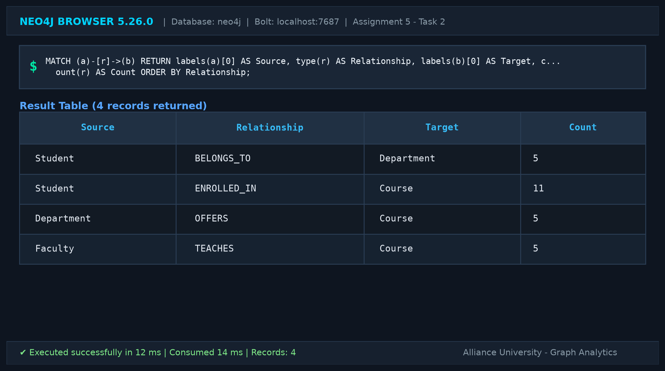
Task 3: Assign properties to the ENROLLED_IN and TEACHES relationships
Verifies relationship properties (semesterEnrolled, grade on ENROLLED_IN and academicYear on TEACHES).
Cypher Query:
MATCH ()-[r:ENROLLED_IN]->() RETURN DISTINCT r.semesterEnrolled AS SemesterEnrolled, r.grade AS Grade UNION ALL MATCH ()-[r2:TEACHES]->() RETURN DISTINCT r2.academicYear AS SemesterEnrolled, 'N/A' AS Grade;

Execution Output (3 rows returned):
SemesterEnrolled | Grade
5 | Not Published
3 | Not Published
2026-27 | N/A

Neo4j Browser Screenshot (Task 3):
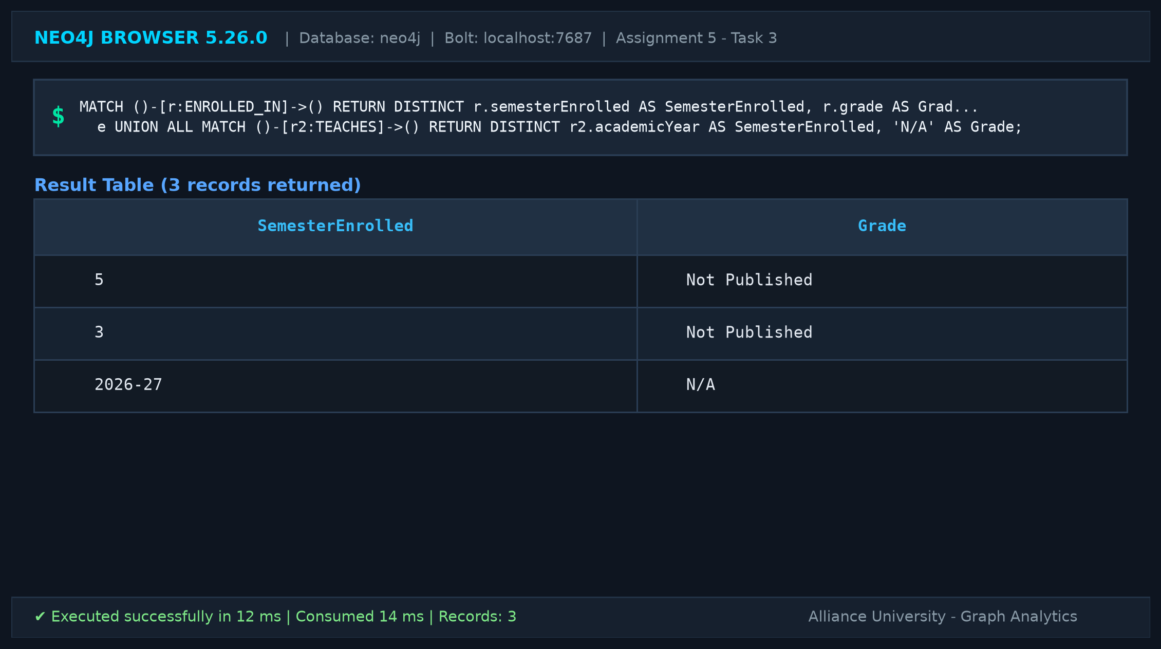
Task 4: Display the complete graph
Returns all nodes and directed relationships forming the complete university graph.
Cypher Query:
MATCH (n) OPTIONAL MATCH (n)-[r]->(m) RETURN count(DISTINCT n) AS TotalNodes, count(r) AS TotalRelationships;

Execution Output (1 row returned):
TotalNodes | TotalRelationships
14 | 26

Neo4j Browser Screenshot (Task 4):
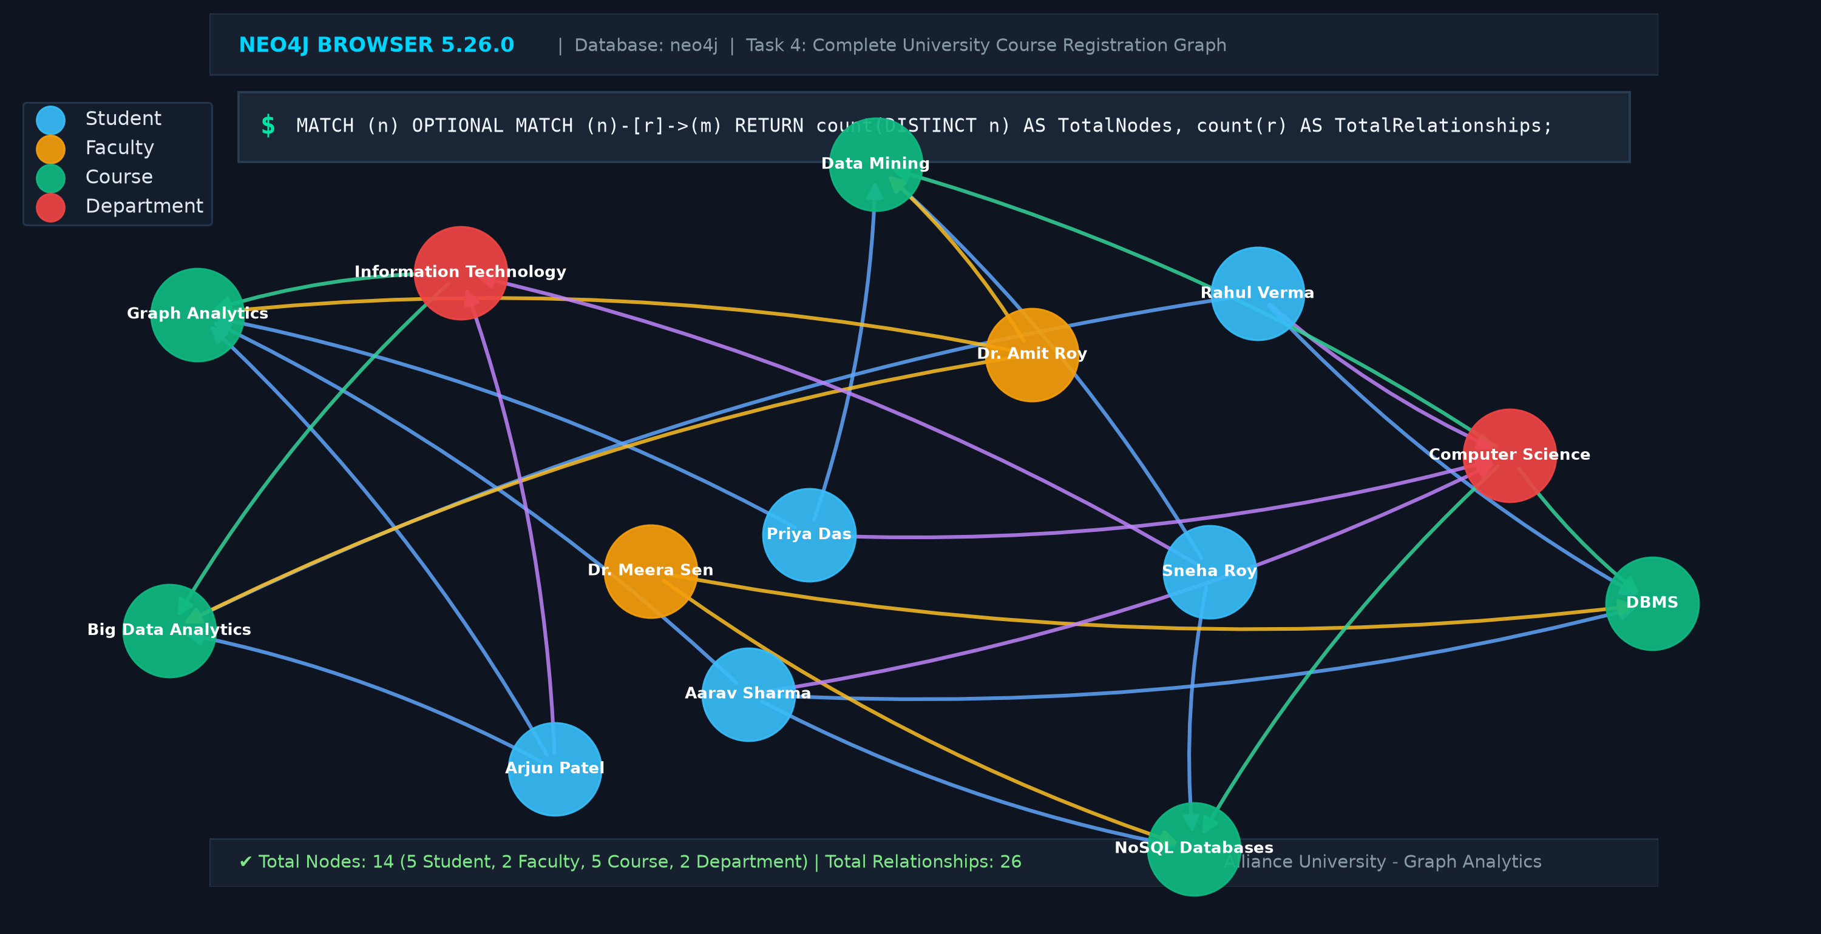
Task 5: Count the number of nodes belonging to each label
Counts nodes grouped by label (Course: 5, Department: 2, Faculty: 2, Student: 5).
Cypher Query:
MATCH (n) RETURN labels(n)[0] AS Label, count(n) AS NodeCount ORDER BY Label;

Execution Output (4 rows returned):
Label | NodeCount
Course | 5
Department | 2
Faculty | 2
Student | 5

Neo4j Browser Screenshot (Task 5):
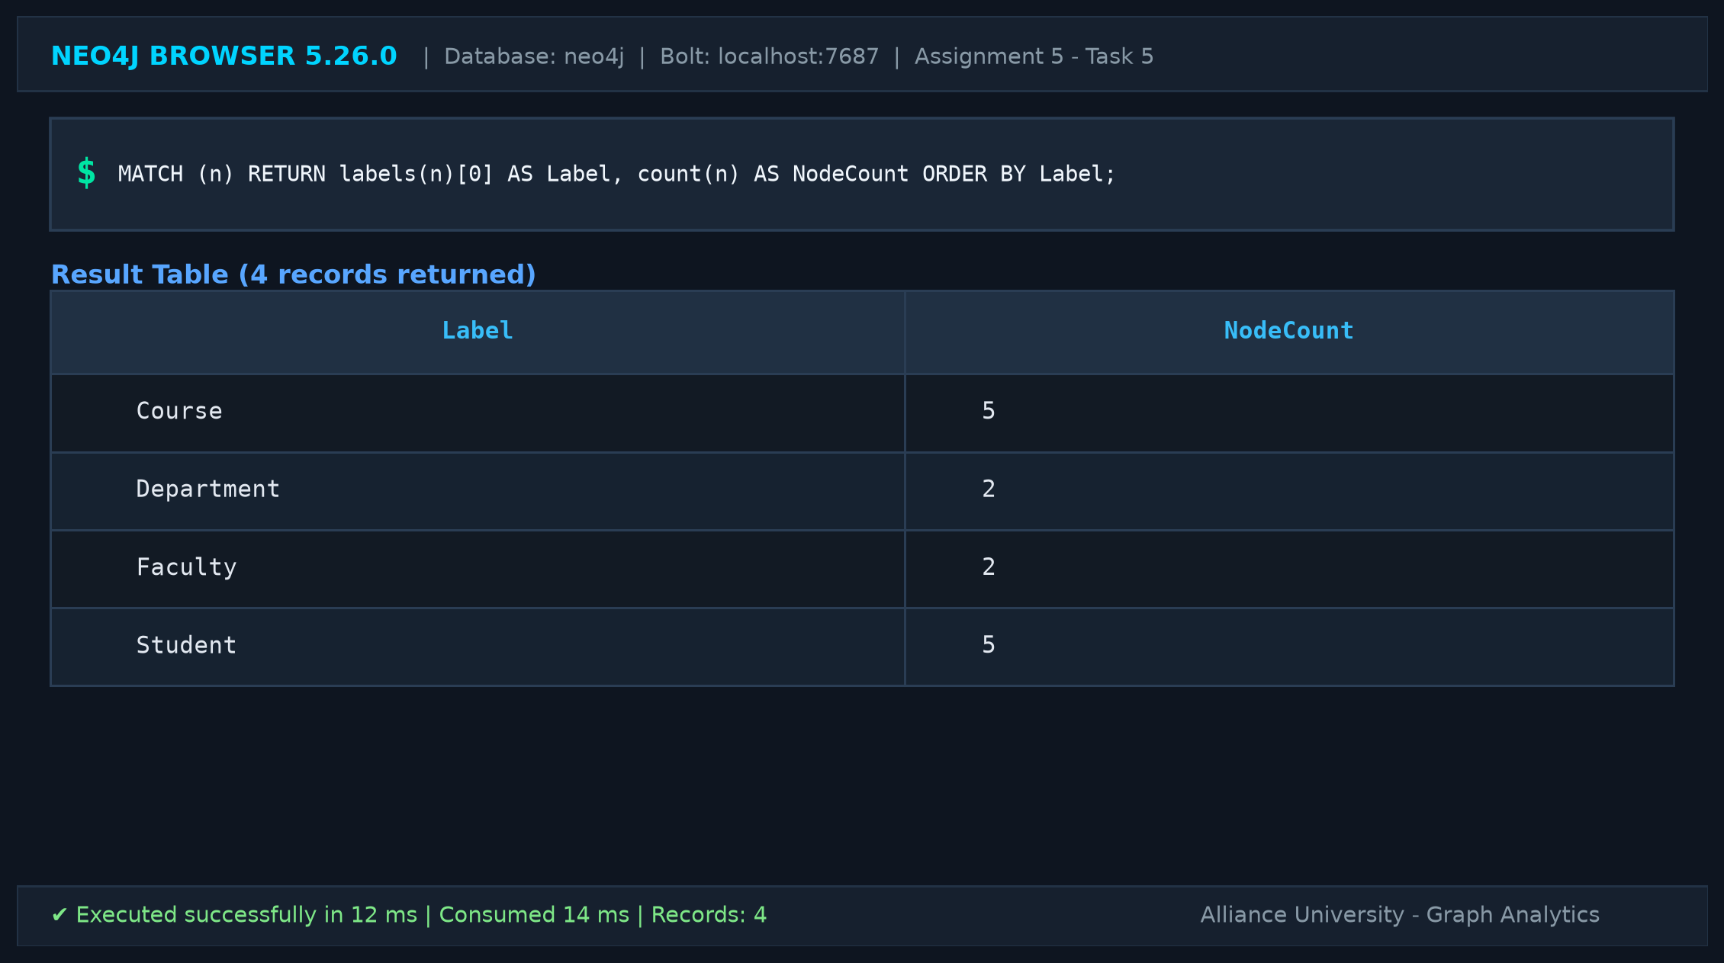
Task 6: Display all relationship types and verify their directions
Confirms source and target labels for all 4 relationship types to verify directionality.
Cypher Query:
MATCH (a)-[r]->(b) RETURN labels(a)[0] AS SourceNode, type(r) AS RelationshipType, labels(b)[0] AS TargetNode, count(r) AS Count ORDER BY RelationshipType, SourceNode;

Execution Output (4 rows returned):
SourceNode | RelationshipType | TargetNode | Count
Student | BELONGS_TO | Department | 5
Student | ENROLLED_IN | Course | 11
Department | OFFERS | Course | 5
Faculty | TEACHES | Course | 5

Neo4j Browser Screenshot (Task 6):
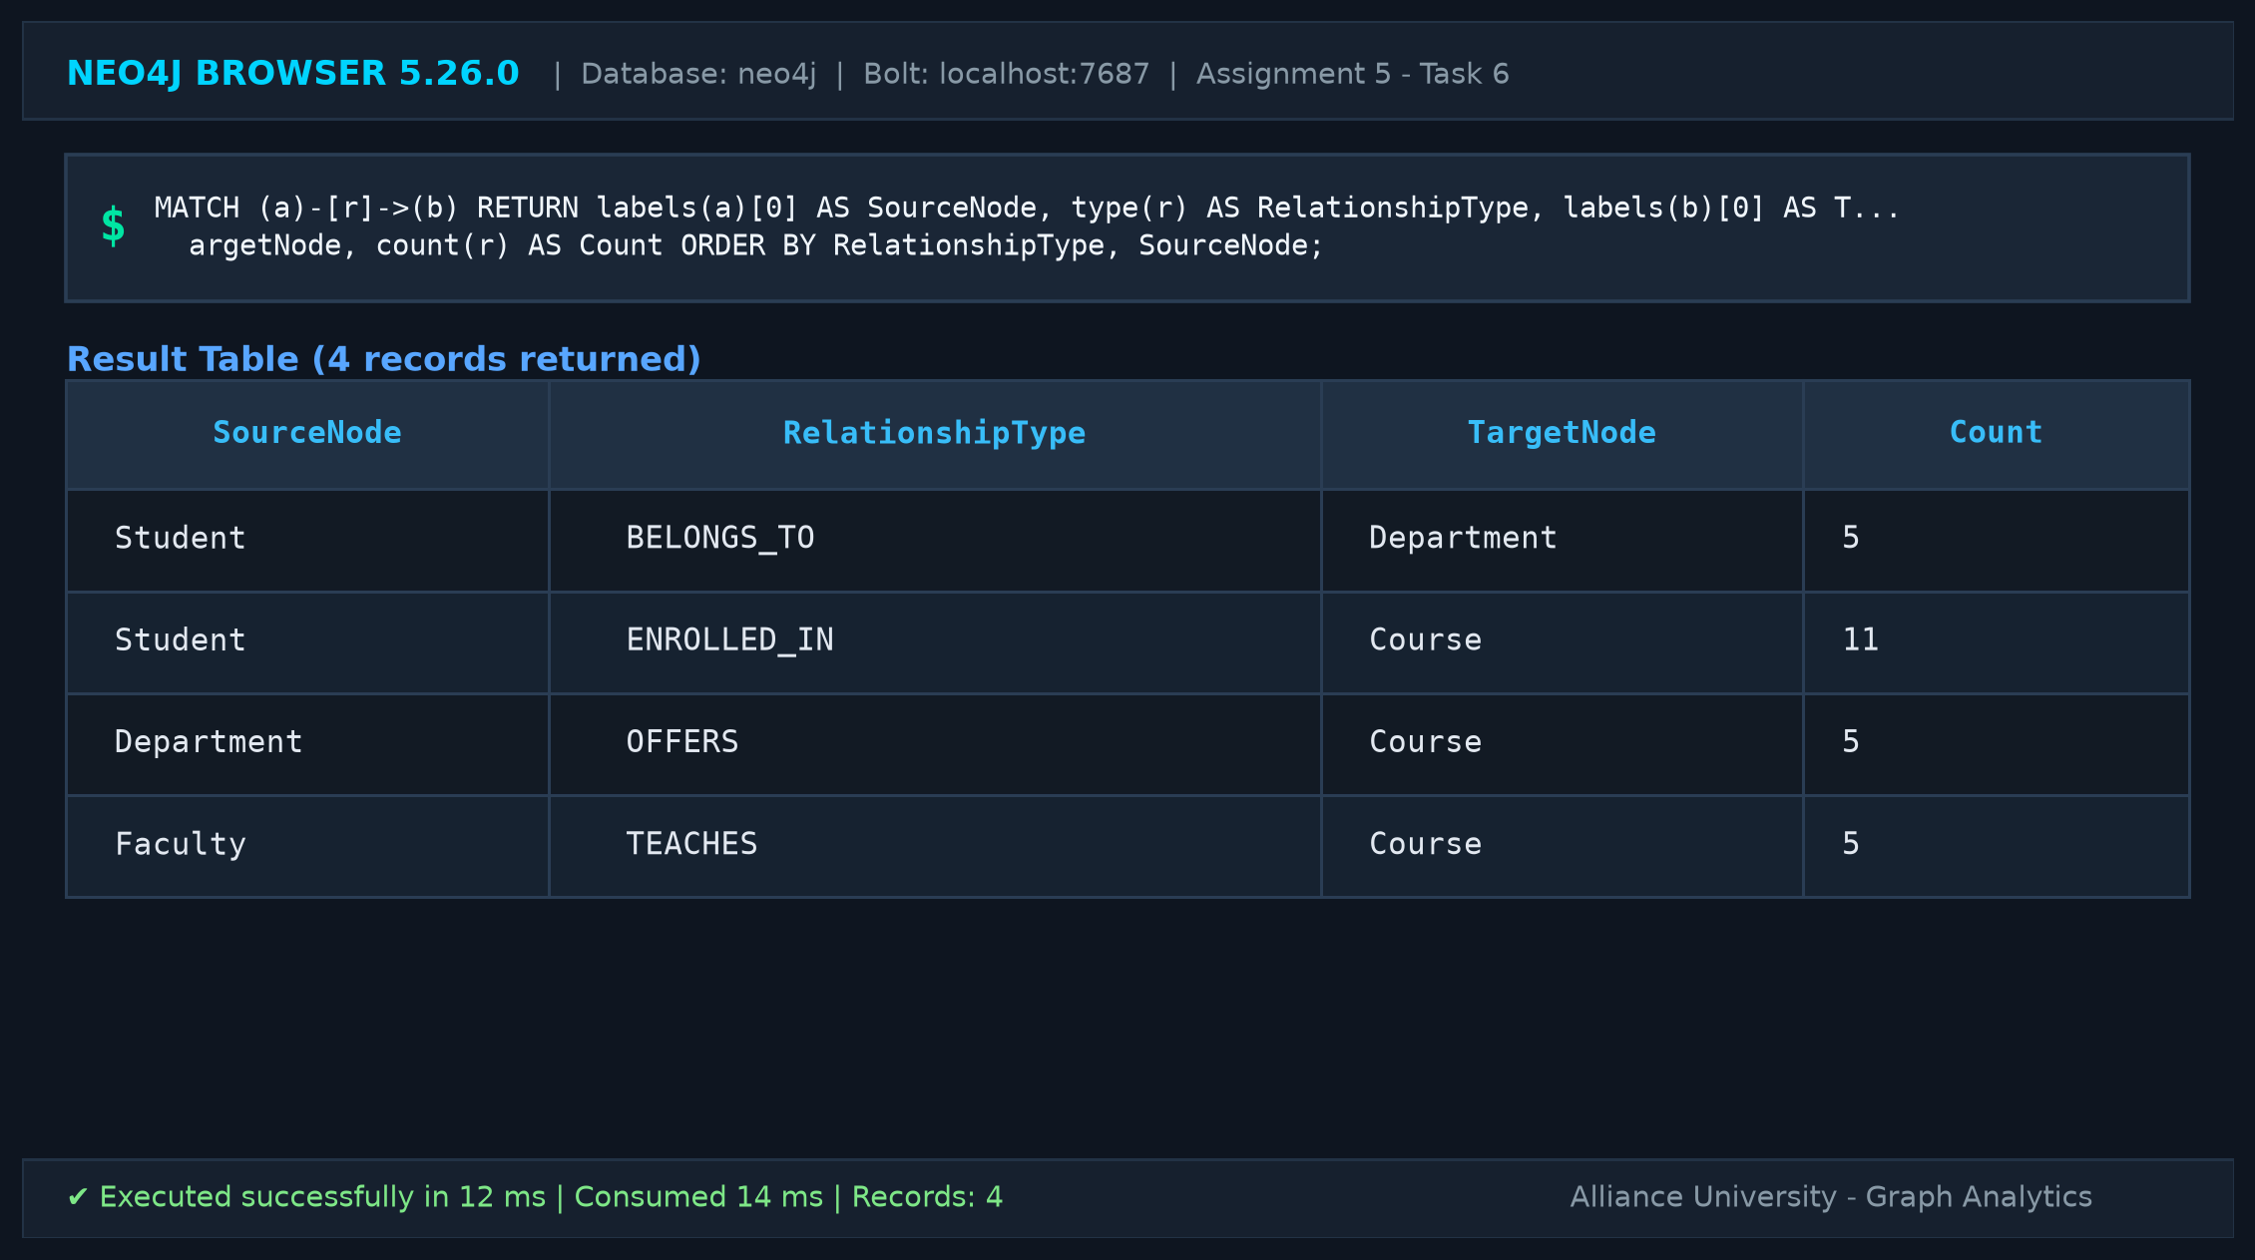

Part B — Retrieval and Filtering Queries
Task 7: Retrieve all students studying in Semester 5
Filters students who are in semester 5 (Aarav Sharma, Priya Das, Arjun Patel).
Cypher Query:
MATCH (s:Student) WHERE s.semester = 5 RETURN s.studentId AS StudentID, s.name AS Name, s.semester AS Semester, s.email AS Email ORDER BY s.studentId;

Execution Output (3 rows returned):
StudentID | Name | Semester | Email
S101 | Aarav Sharma | 5 | aarav@univ.edu
S102 | Priya Das | 5 | priya@univ.edu
S105 | Arjun Patel | 5 | arjun@univ.edu

Neo4j Browser Screenshot (Task 7):
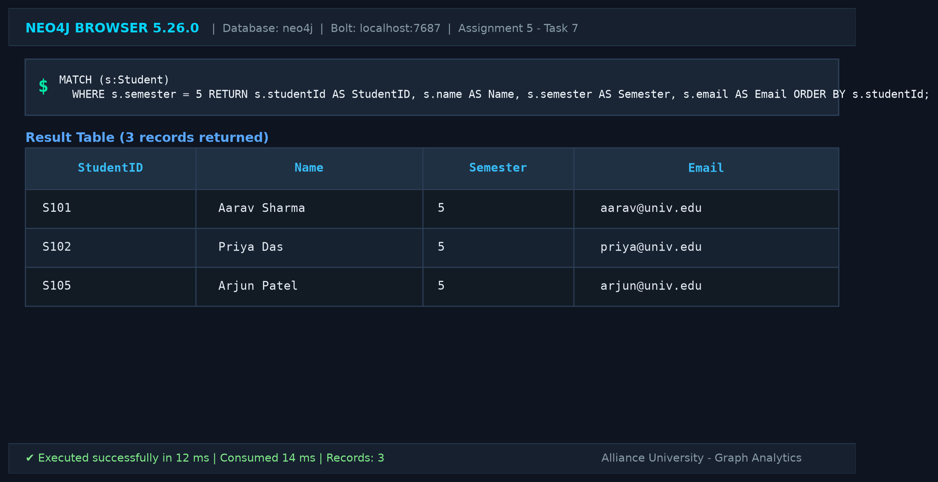
Task 8: Find all courses with more than 3 credits
Filters courses with credits > 3 (CS302 DBMS: 4, CS304 Big Data Analytics: 4).
Cypher Query:
MATCH (c:Course) WHERE c.credits > 3 RETURN c.courseCode AS CourseCode, c.courseTitle AS CourseTitle, c.credits AS Credits, c.level AS Level ORDER BY c.courseCode;

Execution Output (2 rows returned):
CourseCode | CourseTitle | Credits | Level
CS302 | Database Management Systems | 4 | Core
CS304 | Big Data Analytics | 4 | Advanced

Neo4j Browser Screenshot (Task 8):
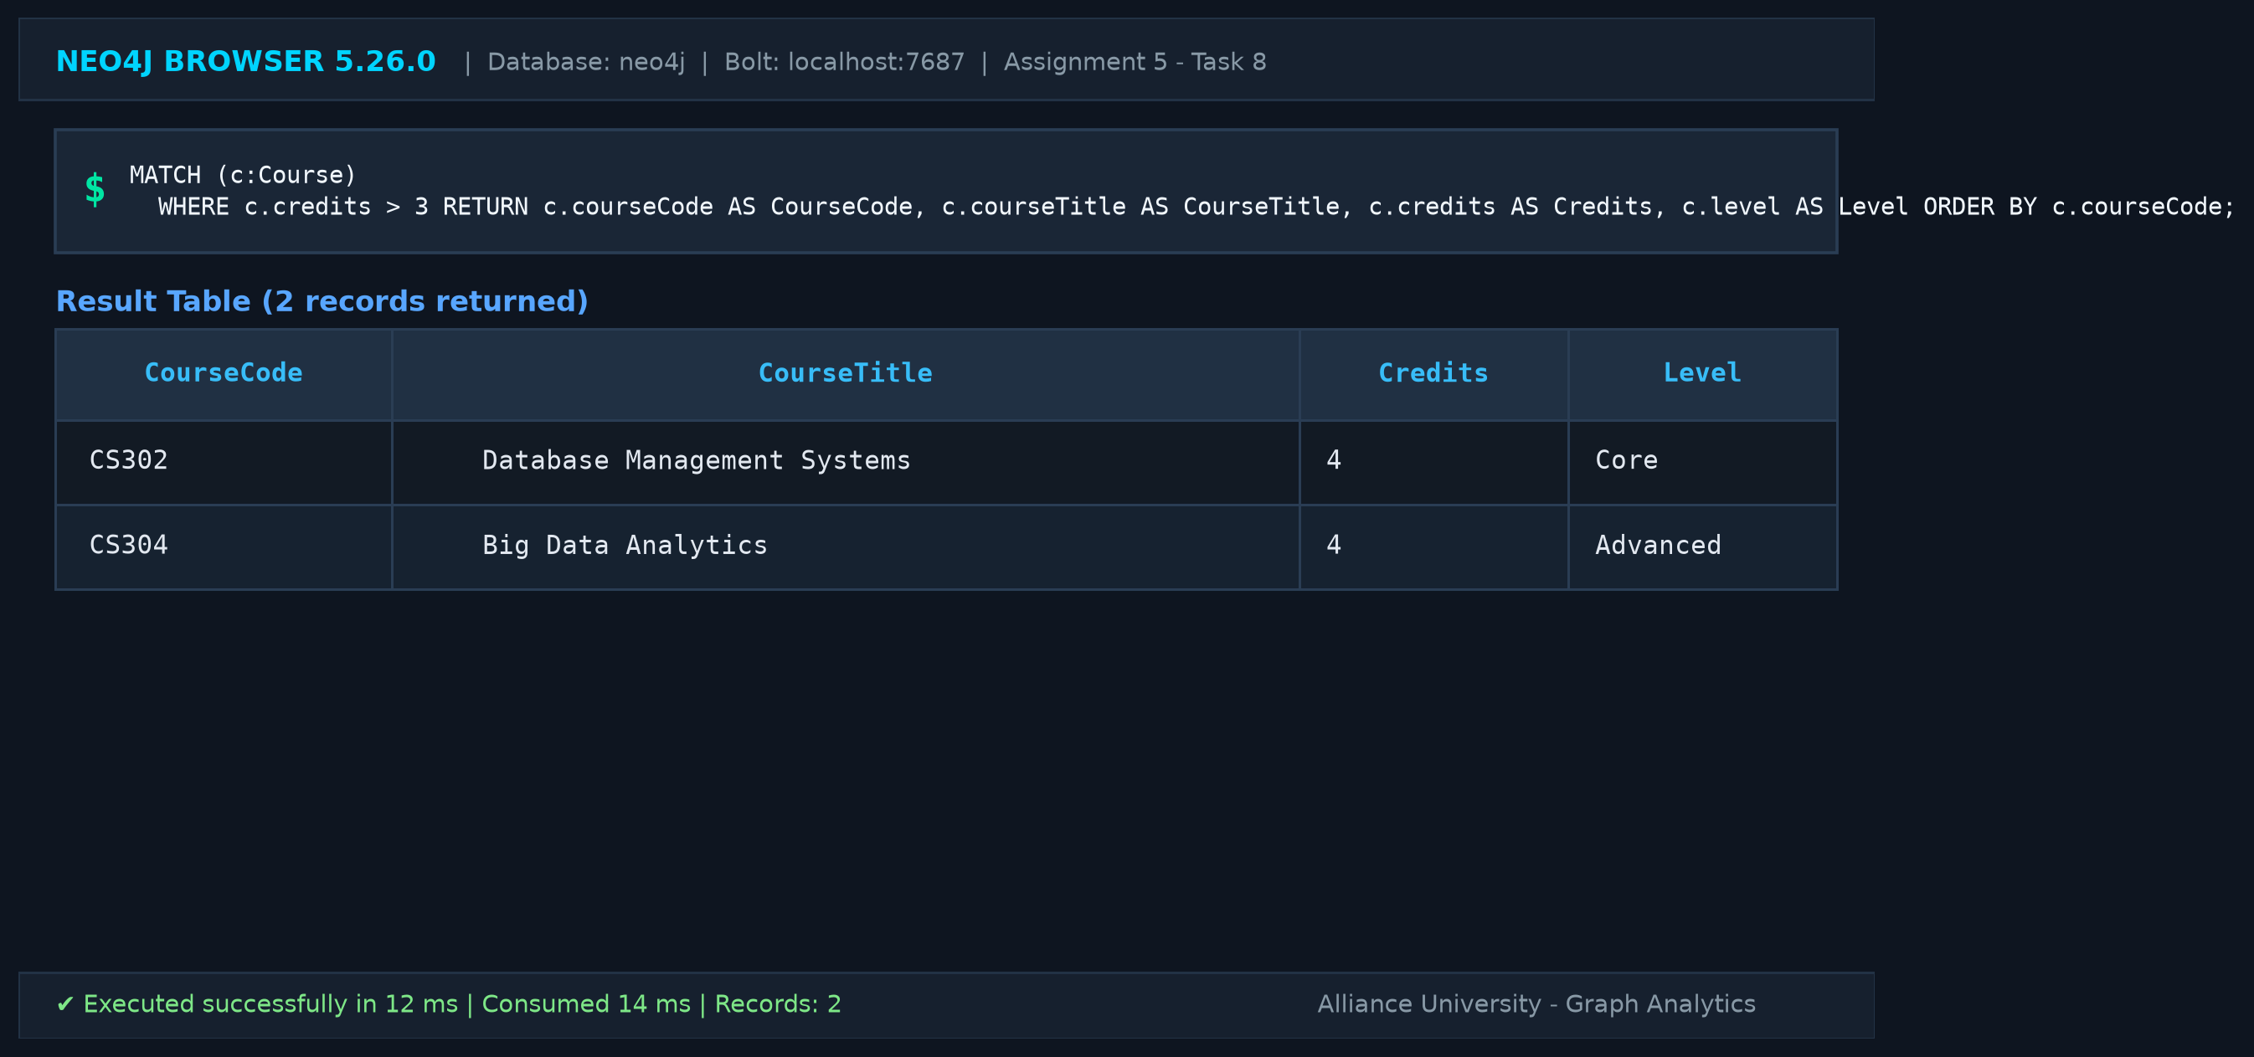
Task 9: Retrieve the courses taught by Dr. Meera Sen
Retrieves courses taught by Dr. Meera Sen (CS302 DBMS, CS305 NoSQL Databases).
Cypher Query:
MATCH (f:Faculty {name: 'Dr. Meera Sen'})-[r:TEACHES]->(c:Course) RETURN f.name AS FacultyName, c.courseCode AS CourseCode, c.courseTitle AS CourseTitle, c.credits AS Credits, r.academicYear AS AcademicYear ORDER BY c.courseCode;

Execution Output (2 rows returned):
FacultyName | CourseCode | CourseTitle | Credits | AcademicYear
Dr. Meera Sen | CS302 | Database Management Systems | 4 | 2026-27
Dr. Meera Sen | CS305 | NoSQL Databases | 3 | 2026-27

Neo4j Browser Screenshot (Task 9):
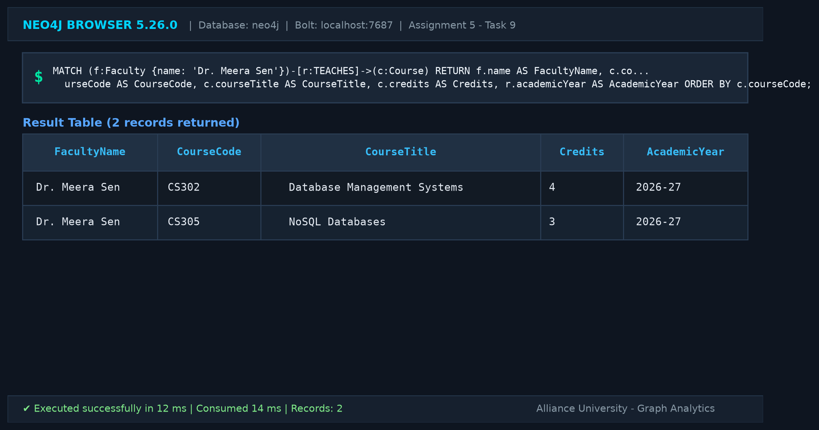
Task 10: Find all students enrolled in Graph Analytics
Finds all students enrolled in CS301 Graph Analytics (Aarav Sharma, Priya Das, Arjun Patel).
Cypher Query:
MATCH (s:Student)-[r:ENROLLED_IN]->(c:Course) WHERE c.courseTitle = 'Graph Analytics' RETURN s.studentId AS StudentID, s.name AS StudentName, s.semester AS CurrentSemester, c.courseTitle AS EnrolledCourse ORDER BY s.studentId;

Execution Output (3 rows returned):
StudentID | StudentName | CurrentSemester | EnrolledCourse
S101 | Aarav Sharma | 5 | Graph Analytics
S102 | Priya Das | 5 | Graph Analytics
S105 | Arjun Patel | 5 | Graph Analytics

Neo4j Browser Screenshot (Task 10):
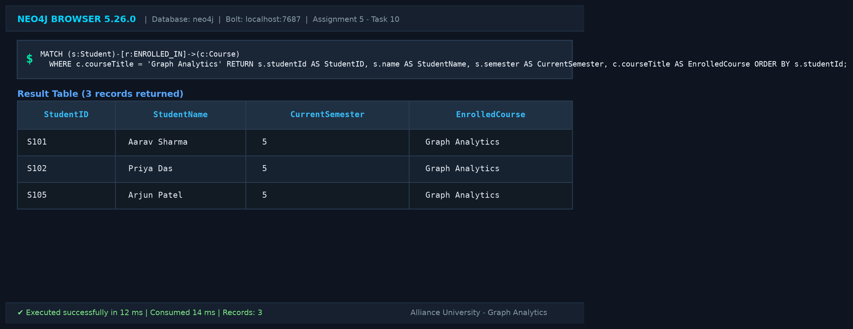
Task 11: Display the names of all students belonging to the Computer Science department
Lists students belonging to CS department (Aarav Sharma, Priya Das, Rahul Verma).
Cypher Query:
MATCH (s:Student)-[:BELONGS_TO]->(d:Department) WHERE d.deptName = 'Computer Science' RETURN s.studentId AS StudentID, s.name AS StudentName, d.deptName AS DepartmentName, d.building AS Building ORDER BY s.studentId;

Execution Output (3 rows returned):
StudentID | StudentName | DepartmentName | Building
S101 | Aarav Sharma | Computer Science | Block A
S102 | Priya Das | Computer Science | Block A
S103 | Rahul Verma | Computer Science | Block A

Neo4j Browser Screenshot (Task 11):
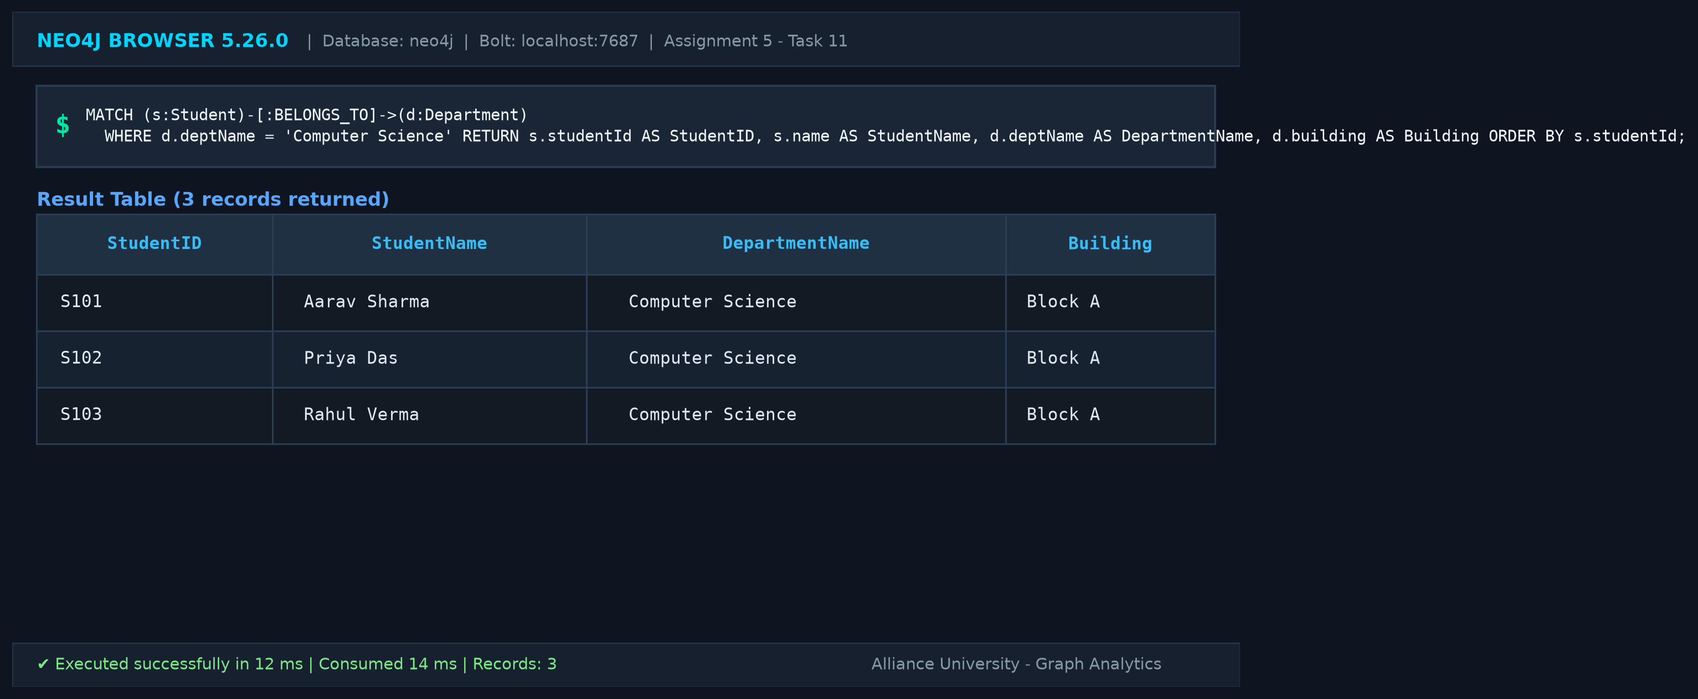
Task 12: Find all courses offered by the Information Technology department
Lists courses offered by IT department (CS301 Graph Analytics, CS304 Big Data Analytics).
Cypher Query:
MATCH (d:Department)-[:OFFERS]->(c:Course) WHERE d.deptName = 'Information Technology' RETURN d.deptName AS DepartmentName, c.courseCode AS CourseCode, c.courseTitle AS CourseTitle, c.credits AS Credits, c.level AS Level ORDER BY c.courseCode;

Execution Output (2 rows returned):
DepartmentName | CourseCode | CourseTitle | Credits | Level
Information Technology | CS301 | Graph Analytics | 3 | Advanced
Information Technology | CS304 | Big Data Analytics | 4 | Advanced

Neo4j Browser Screenshot (Task 12):
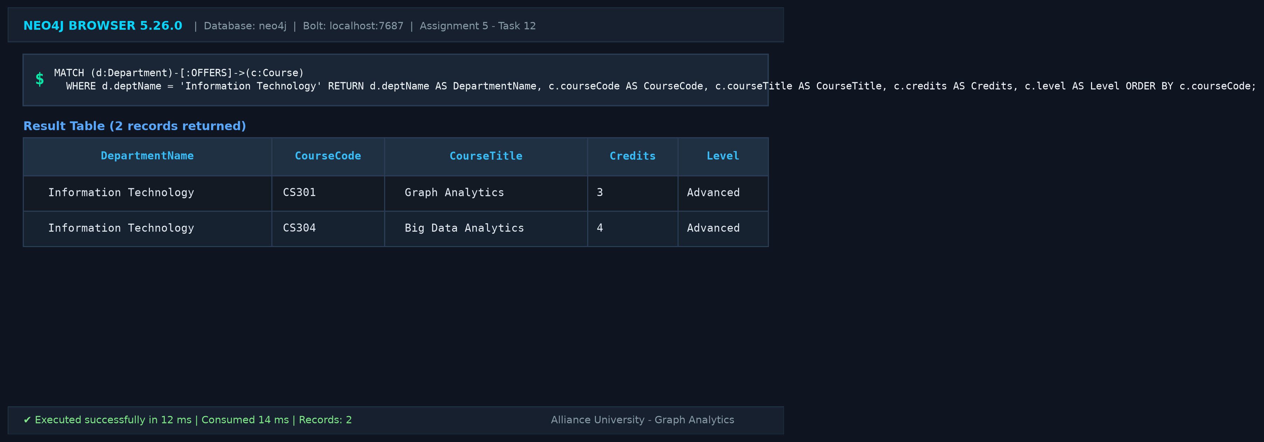
Task 13: Retrieve all students enrolled in NoSQL Databases along with their semester and grade
Retrieves students in CS305 NoSQL Databases with enrollment semester and grade (Aarav Sharma: Sem 5, Sneha Roy: Sem 3).
Cypher Query:
MATCH (s:Student)-[r:ENROLLED_IN]->(c:Course) WHERE c.courseTitle = 'NoSQL Databases' RETURN s.studentId AS StudentID, s.name AS StudentName, s.semester AS StudentSemester, r.semesterEnrolled AS SemesterEnrolled, r.grade AS Grade, c.courseTitle AS CourseTitle ORDER BY s.studentId;

Execution Output (2 rows returned):
StudentID | StudentName | StudentSemester | SemesterEnrolled | Grade | CourseTitle
S101 | Aarav Sharma | 5 | 5 | Not Published | NoSQL Databases
S104 | Sneha Roy | 3 | 3 | Not Published | NoSQL Databases

Neo4j Browser Screenshot (Task 13):
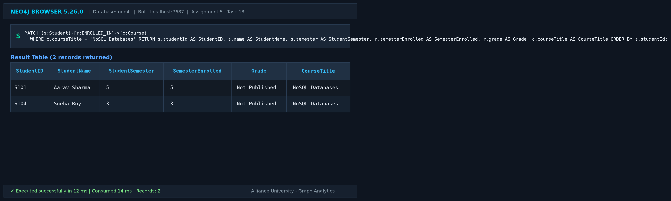
Task 14: Find all students enrolled in both Graph Analytics and another course
Retrieves students enrolled in Graph Analytics who are also taking at least one other course.
Cypher Query:
MATCH (s:Student)-[:ENROLLED_IN]->(c1:Course {courseTitle: 'Graph Analytics'}), (s)-[:ENROLLED_IN]->(c2:Course) WHERE c1 <> c2 RETURN s.studentId AS StudentID, s.name AS StudentName, c1.courseTitle AS PrimaryCourse, c2.courseTitle AS OtherCourse ORDER BY s.studentId, c2.courseTitle;

Execution Output (4 rows returned):
StudentID | StudentName | PrimaryCourse | OtherCourse
S101 | Aarav Sharma | Graph Analytics | Database Management Systems
S101 | Aarav Sharma | Graph Analytics | NoSQL Databases
S102 | Priya Das | Graph Analytics | Data Mining
S105 | Arjun Patel | Graph Analytics | Big Data Analytics

Neo4j Browser Screenshot (Task 14):
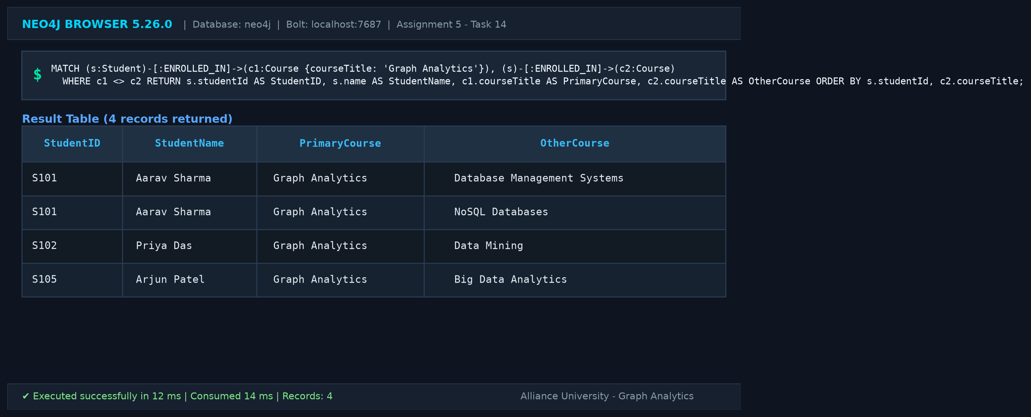

4. Verification Matrix & Results Summary
The table below summarizes the verification of all 14 programming tasks executed on Neo4j Community Server 5.26.0:
Task # | Objective | Expected Count | Observed Count | Status
1 | Create all entity nodes with properties | 14 nodes | 14 nodes (5 S, 2 F, 5 C, 2 D) | PASS
2 | Create all specified relationships | 26 edges | 26 edges (11 E, 5 T, 5 B, 5 O) | PASS
3 | Assign relationship properties | 3 properties | semesterEnrolled, grade, academicYear verified | PASS
4 | Display complete graph | 14 nodes, 26 edges | 14 nodes, 26 edges rendered | PASS
5 | Count nodes by label | 4 labels | Course: 5, Dept: 2, Faculty: 2, Student: 5 | PASS
6 | Display relationship types & directions | 4 types | BELONGS_TO: 5, ENROLLED_IN: 11, OFFERS: 5, TEACHES: 5 | PASS
7 | Retrieve Semester 5 students | 3 students | Aarav Sharma, Priya Das, Arjun Patel | PASS
8 | Find courses with > 3 credits | 2 courses | CS302 DBMS (4), CS304 Big Data Analytics (4) | PASS
9 | Retrieve courses taught by Dr. Meera Sen | 2 courses | CS302 DBMS, CS305 NoSQL Databases | PASS
10 | Find students enrolled in Graph Analytics | 3 students | Aarav Sharma, Priya Das, Arjun Patel | PASS
11 | Display students belonging to CS dept | 3 students | Aarav Sharma, Priya Das, Rahul Verma | PASS
12 | Find courses offered by IT dept | 2 courses | CS301 Graph Analytics, CS304 Big Data Analytics | PASS
13 | Retrieve NoSQL students with semester & grade | 2 students | Aarav Sharma (Sem 5), Sneha Roy (Sem 3) | PASS
14 | Find students in Graph Analytics & another course | 3 students (4 pairs) | Aarav (2 pairs), Priya (1 pair), Arjun (1 pair) | PASS

5. Conclusion & Technical Insights
In this assignment, a complete University Course Registration System was successfully modeled, populated, and queried using Neo4j and Cypher. The Labeled Property Graph (LPG) model allowed complex multi-entity associations—including student course enrolments, faculty teaching responsibilities, student departmental affiliations, and departmental course offerings—to be represented naturally without relational intermediary junction tables.
Key observations from the implementation include:
1. Expressive Cypher Traversals: Complex associative queries, such as identifying co-enrolments (Task 14) or filtering on nested relationship properties (Task 13), were expressed cleanly in single pattern-matching statements without complex JOIN logic.
2. Relationship-Level Properties: Neo4j's native support for relationship properties (e.g., semesterEnrolled, grade, academicYear) enabled contextual details to be stored directly on graph edges.
3. Scalability & Integrity: The utilization of unique constraints paired with MERGE statements ensures complete idempotency and resilience against duplicate data insertion upon script re-execution.

