Q1. What is a Program?
A program is a set of step-by-step instructions written in a language a computer can understand, telling it exactly what tasks to perform and in what order. It takes some input, processes it according to the instructions, and produces an output.
Real-life example: Instagram is a program — when you open the app, it runs instructions to fetch photos from a server, arrange them in your feed, and let you like, comment, or share them.

Q2. Three Popular Programming Languages
Language | Compiled / Interpreted
Java | Both — compiled to bytecode, then interpreted (and JIT-compiled) by the Java Virtual Machine
Python | Interpreted
JavaScript | Interpreted (modern engines like V8 also use JIT compilation internally)

Q3. Flowchart — Booking a Movie Ticket on BookMyShow
Flow of steps (draw as boxes connected by arrows — ovals for Start/End, rectangles for actions, diamonds for decisions):
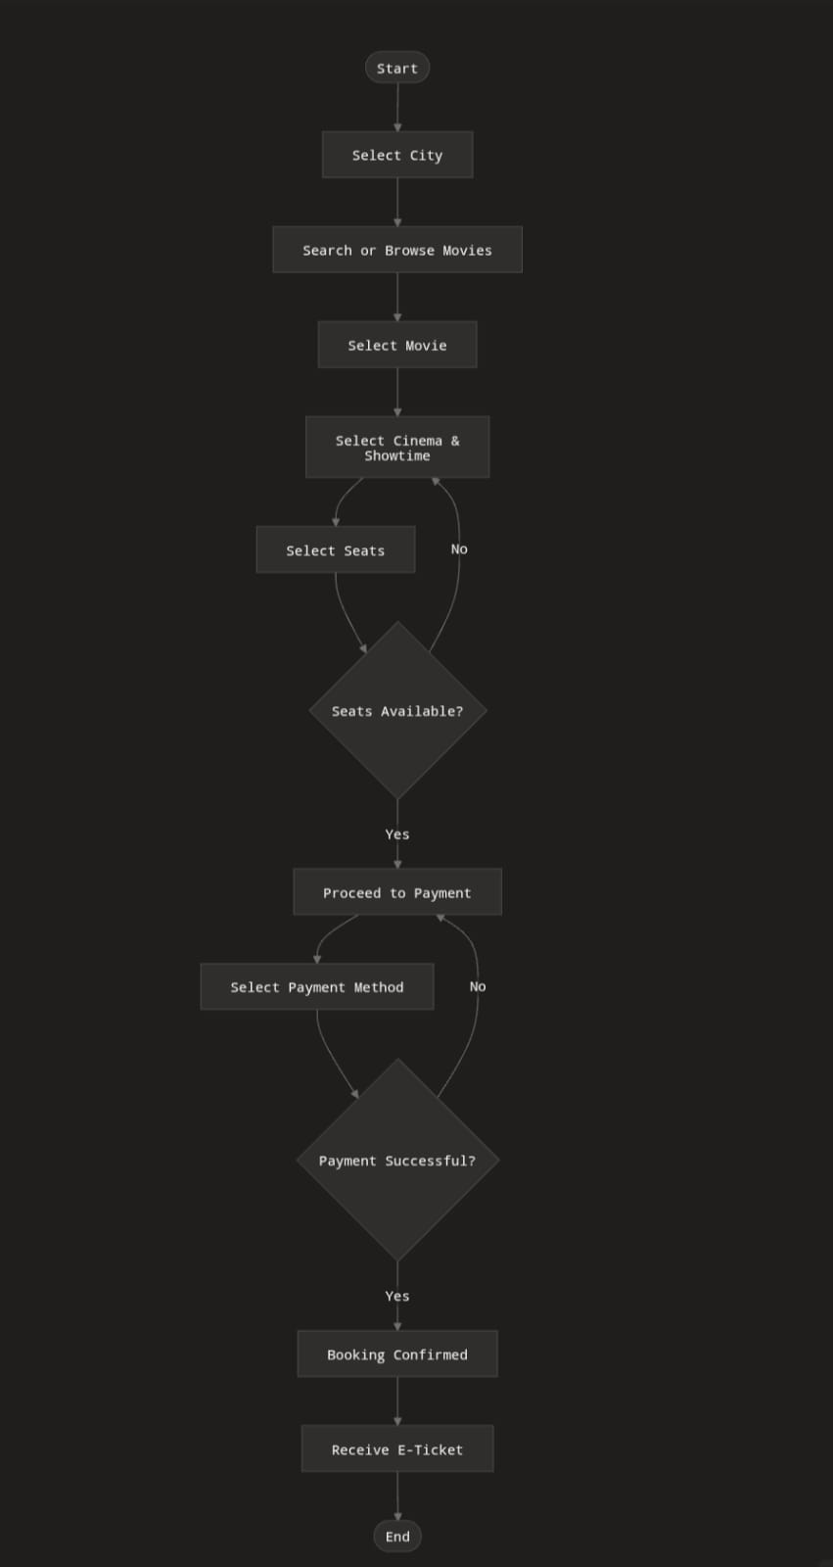

Q4. Algorithm — Ordering Food on Swiggy
- Start
- Open the Swiggy app
- Log in (or sign up if new user)
- Allow/enter delivery location
- Browse restaurants or search for a specific dish/restaurant
- Select a restaurant
- Choose food items and add them to the cart
- Review cart (check items, quantity, price)
- Apply coupon/offer code (if any)
- Proceed to checkout
- Confirm delivery address
- Select payment method (UPI, card, wallet, cash on delivery)
- Make the payment
- If payment successful → order is placed and confirmation is shown
- If payment fails → retry payment or choose another method
- Track order status until delivery
- End

