- Install GCC on your computer and verify the installation by running gcc --version in your terminal or command prompt.
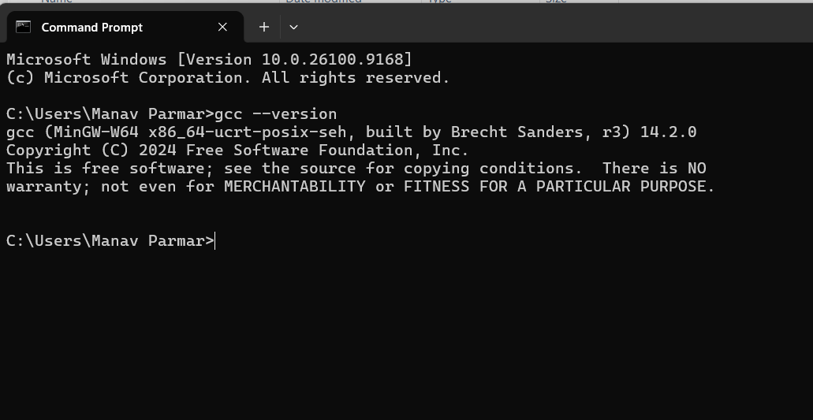

- Open VS Code or DevC++ and create a new file named hello.c. Write a C program that prints 'Hello, Instagram World!' to the console.
- Identify and label the header, main function, and return statement in your hello.c program using comments.

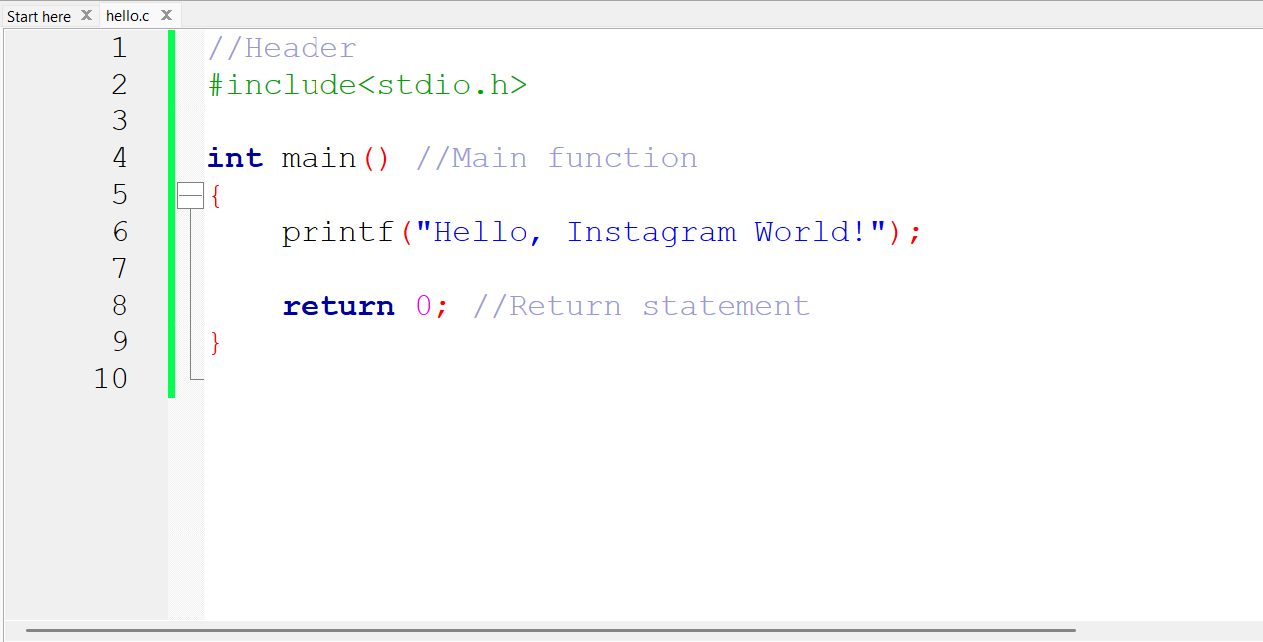

- Compile your hello.c file using the GCC command line (gcc hello.c -o hello) and run the output file to display the message in your terminal.<br><br><em><strong>Hint:</strong> On Windows, the output file will be hello.exe; on Linux/Mac, it will be hello.</em>

