- Create a console-based app called Music Listening Logger that allows users to enter the number of minutes they listened to music each day for a week and stores this data in an array.
Code:
#include <stdio.h>
int main() {
int minutes[7];
int i;
printf("=== Music Listening Logger ===\n\n");
// Take listening minutes for each day
for (i = 0; i < 7; i++) {
printf("Enter music listening minutes for day %d: ", i + 1);
scanf("%d", &minutes[i]);
}
// Display the stored data
printf("\n=== Weekly Music Listening ===\n");
for (i = 0; i < 7; i++) {
printf("Day %d: %d minutes\n", i + 1, minutes[i]);
}
return 0;
}

- Add a menu-driven interface to your Music Listening Logger so users can choose to log new listening minutes, view their weekly summary, or exit the app.<br><br><em><strong>Hint:</strong> Use a loop to repeatedly show the menu until the user selects exit.</em>
Code:
#include <stdio.h>
int main() {
int minutes[7];
int choice, i;
do {
printf("\n=== Music Listening Logger ===\n");
printf("1. Log Listening Minutes\n");
printf("2. View Weekly Summary\n");
printf("3. Exit\n");
printf("Enter your choice: ");
scanf("%d", &choice);
switch (choice) {
case 1:
// Enter listening minutes for each day
printf("\nEnter your music listening minutes:\n");
for (i = 0; i < 7; i++) {
printf("Day %d: ", i + 1);
scanf("%d", &minutes[i]);
}
printf("Listening data saved successfully!\n");
break;
case 2:
// Display weekly listening summary
printf("\n=== Weekly Summary ===\n");
for (i = 0; i < 7; i++) {
printf("Day %d: %d minutes\n", i + 1, minutes[i]);
}
break;
case 3:
printf("\nThank you for using Music Listening Logger!\n");
break;
default:
printf("\nInvalid choice! Please try again.\n");
}
} while (choice != 3);
return 0;
}
music_log.txt file:
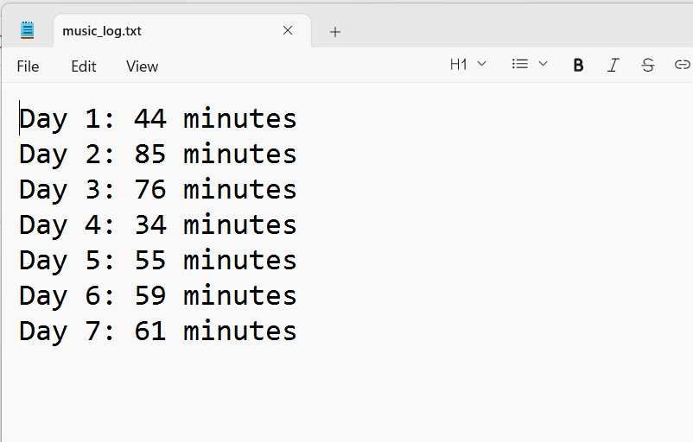

- Implement file handling in your Music Listening Logger so that when the user logs their daily listening minutes, the data is saved to a file named music_log.txt for persistence.
Code:
#include <stdio.h>
int main() {
int minutes[7];
int choice, i;
FILE *file;
do {
printf("\n=== Music Listening Logger ===\n");
printf("1. Log Listening Minutes\n");
printf("2. View Weekly Summary\n");
printf("3. Exit\n");
printf("Enter your choice: ");
scanf("%d", &choice);
switch (choice) {
case 1:
// Enter listening minutes for each day
printf("\nEnter your music listening minutes:\n");

for (i = 0; i < 7; i++) {
printf("Day %d: ", i + 1);
scanf("%d", &minutes[i]);
}
// Open file in write mode
file = fopen("music_log.txt", "w");
if (file == NULL) {
printf("Error opening file!\n");
break;
}
// Save data to the file
for (i = 0; i < 7; i++) {
fprintf(file, "Day %d: %d minutes\n",
i + 1, minutes[i]);
}
fclose(file);
printf("Listening data saved to music_log.txt!\n");
break;
case 2:
// Display weekly summary
printf("\n=== Weekly Summary ===\n");
for (i = 0; i < 7; i++) {
printf("Day %d: %d minutes\n",
i + 1, minutes[i]);
}
break;
case 3:
printf("\nThank you for using Music Listening Logger!\n");
break;
default:
printf("\nInvalid choice! Please try again.\n");
}
} while (choice != 3);
return 0;
}

- Add a feature to your app that reads the saved music_log.txt file and generates a weekly report showing the total, average, and highest listening minutes in the week.
Code:
#include <stdio.h>
int main() {
int minutes[7];
int choice, i;
int total, highest;
float average;
FILE *file;
do {
printf("\n=== Music Listening Logger ===\n");
printf("1. Log Listening Minutes\n");
printf("2. View Weekly Report\n");
printf("3. Exit\n");
printf("Enter your choice: ");
scanf("%d", &choice);
switch (choice) {
case 1:
// Enter listening minutes for each day
printf("\nEnter your music listening minutes:\n");
for (i = 0; i < 7; i++) {
printf("Day %d: ", i + 1);
scanf("%d", &minutes[i]);
}
// Open file in write mode
file = fopen("music_log.txt", "w");
if (file == NULL) {
printf("Error opening file!\n");
break;
}
// Save data to the file
for (i = 0; i < 7; i++) {
fprintf(file, "%d\n", minutes[i]);
}
fclose(file);
printf("Listening data saved successfully!\n");
break;
case 2:
// Open file in read mode
file = fopen("music_log.txt", "r");
if (file == NULL) {
printf("No music log found!\n");
break;
}
total = 0;
highest = 0;
// Read data from file
for (i = 0; i < 7; i++) {
fscanf(file, "%d", &minutes[i]);
total = total + minutes[i];
if (minutes[i] > highest) {
highest = minutes[i];
}
}
fclose(file);
// Calculate average
average = total / 7.0;
printf("\n=== Weekly Report ===\n");
printf("Total Listening: %d minutes\n", total);
printf("Average Listening: %.2f minutes\n", average);
printf("Highest Listening: %d minutes\n", highest);
break;
case 3:
printf("\nThank you for using Music Listening Logger!\n");
break;
default:
printf("\nInvalid choice! Please try again.\n");
}
} while (choice != 3);
return 0;
}

- Refactor your Music Listening Logger to allow users to reset their weekly data by clearing the array and deleting the contents of music_log.txt.<br><br><em><strong>Constraint:</strong> Make sure the reset option is available in the menu and asks for confirmation before deleting data.</em>
Code:
#include <stdio.h>
int main() {
int minutes[7] = {0};
int choice, i;
int total, highest;
float average;
char confirm;
FILE *file;
do {
printf("\n=== Music Listening Logger ===\n");
printf("1. Log Listening Minutes\n");
printf("2. View Weekly Report\n");
printf("3. Reset Weekly Data\n");
printf("4. Exit\n");
printf("Enter your choice: ");
scanf("%d", &choice);
switch (choice) {
case 1:
// Enter listening minutes for each day
printf("\nEnter your music listening minutes:\n");
for (i = 0; i < 7; i++) {
printf("Day %d: ", i + 1);
scanf("%d", &minutes[i]);
}
// Open file in write mode
file = fopen("music_log.txt", "w");
if (file == NULL) {
printf("Error opening file!\n");
break;
}
// Save data to the file
for (i = 0; i < 7; i++) {
fprintf(file, "%d\n", minutes[i]);
}
fclose(file);
printf("Listening data saved successfully!\n");
break;
case 2:
// Open file in read mode
file = fopen("music_log.txt", "r");
if (file == NULL) {
printf("No music log found!\n");
break;
}
total = 0;
highest = 0;
// Read data from file
for (i = 0; i < 7; i++) {
fscanf(file, "%d", &minutes[i]);
total = total + minutes[i];
if (minutes[i] > highest) {
highest = minutes[i];
}
}
fclose(file);
average = total / 7.0;
printf("\n=== Weekly Report ===\n");
printf("Total Listening: %d minutes\n", total);
printf("Average Listening: %.2f minutes\n", average);
printf("Highest Listening: %d minutes\n", highest);
break;
case 3:
// Ask for confirmation before resetting
printf("\nAre you sure you want to reset weekly data? (Y/N): ");
scanf(" %c", &confirm);
if (confirm == 'Y' || confirm == 'y') {
// Clear the array
for (i = 0; i < 7; i++) {
minutes[i] = 0;
}
// Clear the contents of the file
file = fopen("music_log.txt", "w");
if (file != NULL) {
fclose(file);
printf("Weekly data has been reset successfully!\n");
} else {
printf("Error clearing music_log.txt!\n");
}
} else {
printf("Reset cancelled. Your data is safe.\n");
}
break;
case 4:
printf("\nThank you for using Music Listening Logger!\n");
break;
default:
printf("\nInvalid choice! Please try again.\n");
}
} while (choice != 4);
return 0;
}

