- Create a file called playlist.txt and write the names of your top 3 favorite songs from Spotify into it using write mode (w).
Code:
#include<stdio.h>
int main(){
FILE *fp1;
fp1 = fopen("playlist.txt","w");
fprintf(fp1,"52 Bars\n");
fprintf(fp1,"For a reason\n");
fprintf(fp1,"MF Ghabru!\n");
printf("File written");
fclose(fp1);
}

Output:
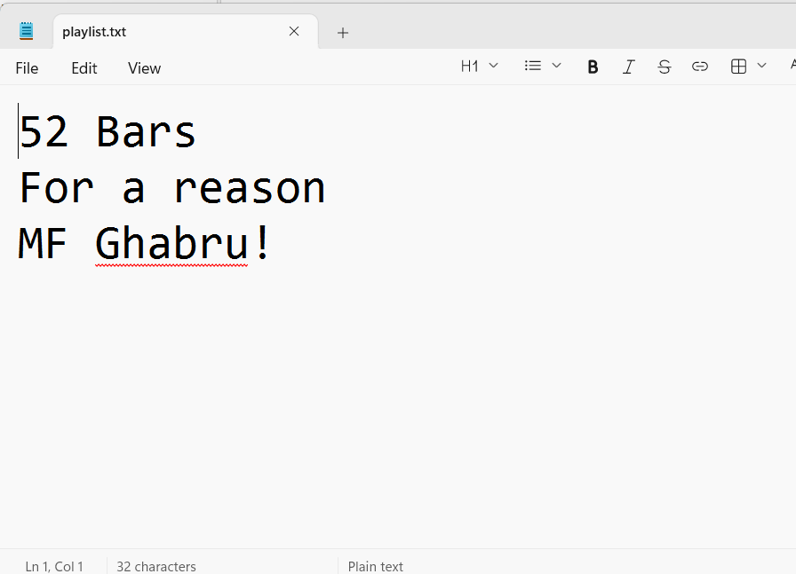

- Open playlist.txt in read mode (r) and display each song name on a separate line in the console.
Code:
#include<stdio.h>
int main(){
FILE *fp;
int song;
fp = fopen("playlist.txt","r");
while(1)
{
song = fgetc(fp);
if(song == EOF)
break;
printf("%c",song);
}
fclose(fp);
}
Output:
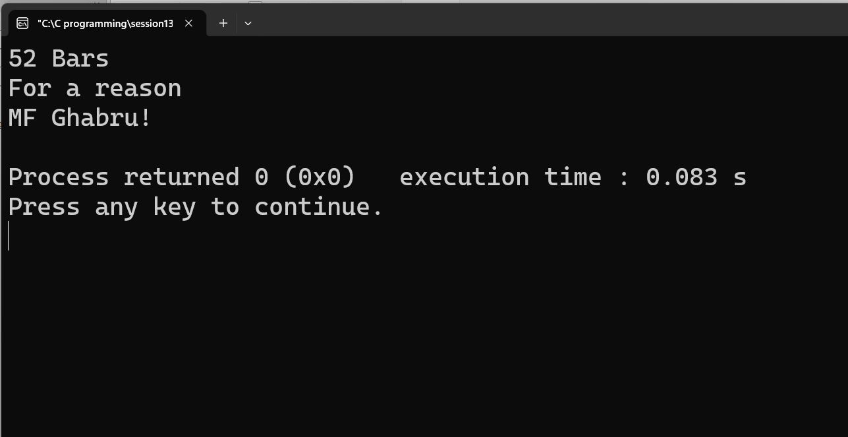

- Add two more song names to playlist.txt without deleting the existing ones by opening the file in append mode (a).
Code:
#include<stdio.h>
int main(){
FILE *fp;
fp = fopen("playlist.txt","a");
if(fp == NULL)
{
printf("File does not exists\n");
return 0;
}
fprintf(fp,"Winning Speech\n");
fprintf(fp,"Boyfriend\n");
printf("Two song added!!");
fclose(fp);
}
Output:
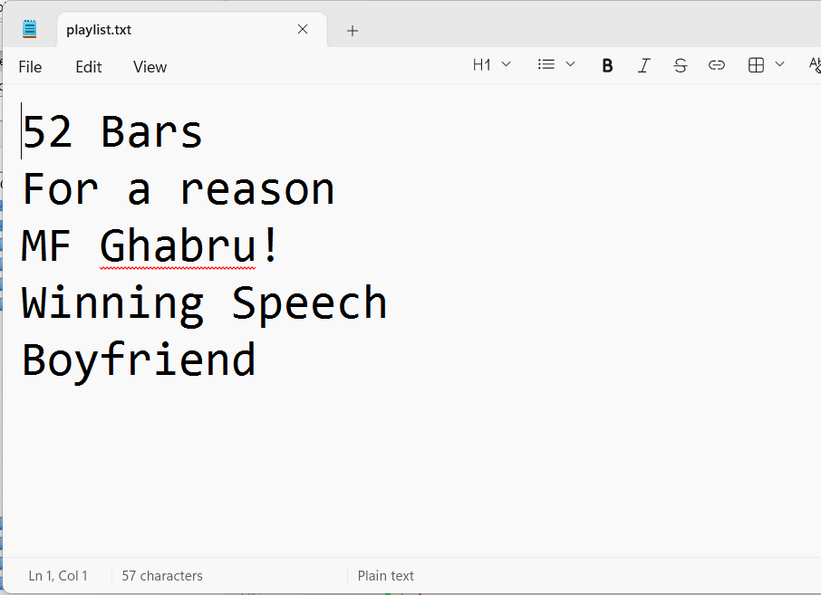

- Write a program that reads all song names from playlist.txt and prints only those that contain the word 'love' (case_insensitive).<br><br><em><strong>Hint:</strong> Use the 'in' keyword or equivalent string method for filtering.</em>
Code:
#include <stdio.h>
#include <string.h>
#include <ctype.h>
int main() {
FILE *file;
char song[100];
file = fopen("playlist.txt", "r");
if (file == NULL) {
printf("File not found!\n");
return 1;
}
printf("Songs containing 'love':\n");
while (fgets(song, sizeof(song), file) != NULL) {
// Convert the song name to lowercase
for (int i = 0; song[i] != '\0'; i++) {
song[i] = tolower(song[i]);
}
// Check whether "love" is present
if (strstr(song, "love") != NULL) {
printf("%s", song);
}
}
fclose(file);
return 0;
}

