- Declare an integer variable called likes and a pointer variable called ptrLikes; assign likes a value, point ptrLikes to likes, and print both the value and the address stored in ptrLikes.
Code:
#include<stdio.h>
int main(){
int likes = 500;
int *ptrLikes = &likes;

printf("Likes: %d\n",likes);
printf("Address stored in ptrLikes: %p",(void *)ptrLikes);
}

- Write a function swapPlaylistCounts(int *a, int *b) that swaps the number of songs in two Spotify playlists using pointers, then call the function in main and print the swapped values.
Code:
#include<stdio.h>
void swapPlaylistCounts(int *a,int *b)
{
int temp = *a;
*a = *b;
*b = temp;
}
int main(){
int playlist1 = 25;
int playlist2 = 40;
swapPlaylistCounts(&playlist1,&playlist2);
printf("Playlist 1 songs: %d\n",playlist1);
printf("Playlist 2 songs: %d\n",playlist2);
}

- Given an array of 5 order amounts (e.g., Zomato orders), use a pointer to iterate through the array and print each amount along with its memory address.<br><br><em><strong>Hint:</strong> Use pointer arithmetic to move to the next element.</em>
Code:
#include<stdio.h>
int main(){
int orders[]={500,465,450,625,700};
int *ptr = orders;

for(int i=0;i<5;i++)
{
printf("Order amount: %d Address: %p\n",*ptr,(void *)ptr);
ptr++;
}
}

- Create a function incrementFollowers(int *followers, int n) that increases each follower count in an array (representing Instagram followers for 5 friends) by 100 using pointer arithmetic, then print the updated counts.
Code:
#include<stdio.h>
void incrementFollowers(int *followers, int n){
for (int i=0;i<n;i++)
{
*followers = *followers + 100;
followers++;
}
}
int main(){
int followers[]={1000,2100,1500,1700,2600};
incrementFollowers(followers, 5);
printf("Updated followers counts:\n");
for(int i=0;i<5;i++)
{
printf("%d\n",followers[i]);
}
}

- Draw a simple memory diagram (on paper or using any drawing tool) showing how a pointer references the address of a variable, using the variables from your likes and ptrLikes example; label the variable, pointer, and address.
Answer:
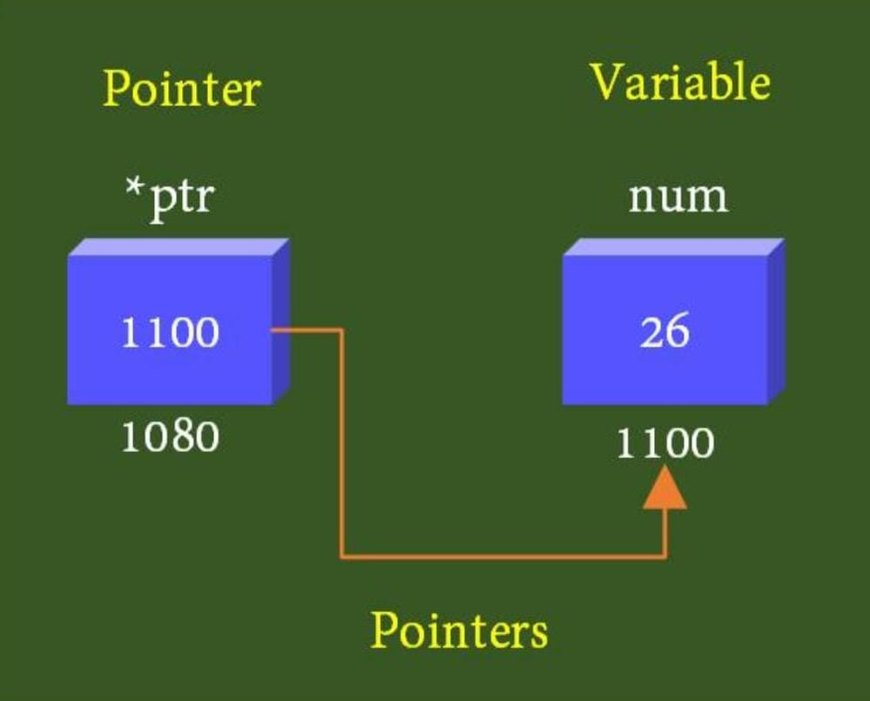

Labels
- Variable: likes
- Value: 50
- Pointer: ptrLikes
- Address of likes: 0x1004 (example address)
- ptrLikes stores the address of likes.

