TASK-1
Motherboard: This is the large, main circuit board that everything else plugs into. It acts like the nervous system, allowing all the different parts to communicate with each other.
CPU (Central Processing Unit): Often hidden under a cooling fan, this is the "brain" of the computer. It processes all the instructions and calculations needed to make your software run.
CPU Cooler (Fan or Heatsink): A fan or metal block sitting directly on top of the CPU. It constantly pulls heat away to prevent the computer's "brain" from overheating while it works hard.
RAM (Random Access Memory): These are long, thin sticks plugged directly into the motherboard. They act as the computer's short-term memory, instantly providing data for the tasks you are actively doing right now.
Storage Drive (SSD or HDD): This is a small rectangular box or a tiny chip where all your files, programs, and the operating system are permanently kept. It serves as the long-term memory of your PC.
Power Supply Unit (PSU): Usually located in a top or bottom corner with a thick bundle of wires coming out of it. It takes electricity from your wall outlet and distributes the correct amount of power to every other part.
GPU (Graphics Processing Unit / Graphics Card): A large, separate board plugged into the lower half of the motherboard, often with its own fans. It handles rendering images and video, which is crucial for gaming or heavy visual editing. (Note: Not all PCs have a separate GPU; some have a basic one built directly into the CPU).
TASK-2
Step 1: Unplug the Power
Turn off the switch on the back of your power supply, then completely unplug the main power cable from the wall and the PC.
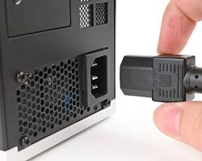
Step 2: Remove the Side Panel
Locate the thumb screws at the back edge of the case. Unscrew them and slide the main side panel away to expose the inside components.
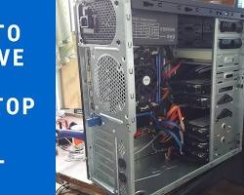
Step 3: Disconnect Internal Power Cables
Unplug the thick cables connecting the power supply to the motherboard. For the massive 24-pin cable, squeeze the plastic release clip on its side before pulling it straight up.
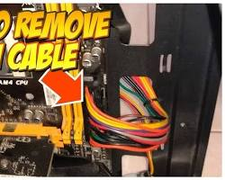
Step 4: Remove the Graphics Card (GPU)
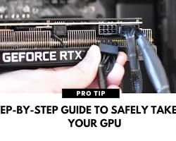
Remove the screws holding the graphics card to the back of the metal case. Next, push down on the plastic locking tab at the very end of the motherboard slot to release the card before pulling it upward.

Step 5: Pop Out the RAM
Find the tall memory sticks. Press firmly down on the plastic clips at the top and bottom edges of the slots. The RAM will pop out on its own.
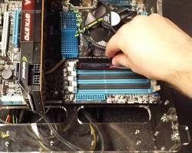
Step 6: Take Out Storage Drives (HDD/SSD)
Unplug the data and power cables connected to the drive. Unscrew it from the metal cage holding it inside the case and carefully slide it out.
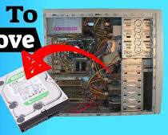
Step 7: Remove the Motherboard
Make sure every wire is unplugged from the board. Locate the screws holding the motherboard to the back wall of the case, unscrew them, and lift the board out safely by its edges.
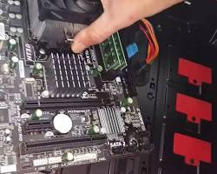
TASK-3
RAM & M.2 SSD (Outside Case): Click them onto the motherboard first. It is way easier to do on a flat table before the case gets crowded.
Motherboard (Into Case): Screw the board into the case to create the foundation for everything else.
Storage Drives: Mount your HDDs/SSDs into their bays so you don't accidentally drop them on delicate parts later.
All Internal Cables: Plug in the power supply cables and front-panel wires now. Why? If you install the giant graphics card first, it will completely block your hands from reaching the plugs.
Graphics Card (GPU): Click it into its slot last because it is the bulkiest item and takes up the most space.
Side Panel & Wall Power: Close the case and plug it into the wall. Never handle open, bare circuits while the PC is connected to electricity.

TASK-4
Essential Tools
- Phillips #2 Screwdriver (Magnetic): Fits 99% of PC screws. The magnet stops screws from dropping into dark, unreachable corners.
- Small Cups: Keeps different tiny screws organized so they don't roll off the table.
Core Safety Rules
- Unplug & Drain Power: Pull the wall plug and hold the PC power button for 10 seconds. This drains leftover electricity so you don't get shocked.
- Kill Static Electricity: Work on a wooden or plastic table—never on carpet. Touch the bare metal of the PC case frequently to discharge static that can fry sensitive chips.
- Hold Edges Only: Never touch the gold pins or green circuit boards. The natural oil on your fingers can ruin the connections.
- Don't Force It: PC parts are shaped to only fit one way. If a cable or stick won't slide in easily, stop—it is probably upside down or backwards.

