TASK-1
Testing a Desktop Power Supply: It measures the voltage on the cables to verify the motherboard is receiving the correct power to turn on.
Checking a Broken Charging Cable: It uses the "continuity" setting to see if the internal wires are snapped or if electricity can flow freely end-to-end.
Diagnosing a Dead Smartphone Battery: It reads the DC voltage directly from the battery contacts to confirm if it is completely dead or still holding a charge.
TASK-2
Here is a quick summary based on the short demo video:
The POST card is plugged into a motherboard's PCI slot, and once the system is turned on, its digital display cycles through different hexadecimal codes as the motherboard runs its self-test. The display eventually halts on the error code d5 d4, while the onboard LEDs indicate power status. By referencing this specific code, the technician could easily identify that the computer's memory (RAM) was not correctly seated in its slot, preventing the system from booting.
TASK-3
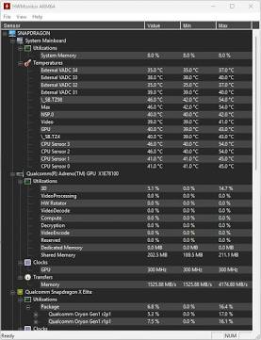
Download & Install: Get a free tool like HWMonitor from the official CPUID website.
Run: Open the application to view your live system health data, such as CPU and GPU temperatures, voltages, and fan speeds.
Screenshot: Press Win + Shift + S (on Windows) to capture the dashboard, making sure to select only the application window to keep your personal desktop background private.
TASK-4
Here is a quick comparison of the three diagnostic tools:
Tool | What it checks | Example Problem Detected
Multimeter | Electrical voltage and continuity (wiring) | Dead power supply or a broken charging cable
POST Card | Motherboard hardware communication during startup | RAM that is not correctly seated in its slot
Software Diagnostics | Live system health (temperatures, usage, speeds) | An overheating CPU or a failing hard drive

