TASK-1
- Dead Power Supply (PSU):

  - Symptom: The PC is completely unresponsive—no lights, no spinning fans, and pressing the power button does nothing.

- Faulty RAM (Memory):

  - Symptom: The computer turns on but gives a series of continuous beeping sounds, or randomly crashes to a "Blue Screen of Death."

- Failing Hard Drive (HDD/SSD):

  - Symptom: The PC takes an unusually long time to boot up, freezes frequently, or displays a "Boot device not found" error on startup.

- Overheating Processor (CPU):

  - Symptom: The computer suddenly shuts down completely without warning, especially when playing games or running heavy programs.

- Failing Graphics Card (GPU):

  - Symptom: You see strange colored dots, lines, or glitches (artifacts) on the monitor, or the screen goes totally black while the PC fans are still running.
TASK-2

1.Verify the Wall Outlet:
Plug a lamp or phone charger into the exact same wall outlet to ensure the socket itself is actually providing electricity.

2.Inspect the Charger and Cable:
Feel along the entire length of the power cable for any sharp bends, cuts, or exposed wires, and check the power brick for a burnt smell or melted plastic.

3.Examine the Laptop's Charging Port:
Look inside the port with a flashlight to see if there is any trapped dust, lint, or a bent center pin that is preventing a solid connection.

4.Test with a Multimeter:Requires a basic multimeter tool.
Set your multimeter to DC voltage, place the probes inside and outside the charger's plug, and verify if it is outputting the correct voltage listed on the power brick.

5.Perform a Hard Power Reset:
Unplug the charger, remove the laptop battery (if it is removable), and hold the power button down for 30-60 seconds to drain any residual static charge before putting it back together.

TASK-3
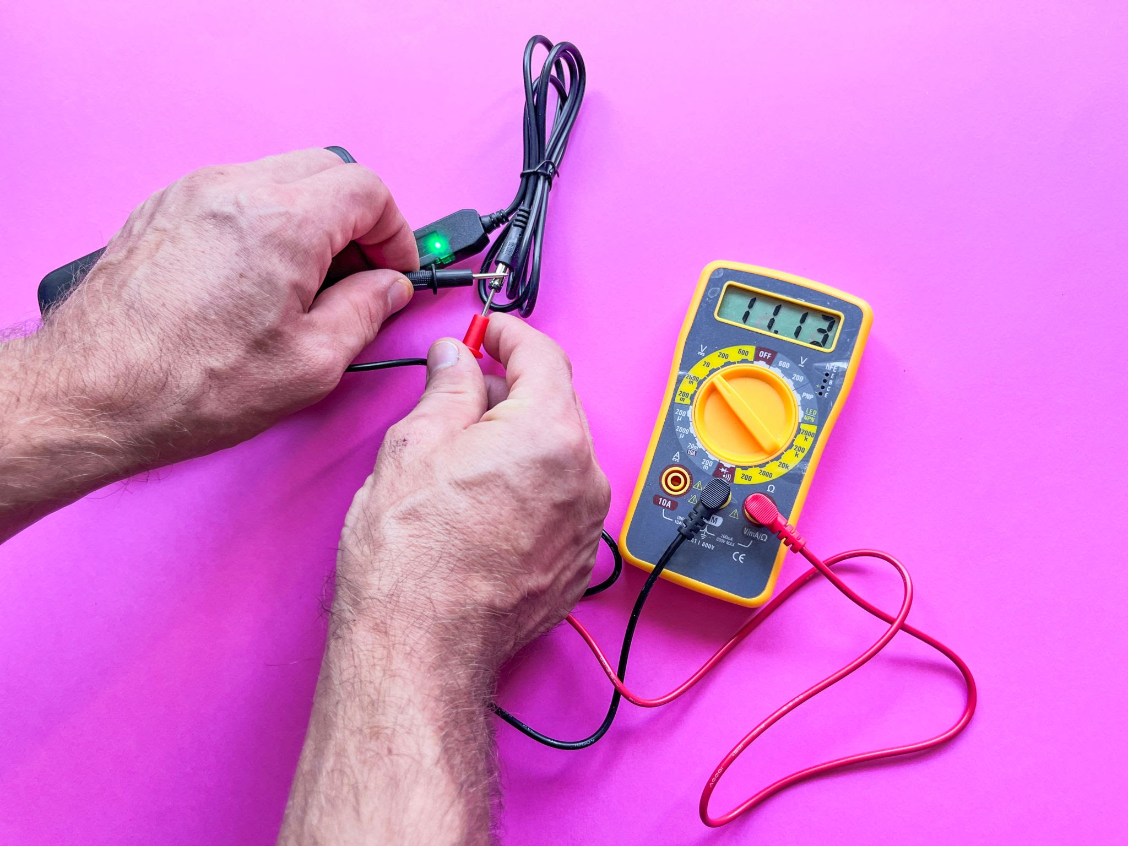
Measured Voltage: 5.06V DC
Status: Normal (Pass)
TASK-4
Here is how to test the 12V rail on a disconnected power supply:

1.Set the Multimeter:
Turn your multimeter dial to DC Voltage (often marked as 20V DC).

2.Place the Black Probe:
Insert the black (negative) probe into any pin hole containing a black wire (Ground).

3.Place the Red Probe:
Insert the red (positive) probe into any pin hole containing a yellow wire (+12V rail).

4.Read the Display:
Check the screen for the voltage output while the power supply is running.

Simulated Result & Meaning:

- Measured Voltage: 11.2V

- What it indicates: A reading below 11.5V means you have a failing Power Supply Unit (PSU). It is struggling to deliver enough stable power to the motherboard, causing the PC to randomly shut down to protect itself.

