TASK-1 GPU IDENTIFY
Brand: Intel
Model Number: Iris Xe
Type: Integrated

TASK-2
The Heatsink (The Sponge): A chunky block of metal that sits directly on the computer's brain (the CPU). Its only job is to soak up all the heat the brain generates.

The CPU Fan (The Cooler): A fan attached directly to the heatsink. It blows air forcefully through the hot metal to cool it down quickly.

The Case Fans (The Movers): * Intake Fans: Suck fresh, cool air from your room into the computer case.

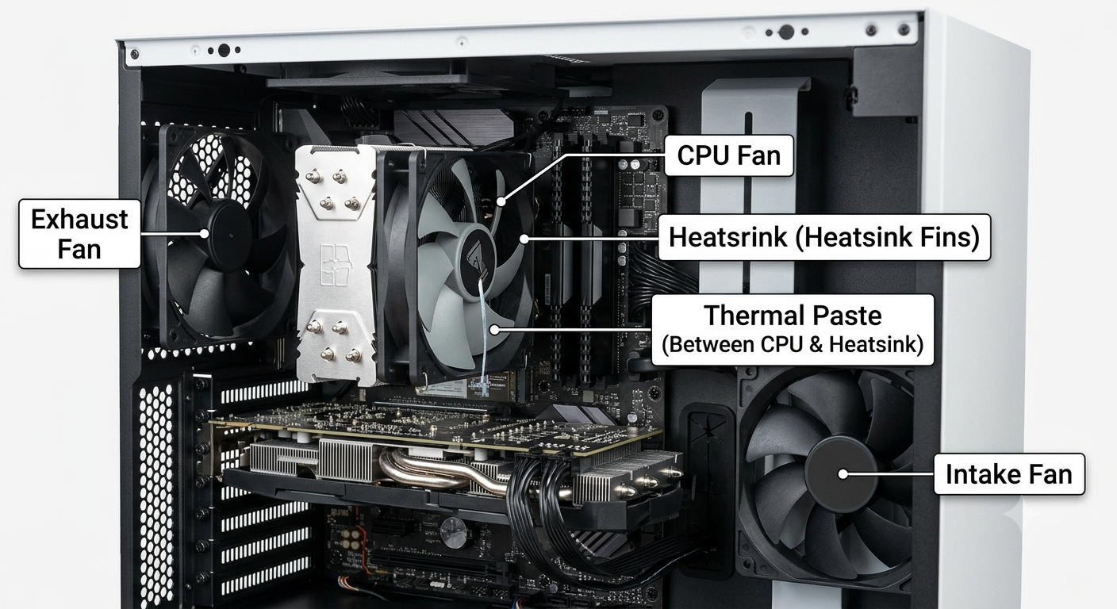
TASK-3
Feature | Air Cooling (Fans) | Liquid Cooling (Water)
Cost | Low (Budget-friendly) | High (Premium)
Efficiency | Standard | High (Best for heavy tasks)
Maintenance | Easy (Just dust it off) | Advanced (Check for leaks)

TASK-4
For a heavy-duty gaming and streaming PC, liquid cooling is the better choice.
- Why: It keeps your GPU much cooler during long, intense gaming or streaming sessions.
- Result: This keeps your game running smoothly without overheating and keeps your PC very quiet, so the fans don't ruin your stream audio.
It’s worth the extra cost because it protects your expensive parts and improves your streaming quality.

