ENGE707 Assessment 3 — Individual Technical Report
Facial Feature Classification Challenge:
A Deep Learning Pipeline for Cat and Dog Facial-Part Recognition

Student: Manav Sandhu
Kaggle username: Manav Sandhu x
Competition: ENGE707-2026-S2: Facial Feature Classification Challenge
Best public leaderboard score: 0.9782 (accuracy)
Code: github.com/manavsandhu555-spec/Kaggle_Comp

Auckland University of Technology — Semester 2, 2026
Word count: approx. 3,030 (Sections 1–10 main text; 3,180 including the abstract; excluding tables, captions, references and appendix)

Contents

Abstract
This report describes a complete deep learning pipeline for the ENGE707-2026-S2 Kaggle competition, an eight-class image classification task in which close-up crops of cat and dog faces must be labelled as CatEye, DogEye, CatFace, DogFace, CatMouth, DogMouth, CatNose or DogNose. The 63,660 labelled training images were explored, cleaned and split with a stratified, duplicate-aware strategy. Four controlled experiments were run: a custom CNN trained from scratch, a frozen ImageNet-pretrained EfficientNet-B0, and EfficientNet-B0 fine-tuned with and without augmentation. The best single model reached 99.60% validation accuracy (macro-F1 0.996) but only 0.9749 on the public leaderboard. Analysis traced this gap to an optimistic validation split and a crop-shape shortcut that does not transfer to the test set. A second round favouring robustness (augmentation with aspect-ratio jitter, a ConvNeXt-Tiny model trained with test-like augmentation, and probability-averaging ensembles) raised the public score to 0.9782. The report closes with an analysis of errors, the limitations of the solution and realistic improvement strategies.

1. Introduction and Problem Definition
The task is single-label, multi-class image classification. Each image shows one facial region of a cat or a dog, and the model must predict exactly one of eight classes. The label combines two factors, the species (cat or dog) and the facial part (eye, face, mouth or nose), so errors can be species errors (for example CatNose predicted as DogNose) or part errors (DogNose predicted as DogMouth). This structure was used throughout the analysis.
Kaggle scores submissions on a hidden test set of 29,443 images. The public leaderboard metric is accuracy (the proportion of correctly classified images). Because the grade depends on the pipeline as much as on the score, the work was organised as a reproducible workflow that follows the six assessment tasks: data exploration, preprocessing, model selection, training and overfitting management, evaluation with Kaggle submission, and analysis with improvement strategies. All code is in a Jupyter notebook (facial_feature_classification.ipynb), a second notebook for the improvement round (improve_score.ipynb) and a helper module (ffc_lib.py), version-controlled on GitHub (Appendix A).

2. Dataset Exploration and Understanding (Task 1)

2.1 Structure of the data
The competition archive (about 1 GB) contains a train/train folder with 63,660 JPEG images, a test/test folder with 29,443 JPEG images, a train_labels.csv file mapping a zero-padded image_id (for example 00001) to a class name, and a sample_submission.csv with the columns image_id and class. The sample submission writes ids without zero padding (1, 2, 3, …), so a normalised id (the integer value of the file stem) was used to match predictions to rows. Every image is an RGB JPEG and no file was corrupt or truncated.

2.2 Class distribution and balance
Table 1. Number of training images per class.
Class | Images | % | Class | Images | %
CatEye | 13,884 | 21.8 | DogEye | 11,580 | 18.2
CatFace | 6,942 | 10.9 | DogFace | 5,790 | 9.1
CatMouth | 6,942 | 10.9 | DogMouth | 5,790 | 9.1
CatNose | 6,942 | 10.9 | DogNose | 5,790 | 9.1

The dataset is mildly imbalanced: the largest class (CatEye) is 2.40 times the size of the smallest (DogFace, DogMouth and DogNose). The counts reveal how the data was generated. Each Eye class has exactly twice as many images as the other classes of the same species, and the three remaining classes of each species have identical counts. Every animal face was therefore cut into one face, two eye, one mouth and one nose crop (6,942 cat faces and 5,790 dog faces). Because the imbalance is structural and the test set was almost certainly generated the same way, the natural class prior was kept and no class re-weighting was used. Macro-F1 was reported alongside accuracy so minority classes were not hidden (Figure 1).
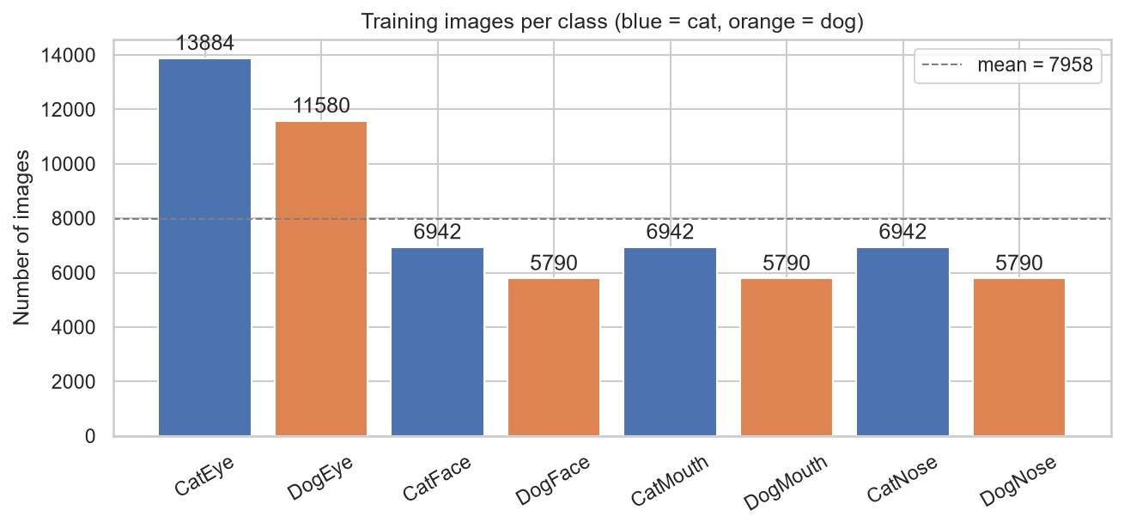
Figure 1. Training images per class (blue = cat, orange = dog).
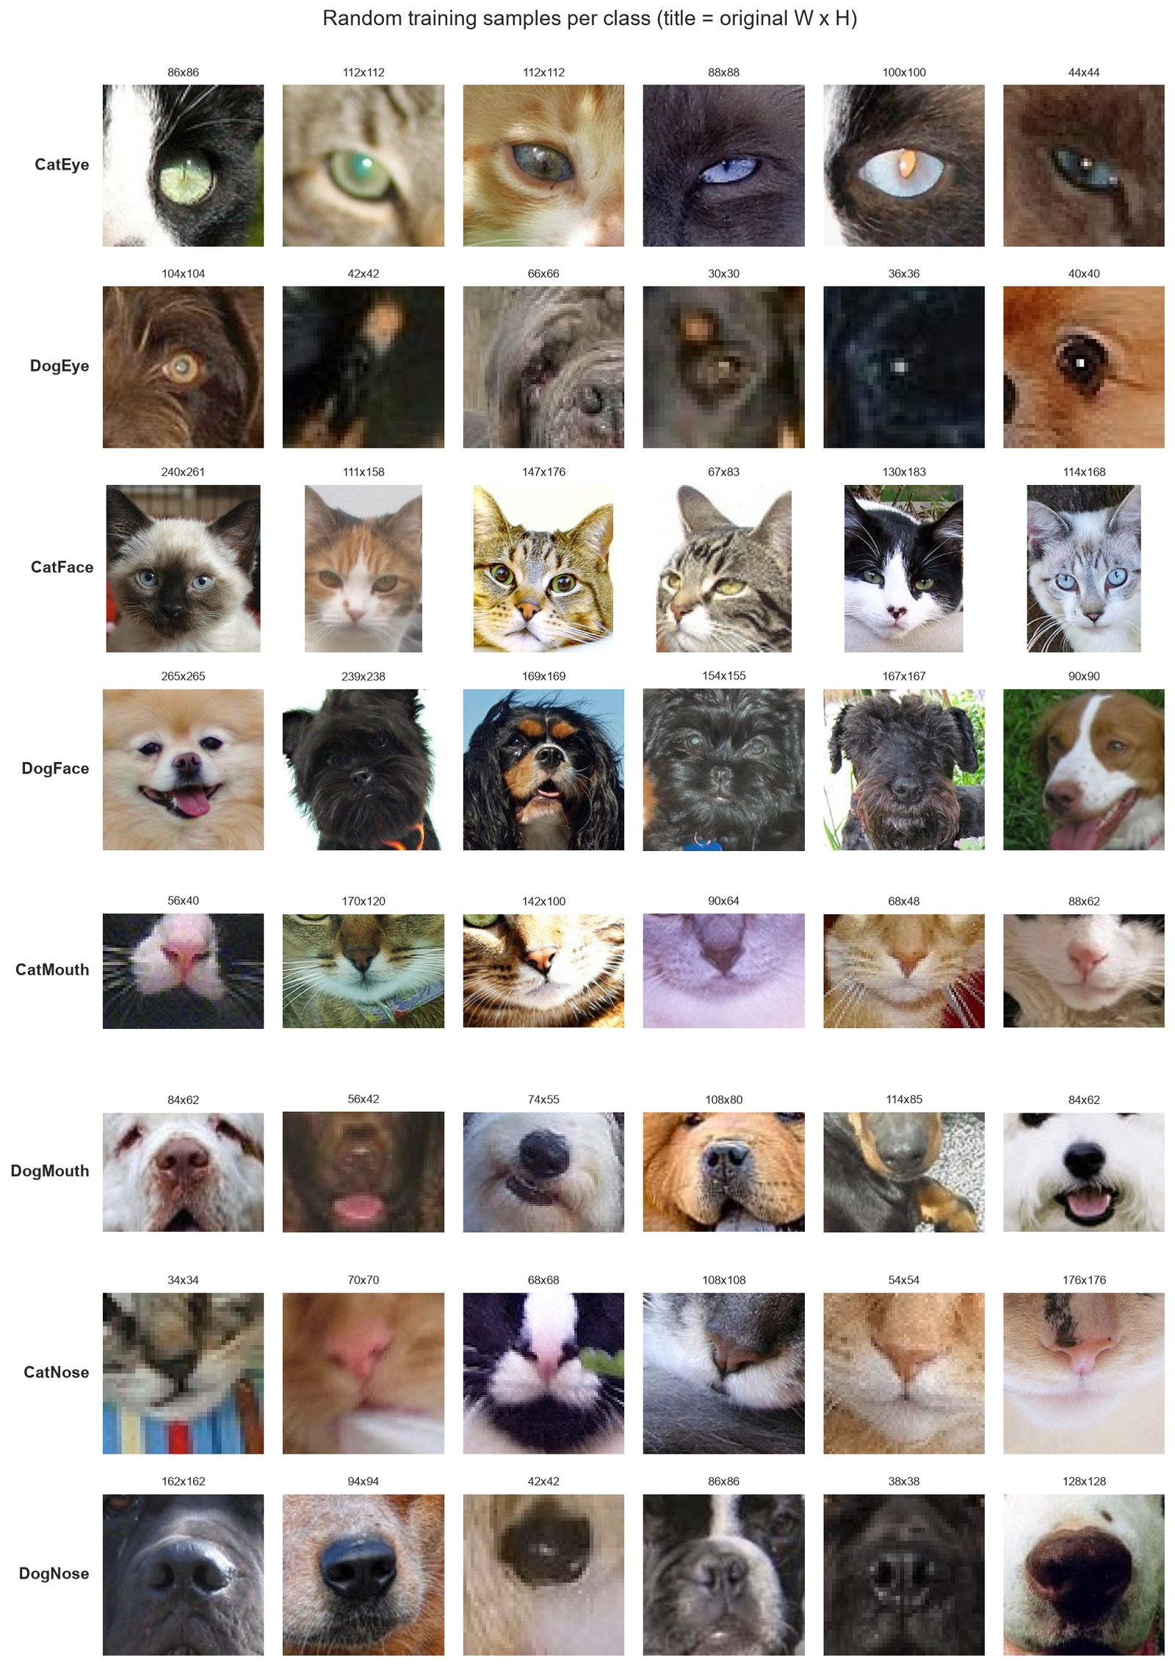
Figure 2. Random training samples for each class, with original width × height.

2.3 Data quality issues
Each of the 93,103 images was opened once to record its size, colour mode, an MD5 hash (exact duplicates), a 64-bit perceptual difference hash or dHash (near-duplicates; Krawetz, 2013), a blur score given by the variance of the Laplacian (Pech-Pacheco et al., 2000) and the mean brightness. The main findings were:
- Inconsistent and very small images. There were 14,347 distinct sizes, from 4 × 4 to 2,219 × 2,219 pixels, with a median of 84 × 80. Of the training images, 37% are smaller than 64 pixels on at least one side and 6.5% smaller than 32 pixels (Figure 3). Many crops are heavily pixelated (Figure 2).
- Blur and lighting. Sharpness varies by two orders of magnitude, and dog crops are on average blurrier than cat crops (median Laplacian variance about 900 versus 1,300–2,200). Some images are almost black.
- Duplicates. There were 15 groups of byte-identical training images (30 files), none with conflicting labels, and no exact overlap between training and test. The perceptual hash grouped 777 visually similar images into 325 groups, 33 of them with mixed labels. Visual inspection showed these were mostly similar-looking crops rather than true copies, such as a mouth crop and a nose crop of the same muzzle (Figure 4), which shows that class boundaries are unclear between neighbouring parts.
- Crop geometry. Eye and nose crops are almost always exactly square (99%), mouth crops are always landscape (median aspect ratio 1.4), cat faces are portrait and dog faces are mixed. Shape alone therefore partly identifies the class. Crucially, 65.5% of training crops are exactly square but only 32.8% of test crops are, which means the test set's crop geometry differs from the training set's.
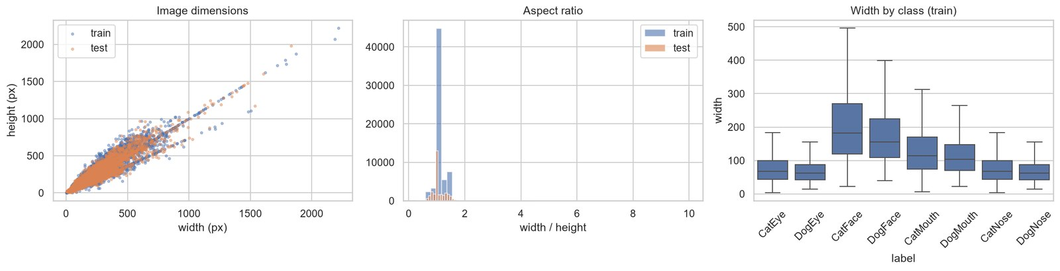
Figure 3. Image dimensions, aspect ratios (train vs test) and width per class.
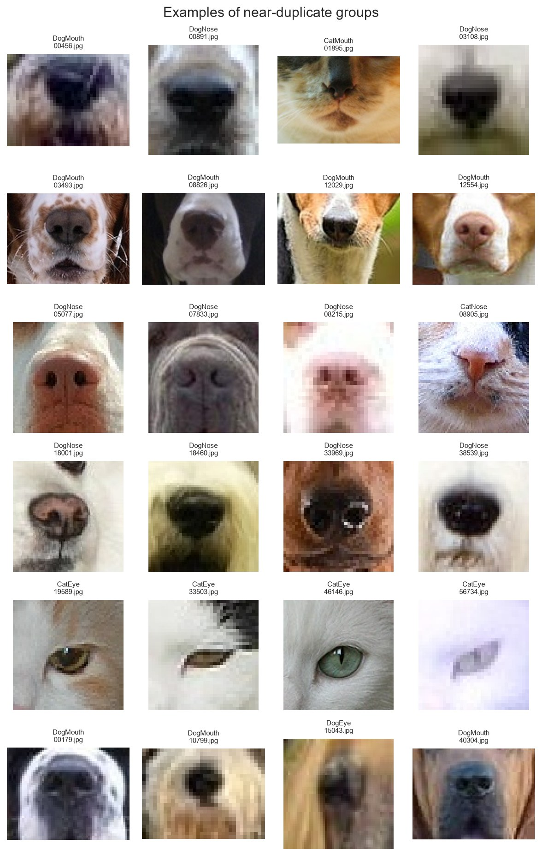
Figure 4. Examples of near-duplicate groups found by the perceptual hash; mouth and nose crops of the same muzzle look very similar.

2.4 How the data was used
Corrupt files (none) and the 15 redundant exact duplicates were removed, leaving 63,645 images. These were split 80/20 into 50,916 training and 12,729 validation images with StratifiedGroupKFold (Pedregosa et al., 2011). Stratification keeps the class proportions identical in both parts. Grouping by perceptual-hash cluster ensures that near-identical copies cannot appear on both sides, which would leak information (Kaufman et al., 2012). The validation split was used only for early stopping, model selection and reporting, and the test images were used only to produce the submission files.

3. Data Preprocessing and Pipeline (Task 2)
- Resizing: every image is converted to RGB and resized to 224 × 224 pixels with bicubic interpolation, the resolution at which the ImageNet-pretrained backbones were trained (Deng et al., 2009). A fixed size is required to batch images of different sizes.
- Normalisation: pixels are rescaled from [0, 255] to [0, 1] and normalised with the ImageNet channel mean and standard deviation, the input distribution the pretrained weights expect.
- Label encoding: class names are mapped to integers 0–7 in a fixed order, saved to label_map.json and decoded back to names when the submission is written.
- Augmentation (training only): a random resized crop (75–100% of the area, aspect ratio 0.75–1.33), horizontal flip, rotation of ±15°, colour jitter, 5% greyscale and random erasing (Zhong et al., 2020). These are label-preserving: a flipped or re-lit cat eye is still a cat eye. Vertical flips were excluded because upside-down faces do not occur. The aspect-ratio jitter was added specifically after the crop-shape analysis in Section 2.3.
- Consistency: validation and test images use the same deterministic transform (resize + normalise), so they are preprocessed identically.
- Data loaders: a PyTorch Dataset reads images from disk and DataLoaders feed batches with four worker processes, pinned memory and seeded workers. The Dataset lives in ffc_lib.py because Windows starts worker processes by re-importing code, which fails for classes defined inside a notebook.
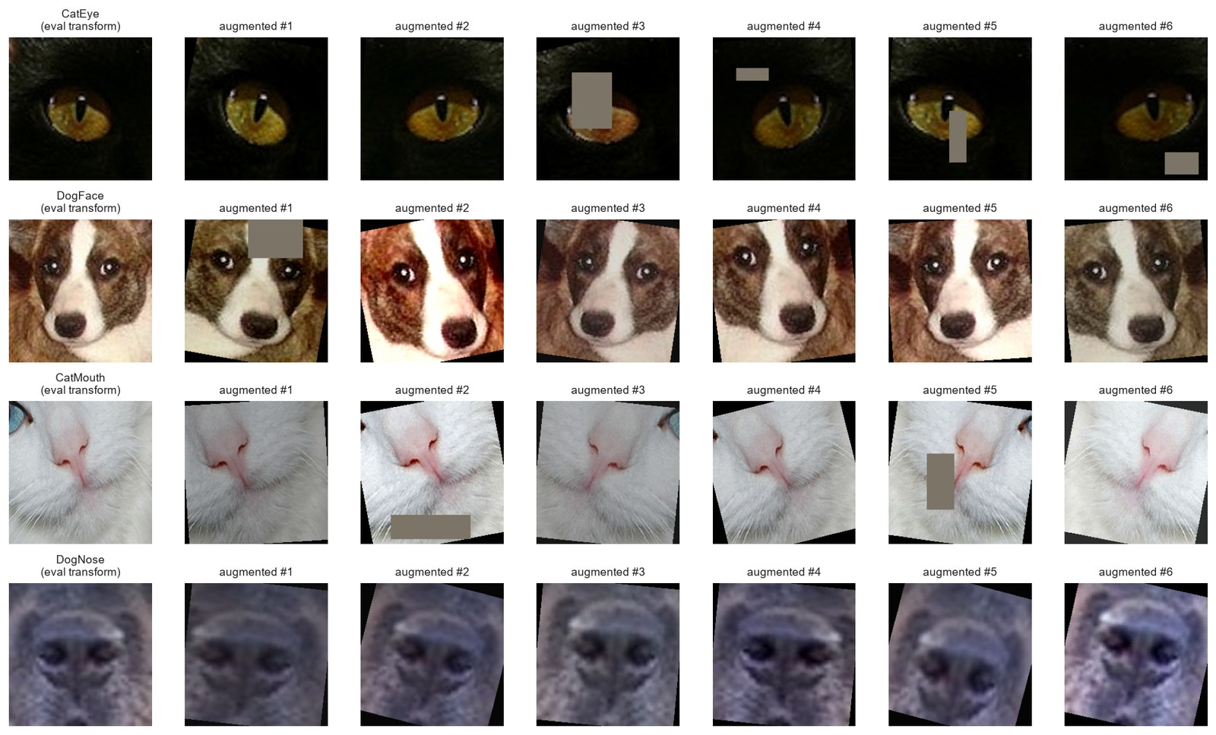
Figure 5. Evaluation transform (left) and six random training augmentations per image.
Choosing 224 pixels means most images are enlarged, because the median crop is only about 84 pixels wide. A smaller input such as 128 pixels would have trained faster and been closer to the native resolution. However, the pretrained filters respond best to objects at the scale seen during ImageNet training, and larger inputs keep more spatial resolution in the final feature maps (7 × 7 instead of 4 × 4), which matters for small structures such as pupils and nostrils. Bicubic interpolation was used because it produces smoother enlargements than bilinear interpolation. Non-square crops are stretched to a square, which deliberately preserves the whole crop rather than cutting off part of a mouth or face, at the cost of distortion that Section 8 shows can become a shortcut.
Reproducibility was ensured by fixing the random seed (42) for Python, NumPy and PyTorch, using deterministic cuDNN, saving the train and validation splits to CSV, caching the image statistics and logging every experiment's history and summary to disk.

4. Model Selection and Architecture (Task 3)
Main model: EfficientNet-B0 with transfer learning (Tan & Le, 2019), loaded through the timm library (Wightman, 2019) with ImageNet weights. Transfer learning was chosen because ImageNet contains many cats and dogs, so pretrained filters for fur, eyes and snouts are directly useful and converge far faster than features learned from scratch (Yosinski et al., 2014). EfficientNet-B0 offers a strong accuracy-to-cost ratio (about 4.0 million parameters with an 8-class head), which suits a laptop GPU.
The network consists of a 3 × 3 convolutional stem and 16 MBConv blocks, which are inverted-residual bottlenecks with depthwise convolutions (Sandler et al., 2018) and squeeze-and-excitation channel attention (Hu et al., 2018). A 1 × 1 convolution expands to 1,280 channels, followed by global average pooling, dropout (p = 0.3) and a fully connected output layer of 8 units. The 8 logits are converted to class probabilities with softmax, which is applied inside the cross-entropy loss during training and explicitly at prediction time. Stochastic depth of 0.1 (Huang et al., 2016) regularises the residual blocks.
Table 2. Main training configuration and justification.
Setting | Value | Justification
Input size | 224 × 224 × 3 | Native resolution of the pretrained weights
Output layer | Linear(1280 → 8) + softmax | One output per mutually exclusive class
Loss | Cross-entropy, label smoothing 0.1 | Standard multi-class loss; smoothing curbs over-confidence (Szegedy et al., 2016)
Optimiser | AdamW, weight decay 0.05 | Adaptive steps with decoupled L2 regularisation (Loshchilov & Hutter, 2019)
Learning rate | Head 1e-3, backbone 1e-4; 1-epoch warm-up then cosine decay | Small backbone LR protects pretrained features (Loshchilov & Hutter, 2017)
Batch size | 64 | Chosen automatically because the GPU has ≥ 7.5 GB of memory
Epochs | Up to 15, early stopping (patience 4) | The best checkpoint by validation loss is kept
Other | Mixed precision, gradient clipping (norm 2) | Speed and stability (Micikevicius et al., 2018)

To justify these choices with evidence, the same pipeline trained three comparison models, changing one factor at a time: E1, a custom CNN trained from scratch (four Conv–BN–ReLU blocks with eight convolutions, 1.18 million parameters); E2, EfficientNet-B0 with a frozen backbone, where only the head is trained (feature extraction); and E3, full fine-tuning without augmentation or label smoothing. E4 is the full recipe in Table 2. The pipeline was implemented in PyTorch (Paszke et al., 2019) and torchvision, and it writes predictions for the test set in the required Kaggle format.

5. Training Strategy and Overfitting/Underfitting (Task 4)
All models were trained on the 50,916-image training split and evaluated on the validation split after every epoch. Training loss and accuracy were recorded on augmented images with dropout active, while validation used clean images. This is why a well-regularised model can show validation accuracy above training accuracy. Figure 6 shows the learning curves and Table 3 summarises each model's fit.
Training ran on a laptop NVIDIA GPU with mixed precision. One epoch of EfficientNet-B0 took about 2 minutes, compared with 2.5 minutes for the custom CNN, whose full-resolution convolutions require more floating-point operations than EfficientNet's depthwise layers. Epoch budgets were set from the dataset size: with about 800 batches per epoch, a pretrained network converges in a few epochs, so 12–15 epochs with early stopping were enough for fine-tuning, while the frozen model was given only 6 because just its head could learn. The 1-epoch warm-up prevented large early updates from damaging the pretrained weights while the randomly initialised head was still producing noisy gradients.
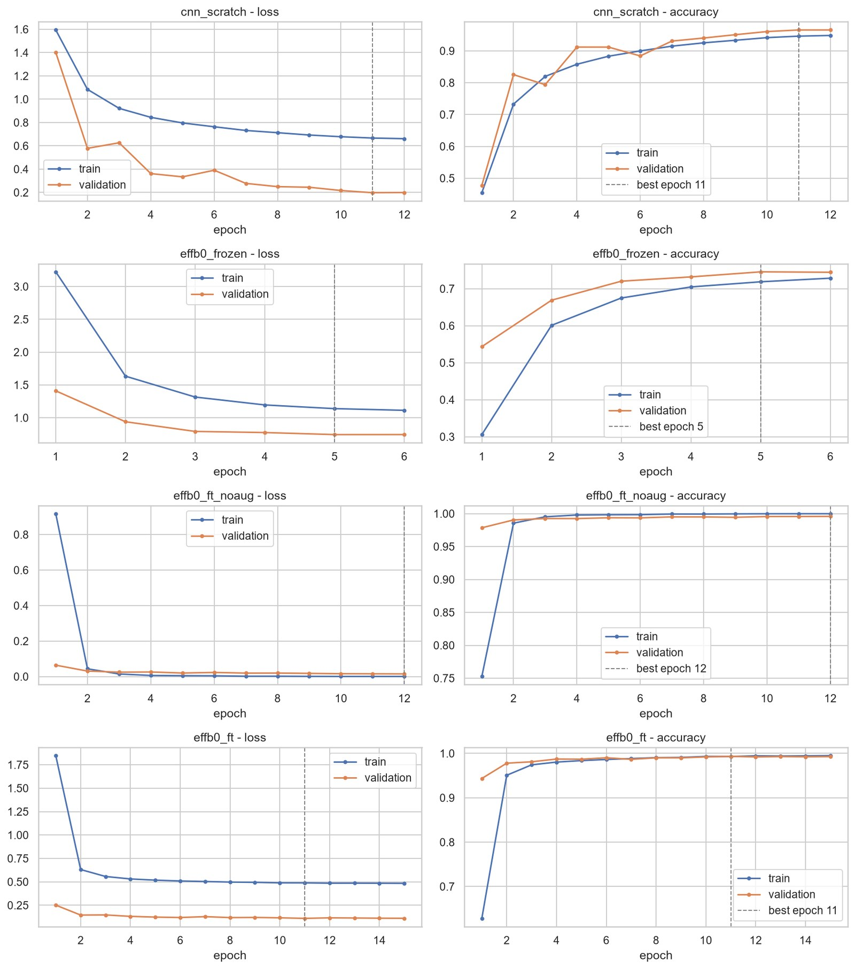
Figure 6. Training and validation loss and accuracy for E1–E4 (dashed line = best epoch).
Table 3. Fit diagnosis at the best epoch (by validation loss).
Model | Best epoch / run | Train acc | Val acc | Diagnosis
E1 CNN from scratch | 11 / 12 | 0.946 | 0.966 | Still improving: slight underfitting, would gain from more epochs
E2 EffB0 frozen | 5 / 6 | 0.719 | 0.746 | Clear underfitting: frozen ImageNet features cannot separate the classes
E3 EffB0 fine-tuned, no aug | 12 / 12 | 0.9998 | 0.996 | Memorises training set (train loss 0.0005 vs val 0.015)
E4 EffB0 fine-tuned + aug | 11 / 15 | 0.993 | 0.993 | Good fit, small gap; early stopping caught the optimum

Underfitting was visible in E2: both losses stayed high (training 1.11, validation 0.74) because only the 10,000 head parameters could adapt. Unfreezing the backbone (E3/E4) solved this immediately, with validation accuracy above 97.8% after a single epoch. E1 underfitted mildly: its accuracy was still rising at epoch 12, and it reached 96.6% only after 30 minutes of training, which shows the cost of learning features from scratch.
Overfitting was most visible in E3. Without augmentation, training accuracy reached 99.98% and training loss fell to 0.0005, about 30 times below the validation loss. Validation accuracy did not collapse, but the model had clearly memorised the training images. E4 added augmentation, label smoothing, dropout and stochastic depth, which kept training and validation accuracy within 0.2 points of each other. Its higher absolute validation loss (0.11) is an artefact of label smoothing, which prevents fully confident probabilities. Other strategies applied to every model were weight decay, batch normalisation (Ioffe & Szegedy, 2015), warm-up with cosine learning-rate decay, gradient clipping, early stopping and best-checkpoint restoration. The change from E3 to E4 was justified by robustness rather than by validation score, a decision confirmed on Kaggle (Section 7).

6. Model Evaluation (Task 5)
Table 4. Validation results (12,729 images). TTA = averaging the predictions for the original and horizontally flipped image.
Model | Params | Train time | Val loss | Val acc | Macro-F1 | Val acc (TTA)
E1 CNN scratch | 1.18 M | 30.5 min | 0.198 | 0.9656 | 0.9617 | 0.9669
E2 EffB0 frozen | 4.02 M | 9.6 min | 0.743 | 0.7457 | 0.7180 | 0.7576
E3 EffB0 no aug | 4.02 M | 24.6 min | 0.015 | 0.9958 | 0.9959 | 0.9960
E4 EffB0 + aug | 4.02 M | 31.6 min | 0.110 | 0.9933 | 0.9927 | 0.9934

Several metrics were used because each answers a different question. Accuracy matches the Kaggle metric. Macro-F1 averages the F1-score of the eight classes equally, so a weakness on a smaller dog class cannot be hidden by the large eye classes. Validation loss (unsmoothed cross-entropy) measures calibration as well as correctness, and the confusion matrix and per-class precision and recall locate the errors. The model-selection rule was fixed before the results were seen to avoid choosing models by hindsight. The validation set was evaluated once per model with and without test-time augmentation.
By the rule fixed before training (highest validation macro-F1 with TTA), E3 was selected: validation loss 0.0144, accuracy 99.60% and macro-F1 0.9961, with 51 errors out of 12,729. Per-class precision and recall were all between 0.991 and 1.000 (Table 5). Face classes were almost perfect, and the weakest classes were CatNose and DogNose (recall 0.991–0.992). The confusion matrix (Figure 7) shows that errors were concentrated in CatEye↔DogEye (14) and in the nose/mouth/eye pairs within a species.
Table 5. Per-class validation metrics of E3 with TTA.
Class | Precision | Recall | F1 | Support
CatEye | 0.9957 | 0.9960 | 0.9959 | 2,776
DogEye | 0.9940 | 0.9961 | 0.9950 | 2,316
CatFace | 1.0000 | 0.9993 | 0.9996 | 1,388
DogFace | 0.9991 | 1.0000 | 0.9996 | 1,157
CatMouth | 0.9950 | 0.9957 | 0.9953 | 1,388
DogMouth | 0.9948 | 0.9974 | 0.9961 | 1,158
CatNose | 0.9957 | 0.9914 | 0.9935 | 1,388
DogNose | 0.9957 | 0.9922 | 0.9939 | 1,158

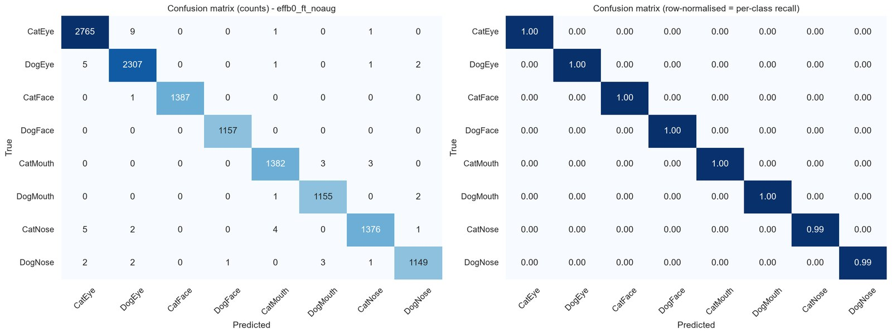
Figure 7. Validation confusion matrix of E3 (counts and row-normalised).

7. Kaggle Submission and Leaderboard Results
Predictions for the 29,443 test images were written in exactly the format of sample_submission.csv (same ids, order and columns), validated programmatically and uploaded through the competition page under the Kaggle username Manav Sandhu x. Table 6 lists every submission and Figures 8–10 provide the evidence.
Each submission file was generated by the notebook rather than edited by hand. The test images were passed through the same evaluation transform as validation, softmax probabilities were averaged over the original and horizontally flipped image, and the class with the highest probability was written as a class name. Assertions checked that the file had 29,443 rows, the ids matched the sample submission exactly and in the same order, and every label was one of the eight valid classes. For ensembles, the saved test probabilities of each model were averaged with equal weights before taking the arg-max, and the probabilities were stored as .npy files so ensembles could be rebuilt without re-running inference. Kaggle allows three submissions per day, so each submission was chosen to test a specific hypothesis: the selected model, then the more robust model, then the ensemble.
Table 6. Kaggle submissions (public leaderboard, accuracy).
Submission file | Model | Val acc | Public score
submission.csv | E3 EffB0 no aug + TTA | 0.9960 | 0.9749
submission_effb0_ft.csv | E4 EffB0 + aug + label smoothing + TTA | 0.9934 | 0.9758
submission_ens_cnx_e4_e3.csv | Average of ConvNeXt-T + E4 + E3 (TTA) | 0.9959 | 0.9782 (best)


Figure 8. First submission (E3): public score 0.9749.
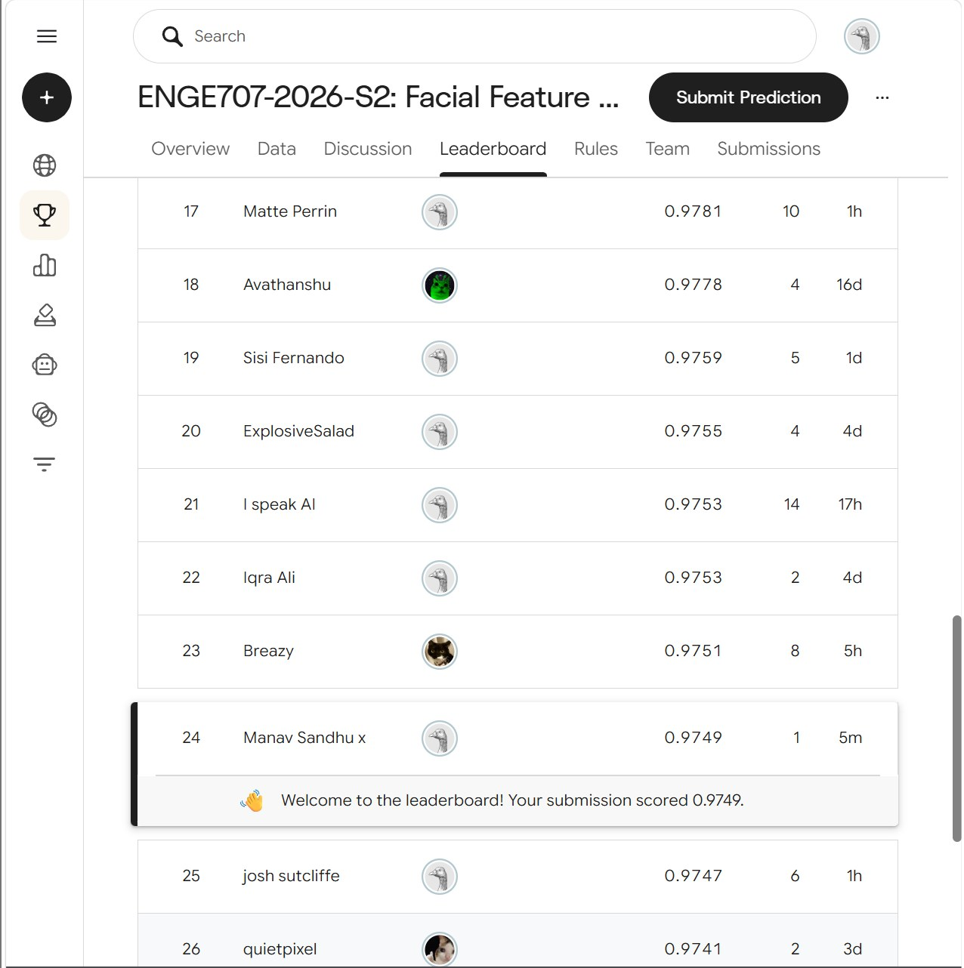
Figure 9. Public leaderboard after the first submission (user Manav Sandhu x, rank 24).

Figure 10a. Second submission (E4): 0.9758.
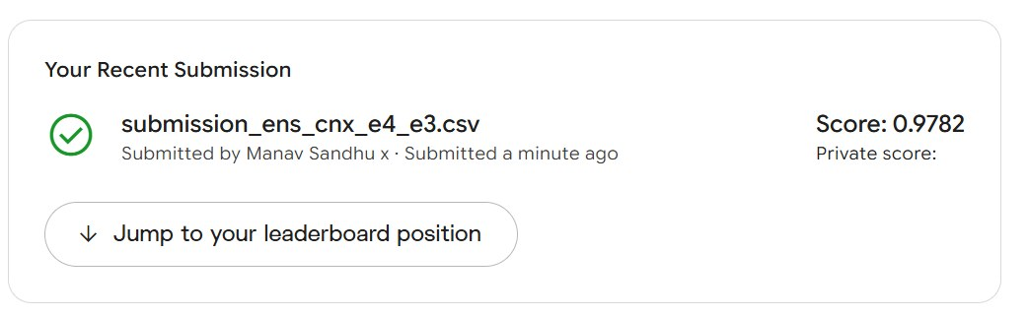
Figure 10b. Third submission (ensemble): 0.9782, the best result.
Validation versus leaderboard. The first submission scored 2.1 points below its validation accuracy (0.9749 vs 0.9960), so validation overestimated generalisation. More tellingly, the ranking reversed: E3, the best model on validation, was the worst on Kaggle, while E4, with lower validation accuracy, scored higher. Section 8 explains why.

8. Results Analysis (Task 6)

8.1 Common misclassifications
Of E3's 51 validation errors, 20 were species-only errors (mostly CatEye↔DogEye), 24 were part-only errors (CatNose→CatEye, CatNose↔CatMouth, DogNose↔DogMouth) and 7 were wrong on both. Figure 11 shows the most confident errors. They are dominated by tiny, heavily pixelated or very dark crops, and several are arguably mislabelled or ambiguous (a green object labelled CatNose, an all-black CatMouth). One third of the errors were made with more than 90% confidence, which is consistent with label noise rather than model uncertainty.
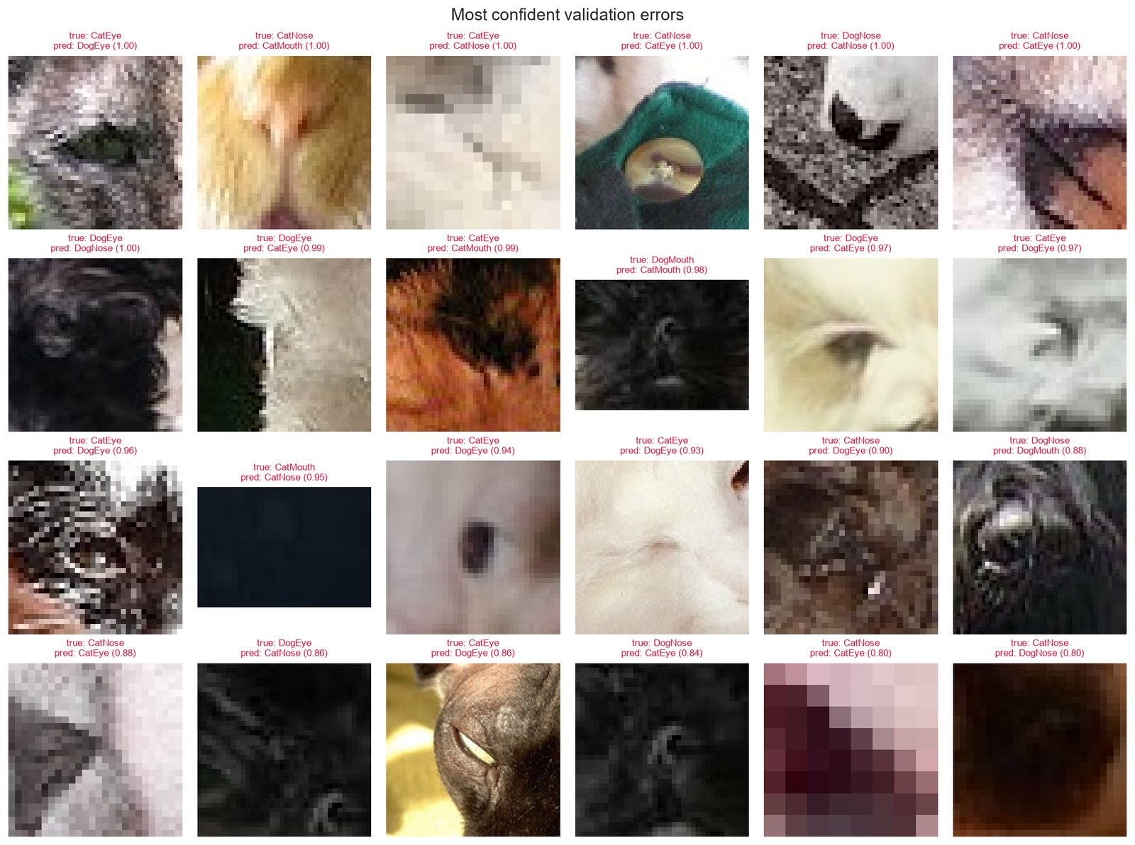
Figure 11. Most confident validation errors (true label, prediction and confidence).
Image quality strongly drives errors. The median width of misclassified images is 42 pixels, half the dataset median. Accuracy is 98.99% for the smallest quarter of images (median width 40 px) against 99.91% for the third quarter (Figure 12). Grad-CAM heat maps (Selvaraju et al., 2017) show that the model looks at the correct region in most errors (the pupil, the nostrils). The image simply lacks the detail needed to tell, for example, a cat's slit pupil from a dog's round one (Figure 13).
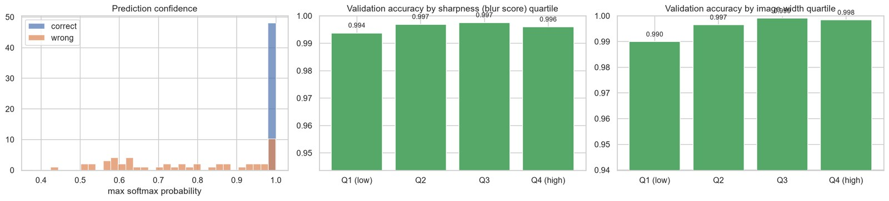
Figure 12. Prediction confidence and accuracy by image-width and sharpness quartile.
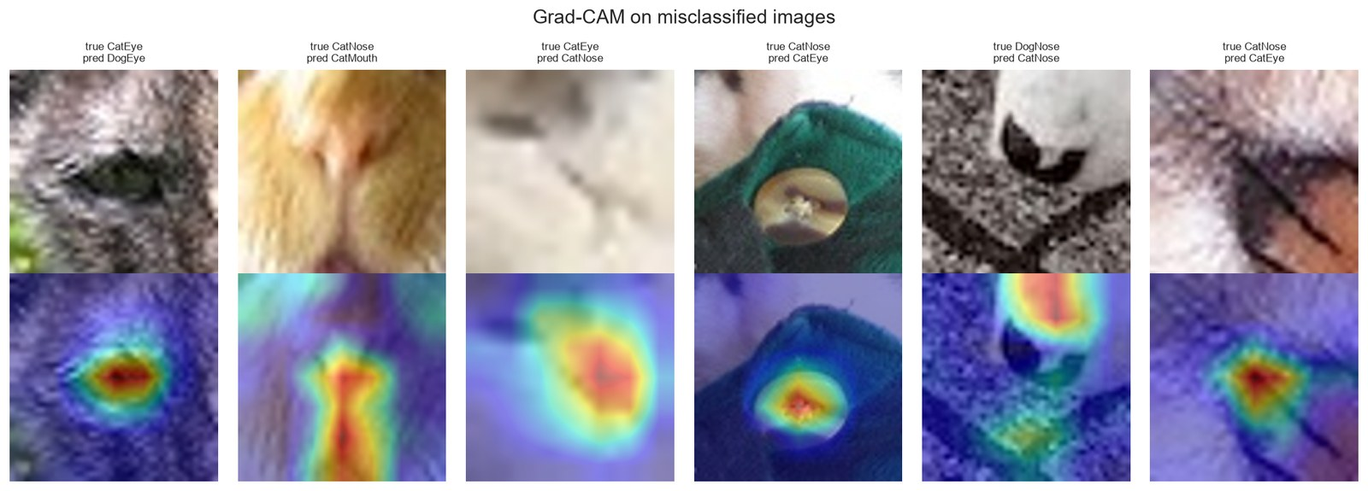
Figure 13. Grad-CAM on misclassified validation images.

8.2 Why validation over-estimated the test score
Two mechanisms explain the gap. First, the ids are shuffled and there is no source-photo identifier, so crops of the same animal (its eyes, nose and face) fall in both the training and validation splits. Validation therefore partly rewards recognising animals already seen, which is a form of leakage the duplicate grouping could not detect (Kaufman et al., 2012). The test set contains new animals. Second, the crop-geometry shift (65.5% square training crops versus 32.8% in test) lets a model learn the shortcut that square crops are eyes or noses and wide crops are mouths (Geirhos et al., 2020). Evidence for this shortcut came from comparing test predictions: E4 changed 807 of E3's test predictions (2.7%), 240 of them from CatNose to CatMouth and 173 between DogNose and DogMouth, exactly the nose/mouth boundary where shape differs. E3, trained without aspect-ratio jitter, relied on shape most strongly and generalised worst.

8.3 Effectiveness of the choices
- Transfer learning versus scratch: fine-tuned EfficientNet-B0 beat the custom CNN by 3 points of validation accuracy in a similar training time.
- Frozen versus fine-tuned: freezing cost 25 points. Close-up, low-resolution facial parts differ too much from ImageNet object images for frozen features to work.
- Augmentation and label smoothing: these lowered validation accuracy slightly (−0.26 points) but improved the Kaggle score (+0.09 points) and closed the train/validation gap, which shows that validation alone was not a reliable guide.
- Test-time augmentation: horizontal-flip averaging added 0.01–0.12 points on validation for every model at no training cost.
- Ensembling: averaging ConvNeXt, E4 and E3 gave the best leaderboard score (0.9782), because models that disagree on 1–3% of images correct some of each other's mistakes (Dietterich, 2000).

8.4 Second-round experiment: ConvNeXt-Tiny with test-like augmentation
A ConvNeXt-Tiny backbone pretrained on ImageNet-22k (Liu et al., 2022) was trained for 8 epochs with heavier augmentation designed to mimic the test set: random down-scaling and pixelation (to simulate tiny crops), random crops with 55–100% of the area and aspect ratio 0.6–1.67, stronger colour jitter, Gaussian blur and random erasing (Figure 14). It reached only 97.85% validation accuracy and its curve was unstable (Figure 15), because training accuracy under such strong augmentation was still 97.6% after 8 epochs. The model underfitted and needed a longer schedule. Its predictions were nevertheless different enough to improve the ensemble.
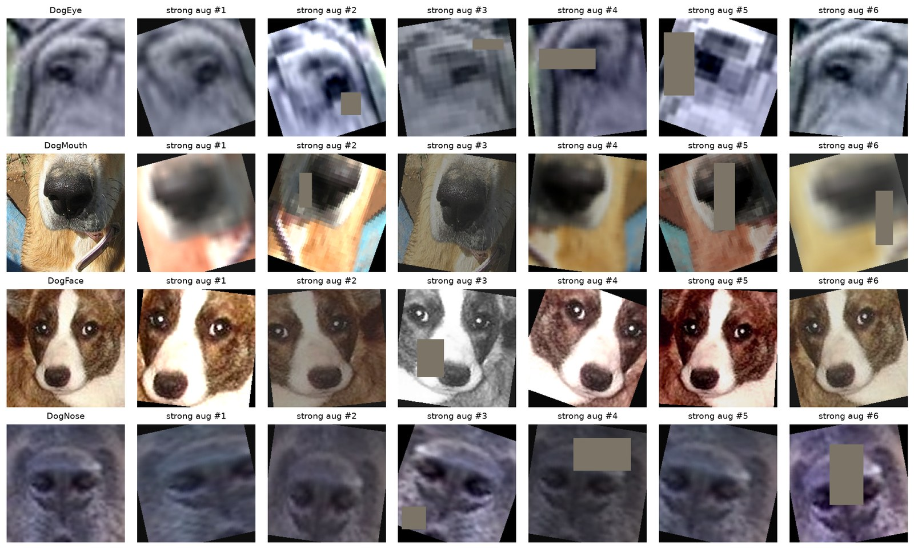
Figure 14. Test-like strong augmentation used for ConvNeXt-Tiny.
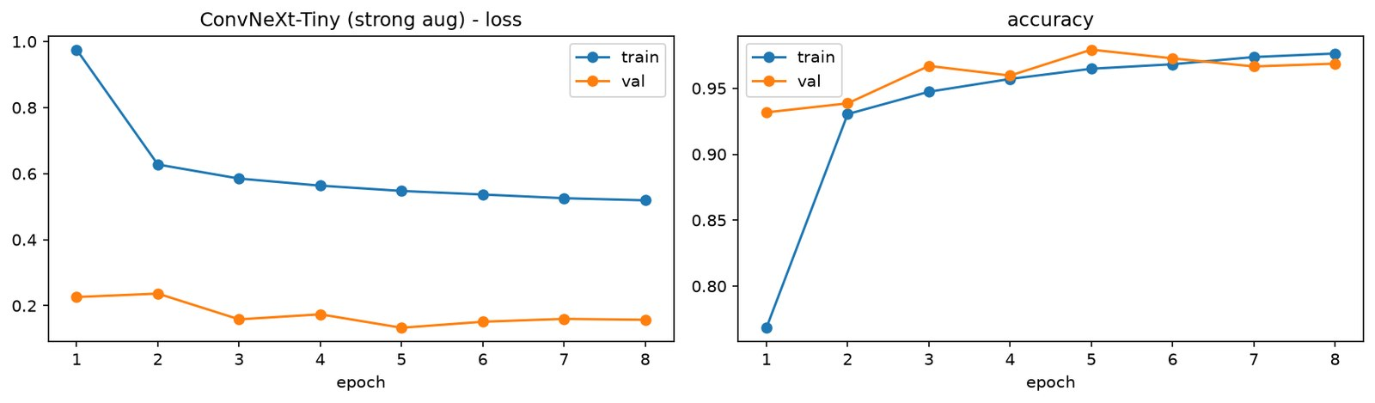
Figure 15. ConvNeXt-Tiny learning curves (strong augmentation).

9. Improvement Strategies
- Better validation: create pseudo-groups of crops from the same photo (for example by matching each eye, nose and mouth crop against face crops with template matching or embedding similarity) and use group k-fold cross-validation, so validation estimates the score on new animals.
- Train on all labelled data: retrain the final recipe on training plus validation data (25% more images and more animals) with the epoch count fixed from the current runs.
- Longer, balanced training of stronger backbones: run ConvNeXt-Tiny or EfficientNetV2 for 15–20 epochs with milder versions of the test-like augmentation, possibly at 288 px input, and add MixUp or CutMix (Zhang et al., 2018; Yun et al., 2019).
- Address the shape shortcut directly: use letterbox resizing that preserves the aspect ratio, or randomise crop shapes during training so shape carries no label information.
- Semi-supervised adaptation: pseudo-label the test images the ensemble predicts with high confidence and fine-tune on them, adapting the model to the test distribution (Lee, 2013).
- Cleaning and ensembles: review high-confidence errors for label noise, and build a k-fold ensemble with tuned ensemble weights.

10. Conclusion and Reflection
A complete, reproducible pipeline was built, from data exploration and leakage-aware splitting through transfer learning, controlled experiments, evaluation, Kaggle submission and error analysis. The final result is a public score of 0.9782 from an ensemble of EfficientNet-B0 and ConvNeXt-Tiny models.
The main strengths are the systematic one-factor-at-a-time experiments, the data analysis that explained the generation process and the train-to-test shift, full reproducibility (fixed seeds, saved splits, logged histories, version control) and evidence-based diagnosis of the generalisation gap. The main weakness is that model selection relied on a validation split that was too optimistic. The model with the best validation score was the worst on the leaderboard, and only three leaderboard submissions were available per day to check decisions. Compute on a laptop GPU also limited epochs and model size. The clearest lesson is that a validation set must reflect how the test set was created. Here, that means grouping by source animal and matching the test crop geometry, which matters more than squeezing out additional validation accuracy.

References
Deng, J., Dong, W., Socher, R., Li, L.-J., Li, K., & Fei-Fei, L. (2009). ImageNet: A large-scale hierarchical image database. In 2009 IEEE Conference on Computer Vision and Pattern Recognition (pp. 248–255). IEEE. https://doi.org/10.1109/CVPR.2009.5206848
Dietterich, T. G. (2000). Ensemble methods in machine learning. In Multiple Classifier Systems (LNCS 1857, pp. 1–15). Springer. https://doi.org/10.1007/3-540-45014-9_1
Geirhos, R., Jacobsen, J.-H., Michaelis, C., Zemel, R., Brendel, W., Bethge, M., & Wichmann, F. A. (2020). Shortcut learning in deep neural networks. Nature Machine Intelligence, 2(11), 665–673. https://doi.org/10.1038/s42256-020-00257-z
Harris, C. R., Millman, K. J., van der Walt, S. J., et al. (2020). Array programming with NumPy. Nature, 585, 357–362. https://doi.org/10.1038/s41586-020-2649-2
Hu, J., Shen, L., & Sun, G. (2018). Squeeze-and-excitation networks. In Proceedings of the IEEE Conference on Computer Vision and Pattern Recognition (pp. 7132–7141).
Huang, G., Sun, Y., Liu, Z., Sedra, D., & Weinberger, K. Q. (2016). Deep networks with stochastic depth. In European Conference on Computer Vision (pp. 646–661). Springer.
Hunter, J. D. (2007). Matplotlib: A 2D graphics environment. Computing in Science & Engineering, 9(3), 90–95. https://doi.org/10.1109/MCSE.2007.55
Ioffe, S., & Szegedy, C. (2015). Batch normalization: Accelerating deep network training by reducing internal covariate shift. In Proceedings of the 32nd International Conference on Machine Learning (pp. 448–456). PMLR.
Kaggle. (2026). ENGE707-2026-S2: Facial Feature Classification Challenge [Competition]. https://www.kaggle.com/competitions/enge-707-2026-s-2-cat-and-dog-facial-feature-classification-ch
Kaufman, S., Rosset, S., Perlich, C., & Stitelman, O. (2012). Leakage in data mining: Formulation, detection, and avoidance. ACM Transactions on Knowledge Discovery from Data, 6(4), Article 15. https://doi.org/10.1145/2382577.2382579
Krawetz, N. (2013, January 21). Kind of like that. The Hacker Factor Blog. https://www.hackerfactor.com/blog/index.php?/archives/529-Kind-of-Like-That.html
Lee, D.-H. (2013). Pseudo-label: The simple and efficient semi-supervised learning method for deep neural networks. ICML 2013 Workshop on Challenges in Representation Learning.
Liu, Z., Mao, H., Wu, C.-Y., Feichtenhofer, C., Darrell, T., & Xie, S. (2022). A ConvNet for the 2020s. In Proceedings of the IEEE/CVF Conference on Computer Vision and Pattern Recognition (pp. 11976–11986).
Loshchilov, I., & Hutter, F. (2017). SGDR: Stochastic gradient descent with warm restarts. In International Conference on Learning Representations.
Loshchilov, I., & Hutter, F. (2019). Decoupled weight decay regularization. In International Conference on Learning Representations.
McKinney, W. (2010). Data structures for statistical computing in Python. In Proceedings of the 9th Python in Science Conference (pp. 56–61). https://doi.org/10.25080/Majora-92bf1922-00a
Micikevicius, P., Narang, S., Alben, J., et al. (2018). Mixed precision training. In International Conference on Learning Representations.
Paszke, A., Gross, S., Massa, F., et al. (2019). PyTorch: An imperative style, high-performance deep learning library. In Advances in Neural Information Processing Systems 32 (pp. 8024–8035).
Pech-Pacheco, J. L., Cristóbal, G., Chamorro-Martínez, J., & Fernández-Valdivia, J. (2000). Diatom autofocusing in brightfield microscopy: A comparative study. In Proceedings of the 15th International Conference on Pattern Recognition (Vol. 3, pp. 314–317). IEEE.
Pedregosa, F., Varoquaux, G., Gramfort, A., et al. (2011). Scikit-learn: Machine learning in Python. Journal of Machine Learning Research, 12, 2825–2830.
Sandler, M., Howard, A., Zhu, M., Zhmoginov, A., & Chen, L.-C. (2018). MobileNetV2: Inverted residuals and linear bottlenecks. In Proceedings of the IEEE Conference on Computer Vision and Pattern Recognition (pp. 4510–4520).
Selvaraju, R. R., Cogswell, M., Das, A., Vedantam, R., Parikh, D., & Batra, D. (2017). Grad-CAM: Visual explanations from deep networks via gradient-based localization. In Proceedings of the IEEE International Conference on Computer Vision (pp. 618–626).
Szegedy, C., Vanhoucke, V., Ioffe, S., Shlens, J., & Wojna, Z. (2016). Rethinking the Inception architecture for computer vision. In Proceedings of the IEEE Conference on Computer Vision and Pattern Recognition (pp. 2818–2826).
Tan, M., & Le, Q. V. (2019). EfficientNet: Rethinking model scaling for convolutional neural networks. In Proceedings of the 36th International Conference on Machine Learning (pp. 6105–6114). PMLR.
TorchVision maintainers and contributors. (2016). TorchVision: PyTorch's computer vision library [Computer software]. GitHub. https://github.com/pytorch/vision
Waskom, M. L. (2021). seaborn: Statistical data visualization. Journal of Open Source Software, 6(60), 3021. https://doi.org/10.21105/joss.03021
Wightman, R. (2019). PyTorch image models (timm) [Computer software]. GitHub. https://doi.org/10.5281/zenodo.4414861
Yosinski, J., Clune, J., Bengio, Y., & Lipson, H. (2014). How transferable are features in deep neural networks? In Advances in Neural Information Processing Systems 27 (pp. 3320–3328).
Yun, S., Han, D., Oh, S. J., Chun, S., Choe, J., & Yoo, Y. (2019). CutMix: Regularization strategy to train strong classifiers with localizable features. In Proceedings of the IEEE/CVF International Conference on Computer Vision (pp. 6023–6032).
Zhang, H., Cisse, M., Dauphin, Y. N., & Lopez-Paz, D. (2018). mixup: Beyond empirical risk minimization. In International Conference on Learning Representations.
Zhong, Z., Zheng, L., Kang, G., Li, S., & Yang, Y. (2020). Random erasing data augmentation. In Proceedings of the AAAI Conference on Artificial Intelligence, 34(7), 13001–13008.
Pillow contributors. (2024). Pillow (PIL fork) [Computer software]. https://python-pillow.org
Anthropic. (2026). Claude [Large language model]. https://claude.ai

Appendix A. Reproducibility and Resources
- Code repository: https://github.com/manavsandhu555-spec/Kaggle_Comp (notebooks, ffc_lib.py, results tables, figures and submission files; the dataset and model checkpoints are excluded by .gitignore).
- Environment: Windows 11, Python 3.13.7, PyTorch 2.14.1 + CUDA 12.6, torchvision 0.29.1, timm 1.0.30, scikit-learn, pandas, NumPy, Matplotlib, seaborn, Pillow; NVIDIA laptop GPU; VS Code with Jupyter.
- Pretrained weights: timm efficientnet_b0 (ImageNet-1k) and convnext_tiny.fb_in22k_ft_in1k (ImageNet-22k, fine-tuned on 1k), downloaded from the Hugging Face Hub.
- Run order: facial_feature_classification.ipynb (Tasks 1–6, E1–E4, first submission), then improve_score.ipynb (ConvNeXt and ensembles). Seed 42 throughout; all splits, histories and metrics are saved in outputs/.
- Generative AI use: Claude (Anthropic, 2026) was used to help develop and debug the pipeline code and to draft this report. All experiments were run, and all results verified, on the author's machine. [Check your course's AI-use policy and edit this statement accordingly.]

