  - UNDERGRADUATE DEEP LEARNING PROJECT

Real Time Vehicle Detection and Traffic Analytics
  - Using UVH 26 and Deep Learning

Detailed Academic Project Report

Project team
Group member | Roll number
Manav Shah | N227
Manav Goyal | N223
Meet Shah | N235

Submission edition 22 October 2026
Scope includes dataset preparation, detector experiments, reproducible evaluation, the application and the current video analytics validation stage. The project title describes its objective; measured throughput and accuracy claims are qualified in the report.

Abstract and project outcome
This project develops a reproducible vehicle detection and traffic analytics system for heterogeneous Indian road scenes. It begins with annotation inspection and a verified local subset, compares compact and larger one-stage detectors, investigates a two-stage detector, and integrates the selected detector into an evidence-based application and a video tracking and counting pipeline.
The experimental dataset is the UVH-26 Majority Voting annotation variant. The full annotation-catalogue audit covers 26,646 image records. The locally verified experimental subset contains 8,000 training and 2,000 validation images. These are different audit scopes: reading the full catalogue does not establish that every original image was downloaded and verified.
YOLOv8s is the retained detector. On historical validation2000, its AP50:95 was 52.48%, compared with 45.84% for YOLOv8n. On the later common calibration500 evaluator, YOLOv8s achieved 48.28% and Faster R-CNN achieved 42.91%. These two comparisons use different protocols and must remain separate. Increasing YOLOv8s inference resolution to 960 did not pass the improvement gate. Calibration-only fusion was tested and rejected under its predefined acceptance criteria.
The application supports historical evidence browsing, new-image inference, labelled evaluation, error analysis and reproducible exports. Phase 3B adds ByteTrack histories, directional finite-line crossing events, independent human annotation and gated event evaluation. Its complete prerecorded-file pipeline processed 900 frames at 60.04 frames per second. It predicted 40 crossing events, but counting precision, recall and F1 remain unavailable because independent human ground truth is incomplete.
The main contribution is an auditable experimental and application workflow, not a claim of a novel detector architecture. Checkpoint hashes, manifests, immutable outputs, source records, tests and explicit failure handling make the work inspectable. Single-seed training, calibration reuse, rare-class support and limited video coverage restrict generalisation claims.

Report navigation
Chapters 1 to 4 cover the problem, data and preprocessing. Chapters 5 to 15 explain the models, experiments, errors and performance. Chapters 16 to 19 cover the application, video analytics and verification. Appendices provide code, reproducibility evidence and references.

1 Problem definition and objectives
Indian traffic contains mixed vehicle sizes, closely packed vehicles, partial occlusion and fine-grained passenger-vehicle categories. Counting boxes independently in every video frame would repeatedly count the same vehicle. A practical system therefore needs object detection, identity association across frames, and a separate crossing-event rule.
The detection task maps an image to a variable-length set of bounding boxes, class labels and confidence scores. The tracking task links detections into temporal identities. The counting task records a vehicle crossing a specified finite line in a specified direction. These outputs answer different questions and require different evaluation methods.
The objectives are to establish a verified dataset and baseline, measure controlled model changes, choose a defensible operational detector, expose results through an understandable interface, and validate video event counting against independent human annotations. Accuracy and speed must be measured with their image set, thresholds and timing boundaries attached.
The scope excludes production deployment certification, physical speed measurement, licence-plate identification and formal multi-object tracking benchmark claims. No new architectural novelty is claimed for YOLO, Faster R-CNN, ByteTrack or the fusion algorithms. The contribution lies in adaptation, controlled experimentation, validation and integration.
Requirement | Implemented evidence
Data integrity | Manifest and class-map hashes, dimension and box validation
Detection quality | Standalone evaluations, per-class support, PR and confusion plots
Controlled experiments | Fixed seeds, frozen settings and explicit acceptance gates
Video analytics | Track histories, finite-line crossings and timing exports
User clarity | Separate historical, new-data and video evaluation workflows
Reproducibility | Immutable run IDs, checkpoints, recovery records and tests

2 System design and development sequence
The system follows a staged dependency chain. Annotation inspection precedes conversion; conversion and visual alignment checks precede training; best-checkpoint verification precedes standalone evaluation. Model selection precedes application deployment. Video-counting correctness requires an additional human-reviewed event dataset.
The data layer validates manifests and annotations. The experiment layer trains and resumes detectors under frozen configurations. The evaluation layer computes detection metrics and timing. The application layer presents evidence and validates uploads. The video layer associates detections, records directional crossings and exports auditable histories.
The repository separates these responsibilities under src/data, src/training, src/experiments, src/evaluation, src/video and dashboard. Small summaries and source files are version controlled. Raw data, large predictions, checkpoints and full run directories remain local and excluded from routine Git delivery.
Stage | Purpose and outcome
Data preparation | Catalogue audit, local subset verification and YOLO conversion
E0 | YOLOv8n baseline, 30 epochs
E1 | YOLOv8s capacity comparison, 30 epochs; retained detector
E2 | 640 versus 960 inference; same E1 checkpoint; gate failed
Accuracy A and B | Faster R-CNN preflight and paired sampling pilots
Accuracy C and D | 20-epoch E3 training, safe recovery and standalone calibration
Accuracy E and F | Common calibration comparison; fusion feasibility rejected
Application | New-data evaluation and faculty-facing evidence dashboard
Phase 3B | Video implementation and throughput verified; human accuracy gate pending

3 Dataset audit and experimental partitions
The project uses UVH-26 Majority Voting annotations with 14 vehicle classes. The annotation catalogue contains 26,646 image records and 316,220 boxes. Catalogue checks establish structural properties of the annotation files. They do not substitute for decoding and hashing each image.
The local experimental subset contains 10,000 verified images: 8,000 training images with 94,609 boxes and 2,000 validation images with 24,342 boxes. The later accuracy-improvement workflow partitions the existing validation pool into calibration500 and reserved1500. Calibration500 contains 6,148 annotated objects and is used for model configuration and selection.
Reserved1500 is not a pristine unseen test set: historical YOLO validation already used the 2,000-image pool. It remains excluded from the later reserved comparison protocol and was not newly evaluated during Phase 3B. Acquisition and integrity verification of unselected full-dataset images remain incomplete. These limitations must accompany any claim about generalisation.
The frozen class order is Hatchback, Sedan, SUV, MUV, Bus, Truck, Three-wheeler, Two-wheeler, LCV, Mini-bus, Tempo-traveller, Bicycle, Van and Others. YOLO uses IDs 0 to 13. Faster R-CNN uses foreground labels 1 to 14 and background label 0; confusing these conventions would invalidate training and evaluation.
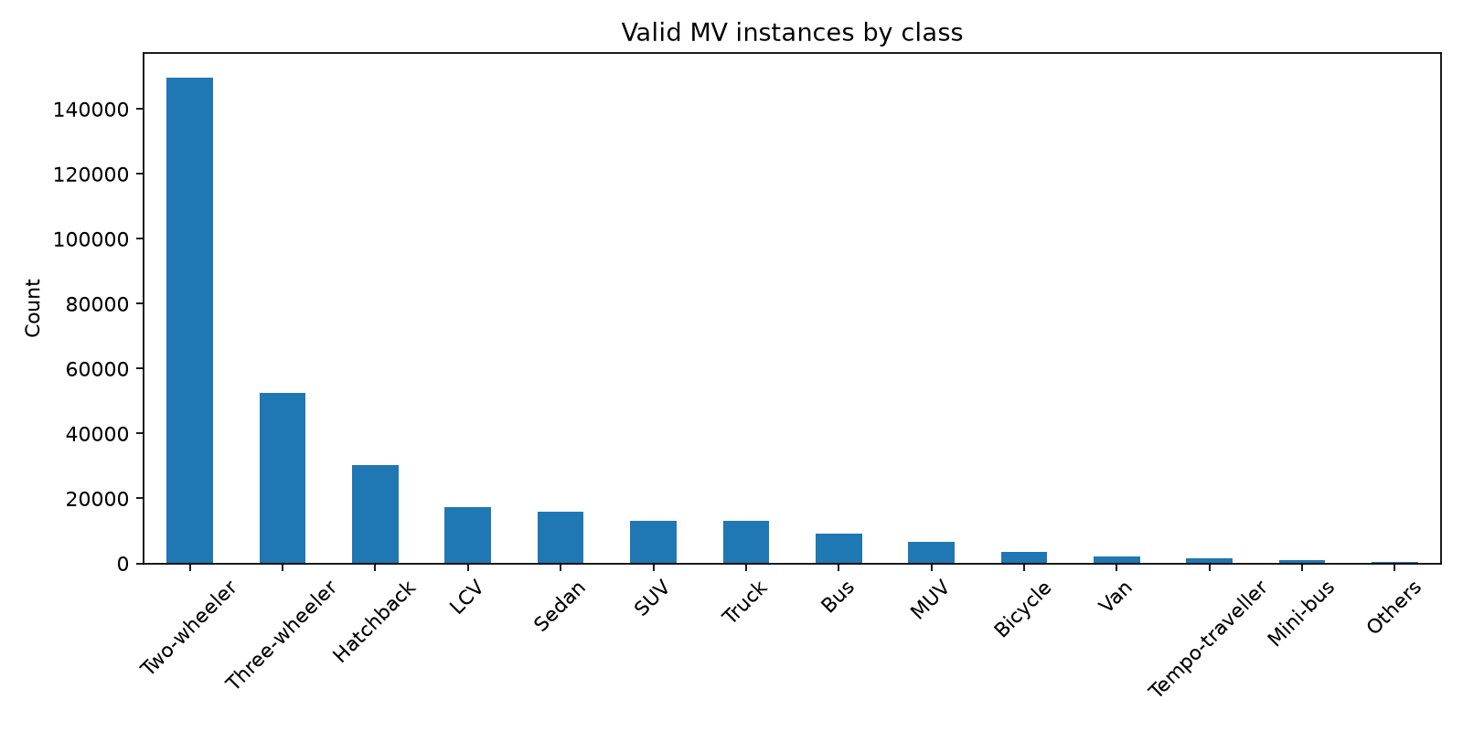
Figure 1. Catalogue-level class distribution from annotation EDA. This is not a frequency chart restricted to the local training subset. Source: reports/figures/class_distribution.png

4 Preprocessing and annotation alignment
Each annotation must refer to a known image and class. Image dimensions must be positive, and every bounding box must have finite coordinates, positive area and valid image bounds. Invalid boxes are rejected and recorded rather than silently clipped. Duplicate identities, filenames and content hashes are checked at the appropriate audit stage.
COCO boxes use top-left x and y plus width and height in pixels. YOLO labels use a class ID followed by normalised centre x, centre y, width and height. For an image of dimensions W by H, the conversion is cx = (x + w/2)/W, cy = (y + h/2)/H, nw = w/W and nh = h/H. The target coordinates are relative to the original image geometry.
Visual overlays are necessary because syntactically valid labels can still be misaligned. A wrong image-dimension assumption or class offset may produce a valid text file while placing boxes on the wrong objects. The project preserves versioned conversions and uses both automated validators and visual inspection. Original aspect ratios are retained until model-specific preprocessing.
The displayed training sample is an illustration of annotation alignment. It is not independent evidence of model accuracy. Source annotation ambiguity remains possible, especially for visually similar passenger vehicles, distant objects and the broad Others category.
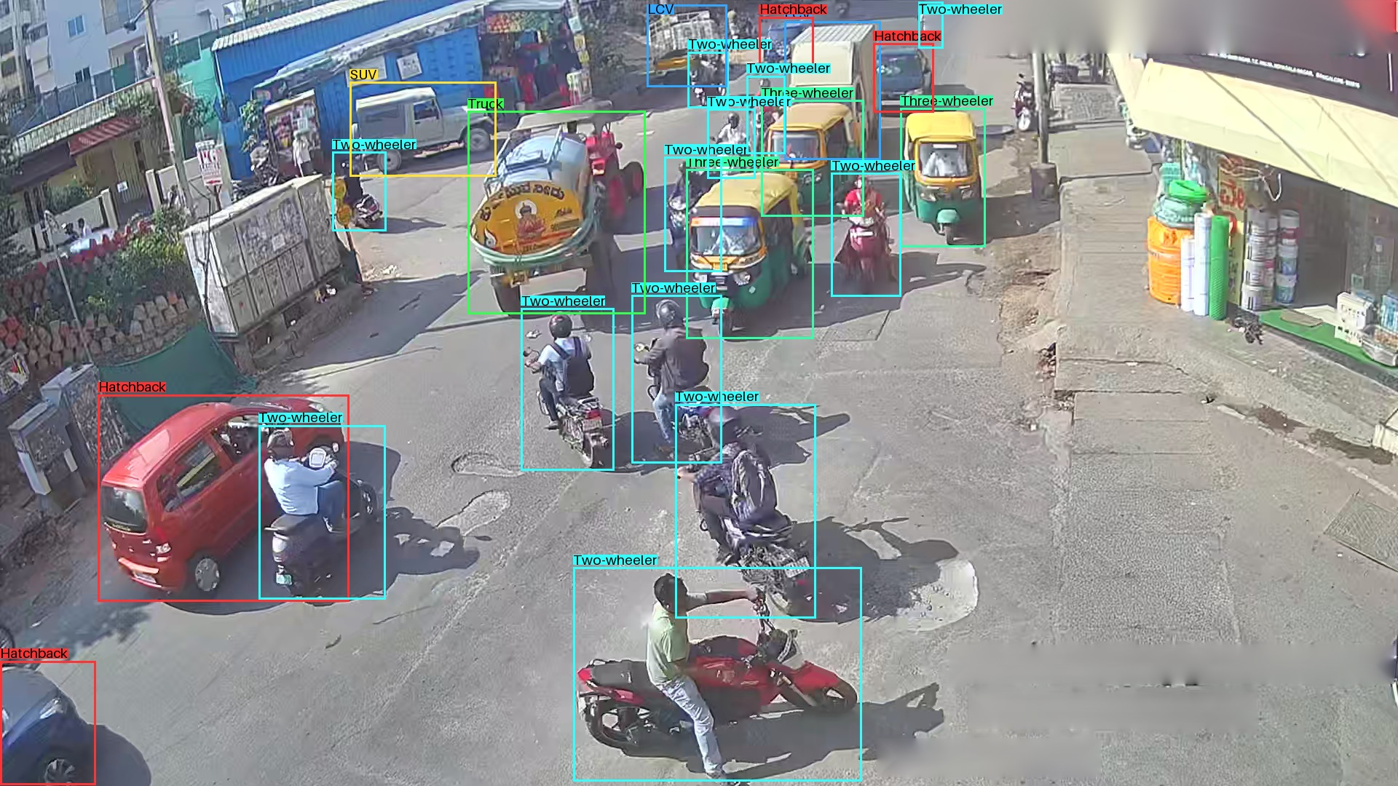
Figure 2. Actual training image with frozen annotation boxes. Labels are ground truth inputs, not predictions. Source: reports/annotation_samples/final_baseline_seed42_v2/train_17614.jpg

5 Baseline detector and YOLOv8s experiment
YOLO is a one-stage object detector: a neural network extracts multiscale image features and predicts classes and boxes without a separate region-proposal stage. Transfer learning begins from pretrained weights and adapts the detector to the 14 UVH categories. Bounding-box losses encourage geometric agreement while classification losses encourage the correct class. Non-maximum suppression removes strongly overlapping competing predictions at inference.
E0 uses YOLOv8n as the compact baseline. E1 increases capacity to YOLOv8s while retaining the frozen 8,000-image training subset and historical 2,000-image validation protocol. Both complete 30 epochs. The selected E0 checkpoint is epoch 30; selected E1 is epoch 22. A selected checkpoint can precede the final epoch because validation quality need not improve monotonically.
The E1 configuration uses 640-pixel input policy, batch 8, MPS, seed 42, workers 0 and AdamW. Its recorded initial learning rate is 0.000556, weight decay 0.0005 and warm-up 3 epochs. Configured detection transforms include horizontal flips, HSV variation, scaling, translation and mosaic, with mosaic closed for the final 5 epochs. Configuration keys are not proof that classification-specific transforms affected the detection pipeline.
Historical AP50:95 improves from 45.84% to 52.48%, a 6.635 percentage-point gain using unrounded records. This supports retaining E1 over E0 under that protocol. It does not establish performance on every Indian road or an independent test population.
Validation2000 | Precision % | Recall % | AP50 % | AP50 to 95 %
E0 YOLOv8n | 61.00 | 54.35 | 56.00 | 45.84
E1 YOLOv8s | 65.03 | 61.03 | 62.33 | 52.48
E2 E1 at 960 | 64.02 | 61.02 | 62.64 | 52.51

6 YOLO training and validation evidence
Training curves provide evidence of optimisation behaviour, but the lowest training loss is not necessarily the best detector. Validation metrics are required to detect divergence between fitting the training data and performance on annotated validation images. The E1 curves below are the recorded 30-epoch run, not the earlier smoke model.
The precision-recall curve evaluates the trade-off across confidence thresholds. A high confidence threshold usually removes weak predictions and can lower recall; a lower threshold can recover missed vehicles while introducing false detections. AP summarises a curve and should not be described as a percentage of correctly classified images.
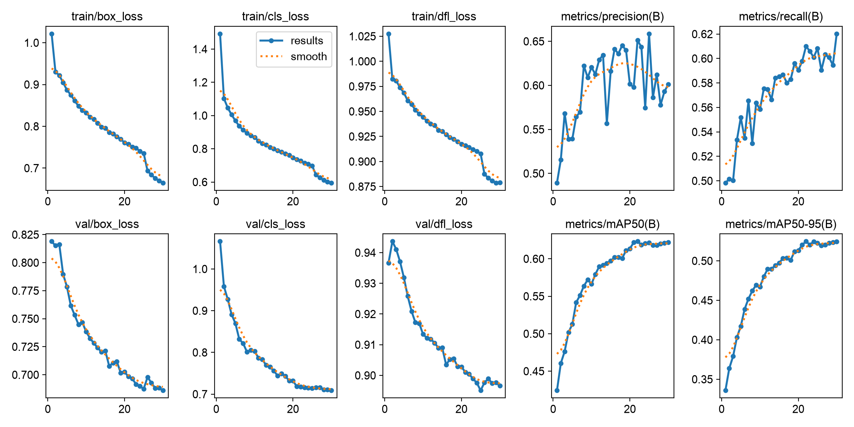
Figure 3. Recorded E1 training losses and validation metrics across epochs. Source: reports/figures/E1_yolov8s_uvh26_mv_640_seed42_results.png
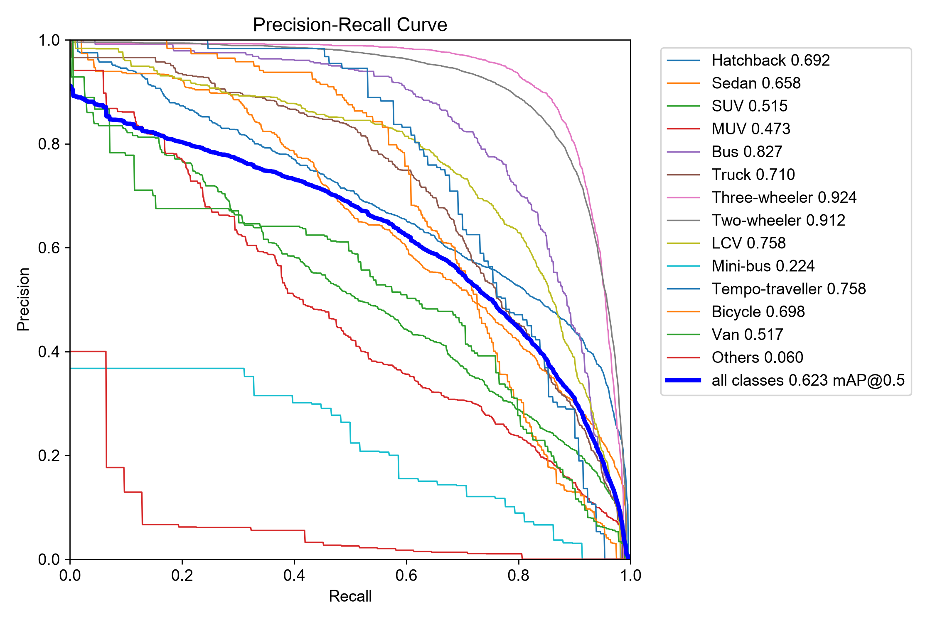
Figure 4. Standalone E1 PR curve on historical validation2000. Source: reports/evaluations/yolov8s_uvh26_mv_e1_validation_seed42_v2/BoxPR_curve.png

7 Resolution ablation and sampling pilots
E2 tests whether the selected E1 checkpoint benefits from inference at 960 rather than 640. It is not a separately trained detector. The overall AP50:95 gain is only 0.038 percentage points, while the preregistered small-object AP decreases by 7.076 points. The improvement gate fails and 640 is retained. More pixels do not guarantee a better result under a particular model and dataset.
The Faster R-CNN workflow first checks that the model and required operations run on Apple MPS with finite losses. Stage A establishes a conservative physical batch of one. Stage B then creates paired three-epoch pilots using 1,000 training images and 250 calibration images. Both start independently from the official COCO_V1 initializer, not from each other.
Sampling is the controlled difference: B1 uses deterministic unweighted shuffle and B2 uses capped weighted sampling. Weighted sampling can expose rare-category images more often but can revisit fewer unique images. Therefore the decision examines exposure, unique coverage, stability and calibration AP rather than a single favourable rare class.
The weighted pilot improves overall AP50:95 slightly but does not improve the supported-minority aggregate AP used by the decision rule. Three epochs are limited evidence. Unweighted sampling is chosen as the lower-risk full-run setting. These pilot scores must not be ranked against the final 20-epoch model as equivalent experiments.
Pilot calibration250 | AP50 % | AP50 to 95 % | Decision
B1 unweighted | 37.70 | 23.41 | Retained for full E3
B2 capped weighted | 37.54 | 23.86 | No sufficient minority benefit

8 Faster R CNN architecture and full training
Faster R-CNN is a two-stage detector. ResNet-50 extracts hierarchical visual features and the Feature Pyramid Network combines information at multiple scales. A Region Proposal Network proposes likely object regions. RoI-based heads classify proposals and refine their boxes. This is architecturally distinct from a one-stage YOLO detector, but architectural complexity alone does not guarantee higher performance.
The official COCO_V1 initializer is adapted by replacing the final predictor with 15 outputs: one background class and 14 UVH foreground categories. E3 uses 8,000 training images, 500 calibration images, unweighted deterministic shuffle, seed 42, MPS float32, physical batch 1 and workers 0. Images are resized with short side 480 and maximum side 640. No augmentation is used for this frozen E3 configuration.
SGD uses momentum 0.9 and weight decay 0.0005. The conservative learning rate is 0.0005 at epoch 1, 0.001 at epochs 2 to 12, 0.0001 at epochs 13 to 17 and 0.00001 at epochs 18 to 20. The lower rate relative to the initially considered 0.005 accommodates the batch-one pilot and is frozen before the full run.
The run E3_fasterrcnn_unweighted_20ep_seed42_v1 completes 20 epochs with exit code 0. The selected best checkpoint is epoch 13. Historical epoch-6 checkpoint-alias publication failure is preserved; provenance-checked recovery resumes at epoch 7 and finishes. It is not treated as a current failed training run.
Code excerpt from src/experiments/stage_b.py, lines 30 to 32
def lr(epoch, base=.001):
if not 1 <= epoch <= 20: raise ValueError('Epoch outside frozen schedule')
return base * min(1., epoch / 2) * .1 ** (int(epoch >= 13) + int(epoch >= 18))
The exact scheduler combines a one-epoch warm-up with two tenfold reductions. The epoch guard prevents silently extending the authorised 20-epoch schedule.

9 E3 convergence and safe recovery evidence
The E3 total loss decreases from 0.784235 to 0.199220. Calibration AP50:95 rises from 0.306132 at epoch 1 to 0.429070 at epoch 13. The first learning-rate reduction coincides with the largest late-stage improvement, but this observational association is not a causal scheduler ablation. Epoch 20 AP50:95 is 0.428324, below the selected checkpoint despite its lower training loss.
Checkpoint format v2 stores the model, optimizer, epoch and recovery/provenance state. Epoch-zero publication provides a recovery point before completed training. Source and data hashes, a session record, process locking and timing reconciliation reduce the chance of mixing runs or duplicating completed epochs. Interrupted partial epochs are not reported as successfully completed epochs.
The audit verifies 20 contiguous timing rows, finite component losses and readable finite model and optimizer tensors. Completed-epoch active time is 39,407.971 seconds, about 10 hours 56 minutes 48 seconds. Calendar elapsed time is 41,721.797 seconds. The difference includes session delay, startup and overhead and must not be called entirely training compute or sleep.
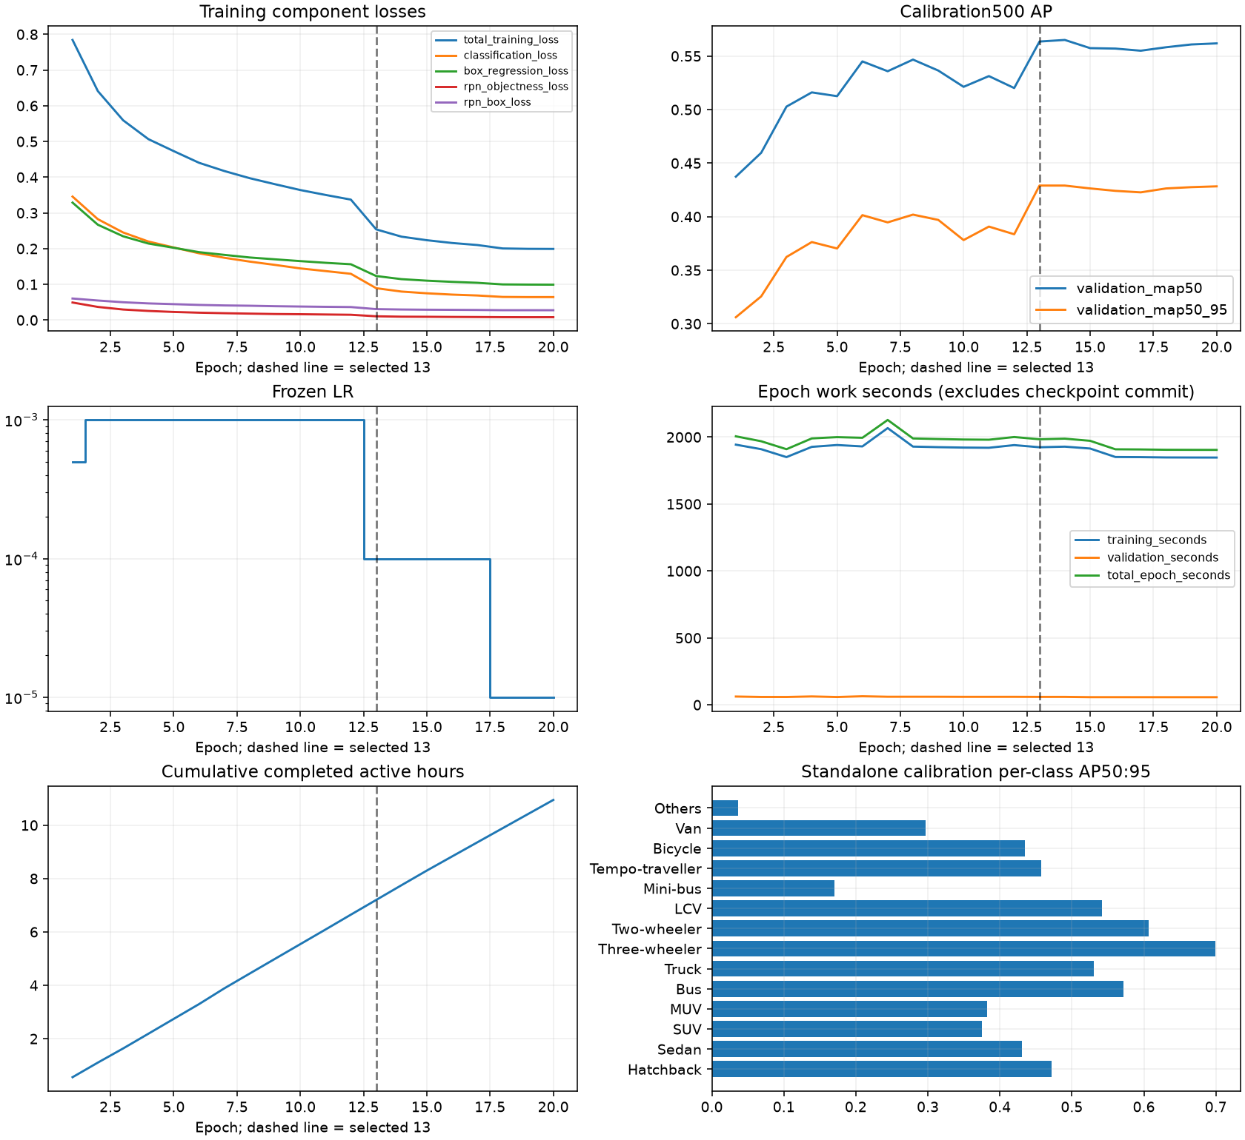
Figure 5. E3 measured loss, calibration AP, learning rate and epoch timing. The selected checkpoint is epoch 13. Source: reports/evaluations/E3_fasterrcnn_best_calibration500_v1/training_curves.png

10 Detection metrics and fair comparison
Intersection over Union is the area shared by a predicted and ground-truth box divided by their union. Fixed-threshold evaluation matches detections to annotations under the stated class and IoU rules. Precision is TP/(TP+FP), recall is TP/(TP+FN), and class F1 is 2PR/(P+R). Zero-denominator conventions and unsupported classes must be explicit.
Harmonic aggregate F1 combines macro precision and macro recall. Macro class F1 instead averages the per-class F1 values. They are generally different. AP integrates precision over recall; AP50 uses IoU 0.50, while AP50:95 averages over IoU 0.50 to 0.95 in 0.05 increments. AP uses a low score floor and must remain separate from the chosen fixed operating threshold.
Stage D independently evaluates E3 best.pth on calibration500. At confidence 0.25 and matching IoU 0.50, macro precision is 45.62%, recall 63.49%, harmonic F1 53.09% and macro class F1 52.63%. AP50 is 56.36% and AP50:95 is 42.91%. Standalone P/R/AP values agree exactly with the recorded epoch-13 values under an absolute tolerance of 0.00001.
Stage E compares E1 and E3 using the same calibration500 annotations and common COCO-style evaluator. AP uses score floor 0.001 and maximum 300 detections. Fixed metrics use IoU 0.50 and calibrated confidences 0.34 for E1 and 0.43 for E3. These thresholds were selected on calibration data, so these are selection results, not independent test estimates.
Calibration500 | P % | R % | Macro F1 % | AP50 % | AP50 to 95 %
E1 at 0.34 | 61.48 | 58.17 | 59.10 | 57.38 | 48.28
E3 at 0.43 | 53.63 | 56.88 | 54.65 | 56.36 | 42.91

11 Per class analysis with support
E3 performs strongly on three-wheelers and two-wheelers, which have substantial calibration support. Others has zero recall at confidence 0.25, and Mini-bus and Van are weak. A result based on 10 or 19 objects is sensitive to individual examples; it cannot justify a broad claim about that vehicle category.
The following values are from the Stage D E3 standalone evaluation at confidence 0.25. AP is integrated from low-confidence predictions, so a class can have nonzero AP even when no prediction survives the displayed operating threshold. These values must not be compared directly with a different evaluation set or threshold.
Class | GT objects | Recall % | AP50 to 95 %
Hatchback | 610 | 81.97 | 47.17
Sedan | 301 | 64.12 | 43.10
SUV | 236 | 65.68 | 37.53
MUV | 147 | 55.78 | 38.24
Bus | 166 | 74.70 | 57.20
Truck | 253 | 78.26 | 53.06
Three-wheeler | 1035 | 90.53 | 69.95
Two-wheeler | 2920 | 88.36 | 60.66
LCV | 311 | 81.99 | 54.16
Mini-bus | 19 | 36.84 | 17.02
Tempo-traveller | 30 | 53.33 | 45.77
Bicycle | 62 | 69.35 | 43.46
Van | 48 | 47.92 | 29.72
Others | 10 | 0.00 | 3.65

Class-aware totals are 5,113 true positives, 3,310 false positives and 1,035 false negatives. The separate class-agnostic confusion matrix uses a different matching procedure; its diagonal must not automatically be substituted for these class-aware totals.

12 Error analysis and visual evidence
The recorded E3 review includes dense scenes, small boxes, two- and three-wheelers, heavy vehicles, rare categories and sparse scenes. Selection is deterministic and aimed at coverage, not an unbiased estimate of error prevalence. The image below juxtaposes original ground truth and model predictions.
Dense traffic demonstrates how occlusion and overlapping vehicles complicate association and box placement. Correct foreground detections coexist with missed small vehicles, redundant boxes and passenger-vehicle confusion. The review records Sedan to Hatchback confusion 111 times and Hatchback to Sedan 82 times under the confusion-matrix protocol.
Geometric diagnostics identify 411 duplicate candidates and 486 localisation candidates. These are diagnostic flags, not mutually exclusive human-adjudicated causes. Possible source-annotation limitations are kept separate: a covered object labelled Sedan may not be identifiable from visible appearance, and Others includes handcart-like objects. Frozen labels are not altered after viewing predictions.
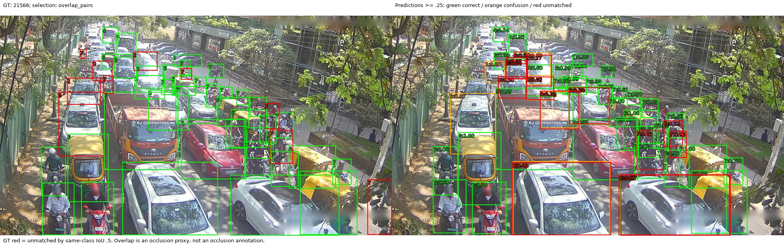
Figure 6. Calibration image 21566 with ground truth and E3 predictions. Dense traffic and occlusion make this a challenging qualitative example. Source: runs/E3_fasterrcnn_best_calibration500_v1/qualitative/21566.jpg

13 Confusion matrix and PR interpretation
A confusion matrix distinguishes class substitutions from background-related misses and false detections. Its axis orientation must be read before interpreting cells. The E3 matrix uses ground truth rows and predicted columns, including a background row and column. Large off-diagonal passenger-vehicle entries show that locating a vehicle and assigning its fine-grained class are separate problems.
The plot provides visual evidence of systematic error patterns; the per-class support table is required alongside it because frequent categories can dominate raw counts. A normalised matrix answers a different question from a raw-count matrix.
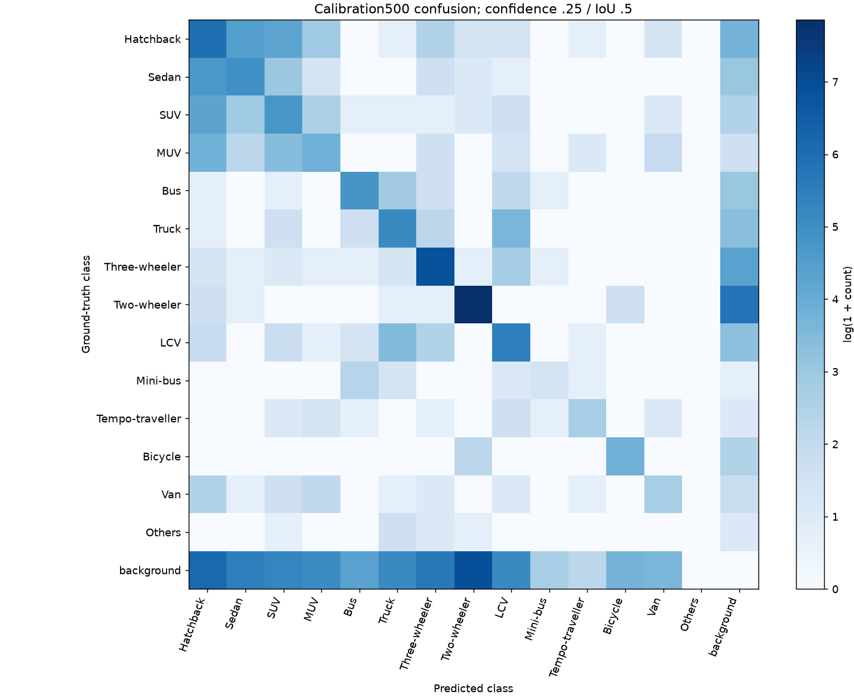
Figure 7. E3 raw confusion matrix on calibration500 at confidence 0.25 and matching IoU 0.50. Source: reports/evaluations/E3_fasterrcnn_best_calibration500_v1/confusion_matrix.png
PR curves, their numerical arrays and fixed-threshold metrics are preserved in the standalone evaluation bundle. Confidence calibration changes a selected operating point; it does not create a new trained detector or change the underlying AP curve when the raw predictions are unchanged.

14 Fusion feasibility and retained model
Stage E identifies complementary detections: E3 detects 467 ground-truth objects missed by E1 at the selected operating thresholds. Complementarity motivates an experiment but does not prove that combining predictions will improve the system. Added detections can also add duplicates and false positives.
Stage F tests union, weighted box fusion and recovery families using five-fold calibration-only out-of-fold selection. Thresholds are selected within training folds. The baseline and fused rows below must be compared within this protocol, not against fixed-threshold Stage E F1 values.
Weighted box fusion gives the strongest AP result, but its AP50:95 gain of 0.009603 is below the required 0.01 and its macro-F1 gain of 0.008530 is below 0.02. All families fail the predefined improvement gate. No final E4 fusion model is selected. A negative result is scientifically useful because it prevents added complexity without sufficient measured benefit.
OOF family | Macro F1 % | AP50 % | AP50 to 95 %
Baseline E1 | 58.62 | 57.38 | 48.28
Union | 57.74 | 60.20 | 46.60
Weighted box fusion | 59.47 | 58.88 | 49.24
Recovery | 57.88 | 55.88 | 46.72

The representative fold-zero WBF sequential benchmark costs 156.78 ms mean and 162.08 ms p95, or 6.38 still images per second. This timing describes a tested representative, not a deployed selected fusion system. E1 remains the operational detector. Full weighted E3 training and YOLO fine-tuning have not been performed in this progression.

15 Latency and throughput protocols
Latency is meaningful only when the timing boundary is defined. Model inference excludes some work that a user experiences, such as file decoding, device transfer, box processing, drawing and saving. Batched validation throughput must not be presented as batch-one real-time performance.
The E3 benchmark uses 100 deterministic calibration images, batch 1, MPS float32, 10 warm-ups, short480/max640 resizing, confidence 0.25, NMS 0.50 and maximum 300 detections. Device operations are synchronised at stage boundaries. Model loading takes 0.510 seconds and is excluded from per-image timings. Inference includes the model internal box decoding and NMS; postprocessing includes original-coordinate mapping, CPU transfer and the final confidence filter.
E3 stage | Mean ms | Median ms | p95 ms
Preprocessing | 28.308 | 28.248 | 29.658
Inference | 84.597 | 83.088 | 93.068
Postprocessing | 1.423 | 1.400 | 1.563
End to end | 114.329 | 112.901 | 122.450

E3 inference-only throughput is 11.821 images per second and end-to-end still-image throughput is 8.747. These are inverse mean times, not live camera frame rates. The model has 41,365,786 parameters. Its approximately 330.60 MB checkpoint contains optimizer and recovery state, so its size is not directly comparable to stripped YOLO inference weights.
Historical matched E0/E1 still-image benchmarks record 32.934 and 33.012 images per second respectively. Those benchmarks use another sample/session and timing definition than E3. No controlled E1-to-E3 speed ratio is inferred from those separate records. Memory samples also do not establish a true peak memory bound.

16 Application and evaluation of new images
The Streamlit application presents an executive overview, historical model evidence, new-data evaluation, detailed errors, prediction exploration, latency and methodology. It separates saved evidence from new inference so an absent checkpoint or absent image upload does not produce an unsupported accuracy claim.
New-data ingestion validates ZIP structure, filenames, annotation references, image geometry and the exact class mapping. It rejects path traversal, symlinks, ambiguous duplicates and invalid boxes. Images and predictions remain session-scoped unless an explicit export is requested. The frozen operational model is E1 epoch 22 at 640, float32, batch 1, confidence 0.34, NMS 0.7 and maximum 300 detections; AP uses score floor 0.001.
An unlabelled upload produces predictions and counts but cannot produce precision, recall or AP. A labelled upload supplies independent ground truth and enables metric calculation. The dashboard separates duplicate, classification, localisation, background and missed-object error candidates. It does not automatically infer weather or occlusion annotations from image appearance.
For a future external study, collect diverse, permitted road images, remove duplicates, annotate before inspecting predictions and freeze the selection. Report class support and source provenance. A generic external car label cannot automatically replace Hatchback, Sedan, SUV and MUV. An independence declaration alone does not prove absence of overlap.
The current software supports this workflow, but implementation and a functioning inference demonstration are not evidence that an independent external accuracy study has already been completed. Imported result bundles have consistency checks but are not authenticated historical scientific runs.
User input | Valid conclusion
No new images | Historical evidence only
Unlabelled images | Qualitative detections, scores and predicted counts
Reviewed labelled images | Dataset-specific P/R/F1/AP and error analysis
Unreviewed video crossings | Predicted event totals and processing speed
Independent reviewed events | Event P/R/F1 and count error under the frozen protocol

17 Video tracking and directional counting
Detection is performed on each frame using E1. ByteTrack associates boxes over time. Track histories retain confidence, observed class and resolved class; a confidence-weighted class vote stabilises categories. A tracked bottom-centre anchor is used for crossing geometry. Track identifiers represent an algorithmic history, not a guarantee of unique physical identity.
The finite counting line runs from normalised coordinates (0.08, 0.60) to (0.72, 0.60). A crossing requires at least three observations, a 5-pixel dead-band, at least 10 pixels displacement, a finite-line intersection and no more than one observed-frame gap. A track can generate at most one event per direction. Returning in the opposite direction can therefore generate a second event; these are crossing counts rather than unique vehicles over the entire clip.
Protocol v1 exposed a late raw ByteTrack ID revival at frame 32. Protocol v2 creates a new public identity after termination rather than joining disconnected histories. Two transitions were recorded in each complete tracking-enabled run. The failed protocol and corrected protocol are preserved separately.
The inherited detector threshold is 0.25, with NMS 0.7. This filters out detections below 0.25 before ByteTrack, even though the configured tracker low threshold is 0.1. Consequently, the full low-confidence association mechanism is not exercised. This is a documented limitation, not a silently adjusted setting.
Code excerpt from src/video/counting.py, lines 21 to 23
def side(self,p):
delta=np.asarray(p)-self.a
return float((self.vector[0]*delta[1]-self.vector[1]*delta[0])/self.length)
The signed distance is a two-dimensional cross product divided by line length. Opposite signs identify opposite sides; dead-band and displacement guards reduce jitter-triggered events.

18 Video benchmark and human validation gate
The Phase 3B pilot uses a permitted 30-second Bangalore road excerpt with 900 fully decoded 1920 by 1080 frames at 30 FPS. The source is Gpkp, Ramana Maharshi Road Bangalore 2025 clip 01, Wikimedia Commons, CC BY-SA 4.0. The view is elevated with minor handheld motion and severe glare. This is a limited image-coordinate pilot, not a stabilised physical road measurement.
All four modes process the same frames independently on MPS with batch one and ten excluded warm-ups. Complete processing includes decoding, synchronised detection, tracking, counting, event-evidence writes, rendering, video encoding and detailed export. It excludes model startup, warm-up, final integrity hashing, live capture and browser/network display.
Mode | FPS | Median frame ms | p95 frame ms
Detection | 85.686 | 11.472 | 13.003
Tracking | 85.431 | 11.126 | 12.922
Counting | 83.433 | 11.316 | 13.582
Complete pipeline | 60.043 | 16.406 | 19.186

The complete pipeline predicts 40 crossings: 12 downward and 28 upward. Its 10,194 frame-level detections and maximum 22 observed active tracks are different quantities. Throughput exceeds the source 30 FPS under this prerecorded-file timing boundary. It does not establish reliable live-camera deployment or correct counting.
Independent human annotations remain pending. The annotation tool shows source frames with the line, supports precise navigation and immutable revisions, and requires completed review before scoring. Event matching uses same class and direction, a 0.5-second tolerance and deterministic globally closest-time pairs. This greedy procedure does not guarantee maximum-cardinality matching.
The preregistered pilot gate requires event F1 at least 0.80 and count WAPE at most 20%. Neither is currently available. UI attestations are not external proof of human independence; uncertainty, prior prediction exposure and sparse support must be documented.

19 Verification provenance and limitations
Scientific evidence and software tests answer different questions. Tests establish expected program behaviour for covered cases; measured validation establishes performance on a particular annotated set. Neither alone proves broad real-world reliability. Immutable run IDs, hashes and completion receipts connect a reported result to its inputs and executed configuration.
The Phase 3B delivery records 311 passing tests in the local workspace and 292 in the isolated eligible staged repository. The difference comes from preserved uncommitted Phase 3A and E4 tests outside that delivery. Focused video coverage has 43 passing tests. Artifact validators pass, and 16 historical summary fingerprints remain unchanged. These are recorded delivery checks, not a newly executed training or evaluation during report preparation.
The Phase 3B code delivery is commit ddfe955e6d2ae6341a300ea1dcd32fa53af96c4d on master, recorded as pushed to origin/master. Additional local E4 and Phase 3A work remains outside that commit. A report generated from current local evidence should not imply that every local artifact is part of one clean Git snapshot.
Limitations include one training seed, selection on calibration data, historical exposure of the reserved validation portion, incomplete acquisition of unselected images, class imbalance and source annotation ambiguity. The video study uses only one short clip, has no completed independent event truth, and does not establish MOT metrics or camera-wide generalisation.
The next defensible steps are independent manual review of the pilot, a diverse external labelled image study, more road/camera conditions, and separately authorised controlled data improvements. No success claim should be made for these future steps before measurements exist.
Evidence | What it establishes
Manifest and mapping hashes | Identity of selected data and class order
Checkpoint receipts and finite tensors | Readable recorded model and recovery state
Standalone evaluation | Metrics for the selected checkpoint and stated set
Recorded tests and validators | Covered code and artifact consistency
Human review pending | Counting accuracy remains unestablished

Appendix A Bounding box conversion code
Code excerpt from src/data/common.py, lines 75 to 92
def convert_box(box, width, height):
"""Reject invalid/out-of-frame boxes; no implicit clipping or repair."""
if not isinstance(box, (list, tuple)) or len(box) != 4:
raise ValueError("bbox must have four numbers")
try:
x, y, w, h = map(float, box)
width, height = float(width), float(height)
except (TypeError, ValueError) as e:
raise ValueError("non_numeric") from e
if not all(math.isfinite(v) for v in (x, y, w, h, width, height)):
raise ValueError("non_finite")
if width <= 0 or height <= 0:
raise ValueError("invalid_image_dimensions")
if w <= 0 or h <= 0:
raise ValueError("non_positive_area")
if min(x, y) < 0 or x + w > width or y + h > height:
raise ValueError("outside_image")
return ((x + w / 2) / width, (y + h / 2) / height, w / width, h / height)
This is the repository conversion function. Rejecting invalid coordinates preserves the source annotation policy and avoids hiding errors through automatic clipping. Conversion is performed against image dimensions, before model resizing.
Worked example: for a 1,000 by 500 image and a COCO box (100, 50, 200, 100), the YOLO geometry is (0.20, 0.20, 0.20, 0.20). The class ID is prepended as the first label field. This numerical example explains the conversion and is not a measured dataset record.
The full conversion workflow additionally verifies category references, annotation identity, split consistency and version signatures. The actual local-subset preparation path must be used for the subset; the legacy full-catalogue converter has a full-image-audit prerequisite and should not be represented as having validated unavailable full-dataset images.

Appendix B Model head and checkpoint verification
Code excerpt from src/experiments/faster_rcnn.py, lines 25 to 29
def load_checkpoint(path,expected_sha,model):
if sha256(path)!=expected_sha:raise ValueError('Checkpoint SHA-256 mismatch')
data=torch.load(path,map_location='cpu',weights_only=True)
model.load_state_dict(data['model'])
return data
Before loading model state, the loader checks the expected checkpoint digest. This establishes file identity against a trusted recorded digest; it does not by itself prove a metric or make an arbitrary checkpoint trustworthy.
The full model builder in src/experiments/faster_rcnn.py creates torchvision Faster R-CNN ResNet-50-FPN using the official COCO_V1 weights and replaces roi_heads.box_predictor with FastRCNNPredictor(..., 15). Its score floor is 0.001, NMS is 0.5 and maximum detections is 300. The full training recovery workflow is implemented separately in src/training/epoch_resume.py; the small loader excerpt above is not a complete resume algorithm.
Selected artifact | Identity
E1 best.pt | Epoch 22; YOLOv8s
E3 best.pth | Epoch 13; 330,600,285 bytes
E3 last.pth | Epoch 20; 330,602,781 bytes

E1 best SHA 256
9f1045381024445b50e33539791da224
b732d61781c73b347013477ebb077fab

E3 best SHA 256
2d035a95206475b1e9939c5686a731a2
427f84918389a2aa4d59148ed5ba5df9

E3 last SHA 256
ae975e629e85125ee19605af7ee9d308
fa9684a99f6c3f3e2302f6274690bd89

Appendix C Reproduction and evidence catalogue
Run commands from the project root with the project environment installed. The dashboard command is .venv/bin/python -m streamlit run dashboard/app.py. It opens the evidence and evaluation interface; it does not launch model training. Lightweight historical browsing and full local inference have different dependency and checkpoint requirements.
For Phase 3B validation, use .venv/bin/python scripts/validate_phase3b.py. For the test suite, use .venv/bin/python -m pytest. These commands inspect the local checkout; preserved uncommitted modules can change test counts. Do not launch training or reserved-split evaluation merely to reproduce the report.
Large artifacts are intentionally local. The full repository path is not embedded in this portable report. Relative evidence paths below resolve from the repository root. Figure and code digests are also recorded in the accompanying local evidence manifest used during document assembly.
All detector scores: docs/ALL_MODEL_PERFORMANCE.md
E0 baseline: docs/phase_reports/PHASE_1_BASELINE.md
E1 comparison: docs/phase_reports/PHASE_2_E1_MODEL_COMPARISON.md
E2 resolution gate: docs/phase_reports/PHASE_2_E2_RESOLUTION_ABLATION.md
Sampling pilots: docs/phase_reports/ACCURACY_IMPROVEMENT_STAGE_B.md
E3 audit and metrics: docs/phase_reports/E3_STANDALONE_CALIBRATION_CLOSEOUT.md
Matched comparison: docs/phase_reports/E1_E3_COMPARISON_PROTOCOL.md
Fusion study: docs/phase_reports/E4_FUSION_FEASIBILITY.md
New data application: docs/phase_reports/NEW_DATA_EVALUATION_DASHBOARD.md
Video protocol and results: docs/phase_reports/PHASE_3B_VIDEO_COUNTING_VALIDATION.md
Recorded test results: reports/phase3b/verification.json

References and conclusion
The project establishes a verified local-data workflow, measured detector baselines and a usable evaluation application. YOLOv8s remains the selected operational detector. E3 provides a completed, audited two-stage comparison. The rejected resolution and fusion proposals demonstrate controlled decision-making rather than assuming every added technique improves results.
The video system has implemented tracking and directional event counting with measured prerecorded-file throughput. Its counting accuracy remains a pending validation objective. The final academic conclusion is therefore a qualified engineering result: the system is implemented and tested, detection performance is measured under stated protocols, and broader independent evaluation remains necessary.
Project repository
https://github.com/manavshah409/Deep_Learning_UHV
Ultralytics YOLOv8 documentation
https://docs.ultralytics.com/models/yolov8/
Ren et al 2015 Faster R CNN
https://arxiv.org/abs/1506.01497
Lin et al 2017 Feature Pyramid Networks
https://arxiv.org/abs/1612.03144
Zhang et al 2022 ByteTrack
https://arxiv.org/abs/2110.06864
Lin et al 2014 Microsoft COCO
https://arxiv.org/abs/1405.0312
Solovyev et al Weighted Boxes Fusion
https://arxiv.org/abs/1910.13302
Phase 3B source video Gpkp CC BY SA 4.0
https://commons.wikimedia.org/wiki/File:Ramana_Maharshi_Road,_Bangalore_(2025)_01.webm
The UVH-26 dataset identity, Majority Voting annotation files, acquisition provenance and original terms are recorded in the project data documentation. Dataset images reproduced here are existing project evidence samples, not newly collected independent evaluation images. Video attribution applies to the cited source; no new video frame is reproduced in this report.

