  - UNDERGRADUATE DEEP LEARNING PROJECT

Real Time Vehicle Detection and Traffic Analytics
  - Using UVH 26 and Deep Learning

Three Member Faculty Explanation Guide

Project team
Group member | Roll number
Manav Shah | N227
Manav Goyal | N223
Meet Shah | N235

Submission edition 22 October 2026
Scope includes dataset preparation, detector experiments, reproducible evaluation, the application and the current video analytics validation stage. The project title describes its objective; measured throughput and accuracy claims are qualified in the report.

How to use this explanation guide
This guide is a proposed speaking division for presenting the entire project. It does not claim that each member individually implemented only the assigned sections. All three members should understand the data split, the chosen model and the limitations.
Suggested duration is about 24 to 30 minutes, including a short demonstration and questions. Speak in your own words. Use the detailed report for figures and evidence rather than memorising every decimal. Scores below are percentages where stated.
Our one-sentence explanation is: We built a system that detects different vehicles, compares models using verified data, explains their mistakes, and tracks vehicles in a video to record directional crossings.
Member | Main explanation | Suggested time
Manav Shah N227 | Problem, data, preprocessing and YOLO baselines | 7 to 8 minutes
Manav Goyal N223 | Faster R-CNN, evaluation, experiments and results | 8 to 9 minutes
Meet Shah N235 | Dashboard, video tracking, testing and conclusion | 8 to 9 minutes

Three statements everyone must remember: E1 YOLOv8s is the retained detector. Different evaluation sets cannot be mixed into one model ranking. The video currently has 40 predicted crossings, not 40 human-verified crossings.
Before the presentation, open the dashboard and keep this report plus the detailed report available. Check that the selected local checkpoint and permitted video are available if you plan an actual demonstration. If they are absent, present saved evidence with a clear label instead of pretending that new inference ran.

Manav Shah Opening and problem statement
Good morning ma’am. Our project is Real Time Vehicle Detection and Traffic Analytics using UVH-26 and Deep Learning. Our group members are Manav Shah, Manav Goyal and Meet Shah. We will explain the data, the models, the results and the application, and also show where validation is still pending.
The problem is that Indian traffic has many different vehicle types in the same scene. Vehicles can overlap, appear far away or look similar. We wanted a system that could find these vehicles, identify their categories and support traffic analysis.
There are three separate jobs. Detection finds a vehicle in one image. Tracking follows it across several frames. Counting records when a tracked vehicle crosses a defined line. If we simply add every detected box in every frame, we count the same vehicle repeatedly.
We did not invent YOLO or Faster R-CNN. We used established models and focused on adapting them correctly, comparing them fairly and building a reliable application around them. Our contribution is the full verified workflow and its measured results.
We followed stages so that errors could be caught early: inspect the annotations, prepare the subset, check the labels visually, train a small baseline, compare alternatives, and then build the application and video pipeline.

What to show
Show the project overview and the development sequence in the detailed report. Point to the difference between detection, tracking and counting. Avoid beginning with a large table of scores before the faculty understands the problem.

If asked what real time means
The title states our goal. We measured 60.04 FPS for one complete prerecorded-video pipeline, above that clip’s 30 FPS. This excludes live camera and browser delays, and counting accuracy is still awaiting human review.

Manav Shah Dataset and preprocessing
We use the UVH-26 Majority Voting annotations. There are 14 vehicle categories, including cars divided into types, buses, trucks, two-wheelers and three-wheelers.
We checked the full annotation catalogue containing 26,646 image records. However, the actual verified local experiment uses 10,000 images: 8,000 for training and 2,000 for historical validation. Checking the catalogue is different from downloading and checking every image in the full dataset.
For later experiments, we divided the existing validation pool into 500 calibration images and 1,500 reserved images. Calibration means the images used to choose settings and compare proposals. The reserved portion had already appeared in earlier YOLO validation, so we do not call it a completely unseen test set.
Preprocessing makes the images and labels usable without changing their meaning. We check that images open, their dimensions are correct, labels refer to valid classes, and boxes have positive size and lie inside the image. We also check for duplicates and split overlap.
YOLO expects box centres and sizes between zero and one. The original annotation describes a box in pixels. We divide by image width and height to convert it. For example, a box centred at pixel 200 in a 1,000-pixel-wide image has a normalised centre of 0.2.
We show the labels drawn on actual images because a label file can have the right format but still be misaligned. We reject invalid boxes instead of silently fixing them. This preserves an audit trail.
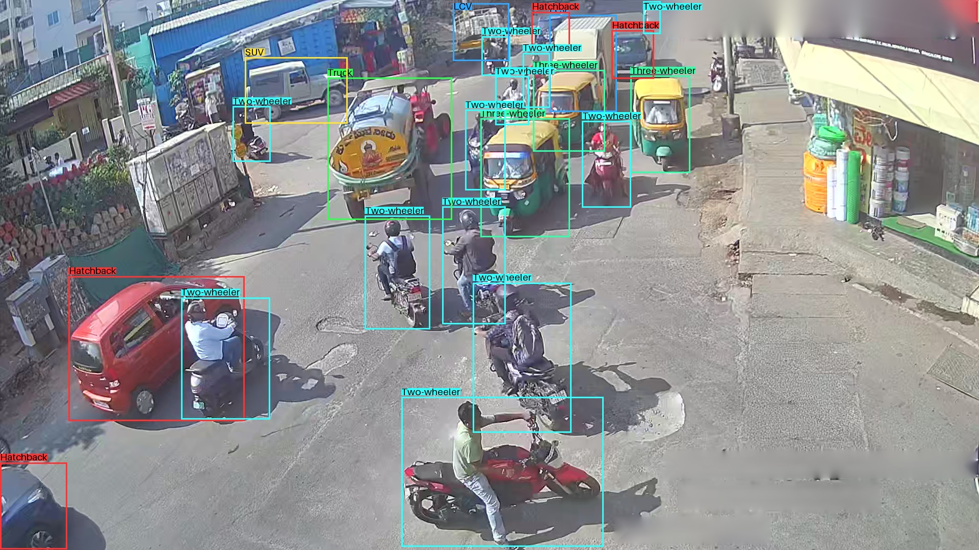
Show this actual training annotation sample. Explain that these boxes are input labels, not model predictions. Source: reports/annotation_samples/final_baseline_seed42_v2/train_17614.jpg

Manav Shah YOLO models and code walkthrough
Our first model was YOLOv8n, a compact detector. We trained it for 30 epochs. An epoch means one pass over the training set, so this run repeatedly learned from the same 8,000 training images rather than using a new dataset every epoch.
Next we trained YOLOv8s, which has more capacity, for 30 epochs on the same training subset. Its selected checkpoint came from epoch 22. The best checkpoint is chosen using validation quality; it is not automatically the final checkpoint.
On the same historical 2,000-image validation set, YOLOv8n achieved 45.84% AP50:95 and YOLOv8s achieved 52.48%. That is why YOLOv8s became our main detector. These numbers are detection scores, not the percentage of entire images classified correctly.
We also tried the same YOLOv8s model at a larger 960 input size. Overall AP improved only slightly and the predefined small-object result became worse. That experiment failed its gate, so we kept 640. We did not train a separate 960 model.
For the code, I will show src/data/common.py and its convert_box function. It checks the box and converts pixel coordinates into normalised coordinates. Then I will show configs/E1_yolov8s_uvh26_mv_640_seed42.yaml, which stores the training settings. Saving settings separately makes the experiment easier to reproduce.
Historical validation2000 | AP50 to 95
YOLOv8n E0 | 45.84%
YOLOv8s E1 | 52.48%
Same E1 at 960 E2 | 52.51%

Handover to Manav Goyal
We now had a working one-stage detector and a verified dataset. Manav Goyal will explain why we tested a different architecture, how we measured performance and what the comparison actually showed.

Manav Goyal Faster R CNN and pilot decisions
YOLO was our one-stage approach. We also tested Faster R-CNN to see whether a two-stage approach would help. It first proposes regions that may contain objects, then classifies and adjusts those regions.
Our Faster R-CNN uses ResNet-50 and a Feature Pyramid Network. In simple words, the backbone extracts visual patterns and the pyramid helps work with objects at different sizes. We replaced the final prediction head with 15 outputs: 14 vehicle classes plus background.
We began from official COCO pretrained weights. Pretraining gives useful visual features; it does not mean the model already knows our exact UVH class definitions. It still needs adaptation and evaluation.
Before a long run, we tested whether the model works on Apple MPS and whether losses remain finite. Batch one was the conservative configuration. Then we ran two three-epoch pilots on 1,000 training and 250 calibration images. One used ordinary shuffle, while the other sampled selected images more often to increase rare-class exposure.
Both pilots began from the same official initializer and used the same settings except sampling. The weighted pilot had a slightly higher overall AP50:95, but it did not improve the supported minority-class measure required by our decision rule. We chose unweighted sampling as the lower-risk setting.
The full Faster R-CNN experiment then ran for 20 epochs on 8,000 training and 500 calibration images. It completed successfully. Its best checkpoint was epoch 13. A historical checkpoint publication problem was recovered with verified resume support; we preserved the history rather than hiding the failure.

Code to show
Open src/experiments/faster_rcnn.py to explain the 15-output prediction head. Open src/experiments/stage_b.py to show the lr function. Explain that a learning rate controls the size of weight updates and was reduced at epochs 13 and 18.

Manav Goyal Explain the metrics clearly
Precision asks: of the detections we made, how many were correct? Recall asks: of the labelled vehicles present, how many did we find? F1 combines precision and recall, but we must state whether we average class F1 scores or combine average precision and recall.
Intersection over Union measures how well a predicted box overlaps the labelled box. AP50 accepts a match at an overlap threshold of 0.50. AP50:95 averages several overlap thresholds, including stricter ones, so it also rewards accurate box placement.
Confidence is the model’s score for a detection. Raising the threshold can remove false detections but may also remove real vehicles. AP uses a range of scores. Precision and recall at a chosen operating point use a fixed threshold.
We cannot compare Faster R-CNN’s 500-image calibration score directly with YOLO’s historical 2,000-image score. We therefore evaluated E1 and E3 on the same 500 images using a common evaluator.
In that matched calibration comparison, E1 achieved 48.28% AP50:95 and E3 achieved 42.91%. E1’s macro F1 was 59.10% compared with 54.65% for E3. Their selected confidence thresholds were 0.34 and 0.43. This supports keeping E1 under this protocol.
These images helped us select settings, so the result is calibration evidence rather than an untouched final-test result. We have not completed the later reserved family comparison. We also do not claim that one decimal difference proves a general scientific advantage without considering support and variation.
Same calibration500 | E1 YOLOv8s | E3 Faster R CNN
AP50 | 57.38% | 56.36%
AP50 to 95 | 48.28% | 42.91%
Macro class F1 | 59.10% | 54.65%

Manav Goyal Evidence errors and fusion
The E3 training curves show falling training loss, but the best calibration result occurs at epoch 13 rather than epoch 20. This shows why we preserve the best validation checkpoint instead of choosing the last file automatically.
E3 is strongest on three-wheelers and two-wheelers in the calibration sample. These categories have 1,035 and 2,920 labelled objects. Others has only 10 examples and zero recall at confidence 0.25. Mini-bus has only 19 examples. We report the support because a small number of objects cannot support a strong general claim.
Common errors include confusing similar passenger vehicles, missing small or partly hidden vehicles and producing overlapping extra boxes. Some uncertain cases may also involve the original annotation. We do not change frozen labels after viewing predictions just to make the score better.
We tested fusion because the models sometimes found different vehicles. Fusion combines predictions; it does not automatically improve them. We tested three families using calibration folds. Weighted box fusion had the best fused AP, but its improvement was below our predefined AP and macro-F1 targets. It also added processing cost. Therefore fusion was rejected and E1 remained the main model.
For speed, E3 achieved 8.747 end-to-end still images per second in its recorded benchmark. This is not live-video FPS. We do not calculate an E1 versus E3 speed ratio from separate benchmarks with different samples and timing boundaries.

Evidence to show
Use Figure 5 in the detailed report for E3 training, Figure 6 for dense-scene errors and the fusion table for the rejected proposal. Explain what each plot demonstrates before pointing to a score.

Handover to Meet Shah
The experiments helped us choose a detector with clear evidence and limitations. Meet Shah will now show how the selected model is used in the dashboard and in the video tracking and counting pipeline.

Meet Shah Dashboard and new image evaluation
The dashboard turns the experimental code into a workflow that a faculty member or developer can understand. It separates the project overview, historical results, new-image evaluation, error analysis and video analytics.
For a new image without labels, the model can draw boxes and show confidence scores. We cannot calculate accuracy because we do not know all the correct answers. For a labelled set, we can compare predictions with independent boxes and calculate precision, recall, F1 and AP.
The application checks uploaded files before evaluation. It verifies image dimensions, label format, class names and box coordinates. It rejects unsafe archive paths and ambiguous file names. If validation fails, the user sees the problem instead of receiving a misleading result.
The new-data workflow uses the selected E1 checkpoint and frozen settings. It reports the dataset, device and thresholds so a result can be interpreted later. The prediction explorer helps us look at specific mistakes rather than only an average score.
If we want a genuinely new study, we should collect varied permitted road photos, annotate them before viewing predictions, freeze the image selection and report how many examples each class has. A few favourable pictures demonstrate the interface but do not prove accuracy.
For the code, I will show dashboard/new_data/ingest.py for upload checks, analysis.py for matching and metrics, and runner.py for evaluation and exports. The project separates these responsibilities so the interface does not contain all the scientific logic.

Short demonstration sequence
- Open the overview and state which evidence is historical.
- Open a saved result and explain its image count, threshold and evaluation scope.
- Show a labelled example with its ground truth and prediction overlay.
- Show one genuine error and explain its category.
- If using unlabelled images, explicitly state that accuracy metrics are unavailable.

Meet Shah Tracking and counting explanation
In a video, the same vehicle appears in many frames. We use ByteTrack to associate detections across frames and assign a track identity. We then count an event when the vehicle crosses a defined line in a defined direction.
Our counting rule uses the bottom-centre point of the vehicle box. We require several observations and enough movement. A small dead zone around the line reduces repeated events caused by jitter. The crossing must also be inside the finite line segment, not simply anywhere along an imaginary infinite line.
A track can be counted once per direction. If it returns across the line in the opposite direction, that can be a second event. Therefore we report directional crossings, not a guaranteed total of unique physical vehicles in the whole clip.
We tested a permitted 30-second Bangalore road clip containing 900 frames at 30 FPS. The complete prerecorded pipeline processed it at 60.04 FPS. It predicted 40 crossings: 12 downward and 28 upward. These are predictions, not verified ground-truth counts.
The important remaining step is independent manual review. The annotation tool lets a reviewer inspect the source frames and mark real crossings without first viewing model predictions. Only after that review can we calculate counting precision, recall, F1 and count error.
Our predefined pilot targets are event F1 of at least 0.80 and count WAPE at most 20%. We have not shown that these targets are met. Processing fast enough and counting correctly are two different requirements.

Code to show
Open src/video/tracking.py for track histories and src/video/counting.py for the LineCounter. Point out the side calculation and duplicate-count guard. The human annotation workflow is in phase3b_annotations.py; event scoring is in phase3b_evaluation.py.

Meet Shah Tests limitations and conclusion
We tested the software and validated saved artifacts. The latest Phase 3B record has 311 passing local tests and 292 in the isolated eligible repository snapshot. The difference is due to additional local tests outside that delivery. Tests check behaviour; they do not replace a labelled real-world evaluation.
We also preserve hashes of data manifests, configurations and checkpoints. A hash acts like a file fingerprint. It helps establish that the file used for evaluation is the recorded one. It does not prove that a model is accurate by itself.
There are clear limitations. We trained with one seed. Rare classes have small support. Calibration images were used for selection. The reserved pool has historical validation exposure. The full original dataset was not completely acquired and verified. The video study is one short clip with human counting validation pending.
Our conclusion is that we have built a working and auditable vehicle detection and traffic analytics project. We have measured detector performance, tested alternatives and retained YOLOv8s. We also have implemented tracking and directional counting with measured processing speed. The next validation step is independent human event review and a broader new-image study.
Thank you. We can now demonstrate the application or explain any part of the code and experiments in more detail.

Keep these claims precise
Say | Avoid saying
AP50 to 95 is 52.48% on historical validation2000 | The model is 52.48% accurate everywhere
40 predicted crossing events | Exactly 40 real vehicles were counted correctly
60.04 FPS for the measured prerecorded pipeline | The deployed live system is guaranteed real time
Fusion was tested and rejected | Fusion is our final deployed model
Calibration result | Completely unseen final test result

Faculty questions and short answers

Why did you choose YOLOv8s?
It improved on the compact YOLOv8n baseline under the same historical validation protocol and led the later matched calibration comparison against E3.

Why use Faster R-CNN if YOLO was already working?
We wanted to test a different two-stage architecture under controlled settings. Its result provides evidence about an alternative rather than assuming one family is always best.

Why is the best epoch not the last?
Training loss and validation quality can move differently. E3 had its best calibration AP at epoch 13, so that checkpoint was selected.

Why did a bigger input not win?
The 960 experiment gave only a tiny overall gain and failed the predefined small-object gate. More computation does not guarantee better results.

What is overfitting?
A model can learn the training data well but perform less well on other images. Validation helps detect that gap, although reused calibration data still has selection bias.

What does a confusion matrix show?
It shows which classes are confused and where predictions or annotations are matched to background. We must read the axis orientation and matching settings.

What does seed 42 do?
It fixes specified random choices for reproducibility. It does not guarantee identical behaviour on every device or show how results vary across multiple training seeds.

Can the model evaluate any external dataset directly?
Only after confirming compatible class meanings, valid box formats and the evaluation protocol. Generic car labels do not directly match our fine-grained passenger-vehicle classes.

What work is still pending?
Independent human review for video-counting accuracy, broader external evaluation and any separately authorised future training improvements.

What did each member contribute?
Explain your actual collaboration honestly. This document divides presentation topics; it is not a historical record of individual implementation ownership.

