# ONLINE BIDDING SYSTEM

**UCS503**

## Software Engineering Project Report End Semester Evaluation

**Submitted by:**

Malvika Tagra(101703316)

Manav sharma(101703320)

Manjot Kaur (101703327)

BE Third Year, COE

## Submitted to

Dr. Amrita

CSED,TIET



## Computer Science and Engineering Department TIET,Patiala

**TABLE OF CONTENTS**

* Project Overview 3
* Project Requirement 4
* Functional Requirement
* Non Functional Requirement
* Structured Analysis 6
* Data Flow Diagram
* Data Flow Diagram Level 0
* Data Flow Diagram Level 1
* Data Dictionary
* Object Oriented Analysis 10
* Use Case Diagram
* Use Case Scenario
* Use Case Template
* Class Diagram
* Sequence Diagram
* Component Diagram
* State-chart Diagram
* Collaboration Diagram
* Activity Diagram
* Deployment Diagram
* Testing 16

## PROJECTOVERVIEW

### Objective:

Our project “Bidding system” is a system of buying and selling goods or services by offering them for bidding, allowing people to bid, and selling to the suitable bidder.

### Introduction:

Person can act as both bidder or seller. Seller can upload information about their project and the bidder can use it to make a bid. Seller has to specify time duration andbidder has to bid in that specific time. Payments and feedbacks are followed after the end of service.

### Purpose:

Purpose of our project is to provide work to the bidders by the sellers. Firstly, bidders bid for a particular project then seller will give it to the preferred bidder. This will be the best platform to give opportunities to people to monetize their skills and talents.  Bidders are often considered to be [self-employed](http://www.businessdictionary.com/definition/self-employed.html), and have the [freedom](http://www.businessdictionary.com/definition/freedom.html) to pick and choose their projects and companies they would like to be [associated](http://www.businessdictionary.com/definition/associated.html) with. It is one of the crucial factors which decides bidder’s earning and suitability to provide the seller with 100% satisfaction and meet the requirements of the project. Bidder should opt for a skill which you are really good at. According to his/her resume he would get the suitable work.

### Future Scope:

### Freelancing has a huge scope if you are willing to put enough efforts to overcome your 9-5 job income. India is a country which is contributing millions of dollars in the freelancing market and the hunt of good freelancers is never-ending. The sky is the limit. As long as the new startups are coming up, the need for manpower and resources will increase drastically. Even multiple established firmsare looking for good freelancers who can get their job done at minimal rates considering time constraint.

## PROJECTREQUIREMENT

### Functional Requirements

In software engineering, a functional requirement defines a system or its component. It describes the functions the software must perform. A function is nothing but inputs, its behavior, and outputs. It can be a calculation, data manipulation, business process, user interaction, or any other specific functionality which defines what function a system is likely to perform.

Following are the functional requirements of our “BIDDING SYSTEM”.

### User Authentication:

### Seller and Bidder are required to fill the details with necessary validated inputs and registered to the system and using credentials doing the logintask.

### Data Input:

### Seller will put projects for bid whereas bidder can see all the projects and can apply for the suitable project which he/she can do in the specified time.

### Browsing:

The user should be able to view items available for purchase. The user should be able to view items requested to be made available for purchase.The user should be able to view the review of a buyer or seller as posted by other users.The interface will include instructions and contextual prompts for performing the tasks of logging on, subscribing, selling, buying and browsing items.

### Bidding on projects/services:

The user should be able to bid on items available for sale. All bids are binding. Non-winning bids are not binding. Winning bids may be negated by agreement of both parties. Variable bidding types/styles will be available. The user can set a ceiling bid over which they will not bid. Thesystem will automatically increment their bid according to theirbid style, up to the ceiling bid.

### Take system Backup:

### The admin can back up the entire database in order to prevent loss of data on system crashes.

### Generate Reports:

### Responsible for checking the logs of different bidders for auditing and maintaining the integrity of thesystem.

### Non-Functional Requirements

A non-functional requirement defines the quality attribute of a software system. They represent a set of standards used to judge the specific operation of a system. A non-functional requirement is essential to ensure the usability and effectiveness of the entire software system. Failing to meet non-functional requirements can result in systems that fail to satisfy user needs.

Following are the non-functional requirements of our “BIDDING SYSTEM”:

**User friendly:**

Interface is user friendly, understandable and easy to use so that the users of the system can easilylearn to use the system.

### Time Element (response and processing time):

The response time of the system is very less and takes less time to execute queries.

### Flexibility:

The system is flexible in nature so that likely changes and alterations can be made easily.

### User Satisfaction:

### System will be able to satisfy the user requirements. This is the main and conspicuous measure of the system performance.

## 3.STRUCTUREDANALYSIS

### Data Flow Diagrams

**3.1.1:**

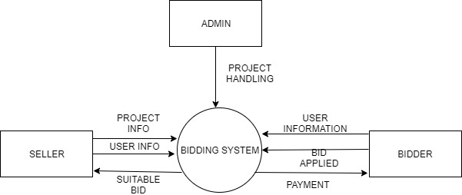

**Figure 1: Level 0 data flow diagram (context diagram)**

**3.1.2:**

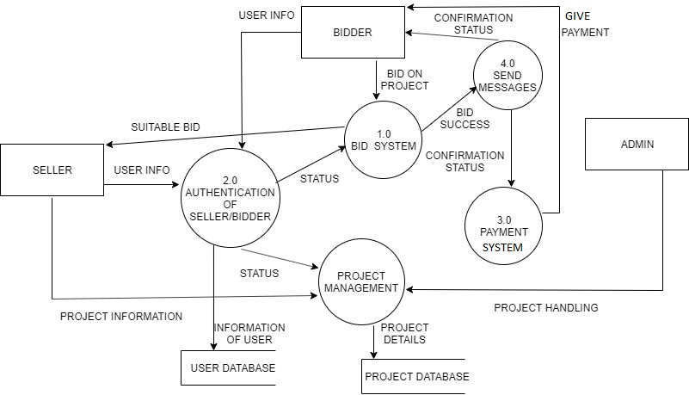

**Figure 2: Level 1 data flow diagram**

## DataDictionary

**Process table**

|  |  |  |  |
| --- | --- | --- | --- |
| **Name of data item** | **Alias** | **Description** | **Range of values** |
| **Authentication** | **Authentication** | **Contains details Of user after authentication of the user** |  |
| **Bid management** | **Bid management** | **Contains bids By various bidders and suitable bid Chosen by the process** |  |
| **Payment System** | **Payment system** | **Process to give payment to the bidders for their work** |  |
| **Project Handling** | **Project Handling** | **Projects handled by admin which are put by the seller** |  |
| **Send messages** | **Send messages** | **When bid is accepted by the bid management then confirmation send to bidder** |  |

### Data Store Table

|  |  |  |  |
| --- | --- | --- | --- |
| **Name of data item** | **alias** | **Description** | **Related data items S no., project id, Project name, max/ min bid (of that specific project)** |
| **Projects** | **Projects** | **Includes details of Projects that are put on the site by the seller or Organization which are to be done by the bidder** |  |
| **User details** | **User details** | **Contains user details** | **User can be seller or buyer which registers on the site** |

**Data flow table**

|  |  |  |  |  |  |
| --- | --- | --- | --- | --- | --- |
| **Name of data item** | **alias** | **description** |  | **Range of values** | **Data structure** |
| **Suitable bid** | **Suitable bid** | **Out of all the bids given by the bidders, best is chosen and given to the Seller** | |  | **number** |
| **Give Payment** | **Give Payment** | **It is generated by The Payment System and given to the bidder for his/her work done** | |  | **number** |
| **Status** | **Status** | **It is a Boolean confirmation to the processes** |  |  | **number** |
| **Project Details** | **Project Details** | **Details of project to be posted** | |  | **varchar** |
| **User info,Project info** | **User info,Project info** | **Details of the person who is using the portal and project info given by the seller** | |  | **varchar** |
| **Confirmation status** | **Confirmation status** | **When suitable bid is found then confirmation is given to the payment system for further proceeding** | |  | **number** |
| **Bid success** | **Bid success** | **When bid is confirmed then messages are to be sent to the seller and bidder** | |  | **number** |

## ER DIAGRAM:

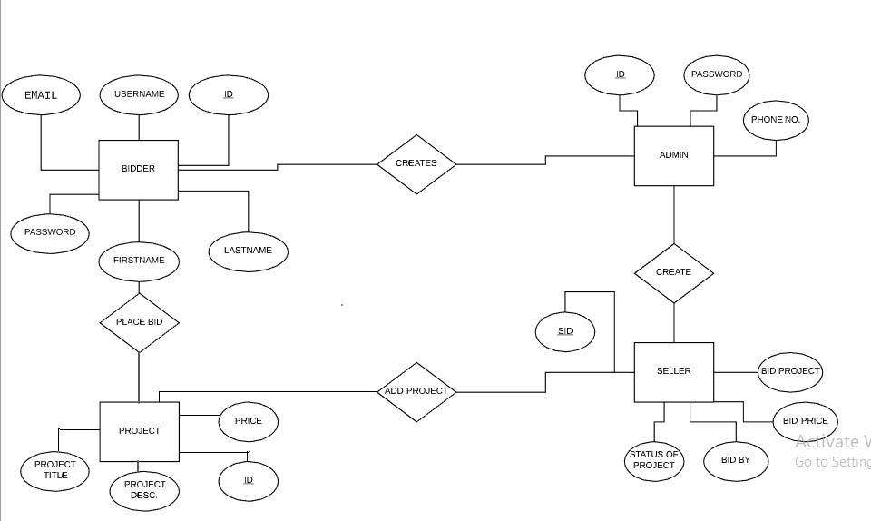

1. **OBJECT ORIENTEDANALYSIS**

**USE CASEDIAGRAM:**

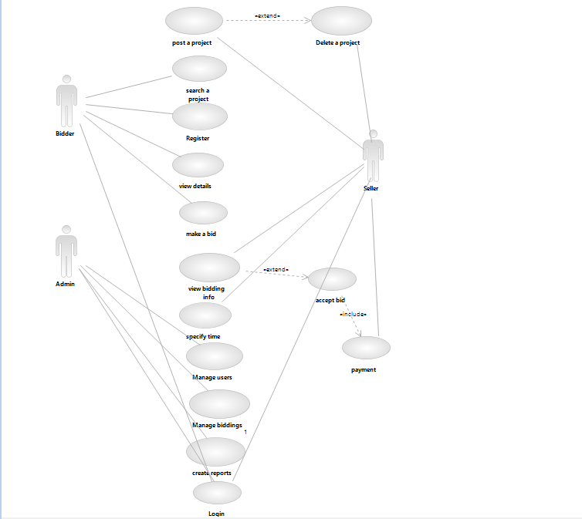

**USE CASE SCENARIO:**

Use case scenario for – make a bid on project.

### Normal Scenario:

1. (SR)The login/register page appears.
2. (SR)Login page asks the user to enter his/her credentials.
3. (SA)Machine reads user id and asks the user password.
4. (AA)The user enters password.
5. (SA)The system verifies the credentials.
6. (SR)The system asks the user to select whether he wants to be a bidder or aseller.
7. (AA)User selects the role.
8. (SR)System displays various options like browsing different projects, adding a project .
9. ( AA)The user bids on project.
10. (AA)User selects the project he wants to do.
11. (SR)System check for lowest bid in some period of time.
12. (SR)System displays that project has been given to bidder successfully.
13. (AA)The user clicks on logout option.
14. (SR)System ask’s user whether they are sure they want to logout.
15. (AA)User indicates yes.

### Alternative Flow of Events:

4. User is entering wrong login password.

**Exception flow of events:**

1. System is not showing login page.

5. System is not logging in.

7. System is not showing list various options.

11. System is not accepting lowest bid.

14. System does not show logout option.

### USE CASE TEMPLATE

|  |  |
| --- | --- |
| **Use case title** | **Bidding management.** |
| **Use case id** | **2** |
| **Actors** | **bidder** |
| **Description** | **With this facility, the bidder can see the available projects and make a bid on project.** |
| **Pre- conditions** | **Bidder and seller must be logged in.** |
| **Task sequence** | **1 screen will be shown by system**  **2. select bidder or seller option**  **3 add or buy projects** |
| **Post conditions** | 1. **Bidder can view new project.** |
| **Modification History** | **2 oct ,2019** |
| **Author** | **Manav Sharma,Manjot,Malvika** |

1. **Class Diagram**

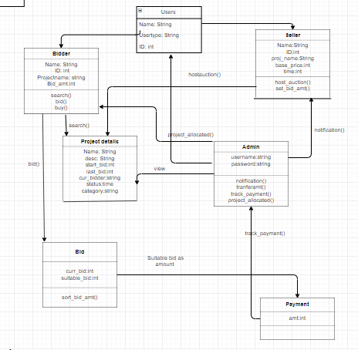

1. **Sequence Diagram**

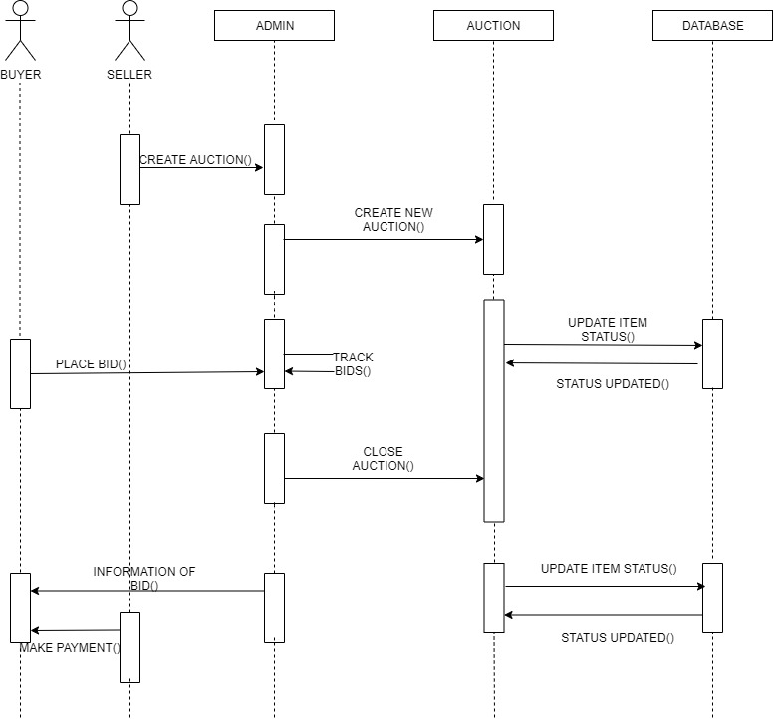

1. **Component diagram**

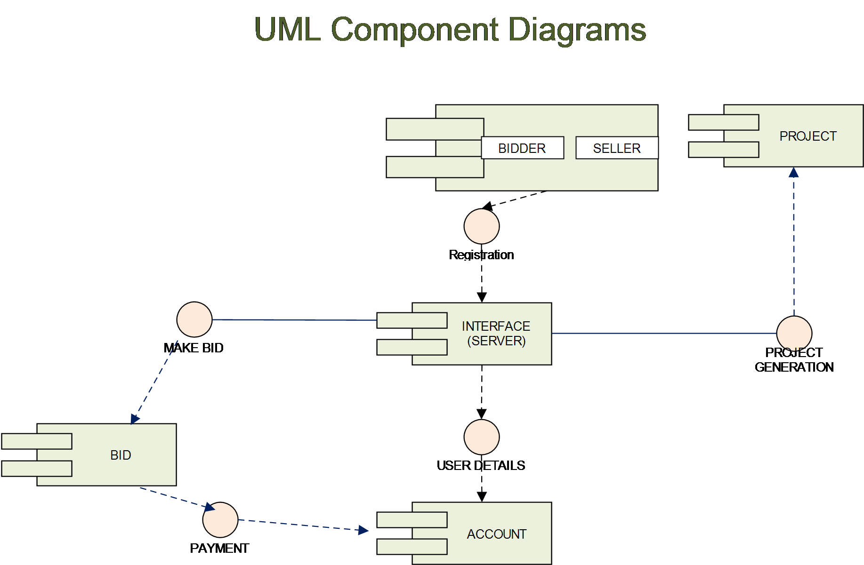

1. **State-Chart Diagram**

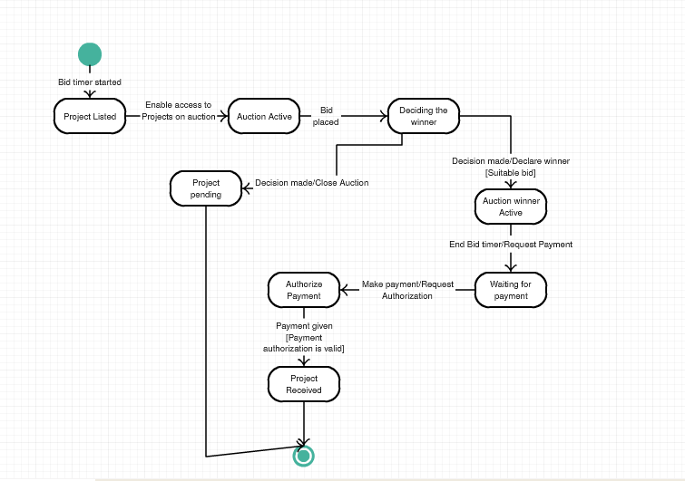

1. **Collaboration Diagram**

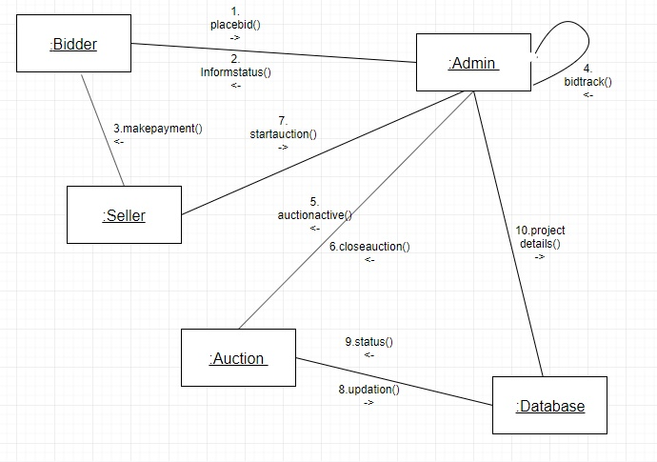

**6. Activity diagram**

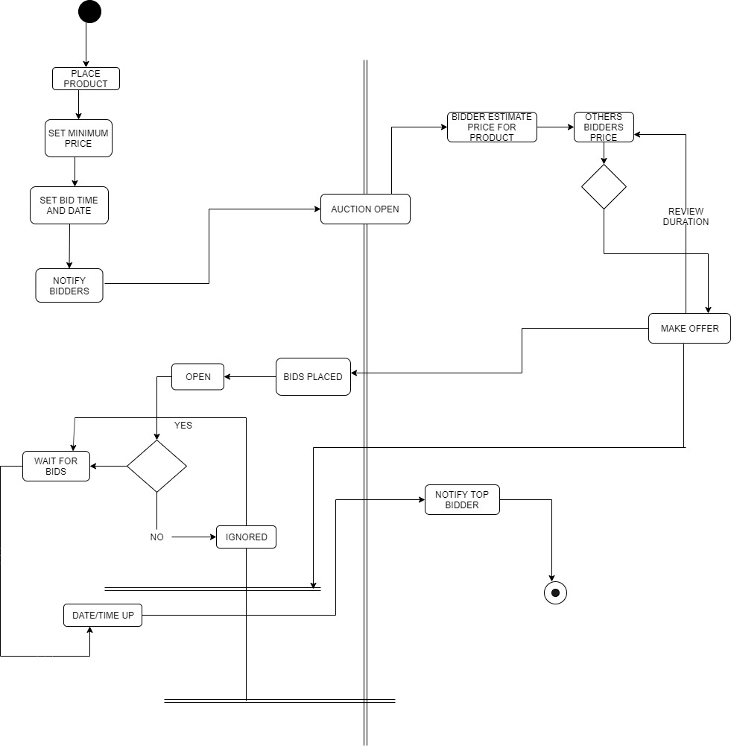

**7.Deployment Diagram**

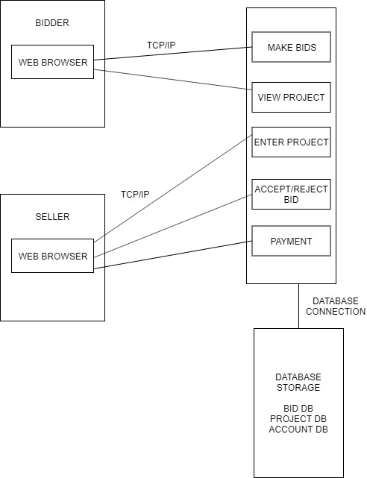

Testing:

**Test Case Report**

|  |
| --- |
| Test Case # : 1 Test case Name : First  Short description : check basic functionality .  Execution Date : 20/11/2019 |

|  |
| --- |
| **Pre-conditions**  The user has a working Android/IOS/Windows smartphone |

|  |  |  |  |
| --- | --- | --- | --- |
| **Input no.** | **Action** | **Expected System Response** | **Pass/Fail** |
| 1 | Entering unregistered credentials | Pop up saying that Login credentials don't match | Pass |
| 2 | Not Filling up the resume | Pop up asking user to enter the resume | Pass |
| 3 | Entering email id without @ | Pop up asking user to enter correct email | Pass |
| 4 | Entering wrong password to the previous one | Pop up displaying credentials don't match | Pass |
| 5 | Enter less digits of mobile no | Pop up to display enter correct phone no | Pass |
|  |  |  |  |

SCREENSHOT

1.

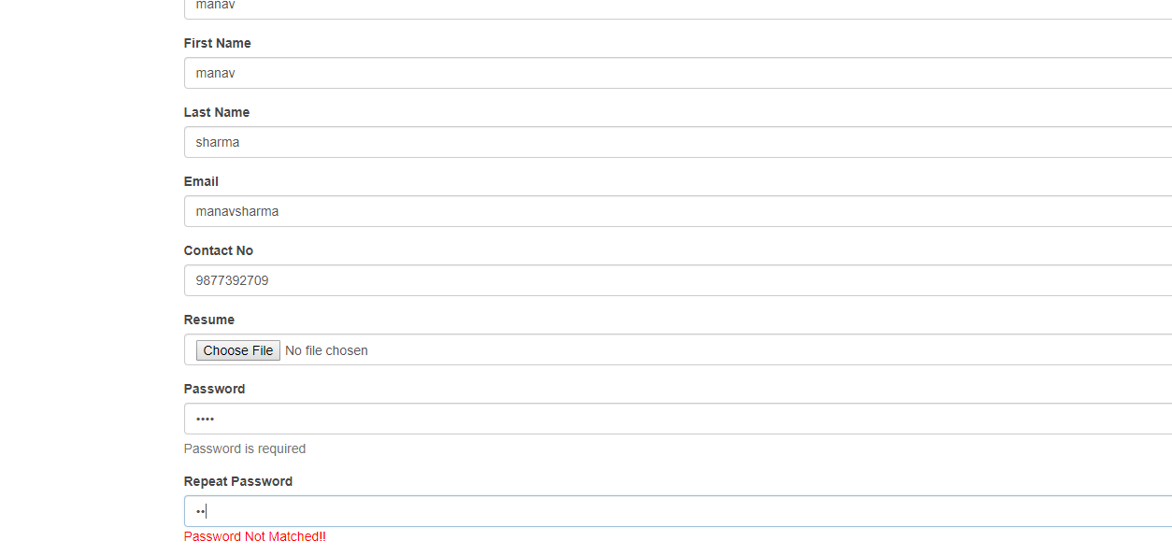

POP –UP on entering wrong password.

2.

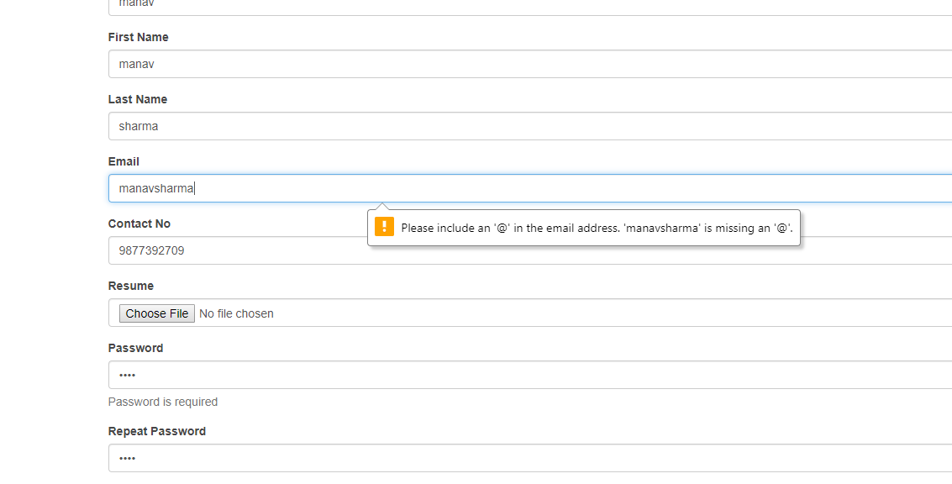

Pop up on entering email without @

3.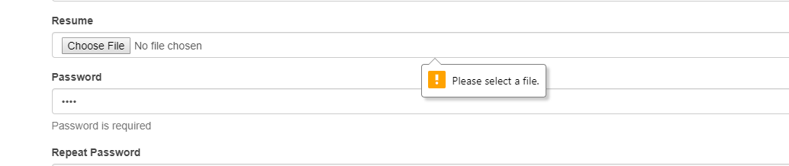

Pop –up showing for resume file not chosen.