PHASE-3

PROJECT

Sportyshoes.com

Spring MVC Application

# 

Dakamanbha Ryngkhlem

dakamanbha@gmail.com

Abstract

A prototype Web Application developed using Spring Boot framework

# 

Contents

0

PROJECT DESCRIPTION 2

Objective 2

BACKGROUND OF THE PROBLEM STATEMENT 2

REQUIREMENTS 2

Admin: 2

Products 2

Software Used 2

GITHUB LINK 2

SPRINT PLANNING 3

WORKING TREE 3

OUTPUT 4

# PROJECT DESCRIPTION

## Objective

1. To develop a prototype of the application named as SportyShoes.com
2. Use the GitHub repository to manage the project artifacts.

# BACKGROUND OF THE PROBLEM STATEMENT

Sporty Shoes is a company that manufactures and sells sports shoes. They have a walk-in store, and now, they wish to launch their e-commerce portal sportyshoes.com.

# REQUIREMENTS

## Admin:

1. The admin should be able to change his password.
2. Browse the list of users who have signed up and be able to add users

## Products

1. Manage the products in the store including categorizing them.
2. See purchase reports filtered by category

## Software Used

1. Intellij Idea: An IDE to code for the application
2. Java: A programming language to develop the web pages, databases, and others
3. Spring: provides a framework that is more flexible and it also has a lot of the tools that come with the Spring framework
4. SQL: To create tables for admin, airlines, and other specifics
5. Maven: To create a web-enabled Maven project
6. Git: To connect and push files from the local system to GitHub
7. GitHub: To store the application code and track its versions
8. Scrum: An efficient agile framework to deliver the product incrementally
9. diagrams.net: An open-source for drawing a flow-chart.
10. Microsoft Excel: To create a Sprint Planning Work-flow.
11. Hibernate: provides a framework to map object-oriented domain models to relational databases for web applications

# GITHUB LINK

**GitHub Repository**: <https://github.com/manbha03/Phase-3-Project>

# SPRINT PLANNING

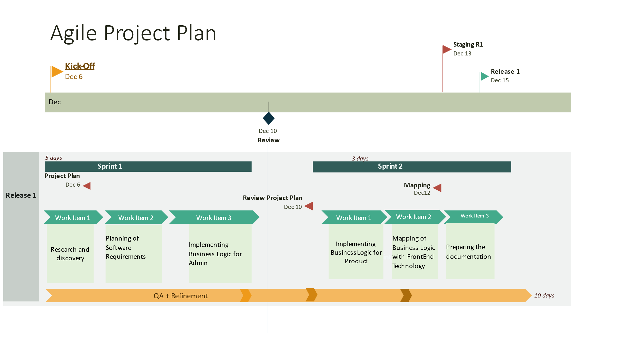

# WORKING TREE

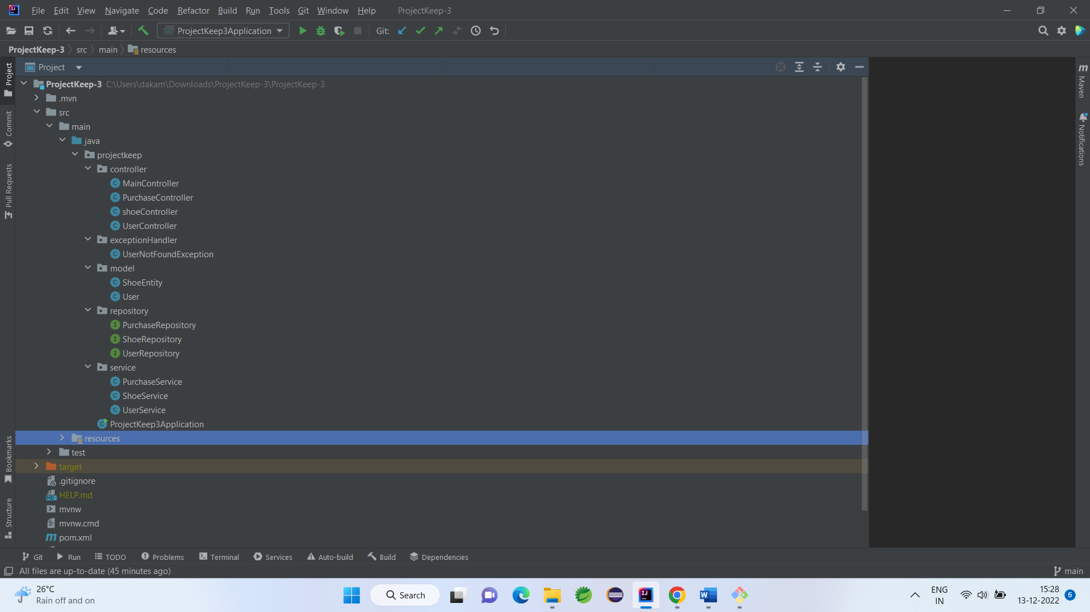

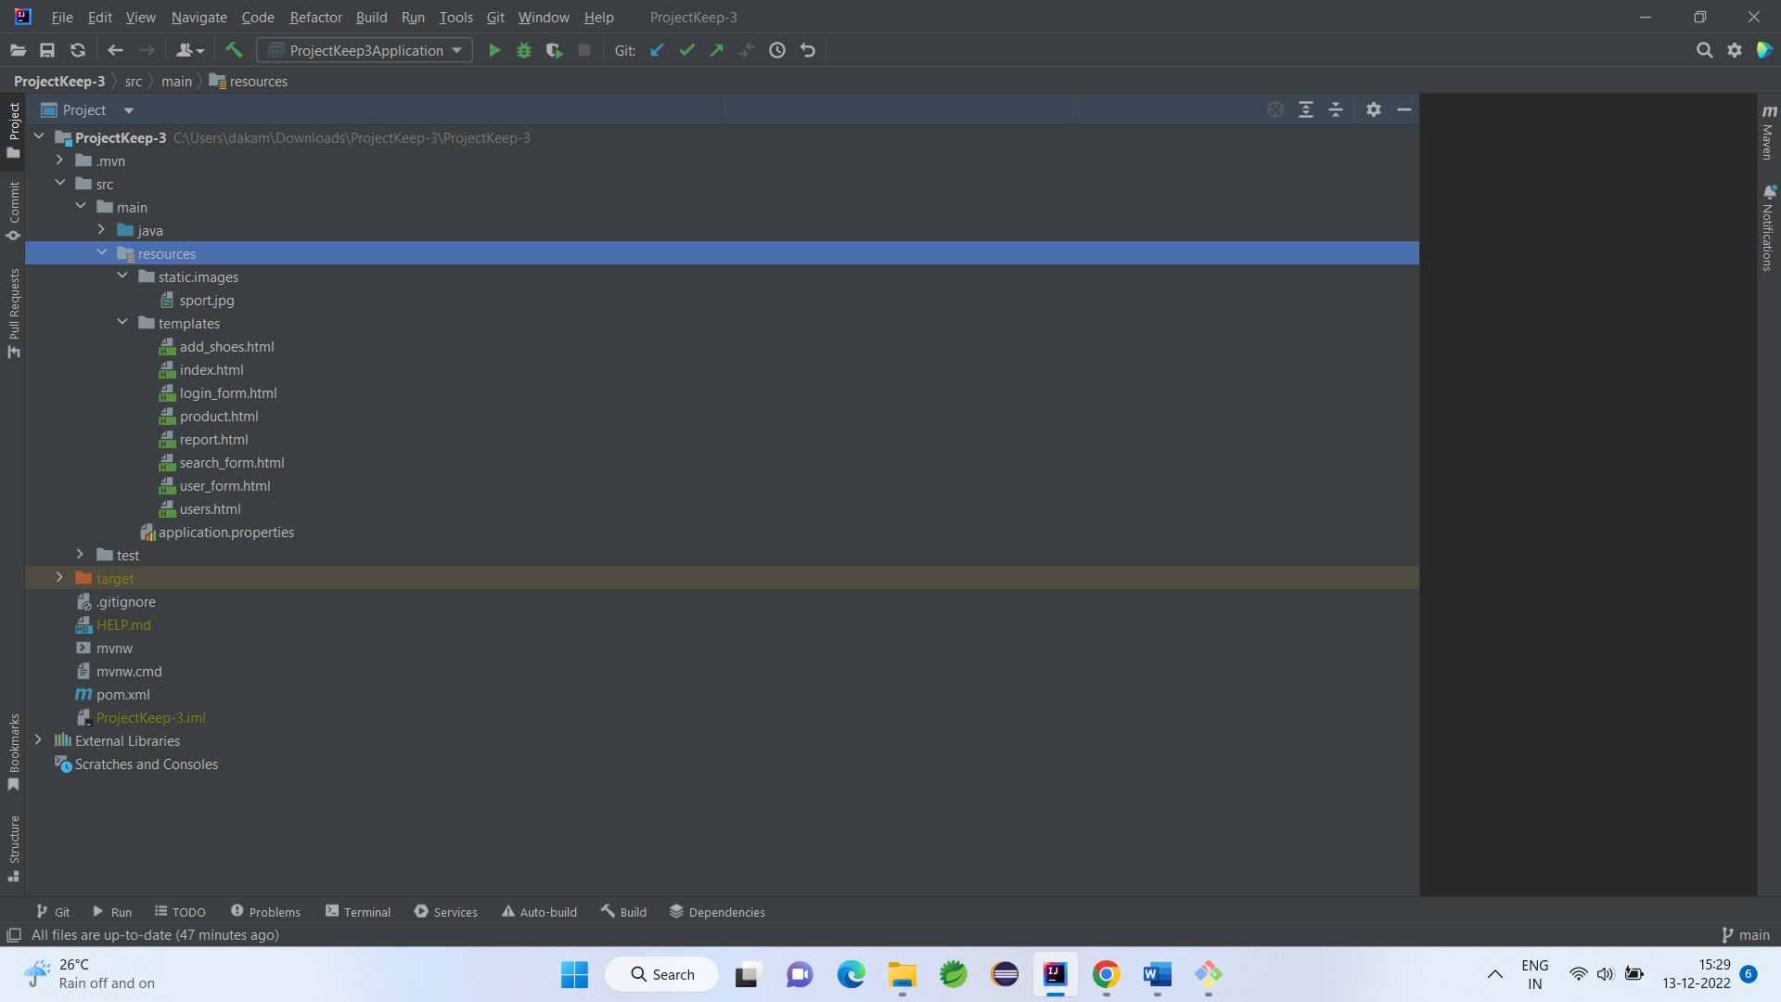

# OUTPUT

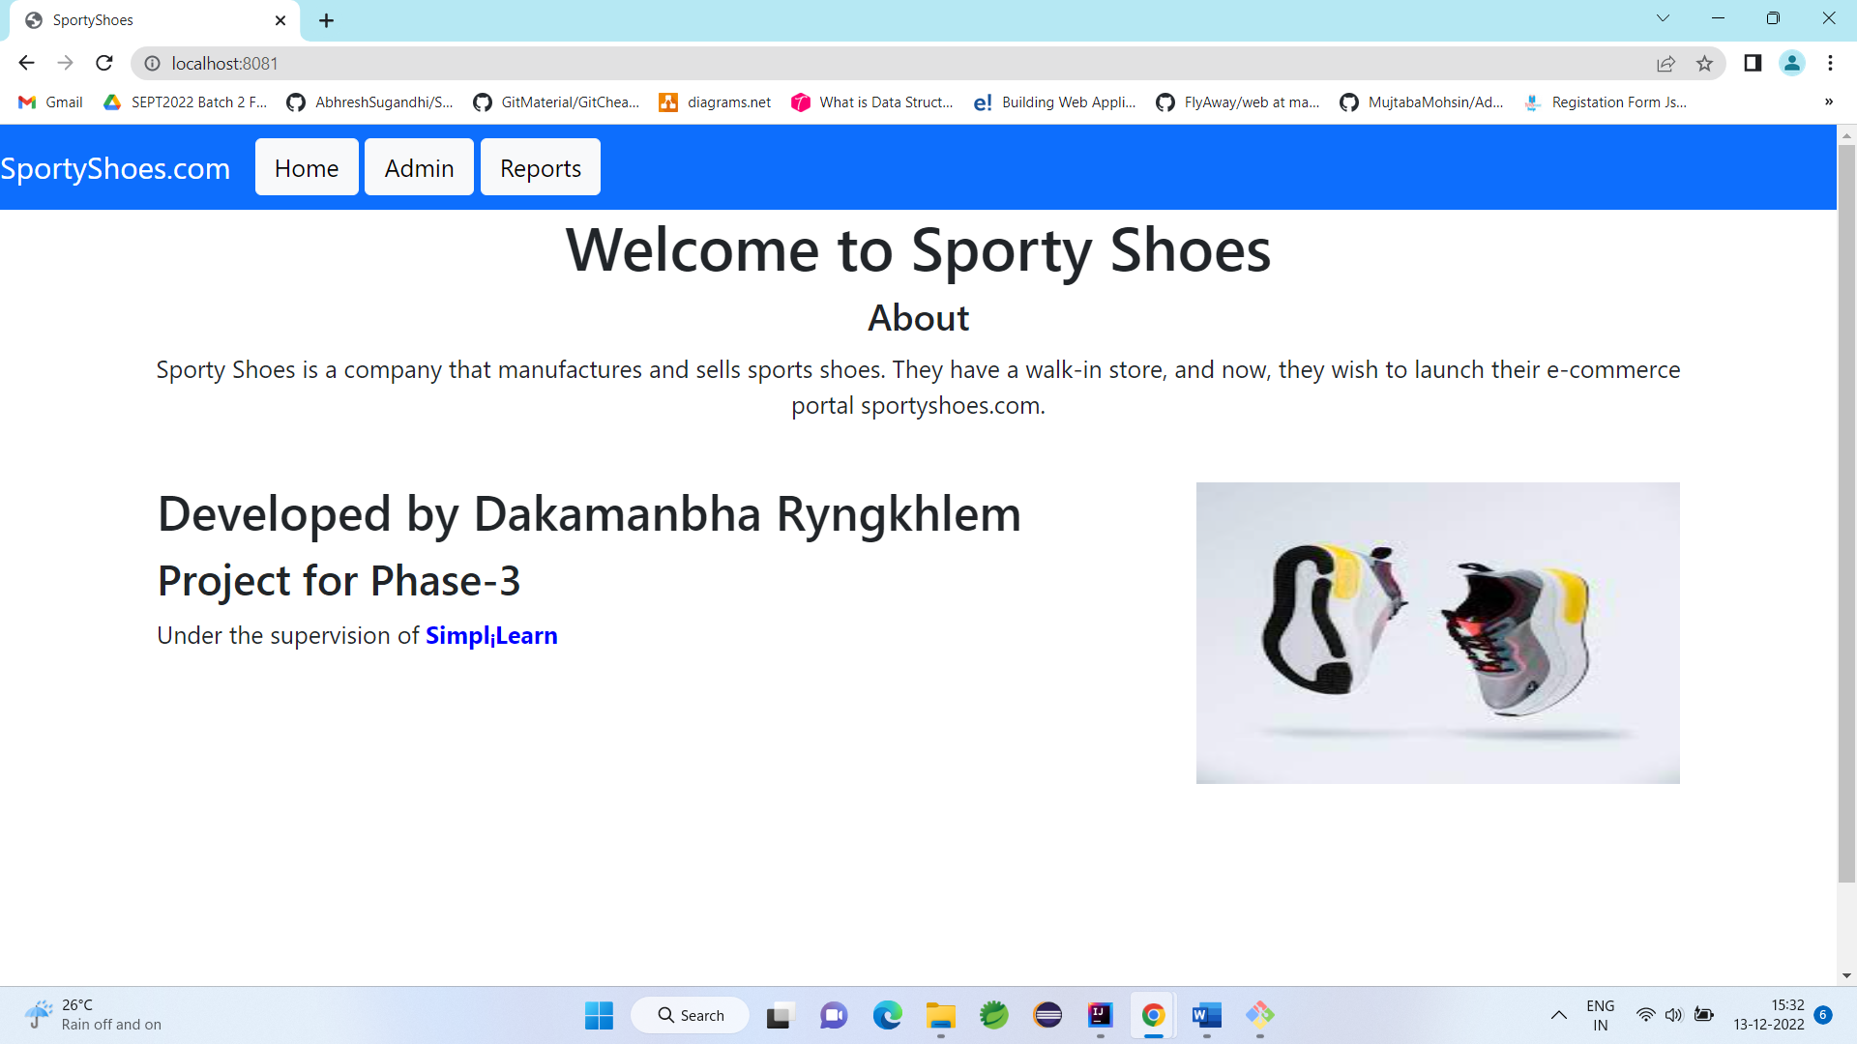

Figure 1: http://localhost:8081

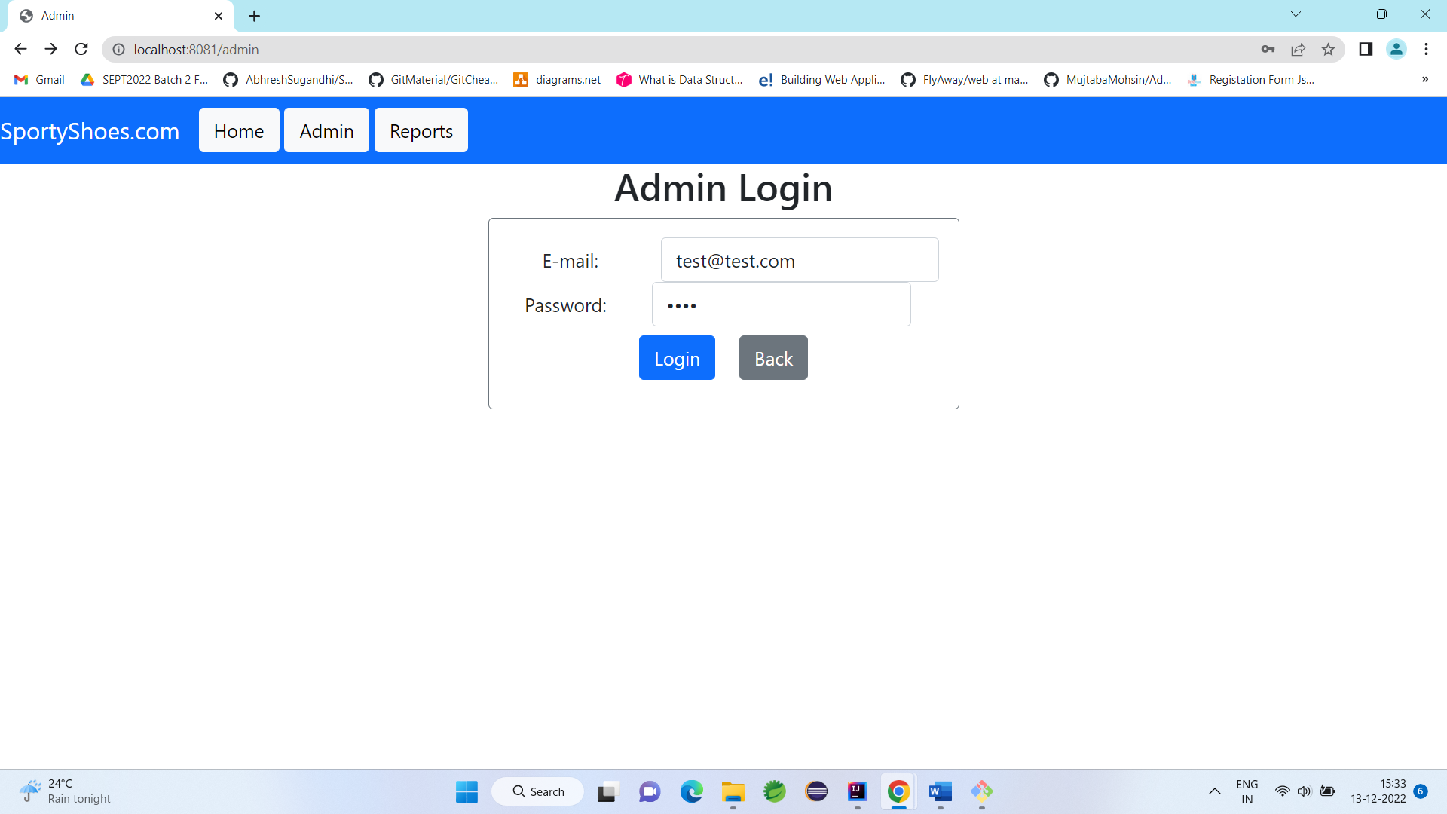

Figure 2: http://localhost:8081/login

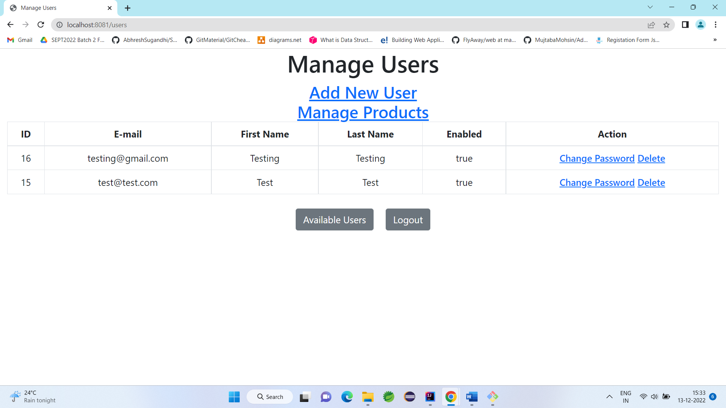

Figure 3:http://localhost:8081/users

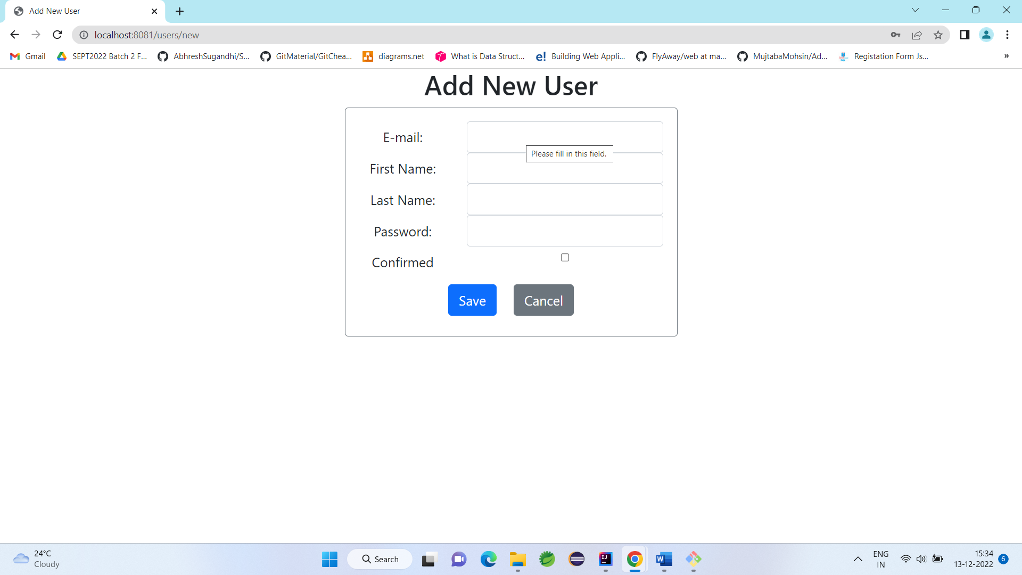

Figure 4:http://localhost:8081/users/new

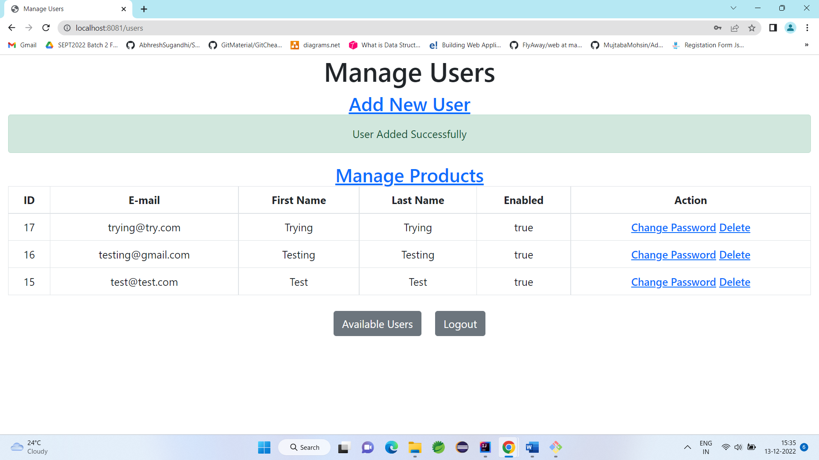

Figure 5: User Added Successfully

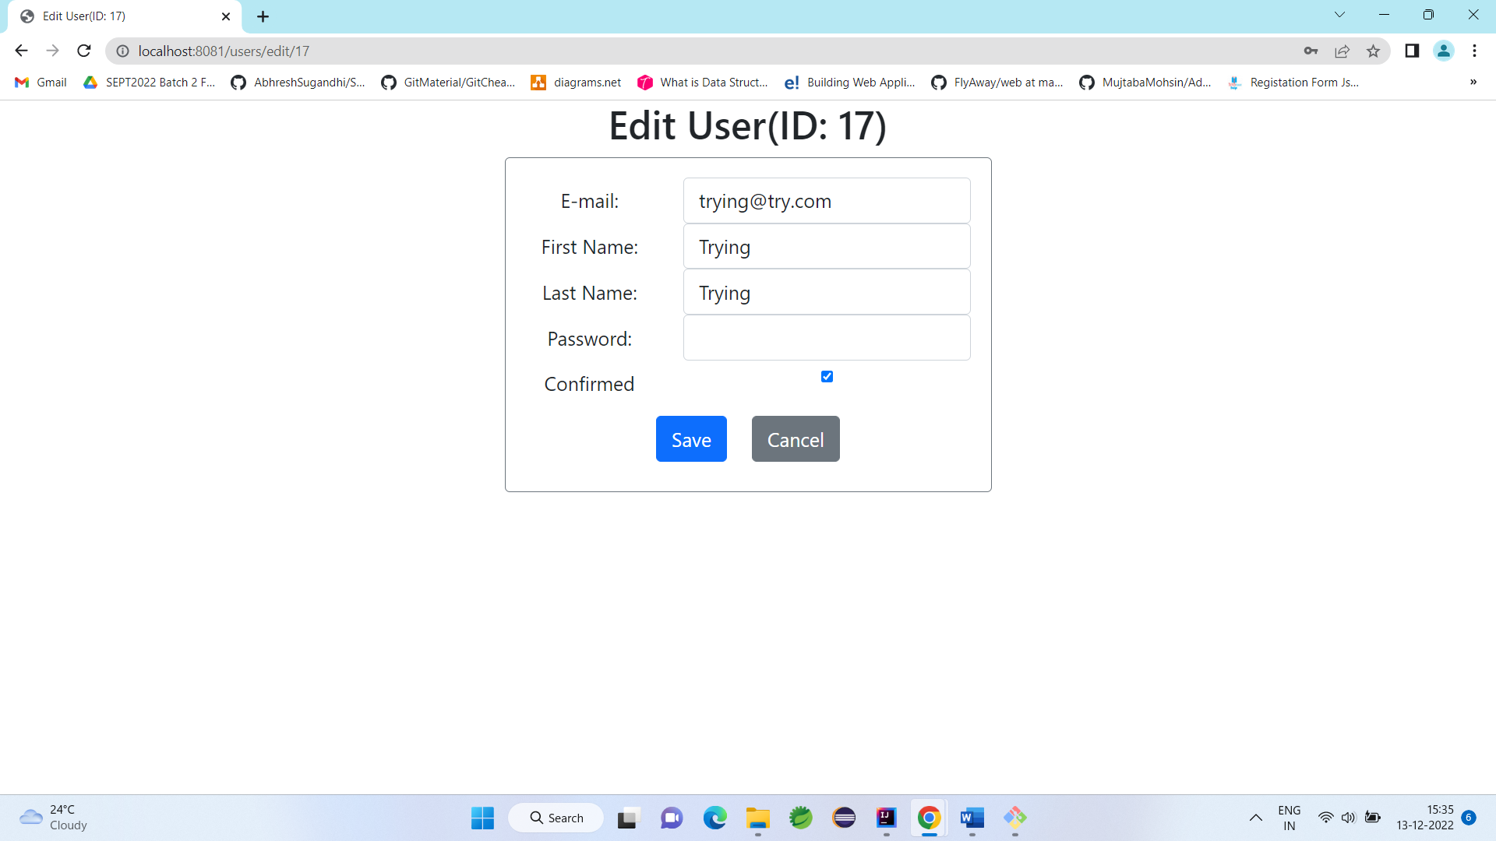

Figure 6: http://localhost:8081/users/edit/15

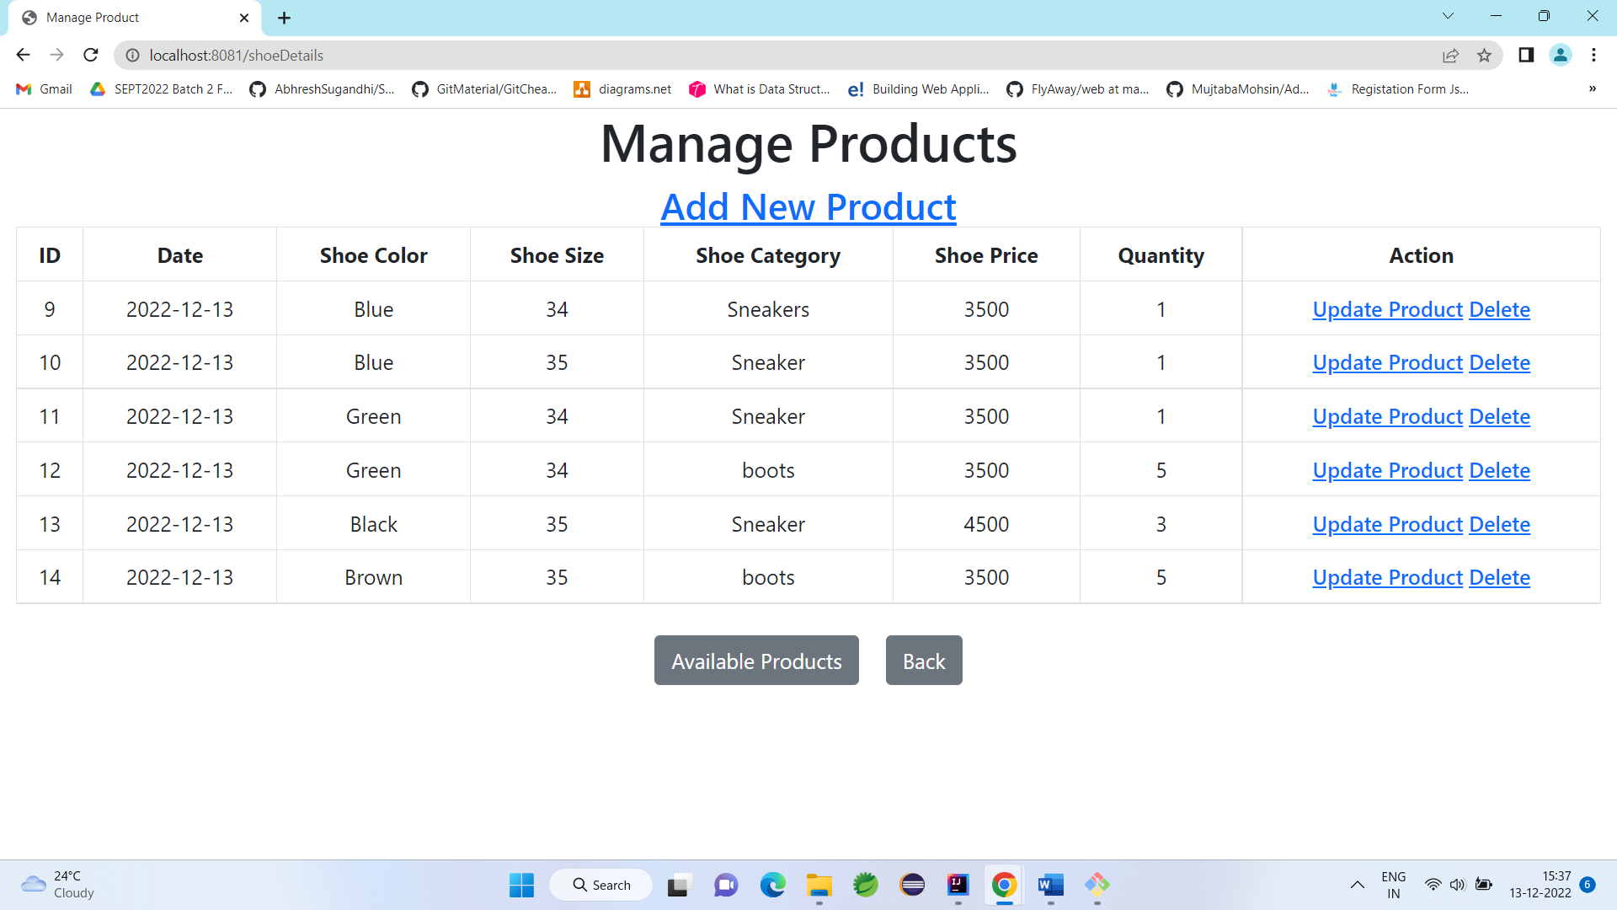

Figure 7: http://localhost:8081/shoeDetails

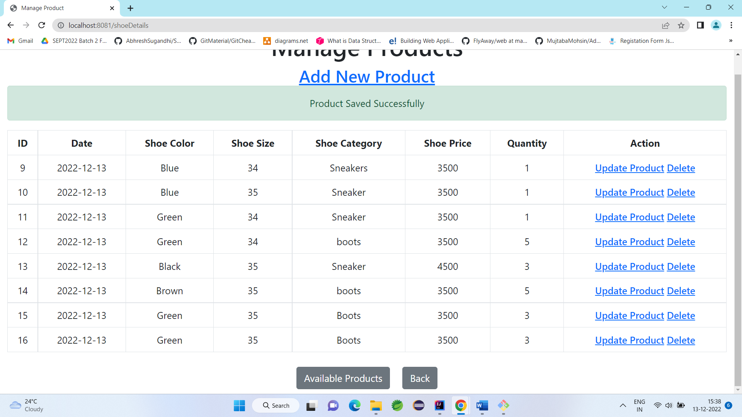

Figure 8: Product Added Successfully

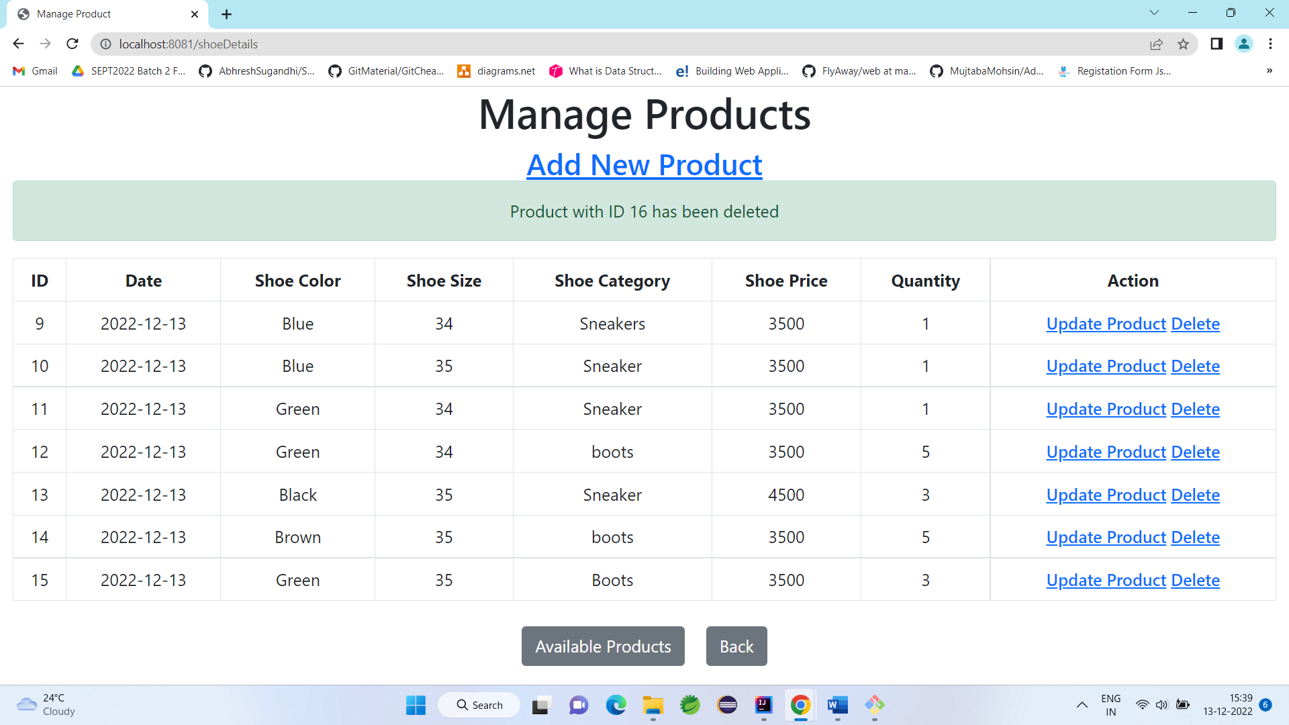

Figure 9: Product Delete Successfully

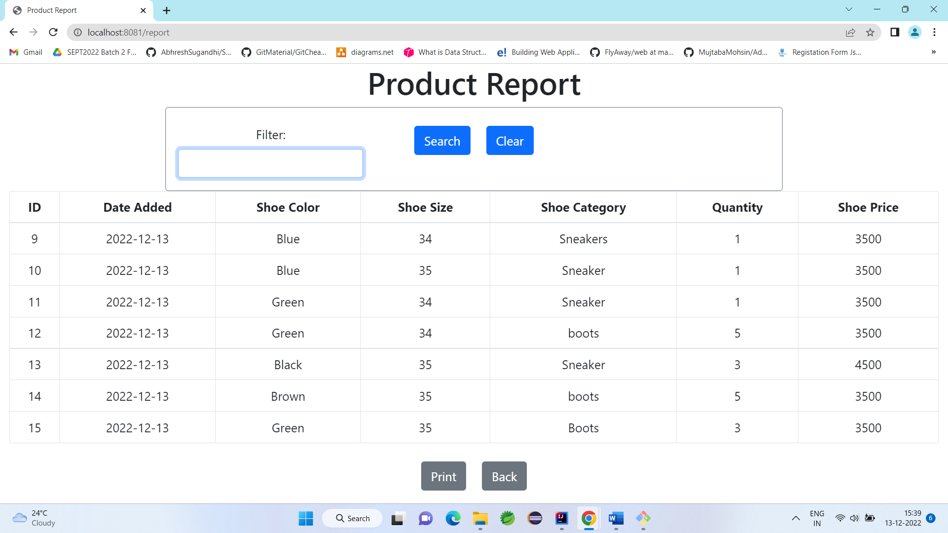

Figure 10: http://localhost:8081/report

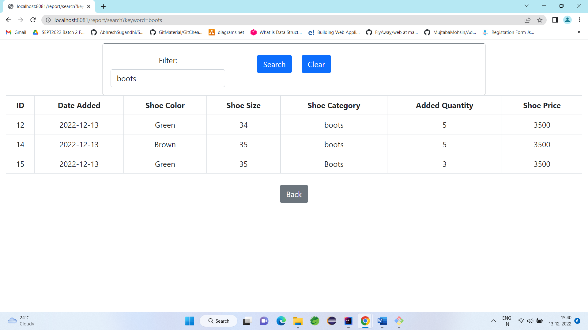

Figure 11: http://localhost:8081/report/search?keyword=boots

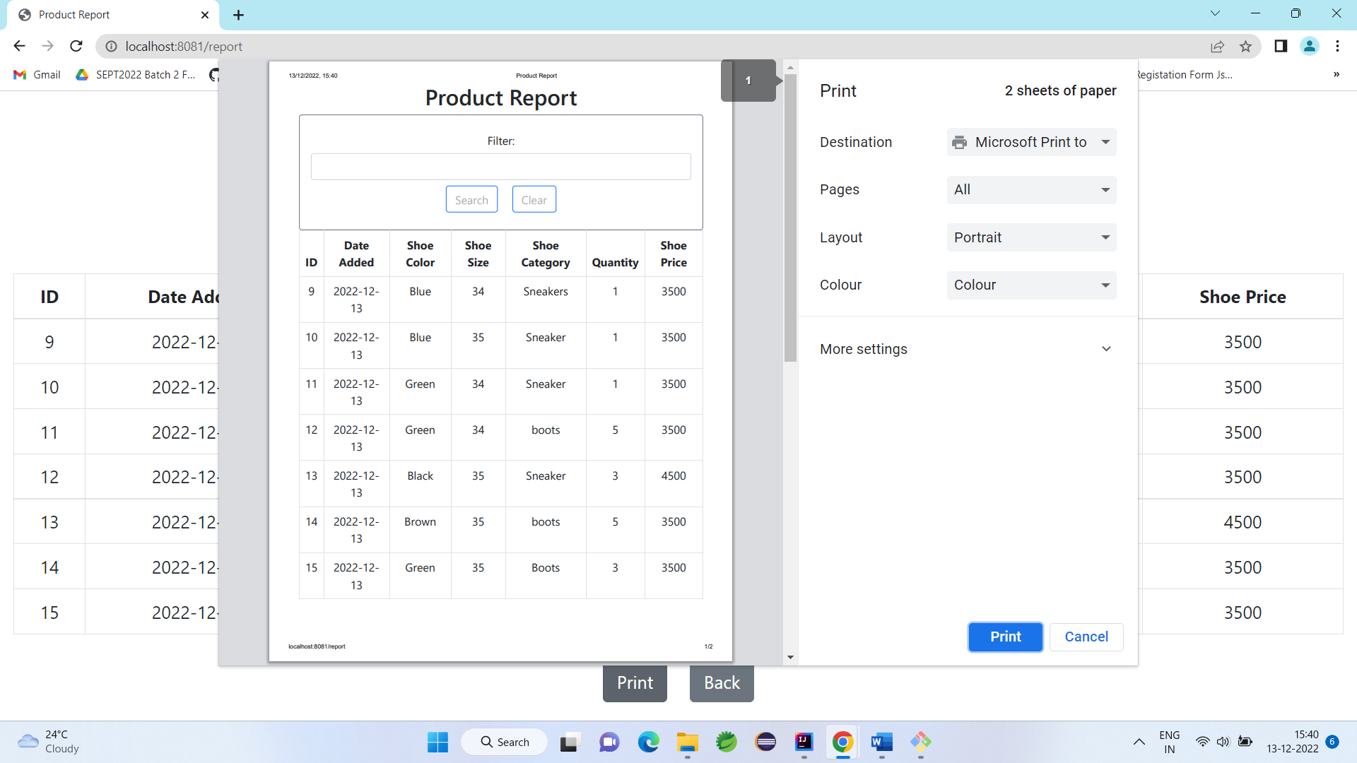

Figure 12: Print Report