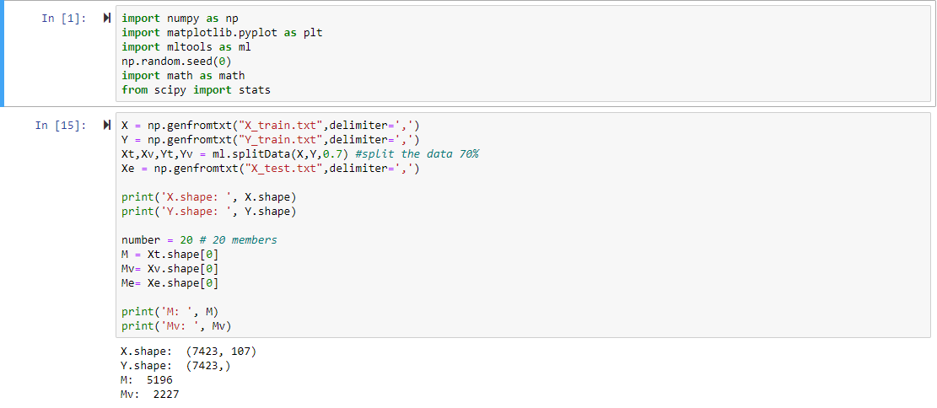
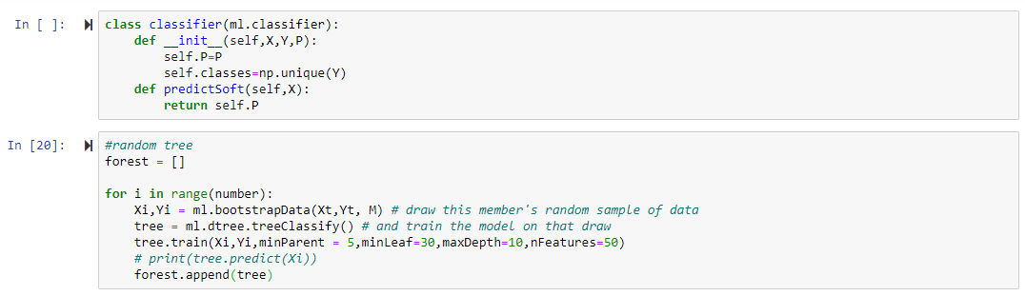
This model is a random forest model of bagged trees. The algorithms are constructed on Python and using the base functions provided by class like mltools. The main packages imported are matplotlib and numpy. The data is split by 70%. Here I use 20 members for this algorithm. Firstly, a forest(list of trees) is built. For each member, the function draws the member’s random sample of data and then train the model on the draw. It is trained by assigned hyperparameters of minParent=5, minLeaf=30, maxDepth=10, and nFeatures=50). Then put the forest into prediction algorithm with X_validation and X_test. Using the soft prediction provided by class to generate predicted results. The estimated AUC here is around 0.65. At last, the predicted results are loaded into a new file.
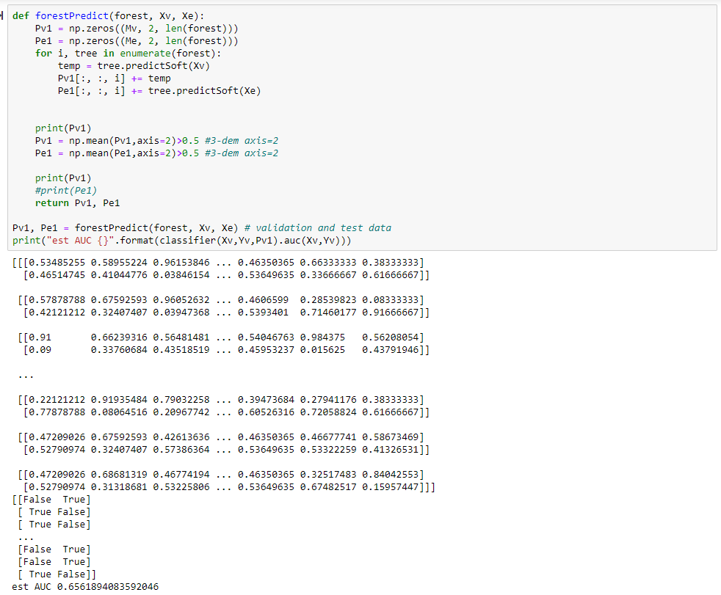
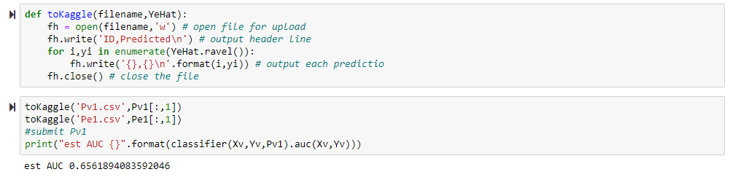
The trees are appended into a forest list and learns every one. After learning and averaging, they will be combined. The random forest is picked because it can better handle some data with more dimensions and can learn the whole data’s accuracy from the provided sample data which can be efficient.

The algorithm here is not that effective considered the reported AUC score which is less than 0.7. We have several hypotheses to this disadvantage. First, we may have a small number of entry members (20 may not be enough). Second, the hyperparameters are set poorly and result in overfitting. Thirdly, the prediction algorithm is done with 3-dimensional array which may increase the complexity.

score of the poorest model on Kaggle: 0.63841 (use it? ROC? LOL)
(no particular why about how good is it, how to combine models??? ummm)

（我只能帮到这了，应该not perfect呜呜呜呜）

