Architecture — Airbnb Stay Value Predictor (Amsterdam)

Architecture Diagram
The diagram below shows the full system. In the architecture.png file I also submitted is the full rendered image.
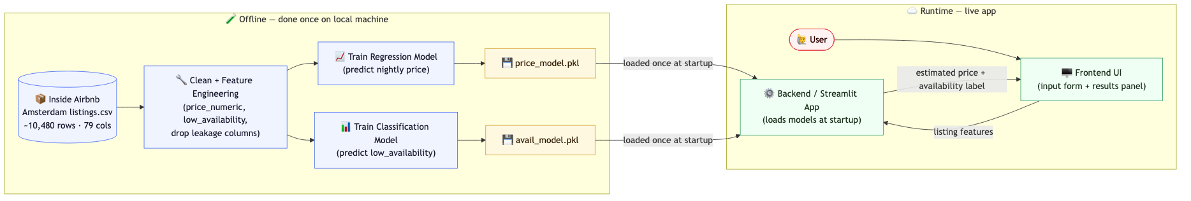

Offline Layer (done once on local machine)
- Raw data source: Inside Airbnb Amsterdam listings.csv (~10,480 rows, 79 columns)
- Clean + Feature Engineering: derive price_numeric, low_availability, drop leakage columns
- Train Regression Model: predict nightly price → saved as price_model.pkl
- Train Classification Model: predict low_availability → saved as avail_model.pkl

Runtime Layer (live app)
- Backend / Streamlit App: loads price_model.pkl and avail_model.pkl once at startup
- Frontend UI: input form where the user enters listing features
- User submits feature values → backend returns estimated price + availability label → displayed in frontend

Mermaid Source Code
Paste the code block below into any Mermaid renderer or Claude to reproduce the diagram.

flowchart LR
subgraph Offline["Offline — done once on local machine"]
direction TB
DATA[("Inside Airbnb\nAmsterdam listings.csv\n~10,480 rows · 79 cols")]
CLEAN["Clean + Feature Engineering\n(price_numeric, low_availability,\ndrop leakage columns)"]
TRAIN_R["Train Regression Model\n(predict nightly price)"]
TRAIN_C["Train Classification Model\n(predict low_availability)"]
MODEL_R["price_model.pkl"]
MODEL_C["avail_model.pkl"]
DATA --> CLEAN
CLEAN --> TRAIN_R
CLEAN --> TRAIN_C
TRAIN_R --> MODEL_R
TRAIN_C --> MODEL_C
end
subgraph Runtime["Runtime — live app"]
direction TB
BE["Backend / Streamlit App\n(loads models at startup)"]
FE["Frontend UI\n(input form + results panel)"]
USER(["User"])
MODEL_R -->|loaded once at startup| BE
MODEL_C -->|loaded once at startup| BE
USER --> FE
FE -->|listing features| BE
BE -->|estimated price + availability label| FE
end

Written Explanation
Both models are trained offline, once, on my local machine using the downloaded Inside Airbnb Amsterdam listings CSV. During training, the raw data is cleaned and engineered into features — including deriving price_numeric and the low_availability binary label — and two separate models are fitted: one regression model for nightly price and one classification model for availability. Each fitted pipeline is saved to disk as a .pkl file (price_model.pkl and avail_model.pkl). The Streamlit app loads both model files once at startup, so no training happens at runtime. When a user fills in listing details in the frontend form and submits, the backend calls .predict() on the pre-loaded models and returns the estimated price and the availability prediction to the frontend — inference is fast because the models are already in memory.

