Entry for Riot Games 2016 API Challenge
You can find a running version of this software at – http://deom.nfoservers.com/LoLMain
ChampVersus is a utility that lets you compare the champions mastery data from two players, champion by champion, even if these are from different regions.

It sorts the first player's champions by number of champion points obtained descending then the second player's champions are sort to match with the first!

Site Features

Easy input of players

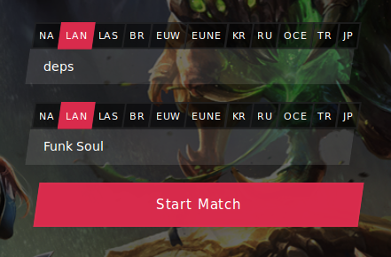

Resumed best stats



List all champions from players side by side

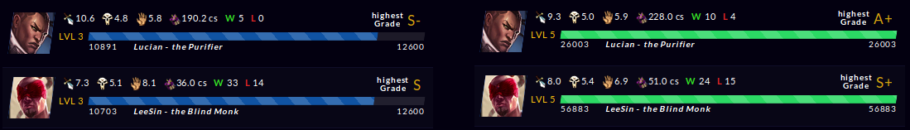

Technical Details

Run locally
All you need is to be installed PHP 5 and Apache 2 then you'll be fine.

Third party libs
- Bootstrap
- jQuery
- Owl Carousel
- Core

