Predicting Hospital Readmission – Machine Learning Approach
This document describes an end-to-end machine learning approach for predicting 30-day hospital readmission risk. The solution is designed to be realistic, explainable, and suitable for real-world healthcare deployment.

1. Problem Understanding
Hospital readmission within 30 days is a critical quality and cost metric in healthcare. The objective of this project is to build a binary classification model that predicts whether a patient will be readmitted within 30 days after discharge. Early identification of high-risk patients enables preventive interventions and improved patient outcomes.

2. Dataset Description
A realistic synthetic dataset was used to simulate hospital data while preserving patient privacy. The dataset includes patient demographics, diagnosis codes, procedures, lab results, length of stay, previous admissions, and discharge disposition.

3. Real-World Challenges Addressed
The dataset intentionally includes class imbalance, missing values, outliers, inconsistent casing, and noisy clinical signals to reflect real hospital environments.

4. Data Cleaning and Preprocessing
Missing lab values were imputed using the median to reduce sensitivity to outliers. Missing procedure values were assigned an explicit 'Unknown' category. All text columns were normalized to lowercase to handle casing inconsistencies. Length of stay values were rounded to reflect day-level granularity.

5. Feature Engineering
A procedure priority score was engineered to capture the clinical severity of medical procedures. Categorical features such as diagnosis codes and discharge disposition were encoded using one-hot encoding, while ordinal encodings were used where clinical ordering was meaningful.

6. Handling Class Imbalance
Hospital readmissions are naturally imbalanced. SMOTE (Synthetic Minority Oversampling Technique) was applied to balance the dataset, improving the model’s ability to identify high-risk patients.

7. Model Selection and Training
X was selected due to its strong performance on tabular healthcare data, robustness to noise, ability to capture non-linear relationships, and compatibility with SHAP explainability. The dataset was split into training and test sets using stratified sampling, and 5-fold cross-validation was applied on the training data.

8. Model Performance
Test Accuracy: 0.847
Precision: 0.850
Recall: 0.995
High recall ensures that almost no high-risk patients are missed, which is critical in clinical settings.

9. Explainability Using SHAP
SHAP (SHapley Additive exPlanations) was used to interpret model predictions. Global SHAP analysis identified lab results and procedure severity as the most influential features affecting readmission risk.
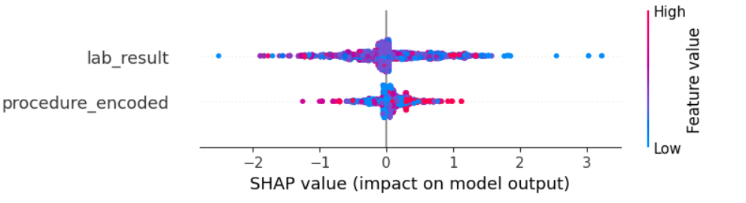

10. Confusion Matrix Analysis
The confusion matrix shows near-perfect recall, with only one readmitted patient missed. While the model produces some false positives, this trade-off is acceptable in healthcare, as false negatives carry a much higher risk.
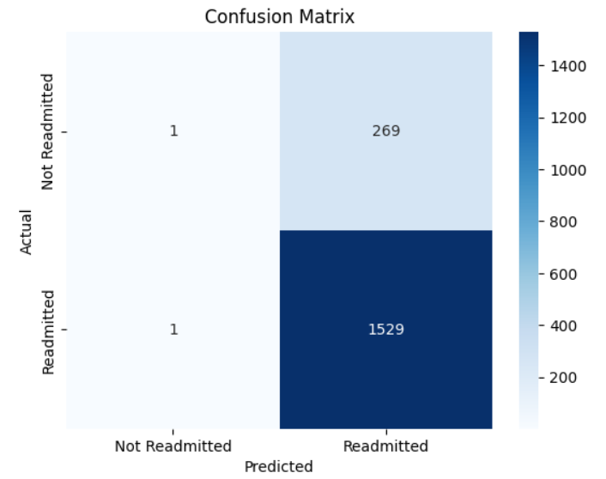

11. Key Insights
- Lab abnormalities are the strongest predictor of readmission risk.
- Procedure severity significantly influences outcomes.
- The model aligns well with clinical intuition and healthcare priorities.

12. Conclusion
This project demonstrates a production-ready, explainable machine learning pipeline for hospital readmission prediction. The approach balances performance, interpretability, and real-world applicability.

