


#. CLIPPING
By Kapil Manchandani


# Overview #

- Introduction.

- Point Clipping.

- End Point Codes.

- Algorithm :

  - Cohen-Sutherland Algorithm.

  - Mid-Point Subdivision Algorithm.

  - Sutherland-Hodgeman Algorithm.

- Text Clipping.


# Clipping

- Clipping is a process of extracting a portion of a data base or identifying elements of a scene or picture inside or outside a specified region, called the clipping region.

- E.g.,
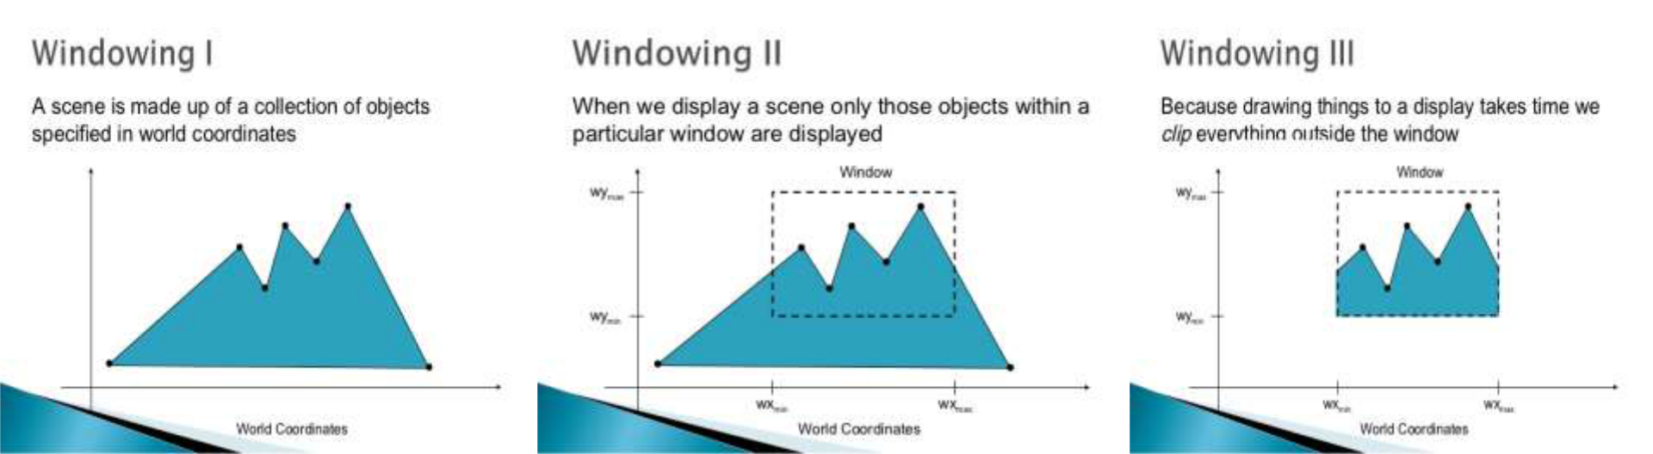
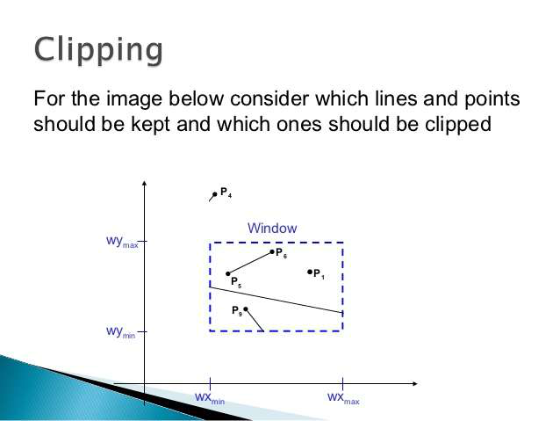
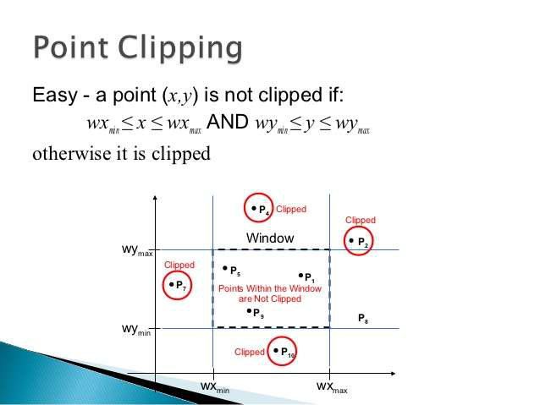

  - End Point Codes :

- This technique uses a 4 bit (digit) code to indicate which of nine regions contains the end point of a line.

- This test is formalized by Dan Cohen & Ivan Sutherland.

- The rightmost bit is the first bit.

- The bits are set to 1, based on the following scheme:
- | 1st -bit set | -if the end pt is to the left of the window.
- | 2nd-bit set | -if the end pt is to the right of the window.
- | 3rd-bit set | -if the end pt is below the window.
- | 4th-bit set | -if the end pt is above the window.

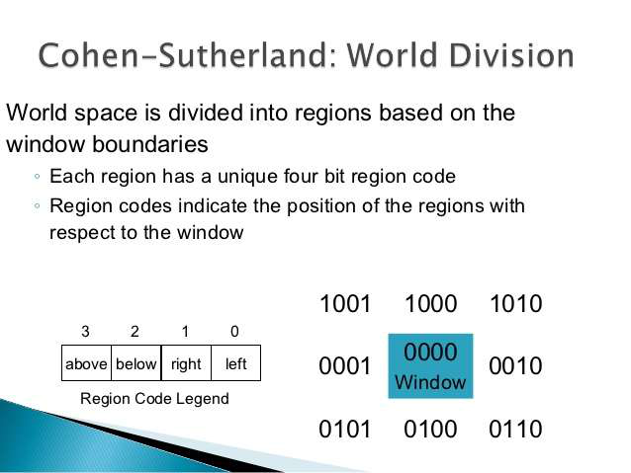
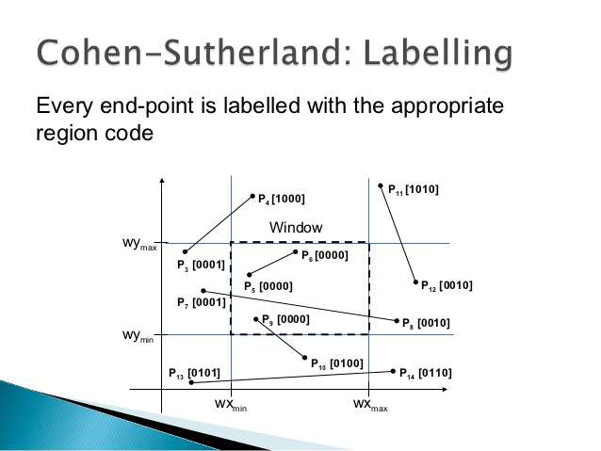
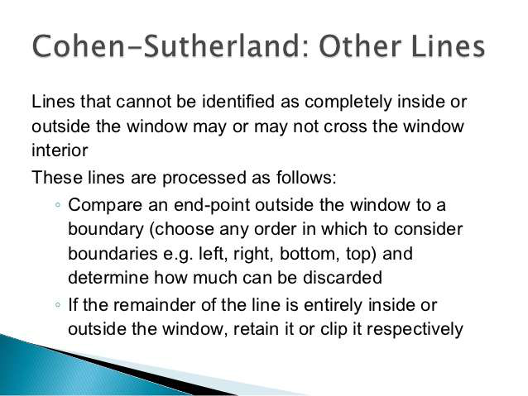
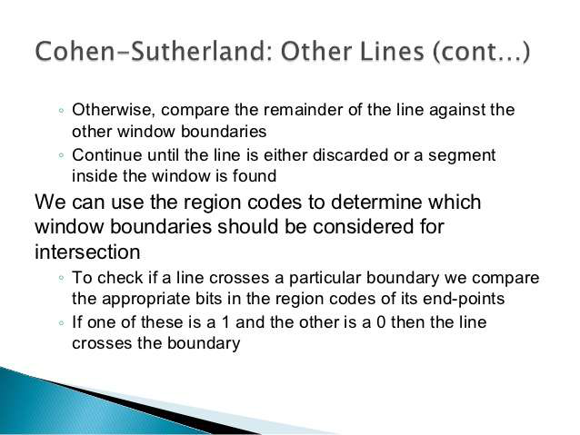
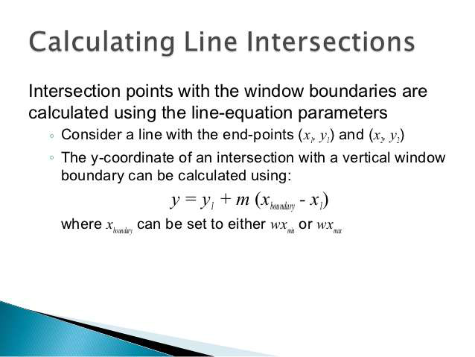
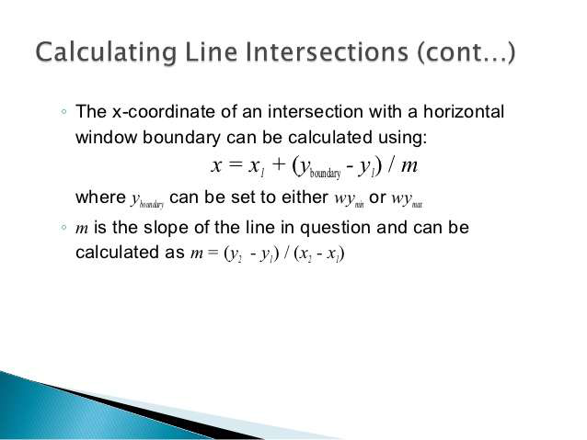

Mid Point Subdivision Algorithm

- The Cohen-Sutherland algorithm requires the calculation of the intersection of the line with the window edge.

- The direct calculation is avoided by performing a binary search for the intersection by always dividing the line at its midpoint.

