Task 1

Introduction
Part 1 of Task 1 is to write a program that web scraps a webpage to get a list of 1000 most commonly used words in the English language. When the list has been obtained, the list is to be written in an Excel workbook.
Part 2 of Task 1 is to use the 1000 words to make a word guessing game. A random word will be read from the workbook and displayed as underscores separated by a space. When a letter is guessed, the underscore will be replaced by the letter. If the word has more than one of the same letters, all underscores will be replaced by the letter. There will be no more than five guesses allowed before a “You Lost!” message is displayed. A “You Won!” message is displayed if the word is guessed. Whether the word is guessed or not, at the end the word will be displayed without spaces. The program will then terminate.
I have slightly modified these requirements because some of the words in the list are not actually words, and even though I do read them and save them, I do not use them as possibilities to be the word that is guessed. In fact, many of the words are so small (five letters or less) that I have written code that will only select a word to be guessed if it is at least six letters long. That makes the game more challenging to play.

Table of Functions
Function Prototype | Description of its Purpose
check_page | Takes a URL in the form of a string to get the text of the webpage. It returns the text of the webpage. If the webpage is not valid or does not exist, it terminates the program and displays an error message.
check_word | Takes a letter (char) input by the user and the word (string) that is to be guessed. If the letter exists in the word, it returns the indices (int) of the letter or 0 (int) if the letter does not appear in the word.
rand_cell | Takes the max rows (int) of a workbook. It returns a random cell from the active work sheet in the workbook (string)
get_clean_list | Takes the text of a webpage (request object). Returns a list (list) of the 1000 words on the page.
new_wb | Takes a list (list) of words and writes them to a new Excel workbook, saves the workbook to file. Returns the active sheet (openpyxl object)
get_word | Takes a workbook sheet (openpyxl object). Returns a random word from the sheet (string)
Snapshots of Program Execution

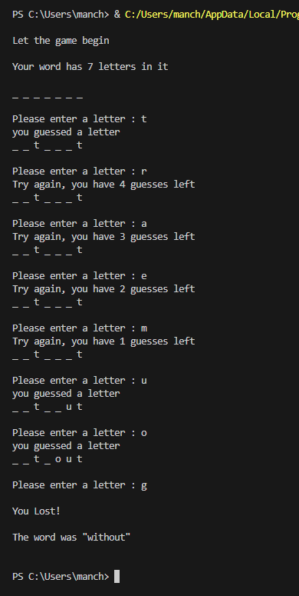
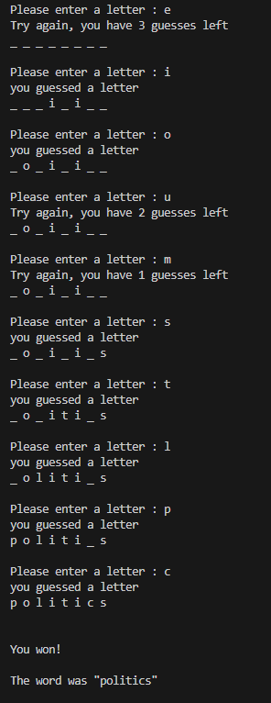
Group Members
Josh Manchester - All roles

