CS4500 (or CS5500) Operating Systems
Section 001
Project # 4
Title: Kernel Modules for Memory Management

Josh Manchester
Ronan Hella
May 9, 2025

Statement: “We have neither given nor received unauthorized assistance on this work.”

1 Virtual Machine Information

Directory: /home/josh/Public/Project_01/project_04
VM name: josh-virtual-machine
VM account: josh
Password for VM Account: KMJNkmjn9090

Path to Source Code:
/home/josh/Public/Project_01/project_04/part_1
/home/josh/Public/Project_01/project_04/part_2

2 Description

2.1 How We Solved the Problems
Below is what we did for each part of the project and how we solved the problems respectively.
Part 1 (va_space):
Declared a module parameter pid with module_param(pid, int, 0444).
Used find_get_pid() → pid_task() → get_task_mm() inside an RCU read-side section to safely access the target process’s mm_struct.
Employed the VMA_ITERATOR and for_each_vma macros to walk every vm_area_struct in that mm_struct.
For each VMA printed its start and end addresses, calculated its size, and accumulated into vm_space.
Emitted a final pr_info() with the total virtual address–space size in bytes and kilobytes.
Part 2 (va_status):
Expanded the module to take a second parameter, vaddr_str, as a hex string.
Converted the string to an unsigned long via kstrtoul().
Inside the same RCU section, walked the five-level x86-64 page tables:
  - PGD with pgd_offset()
  - P4D with p4d_offset()
  - PUD with pud_offset()
  - PMD with pmd_offset() (and detected huge pages)
  - PTE with pte_offset_kernel()
Printed each level’s raw entry via pr_info(pgd_val(…)), etc., then tested pmd_present() or pte_present() to determine if that VA was resident.
Produced a summary line: ”Address 0x… in PID … is in memory” or “Address 0x… in PID … is not in memory”

2.2 What We learned
We learned a lot about kernel modules, the RCU, memory management internals and debugging from this project. More specifically they are stated below.
Kernel Modules: how to structure module_init/module_exit, use module_param, and build against /lib/modules/$(uname -r)/build.
RCU: why rcu_read_lock()/rcu_read_unlock() is needed when traversing process structures in the kernel, basically so we don’t have the page tables change when we are trying to read them.
Memory Management Internals:
How Linux represents a process’s virtual address space via mm_struct and its VMAs.
The five-level page-table hierarchy (PGD→P4D→PUD→PMD→PTE) on x86-64.
Debugging: using pr_info()/pr_err() and dmesg -T to trace and verify kernel logic.

2.3 How to Run Our Code

We have made read.me files in each of the folders that tell how to run the code for each part.

3 Screenshots of Output

3.1 Code Output Screenshots

Part 1 Output:
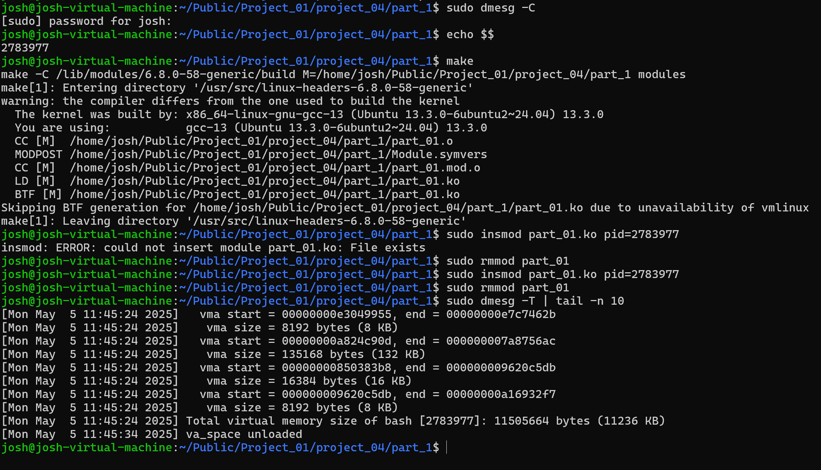

Part 2 Output:
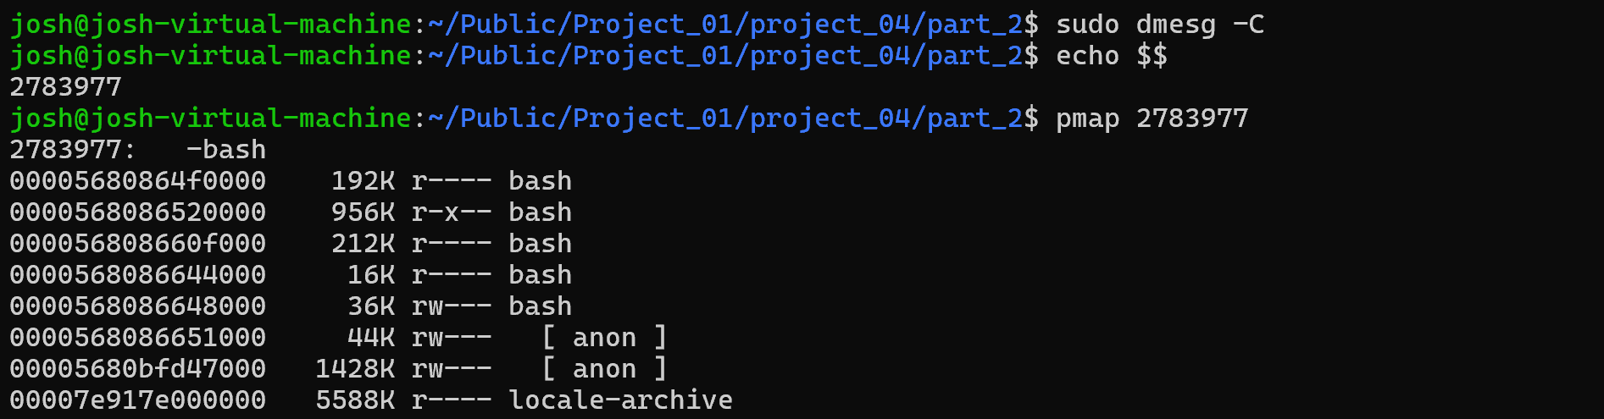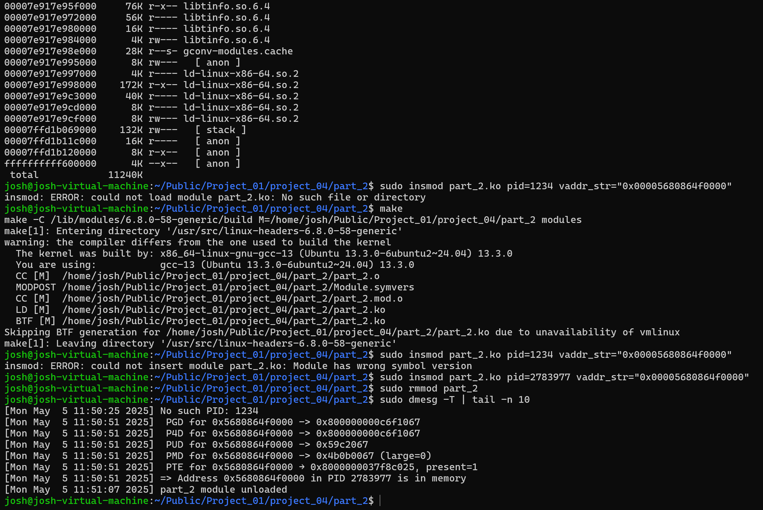

Reminder: Submit Source Code with All Projects

