CS4500 Operating Systems
Section 001
Project 2
Kernel Module Process Information and System Call Analysis

Josh Manchester, Ronan Hella
Date of Submission: 23 Feb 2025

Statement: “We have neither given nor received unauthorized assistance on this work.”

1. Virtual Machine Information
Directory and Name of Virtual Machine:
Name: josh_ronan under jmanches profile
Directory: /home/josh/Public/Project_01/project_02
Username: josh
Password: KMJNkmjn9090
Path to Source Code:
/home/josh/Public/Project_01/project_02
(Subdirectories: part_1, part_2, part_3)
2. Description
2.1 How We Solved the Problems
- Part 1 (HelloWorld Kernel Module):
We created a simple kernel module that prints "Hello world!" when loaded and "Goodbye world!" when removed. We fixed issues in the provided Makefile by correcting spacing and using the proper object file declaration (e.g., “obj-m += hello.o”).
- Part 2 (Print Self Kernel Module):
We implemented a module that uses the current macro to identify the current process and prints its name, PID, and state. The module then traverses the parent process chain until reaching init. Adjustments were made to accommodate updates in header files and structure definitions.
- Part 3 (Print Other Kernel Module):
We developed a module that takes a process PID as an argument and prints the target process's information (name, PID, state), then traverses the process’s parent chain until reaching PID 1. We used module parameters and the function pid_task(find_vpid(target_pid), PIDTYPE_PID) for process lookup. Corrections in the Makefile (using the proper .o extension) were also applied.
- Part 4 (Kernel Modules and System Calls Questions):
What is the difference between a kernel module and a system call?
- A kernel module is dynamically loadable code that extends the functionality of the kernel (e.g., drivers, file systems) without requiring a reboot.
- A system call is a fixed, statically defined interface within the kernel that allows user-space applications to request services (like file I/O, process management) from the kernel.
Reflection on a 20-year-old kernel module example:
- Although the basic concept of kernel modules remains the same, modern kernels have significantly updated APIs, security measures (e.g., module signing), and improved stability and performance.
- Legacy examples may fail to compile or run due to changes such as renamed structure fields (e.g., task_struct state field) and stricter policies. However, these changes are beneficial overall as they improve system security and reliability.
2.2 What We Learned
- We gained hands-on experience with writing and compiling Linux kernel modules.
- We learned to pass parameters to modules and retrieve process information from within the kernel.
- We improved our troubleshooting skills by debugging Makefile issues and adapting to changes in kernel APIs.
- We developed a deeper understanding of how kernel modules extend the functionality of the Linux kernel and the differences between modules and system calls.
2.3 How to Run Our Code
For each part, follow these steps:
a. Open a terminal and navigate to the corresponding directory:
For Part 1:
cd /home/josh/Public/Project_01/project_02/part_1
For Part 2:
cd /home/josh/Public/Project_01/project_02/part_2
For Part 3:
cd /home/josh/Public/Project_01/project_02/part_3
(Note: Part 4 does not require code execution.)
b. Compile each module using:
make
(This produces the .ko file for the module.)
c. Load the module:
For Part 1:
sudo insmod hello.ko
For Part 2:
sudo insmod print_self.ko
For Part 3 (include the process PID parameter):
sudo insmod print_other.ko target_pid=1234
(Replace 1234 with a valid process PID, e.g., from pgrep bash.)
d. View the module output by running:
sudo dmesg -T | tail
e. Remove the module with:
For Part 1:
sudo rmmod hello
For Part 2:
sudo rmmod print_self
For Part 3:
sudo rmmod print_other
(After each removal, check the output with sudo dmesg -T | tail to verify removal.)
f. Clean up build artifacts using:
make clean

3. Screenshots of Output
3.1 Code Output Screenshots
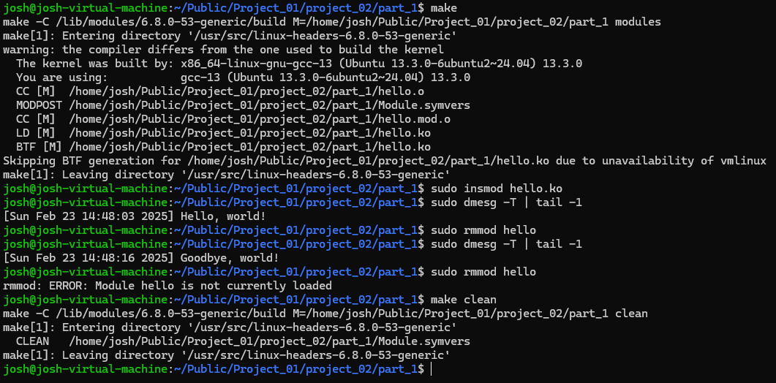
- Part 1 Output:

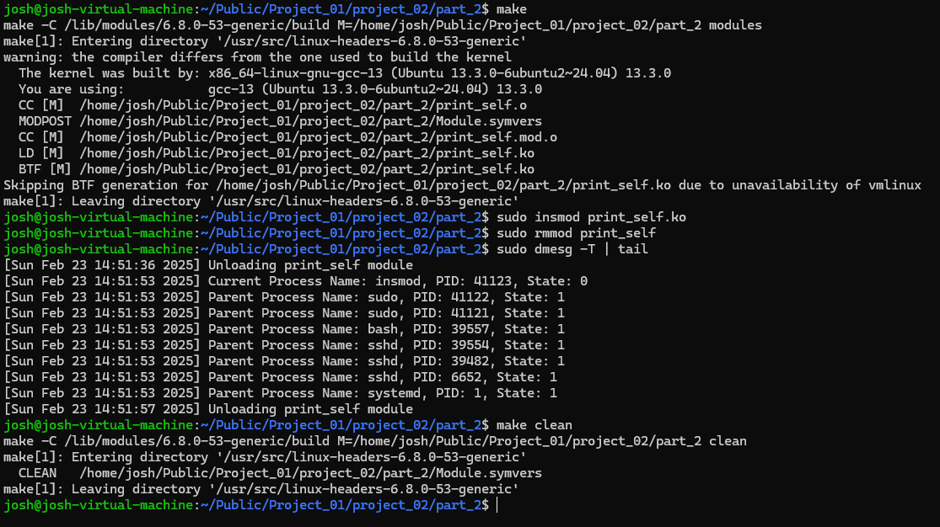
- Part 2 Output:

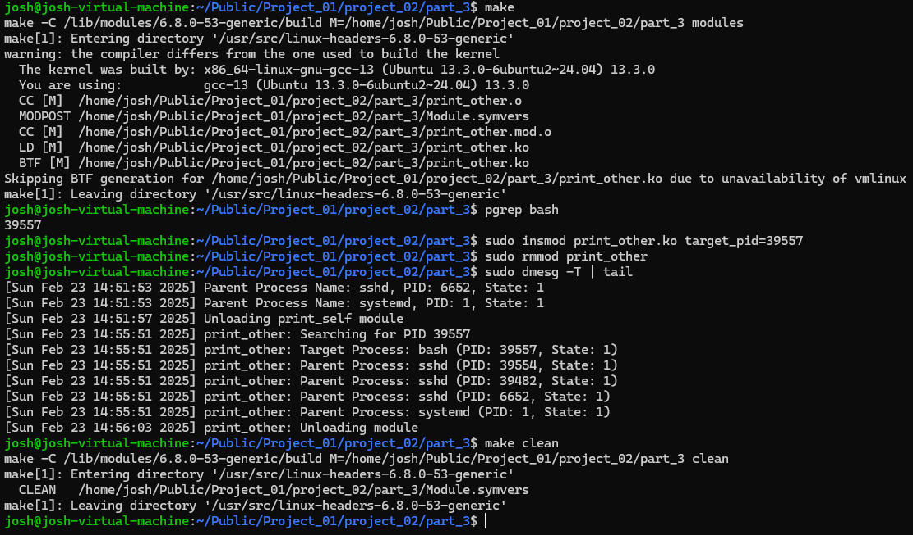
- Part 3 Output:

Interpretation: The output demonstrates that our modules are correctly interacting with the kernel. The process information is retrieved and printed as expected, confirming that our implementation meets the assignment requirements.

