11 Policy-gradient and actor-critic methods
In this chapter
- You will learn about a family of deep reinforcement learning methods that can optimize their performance directly, without the need for value functions.
- You will learn how to use value function to make these algorithms even better.
- You will implement deep reinforcement learning algorithms that use multiple processes at once for very fast learning.
There is no better than adversity. Every defeat, every heartbreak, every loss, contains its own seed, its own lesson on how to improve your performance the next time.
— Malcolm X
American Muslim minister and human rights activist
In this book, we’ve explored methods that can find optimal and near-optimal policies with the help of value functions. However, all of those algorithms learn value functions when what we need are policies.
In this chapter, we explore the other side of the spectrum and what’s in the middle. We start exploring methods that optimize policies directly. These methods, referred to as policy-based or policy-gradient methods, parameterize a policy and adjust it to maximize expected returns.
After introducing foundational policy-gradient methods, we explore a combined class of methods that learn both policies and value functions. These methods are referred to as actor-critic because the policy, which selects actions, can be seen as an actor, and the value function, which evaluates policies, can be seen as a critic. Actor-critic methods often perform better than value-based or policy-gradient methods alone on many of the deep reinforcement learning benchmarks. Learning about these methods allows you to tackle more challenging problems.
These methods combine what you learned in the previous three chapters concerning learning value functions and what you learn about in the first part of this chapter, about learning policies. Actor-critic methods often yield state-of-the-art performance in diverse sets of deep reinforcement learning benchmarks.
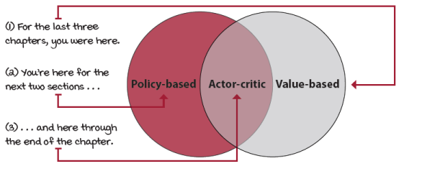
Policy-based, value-based, and actor-critic methods
REINFORCE: Outcome-based policy learning
In this section, we begin motivating the use of policy-based methods, first with an introduction; then we discuss several of the advantages you can expect when using these kinds of methods; and finally, we introduce the simplest policy-gradient algorithm, called REINFORCE.
Introduction to policy-gradient methods
The first point I’d like to emphasize is that in policy-gradient methods, unlike in value-based methods, we’re trying to maximize a performance objective. In value-based methods, the main focus is to learn to evaluate policies. For this, the objective is to minimize a loss between predicted and target values. More specifically, our goal is to match the true action-value function of a given policy, and therefore, we parameterized a value function and minimized the mean squared error between predicted and target values. Note that we didn’t have true target values, and instead, we used actual returns in Monte Carlo methods or predicted returns in bootstrapping methods.
In policy-based methods, on the other hand, the objective is to maximize the performance of a parameterized policy, so we’re running gradient ascent (or executing regular gradient descent on the negative performance). It’s rather evident that the performance of an agent is the expected total discounted reward from the initial state, which is the same thing as the expected state-value function from all initial states of a given policy.
 | Show Me The Math  Value-based vs. policy-based methods objectives
 | 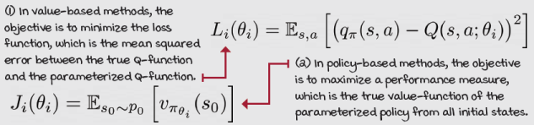

ŘŁ | With An RL Accent  Value-based vs. policy-based vs. policy-gradient vs. actor-critic methods
Value-based methods: Refers to algorithms that learn value functions and only value functions.Q-learning, SARSA, DQN, and company are all value-based methods.
Policy-based methods: Refers to a broad range of algorithms that optimize policies, including black-box optimization methods, such as genetic algorithms.
Policy-gradient methods: Refers to methods that solve an optimization problem on the gradient of the performance of a parameterized policy, methods you’ll learn in this chapter.
Actor-critic methods: Refers to methods that learn both a policy and a value function, primarily if the value function is learned with bootstrapping and used as the score for the stochastic policy gradient. You learn about these methods in this and the next chapter.
Advantages of policy-gradient methods
The main advantage of learning parameterized policies is that policies can now be any learnable function. In value-based methods, we worked with discrete action spaces, mostly because we calculate the maximum value over the actions. In high-dimensional action spaces, this max could be prohibitively expensive. Moreover, in the case of continuous action spaces, value-based methods are severely limited.
Policy-based methods, on the other hand, can more easily learn stochastic policies, which in turn has multiple additional advantages. First, learning stochastic policies means better performance under partially observable environments. The intuition is that because we can learn arbitrary probabilities of actions, the agent is less dependent on the Markov assumption. For example, if the agent can’t distinguish a handful of states from their emitted observations, the best strategy is often to act randomly with specific probabilities.
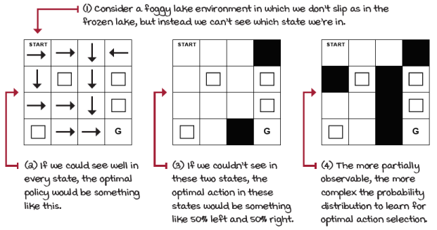
Learning stochastic policies could get us out of trouble
Interestingly, even though we’re learning stochastic policies, nothing prevents the learning algorithm from approaching a deterministic policy. This is unlike value-based methods, in which, throughout training, we have to force exploration with some probability to ensure optimality. In policy-based methods with stochastic policies, exploration is embedded in the learned function, and converging to a deterministic policy for a given state while training is possible.
Another advantage of learning stochastic policies is that it could be more straightforward for function approximation to represent a policy than a value function. Sometimes value functions are too much information for what’s truly needed. It could be that calculating the exact value of a state or state-action pair is complicated or unnecessary.
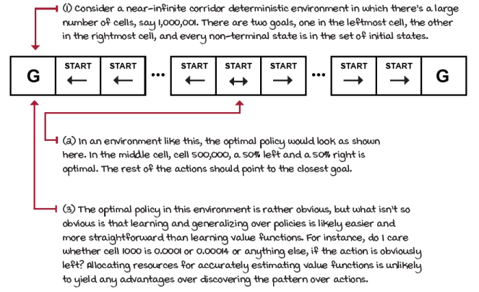
Learning policies could be an easier, more generalizable problem to solve
A final advantage to mention is that because policies are parameterized with continuous values, the action probabilities change smoothly as a function of the learned parameters. Therefore, policy-based methods often have better convergence properties. As you remember from previous chapters, value-based methods are prone to oscillations and even divergence. One of the reasons for this is that tiny changes in value-function space may imply significant changes in action space. A significant difference in actions can create entirely unusual new trajectories, and therefore create instabilities.
In value-based methods, we use an aggressive operator to change the value function; we take the maximum over Q-value estimates. In policy-based methods, we instead follow the gradient with respect to stochastic policies, which only progressively and smoothly changes the actions. If you directly follow the gradient of the policy, you’re guaranteed convergence to, at least, a local optimum.
 | I Speak Python  Stochastic policy for discrete action spaces 1/2
class FCDAP(nn.Module): ①
def __init__(self,
input_dim, ②
output_dim,
hidden_dims=(32,32),
init_std=1,
activation_fc=F.relu):
super(FCDAP, self).__init__()
self.activation_fc = activation_fc
self.input_layer = nn.Linear( ③
input_dim, hidden_dims[0])
self.hidden_layers = nn.ModuleList() ④
for i in range(len(hidden_dims)-1):
hidden_layer = nn.Linear(
hidden_dims[i], hidden_dims[i+1])
self.hidden_layers.append(hidden_layer)
self.output_layer = nn.Linear( ⑤
hidden_dims[-1], output_dim)
def forward(self, state): ⑥
x = state
if not isinstance(x, torch.Tensor): ⑦
x = torch.tensor(x, dtype=torch.float32)
x = x.unsqueeze(0)
x = self.activation_fc(self.input_layer(x)) ⑧
for hidden_layer in self.hidden_layers: ⑨
x = self.activation_fc(hidden_layer(x))
return self.output_layer(x) ⑩
① This class, FCDAP stands for fully connected discrete-action policy.
② The parameters allow you to specify a fully connected architecture, activation function, and weight and bias max magnitude.
③ The __init__ function creates a linear connection between the input and the first hidden layer.
④ Then, it creates connections across all hidden layers.
⑤ Last, it connects the final hidden layer to the output nodes, creating the output layer.
⑥ Here we have the method that takes care of the forward functionality.
⑦ First, we make sure the state is of the type of variable and shape we expect before we can pass it through the network.
⑧ Next, we pass the properly formatted state into the input layer and then through the activation function.
⑨ Then, we pass the output of the first activation through the sequence of hidden layers and respective activations.
⑩ Finally, we obtain the output, which are logits, preferences over actions.

I Speak Python
Stochastic policy for discrete action spaces 1/2
return self.output_layer(x) ⑪
def full_pass(self, state): ⑫
logits = self.forward(state) ⑬
dist = torch.distributions.Categorical(logits=logits) ⑭
action = dist.sample() ⑭
logpa = dist.log_prob(action).unsqueeze(-1) ⑮
entropy = dist.entropy().unsqueeze(-1) ⑯
is_exploratory = action != np.argmax( \ ⑰
logits.detach().numpy())
return action.item(), is_exploratory.item(), \ ⑱
logpa, entropy
def select_action(self, state): ⑲
logits = self.forward(state)
dist = torch.distributions.Categorical(logits=logits)
action = dist.sample()
return action.item()
def select_greedy_action(self, state): ⑳
logits = self.forward(state)
return np.argmax(logits.detach().numpy())
⑪ This line repeats the last line on the previous page.
⑫ Here we do the full forward pass. This is a handy function to obtain probabilities, actions, and everything needed for training.
⑬ The forward pass returns the logits, the preferences over actions.
⑭ Next, we sample the action from the probability distribution.
⑮ Then, calculate the log probability of that action and format it for training.
⑯ Here we calculate the entropy of the policy.
⑰ And in here, for stats, we determine whether the policy selected was exploratory or not.
⑱ Finally, we return an action that can be directly passed into the environment, the flag indicating whether the action was exploratory, the log probability of the action, and the entropy of the policy.
⑲ This is a helper function for when we only need sampled action.
⑳ And this one is for selecting the greedy action according to the policy.
Learning policies directly
One of the main advantages of optimizing policies directly is that, well, it’s the right objective. We learn a policy that optimizes the value function directly, without learning a value function, and without taking into account the dynamics of the environment. How is this possible? Let me show you.
Show Me The Math
Deriving the policy gradient
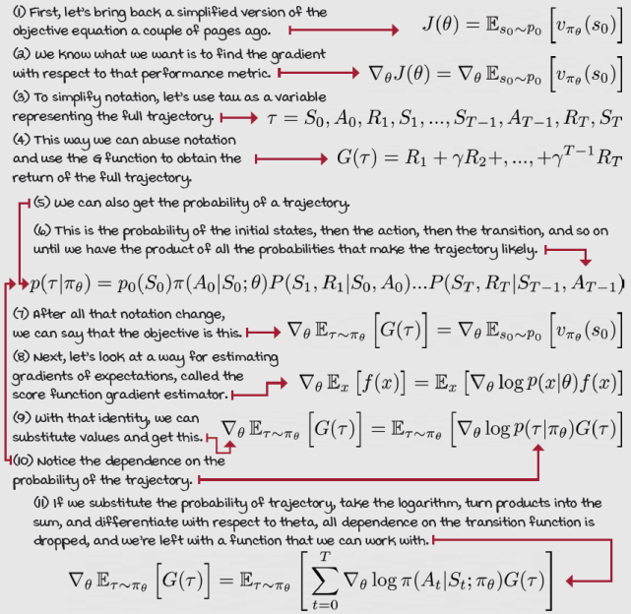
Reducing the variance of the policy gradient
It’s useful to have a way to compute the policy gradient without knowing anything about the environment’s transition function. This algorithm increases the log probability of all actions in a trajectory, proportional to the goodness of the full return. In other words, we first collect a full trajectory and calculate the full discounted return, and then use that score to weight the log probabilities of every action taken in that trajectory: A_{t}, A_{t+1}, ..., A_{T–1}.
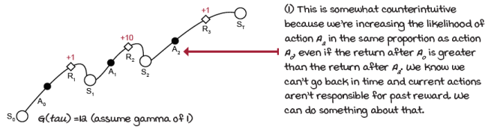
Let’s use only rewards that are a consequence of actions
Show Me The Math
Reducing the variance of the policy gradient
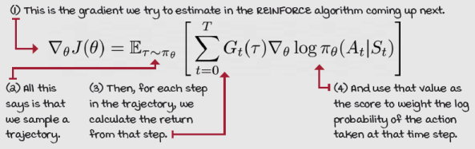

0001 | A Bit Of History  Introduction of the REINFORCE algorithm
Ronald J. Williams introduced the REINFORCE family of algorithms in 1992 in a paper titled “Simple Statistical Gradient-Following Algorithms for Connectionist Reinforcement Learning.”
In 1986, he coauthored a paper with Geoffrey Hinton et al. called “Learning representations by back-propagating errors,” triggering growth in artificial neural network (ANN) research at the time.

I Speak Python
REINFORCE
class REINFORCE(): ①
<...>
def optimize_model(self):
T = len(self.rewards)
discounts = np.logspace(0, T, num=T, base=self.gamma, ②
endpoint=False)
returns = np.array( ③
[np.sum(discounts[:T-t] * self.rewards[t:]) \ ④
for t in range(T)])
<...>
policy_loss = -(discounts * returns * \ ⑤⑥
self.logpas).mean()
self.policy_optimizer.zero_grad()
policy_loss.backward() ⑦
self.policy_optimizer.step()
def interaction_step(self, state, env): ⑧
action, is_exploratory, logpa, _ = \
self.policy_model.full_pass(state)
new_state, reward, is_terminal, _ = env.step(action)
<...>
return new_state, is_terminal
class REINFORCE(): ⑨
<...>
def train(self, make_env_fn, make_env_kargs, seed, gamma, ⑩
max_minutes, max_episodes, goal_mean_100_reward):
for episode in range(1, max_episodes + 1): ⑪
state, is_terminal = env.reset(), False ⑫
<...> ⑫
self.logpas, self.rewards = [], [] ⑫
for step in count(): ⑬
state, is_terminal = \
self.interaction_step(state, env)⑭
if is_terminal:
break ⑭
self.optimize_model() ⑮
def evaluate(self, eval_policy_model, ⑯
eval_env, n_episodes=1,
greedy=True):
rs = []
for _ in range(n_episodes):
<...>
for _ in count():
if greedy:
a = eval_policy_model.\
select_greedy_action(s)
else:
a = eval_policy_model.select_action(s)
s, r, d, _ = eval_env.step(a)
<...>
return np.mean(rs), np.std(rs)
① This is the REINFORCE algorithm. When you see the <...>, that means code was removed for simplicity. Go to the chapter’s Notebook for the complete code.
② First, we calculate the discounts as with all Monte Carlo methods. The logspace function with these parameters returns the series of per time step gammas; for example, [1, 0.99, 0.9801, ... ].
③ Next, we calculate the sum of discounted returns for all time steps.
④ To emphasize, this is the returns for every time step in the episode, from the initial state at time step 0, to one before the terminal T-1.
⑤ Notice here that we’re using the mathematically correct policy-gradient update, which isn’t what you commonly find out there. The extra discount assumes that we’re trying to optimize the expect discounted return from the initial state, so returns later in an episode get discounted.
⑥ This is policy loss; it’s the log probability of the actions selected weighted by the returns obtained after that action was selected. Notice that because PyTorch does gradient descent by default and the performance is something we want to maximize, we use the negative mean of the performance to flip the function. Think about it as doing gradient ascent on the performance. Also, we account for discounted policy gradients, so we multiply the returns by the discounts.
⑦ In these three steps, we first zero the gradients in the optimizer, then do a backward pass, and then step in the direction of the gradient.
⑧ This function obtains an action to be passed to the environment and all variables required for training.
⑨ Still exploring functions of the REINFORCE class
⑩ The train method is the entry point for training the agent.
⑪ We begin by looping through the episodes.
⑫ For each new episode, we initialize the variables needed for training and stats.
⑬ Then, do the following for each time step.
⑭ First, we collect experiences until we hit a terminal state.
⑮ Then, we run one optimization step with the batch of all time steps in the episode.
⑯ Another thing I want you to see is the way I select the policy during evaluation. Instead of selecting a greedy policy, I sample from the learned stochastic policy. The correct thing to do here depends on the environment, but sampling is the safe bet.
VPG: Learning a value function
The REINFORCE algorithm you learned about in the previous section works well in simple problems, and it has convergence guarantees. But because we’re using full Monte Carlo returns for calculating the gradient, its variance is a problem. In this section, we discuss a few approaches for dealing with this variance in an algorithm called vanilla policy gradient or REINFORCE with baseline.
Further reducing the variance of the policy gradient
REINFORCE is a principled algorithm, but it has a high variance. You probably remember from the discussion in chapter 5 about Monte Carlo targets, but let’s restate. The accumulation of random events along a trajectory, including the initial state sampled from the initial state distribution—transition function probabilities, but now in this chapter with stochastic policies—is the randomness that action selection adds to the mix. All this randomness is compounded inside the return, making it a high-variance signal that's challenging to interpret.
One way for reducing the variance is to use partial returns instead of the full return for changing the log probabilities of actions. We already implemented this improvement. But another issue is that action log probabilities change in the proportion of the return. This means that, if we receive a significant positive return, the probabilities of the actions that led to that return are increased by a large margin. And if the return is of significant negative magnitude, then the probabilities are decreased by of large margin.
However, imagine an environment such as the cart-pole, in which all rewards and returns are positive. In order to accurately separate okay actions from the best actions, we need a lot of data. The variance is, otherwise, hard to muffle. It would be handy if we could, instead of using noisy returns, use something that allows us to differentiate the values of actions in the same state. Recall?
 | Refresh My Memory  Using estimated advantages in policy-gradient methods
 | 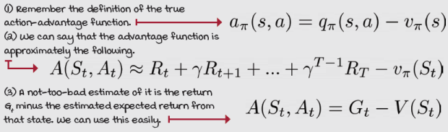
Learning a value function
As you see on the previous page, we can further reduce the variance of the policy gradient by using an estimate of the action-advantage function, instead of the actual return. Using the advantage somewhat centers scores around zero; better-than-average actions have a positive score, worse-than-average, a negative score. The former decreases the probabilities, and the latter increases them.
We’re going to do exactly that. Let’s now create two neural networks, one for learning the policy, the other for learning a state-value function, V. Then, we use the state-value function and the return for calculating an estimate of the advantage function, as we see next.
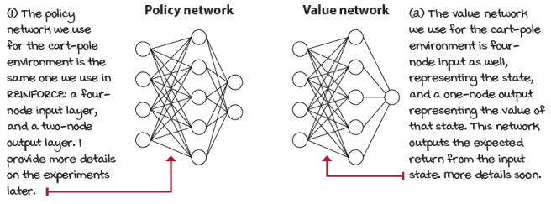
Two neural networks, one for the policy, one for the value function
ŘŁ | With An RL Accent  REINFORCE, vanilla policy gradient, baselines, actor-critic
Some of you with prior DRL exposure may be wondering, is this a so-called “actor-critic”? It’s learning a policy and a value-function, so it seems it should be. Unfortunately, this is one of those concepts where the “RL accent” confuses newcomers. Here’s why.
First, according to one of the fathers of RL, Rich Sutton, policy-gradient methods approximate the gradient of the performance measure, whether or not they learn an approximate value function. However, David Silver, one of the most prominent figures in DRL, and a former student of Sutton, disagrees. He says that policy-based methods don’t additionally learn a value function, only actor-critic methods do. But, Sutton further explains that only methods that learn the value function using bootstrapping should be called actor-critic, because it’s bootstrapping that adds bias to the value function, and thus makes it a “critic.” I like this distinction; therefore, REINFORCE and VPG, as presented in this book, aren’t considered actor-critic methods. But beware of the lingo, it’s not consistent.
Encouraging exploration
Another essential improvement to policy-gradient methods is to add an entropy term to the loss function. We can interpret entropy in many different ways, from the amount of information one can gain by sampling from a distribution to the number of ways one can order a set.
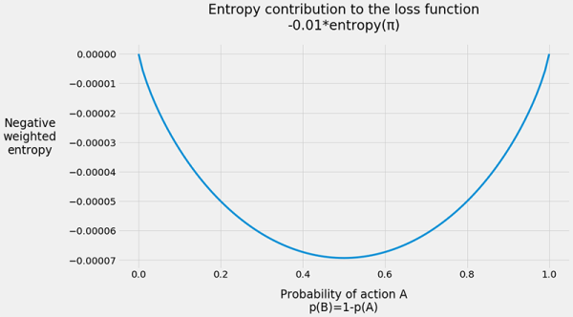
The way I like to think of entropy is straightforward. A uniform distribution, which has evenly distributed samples, has high entropy, in fact, the highest it can be. For instance, if you have two samples, and both can be drawn with a 50% chance, then the entropy is the highest it can be for a two-sample set. If you have four samples, each with a 25% chance, the entropy is the same, the highest it can be for a four-sample set. Conversely, if you have two samples, and one has a 100% chance and the other 0%, then the entropy is the lowest it can be, which is always zero. In PyTorch, the natural log is used for calculating the entropy instead of the binary log. This is mostly because the natural log uses Euler’s number, e, and makes math more “natural.” Practically speaking, however, there’s no difference and the effects are the same. The entropy in the cart-pole environment, which has two actions, is between 0 and 0.6931.
The way to use entropy in policy-gradient methods is to add the negative weighted entropy to the loss function to encourage having evenly distributed actions. That way, a policy with evenly distributed actions, which yields the highest entropy, contributes to minimizing the loss. On the other hand, converging to a single action, which means entropy is zero, doesn’t reduce the loss. In that case, the agent had better converge to the optimal action.
Show Me The Math
Losses to use for VPG
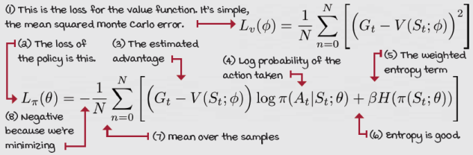

I Speak Python
State-value function neural network model
class FCV(nn.Module): ①
def __init__(self,
input_dim,
hidden_dims=(32,32), ②
activation_fc=F.relu):
super(FCV, self).__init__()
self.activation_fc = activation_fc
self.input_layer = nn.Linear(input_dim, ③
hidden_dims[0])
self.hidden_layers = nn.ModuleList()
for i in range(len(hidden_dims)-1):
hidden_layer = nn.Linear( ④
hidden_dims[i], hidden_dims[i+1])
self.hidden_layers.append(hidden_layer)
self.output_layer = nn.Linear( ⑤
hidden_dims[-1], 1) ⑤
def forward(self, state): ⑥
x = state
if not isinstance(x, torch.Tensor):
x = torch.tensor(x, dtype=torch.float32) ⑦
x = x.unsqueeze(0)
x = self.activation_fc(self.input_layer(x))
for hidden_layer in self.hidden_layers: ⑧
x = self.activation_fc(hidden_layer(x))
return self.output_layer(x) ⑨
① This is the state-value function neural network. It’s similar to the Q-function network we used in the past.
② Notice I left handy hyperparameters for you to play around with, so go ahead and do so.
③ Here we create linear connections between the input nodes and the first hidden layer.
④ Here we create the connections between the hidden layers.
⑤ Here we connect the last hidden layer to the output layer, which has only one node, representing the value of the state.
⑥ This is the forward-pass function.
⑦ This is formatting the input as we expect it.
⑧ Doing a full forward pass ...
⑨ ... and returning the value of the state.

I Speak Python
Vanilla policy gradient a.k.a. REINFORCE with baseline
class VPG(): ①
<...> ①
def optimize_model(self):
T = len(self.rewards)
discounts = np.logspace(0, T, num=T, base=self.gamma,
endpoint=False)
returns = np.array( ②
[np.sum(discounts[:T-t] * self.rewards[t:]) for t in range(T)]) ③
value_error = returns - self.values
policy_loss = -( ④
discounts * value_error.detach() * self.logpas).mean()
entropy_loss = -self.entropies.mean() ⑤
loss = policy_loss + \
self.entropy_loss_weight * entropy_loss
self.policy_optimizer.zero_grad()
loss.backward() ⑥
torch.nn.utils.clip_grad_norm_(
self.policy_model.parameters(),
self.policy_model_max_grad_norm)
self.policy_optimizer.step() ⑦
value_loss = value_error.pow(2).mul(0.5).mean()
self.value_optimizer.zero_grad()
value_loss.backward()
torch.nn.utils.clip_grad_norm_( ⑧
self.value_model.parameters(),
self.value_model_max_grad_norm)
self.value_optimizer.step()
① This is the VPG algorithm. I removed quite a bit of code, so if you want the full implementation, head to the chapter’s Notebook.
② Very handy way for calculating the sum of discounted rewards from time step 0 to T
③ I want to emphasize that this loop is going through all steps from 0, then 1, 2, 3 all the way to the terminal state T, and calculating the return from that state, which is the sum of discounted rewards from that state at time step t to the terminal state T.
④ First, calculate the value error; then use it to score the log probabilities of the actions. Then, discount these to be compatible with the discounted policy gradient. Then, use the negative mean.
⑤ Calculate the entropy, and add a fraction to the loss.
⑥ Now, we optimize the policy. Zero the optimizer, do the backward pass, then clip the gradients, if desired.
⑦ We step the optimizer.
⑧ Last, we optimize the value-function neural network.
A3C: Parallel policy updates
VPG is a pretty robust method for simple problems; it is, for the most part, unbiased because it uses an unbiased target for learning both the policy and value function. That is, it uses Monte Carlo returns, which are complete actual returns experienced directly in the environment, without any bootstrapping. The only bias in the entire algorithm is because we use function approximation, which is inherently biased, but since the ANN is only a baseline used to reduce the variance of the actual return, little bias is introduced, if any at all.
However, biased algorithms are necessarily a thing to avoid. Often, to reduce variance, we add bias. An algorithm called asynchronous advantage actor-critic (A3C) does a couple of things to further reduce variance. First, it uses n-step returns with bootstrapping to learn the policy and value function, and second, it uses concurrent actors to generate a broad set of experience samples in parallel. Let’s get into the details.
Using actor-workers
One of the main sources of variance in DRL algorithms is how correlated and non-stationary online samples are. In value-based methods, we use a replay buffer to uniformly sample mini-batches of, for the most part, independent and identically distributed data. Unfortunately, using this experience-replay scheme for reducing variance is limited to off-policy methods, because on-policy agents cannot reuse data generated by previous policies. In other words, every optimization step requires a fresh batch of on-policy experiences.
Instead of using a replay buffer, what we can do in on-policy methods such as the policy-gradient algorithms we learn about in this chapter, is have multiple workers generating experience in parallel and asynchronously updating the policy and value function. Having multiple workers generating experience on multiple instances of the environment in parallel decorrelates the data used for training and reduces the variance of the algorithm.
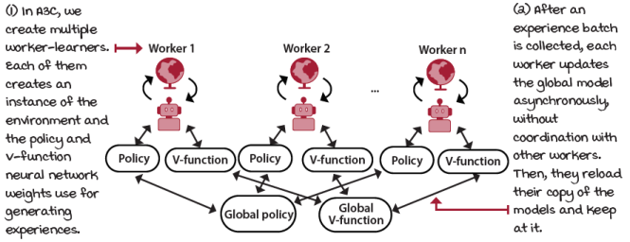
Asynchronous model updates
I Speak Python
A3C worker logic 1/2
class A3C(): ①
<...> ②
def work(self, rank): ③
local_seed = self.seed + rank ④
env = self.make_env_fn(
**self.make_env_kargs, ⑤
seed=local_seed)
torch.manual_seed(local_seed)
np.random.seed(local_seed) ⑥
random.seed(local_seed)
nS = env.observation_space.shape[0] ⑦
nA = env.action_space.n
local_policy_model = self.policy_model_fn(nS, nA)
local_policy_model.load_state_dict( ⑧
self.shared_policy_model.state_dict())
local_value_model = self.value_model_fn(nS)
local_value_model.load_state_dict( ⑨
self.shared_value_model.state_dict())
while not self.get_out_signal: ⑩
state, is_terminal = env.reset(), False ⑪
n_steps_start = 0 ⑫
logpas, entropies, rewards, values = [], [], [], []
for step in count(start=1): ⑬
① This is the A3C agent.
② As usual, these are snippets. You know where to find the working code.
③ This is the work function each worker loops around in. The rank parameter is used as an ID for workers.
④ See how we create a unique seed per worker. We want diverse experiences.
⑤ We create a uniquely seeded environment for each worker.
⑥ We also use that unique seed for PyTorch, NumPy and Python.
⑦ Handy variables
⑧ Here we create a local policy model. See how we initialize its weights with the weights of a shared policy network. This network allow us to synchronize the agents periodically.
⑨ We do the same thing with the value model. Notice we don’t need nA for output dimensions.
⑩ We start the training loop, until the worker is signaled to get out of it.
⑪ The first thing is to reset the environment, and set the done or is_terminal flag to false.
⑫ As you see next, we use n-step returns for training the policy and value functions.
⑬ Let’s continue on the next page.

I Speak Python
A3C worker logic 2/2
for step in count(start=1): ⑭ ⑮
state, reward, is_terminal, is_truncated, \
is_exploratory = self.interaction_step( ⑮
state, env, local_policy_model,
local_value_model, logpas,
entropies, rewards, values)
if is_terminal or step - n_steps_start == \ ⑯
self.max_n_steps:
is_failure = is_terminal and not is_truncated ⑰
next_value = 0 if is_failure else \ ⑱
local_value_model(state).detach().item()
rewards.append(next_value) ⑲
self.optimize_model( ⑳
logpas, entropies, rewards, values,
local_policy_model, local_value_model)
logpas, entropies, rewards, values = [], [], [], [] ㉑
n_steps_start = step ㉑
if is_terminal: ㉒
break
<...> ㉓
⑭ I removed eight spaces from the indentation to make it easier to read.
⑮ We are in the episode loop. The first thing is to collect a step of experience.
⑯ We collect n-steps maximum. If we hit a terminal state, we stop there.
⑰ We check if the time wrapper was triggered or this is a true terminal state.
⑱ If it’s a failure, then the value of the next state is 0; otherwise, we bootstrap.
⑲ Look! I’m being sneaky here and appending the next_value to the rewards. By doing this, the optimization code from VPG remains largely the same, as you’ll see soon. Make sure you see it.
⑳ Next we optimize the model. We dig into that function shortly.
㉑ We reset the variables after the optimization step and continue.
㉒ And, if the state is terminal, of course exit the episode loop.
㉓ There is a lot removed.
Using n-step estimates
On the previous page, you notice that I append the value of the next state, whether terminal or not, to the reward sequence. That means that the reward variable contains all rewards from the partial trajectory and the state-value estimate of that last state. We can also see this as having the partial return and the predicted remaining return in the same place. The partial return is the sequence of rewards, and the predicted remaining return is a single-number estimate. The only reason why this isn’t a return is that it isn’t a discounted sum, but we can take care of that as well.
You should realize that this is an n-step return, which you learned about in chapter 5. We go out for n-steps collecting rewards, and then bootstrap after that nth state, or before if we land on a terminal state, whichever comes first.
A3C takes advantage of the lower variance of n-step returns when compared to Monte Carlo returns. We use the value function also to predict the return used for updating the policy. You remember that bootstrapping reduces variance, but it adds bias. Therefore, we’ve added a critic to our policy-gradient algorithm. Welcome to the world of actor-critic methods.
Show Me The Math
Using n-step bootstrapping estimates
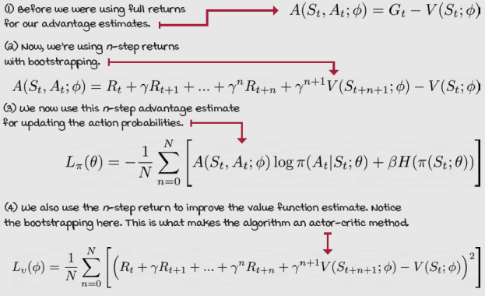

I Speak Python
A3C optimization step 1/2
class A3C(): ①
<...>
def optimize_model( ①
self, logpas, entropies, rewards, values,
local_policy_model, local_value_model):
T = len(rewards) ②
discounts = np.logspace(0, T, num=T, base=self.gamma, ③
endpoint=False)
returns = np.array(
[np.sum(discounts[:T-t] * rewards[t:]) for t in range(T)]) ④
discounts = torch.FloatTensor(
discounts[:-1]).unsqueeze(1) ⑤
returns = torch.FloatTensor(returns[:-1]).unsqueeze(1)
value_error = returns - values ⑥
policy_loss = -(discounts * value_error.detach() * \
logpas).mean()
entropy_loss = -entropies.mean() ⑦
loss = policy_loss + self.entropy_loss_weight * \
entropy_loss
self.shared_policy_optimizer.zero_grad()
loss.backward() ⑧
torch.nn.utils.clip_grad_norm_(
local_policy_model.parameters(), ⑨
self.policy_model_max_grad_norm)
for param, shared_param in zip( ⑩
① A3C, optimization function
② First get the length of the reward. Remember, rewards includes the bootstrapping value.
③ Next, we calculate all discounts up to n+1.
④ This now is the n-step predicted return.
⑤ To continue, we need to remove the extra elements and format the variables as expected.
⑥ Now, we calculate the value errors as the predicted return minus the estimated values.
⑦ We calculate the loss as before.
⑧ Notice we now zero the shared policy optimizer, then calculate the loss.
⑨ Then, clip the gradient magnitude.
⑩ Continue on the next page.

I Speak Python
A3C optimization step 2/2
for param, shared_param in zip( ⑪
local_policy_model.parameters(),
self.shared_policy_model.parameters()): ⑪
if shared_param.grad is None: ⑫
shared_param._grad = param.grad
self.shared_policy_optimizer.step() ⑬
local_policy_model.load_state_dict( ⑭
self.shared_policy_model.state_dict())
value_loss = value_error.pow(2).mul(0.5).mean() ⑮
self.shared_value_optimizer.zero_grad() ⑯
value_loss.backward() ⑰
torch.nn.utils.clip_grad_norm_( ⑱
local_value_model.parameters(),
self.value_model_max_grad_norm)
for param, shared_param in zip(
local_value_model.parameters(),
self.shared_value_model.parameters()):
if shared_param.grad is None:
shared_param._grad = param.grad ⑲
self.shared_value_optimizer.step() ⑳
local_value_model.load_state_dict( ㉑
self.shared_value_model.state_dict())
⑪ Okay, so check this out. What we’re doing here is iterating over all local and shared policy network parameters.
⑫ And what we want to do is copy every gradient from the local to the shared model.
⑬ Once the gradients are copied into the shared optimizer, we run an optimization step.
⑭ Immediately after, we load the shared model into the local model.
⑮ Next, we do the same thing but with the state-value network. Calculate the loss.
⑯ Zero the shared value optimizer.
⑰ Backpropagate the gradients.
⑱ Then, clip them.
⑲ Then, copy all the gradients from the local model to the shared model.
⑳ Step the optimizer.
㉑ Finally, load the shared model into the local variable.
Non-blocking model updates
One of the most critical aspects of A3C is that its network updates are asynchronous and lock-free. Having a shared model creates a tendency for competent software engineers to want a blocking mechanism to prevent workers from overwriting other updates. Interestingly, A3C uses an update style called a Hogwild!, which is shown to not only achieve a near-optimal rate of convergence but also outperform alternative schemes that use locking by an order of magnitude.
I Speak Python
Shared Adam optimizer
class SharedAdam(torch.optim.Adam): ①
<...>

for group in self.param_groups:
for p in group['params']:
state = self.state[p]
state['step'] = 0
state['shared_step'] =
\torch.zeros(1).share_memory_()
state['exp_avg'] =
\torch.zeros_like(p.data).share_memory_() ②
<...> ③

def step(self, closure=None): ④
for group in self.param_groups:
for p in group['params']:
if p.grad is None: continue
self.state[p]['steps'] = \ ④
self.state[p]['shared_step'].item()
self.state[p]['shared_step'] += 1
super().step(closure) ⑤
① We need to create an Adam (and RMSprop in the Notebook) optimizer that puts internal variables into shared memory. Gladly, PyTorch makes this straightforward.
② We only need to call the share_memory_method on the variables we need shared across workers.
③ More variables than shown here.
④ Then, override the step function so that we can manually increment the step variable, which isn’t easily put into shared memory.
⑤ Last, call the parent's 'step'.

0001 | A Bit of history  Introduction of the asynchronous advantage actor-critic (A3C)
 | Vlad Mnih et al. introduced A3C in 2016 in a paper titled “Asynchronous Methods for Deep Reinforcement Learning.” If you remember correctly, Vlad also introduced the DQN agent in two papers, one in 2013 and the other in 2015. While DQN ignited growth in DRL research in general, A3C directed lots of attention to actor-critic methods more precisely.
GAE: Robust advantage estimation
A3C uses n-step returns for reducing the variance of the targets. Still, as you probably remember from chapter 5, there’s a more robust method that combines multiple n-step bootstrapping targets in a single target, creating even more robust targets than a single n-step: the λ-target. Generalized advantage estimation (GAE) is analogous to the λ-target in TD(λ), but for advantages.
Generalized advantage estimation
GAE is not an agent on its own, but a way of estimating targets for the advantage function that most actor-critic methods can leverage. More specifically, GAE uses an exponentially weighted combination of n-step action-advantage function targets, the same way the λ-target is an exponentially weighted combination of n-step state-value function targets. This type of target, which we tune in the same way as the λ-target, can substantially reduce the variance of policy-gradient estimates at the cost of some bias.
Show Me The Math
Possible policy-gradient estimators
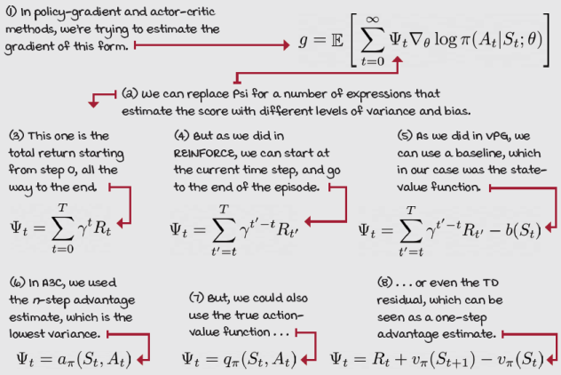

Show Me The Math
GAE is a robust estimate of the advantage function
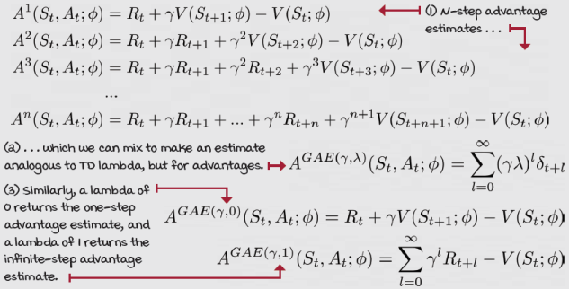

Show Me The Math
Possible value targets
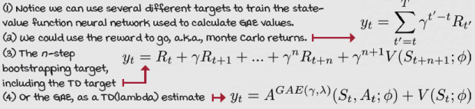

0001 | A Bit Of History  Introduction of the generalized advantage estimations
John Schulman et al. published a paper in 2015 titled “High-dimensional Continuous Control Using Generalized Advantage Estimation,” in which he introduces GAE.
John is a research scientist at OpenAI, and the lead inventor behind GAE, TRPO, and PPO, algorithms that you learn about in the next chapter. In 2018, John was recognized by Innovators Under 35 for creating these algorithms, which are to this date state of the art.

I Speak Python
GAE’s policy optimization step
class GAE(): ①
<...>
def optimize_model(
self, logpas, entropies, rewards, values,
local_policy_model, local_value_model):
T = len(rewards)
discounts = np.logspace(0, T, num=T, base=self.gamma, ②
endpoint=False)
returns = np.array(
[np.sum(discounts[:T-t] * rewards[t:]) for t in range(T)])
np_values = values.view(-1).data.numpy()
tau_discounts = np.logspace(0, T-1, num=T-1, ③
base=self.gamma*self.tau, endpoint=False)
advs = rewards[:-1] + self.gamma * \ ④
np_values[1:] - np_values[:-1]
gaes = np.array( ⑤
[np.sum(tau_discounts[:T-1-t] * advs[t:]) for t in range(T-1)])
<...> ⑥
policy_loss = -(discounts * gaes.detach() * \
logpas).mean()
entropy_loss = -entropies.mean()
loss = policy_loss + self.entropy_loss_weight * \
entropy_loss
value_error = returns - values ⑦
value_loss = value_error.pow(2).mul(0.5).mean() ⑦
<...> ⑦
① This is the GAE optimize model logic.
② First, we create the discounted returns, the way we did with A3C.
③ These two lines are creating, first, a NumPy array with all the state values, and second, an array with the (gamma*lambda)^t. Note, lambda is often referred to as tau, too. I’m using that.
④ This line creates an array of TD errors: R_t + gamma * value_t+1 - value_t, for t=0 to T.
⑤ Here we create the GAEs, by multiplying the tau discounts times the TD errors.
⑥ We now use the gaes to calculate the policy loss.
⑦ And proceed as usual.
A2C: Synchronous policy updates
In A3C, workers update the neural networks asynchronously. But, asynchronous workers may not be what makes A3C such a high-performance algorithm. Advantage actor-critic (A2C) is a synchronous version of A3C, which despite the lower numbering order, was proposed after A3C and showed to perform comparably to A3C. In this section, we explore A2C, along with a few other changes we can apply to policy-gradient methods.
Weight-sharing model
One change to our current algorithm is to use a single neural network for both the policy and the value function. Sharing a model can be particularly beneficial when learning from images because feature extraction can be compute-intensive. However, model sharing can be challenging due to the potentially different scales of the policy and value function updates.
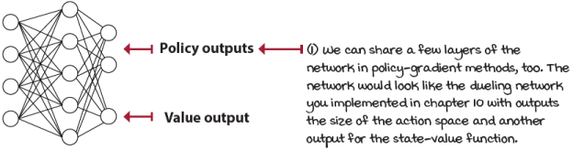
Sharing weights between policy and value outputs
I Speak Python
Weight-sharing actor-critic neural network model 1/2
class FCAC(nn.Module): ①
def __init__(
self, input_dim, output_dim,
hidden_dims=(32,32), activation_fc=F.relu):
super(FCAC, self).__init__()
self.activation_fc = activation_fc
self.input_layer = nn.Linear(input_dim, hidden_dims[0])
self.hidden_layers = nn.ModuleList()
for i in range(len(hidden_dims)-1): ②
hidden_layer = nn.Linear(
hidden_dims[i], hidden_dims[i+1])
self.hidden_layers.append(hidden_layer)
self.value_output_layer = nn.Linear( ③
① This is the fully connected actor-critic model.
② This is the network instantiation process. This is similar to the independent network model.
③ Continues ...

I Speak Python
Weight-sharing actor-critic neural network model 2/2
self.value_output_layer = nn.Linear(
hidden_dims[-1], 1) ④
self.policy_output_layer = nn.Linear(
hidden_dims[-1], output_dim)
def forward(self, state):
x = state ⑤
if not isinstance(x, torch.Tensor):
x = torch.tensor(x, dtype=torch.float32)
if len(x.size()) == 1:
x = x.unsqueeze(0)
x = self.activation_fc(self.input_layer(x))
for hidden_layer in self.hidden_layers:
x = self.activation_fc(hidden_layer(x))
return self.policy_output_layer(x), \
self.value_output_layer(x) ⑥
def full_pass(self, state):
logits, value = self.forward(state)
dist = torch.distributions.Categorical(logits=logits)
action = dist.sample()
logpa = dist.log_prob(action).unsqueeze(-1)
entropy = dist.entropy().unsqueeze(-1)
action = action.item() if len(action) == 1 \
else action.data.numpy()
is_exploratory = action != np.argmax(
logits.detach().numpy(), axis=int(len(state)!=1))
return action, is_exploratory, logpa, entropy, value ⑦
def select_action(self, state):
logits, _ = self.forward(state)
dist = torch.distributions.Categorical(logits=logits)
action = dist.sample()
action = action.item() if len(action) == 1 \
else action.data.numpy()
return action ⑧
④ Okay. Here’s where it’s built, both the value output and the policy output connect to the last layer of the hidden layers.
⑤ The forward pass starts by reshaping the input to match the expected variable type and shape.
⑥ And notice how it outputs from the policy and a value layers.
⑦ This is a handy function to get log probabilities, entropies, and other variables at once.
⑧ This selects the action or actions for the given state or batch of states.
Restoring order in policy updates
Updating the neural network in a Hogwild!-style can be chaotic, yet introducing a lock mechanism lowers A3C performance considerably. In A2C, we move the workers from the agent down to the environment. Instead of having multiple actor-learners, we have multiple actors with a single learner. As it turns out, having workers rolling out experiences is where the gains are in policy-gradient methods.
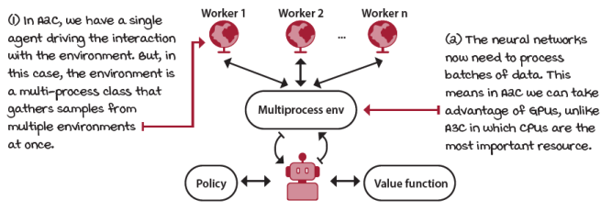
I Speak Python
Multi-process environment wrapper 1/2
class MultiprocessEnv(object):
def __init__(self, make_env_fn,make_env_kargs,
seed, n_workers):
self.make_env_fn = make_env_fn
self.make_env_kargs = make_env_kargs
self.seed = seed
self.n_workers = n_workers
self.pipes = [
mp.Pipe() for rank in range(self.n_workers)]①
self.workers = [ ②
mp.Process(target=self.work,
args=(rank, self.pipes[rank][1])) \
for rank in range(self.n_workers)]
[w.start() for w in self.workers] ③
① This is the multi-process environment class, which creates pipes to communicate with the workers, and creates the workers themselves.
② Here we create the workers.
③ Here we start them.

I Speak Python
Multi-process environment wrapper 2/2
[w.start() for w in self.workers] ④
def work(self, rank, worker_end):
env = self.make_env_fn(
**self.make_env_kargs, seed=self.seed + rank) ⑤
while True: ⑥
cmd, kwargs = worker_end.recv()
if cmd == 'reset':
worker_end.send(env.reset(**kwargs)) ⑦
elif cmd == 'step':
worker_end.send(env.step(**kwargs))
elif cmd == '_past_limit':
# Another way to check time limit truncation
worker_end.send(\
env._elapsed_steps >= env._max_episode_steps)
else:
env.close(**kwargs) ⑦
del env
worker_end.close()
break
def step(self, actions): ⑧
assert len(actions) == self.n_workers
[self.send_msg(('step',{'action':actions[rank]}),rank)\ ⑨
for rank in range(self.n_workers)]
results = []
for rank in range(self.n_workers): ⑩
parent_end, _ = self.pipes[rank]
o, r, d, _ = parent_end.recv()
if d:
self.send_msg(('reset', {}), rank) ⑪
o = parent_end.recv()
results.append((o, ⑫
np.array(r, dtype=np.float),
np.array(d, dtype=np.float), _))
return \
[np.vstack(block) for block in np.array(results).T] ⑫
④ Continuation
⑤ Workers first create the environment.
⑥ Get in this loop listening for commands.
⑦ Each command calls the respective env function and sends the response back to the parent process.
⑧ This is the main step function, for instance.
⑨ When called, it broadcasts the command and arguments to workers.
⑩ Workers do their part and send back the data, which is collected here.
⑪ We automatically reset on done.
⑫ Last, append and stack the results by observations, rewards, dones, infos.

I Speak Python
The A2C train logic
class A2C():
def train(self, make_envs_fn, make_env_fn, ①
make_env_kargs, seed, gamma, max_minutes,
max_episodes, goal_mean_100_reward):
envs = self.make_envs_fn(make_env_fn, ②
make_env_kargs, self.seed,
self.n_workers)
<...>
self.ac_model = self.ac_model_fn(nS, nA) ③
self.ac_optimizer = self.ac_optimizer_fn(
self.ac_model, self.ac_optimizer_lr)
states = envs.reset() ④
for step in count(start=1):
states, is_terminals = \ ⑤
self.interaction_step(states, envs)
if is_terminals.sum() or \
step - n_steps_start == self.max_n_steps:
past_limits_enforced = envs._past_limit()
failure = np.logical_and(is_terminals,
np.logical_not(past_limits_enforced)) ⑤
next_values = self.ac_model.evaluate_state( ⑤
states).detach().numpy() * (1 - failure)
self.rewards.append(next_values)
self.values.append(torch.Tensor(next_values))
self.optimize_model()
self.logpas, self.entropies = [], []
self.rewards, self.values = [], [] ⑥
n_steps_start = step
① This is how we train with the multi-processor environment.
② Here, see how to create, basically, vectorized environments.
③ Here we create a single model. This is the actor-critic model with policy and value outputs.
④ Look, we reset the multi-processor environment and get a stack of states back.
⑤ The main thing is we work with stacks now.
⑥ But, at its core, everything is the same.

I Speak Python
The A2C optimize-model logic
class A2C(): ①
def optimize_model(self):
T = len(self.rewards)
discounts = np.logspace(0, T, num=T, base=self.gamma,
endpoint=False)
returns = np.array(
[[np.sum(discounts[:T-t] * rewards[t:, w])
for t in range(T)] \ ②
for w in range(self.n_workers)]) ②
np_values = values.data.numpy()
tau_discounts = np.logspace(0, T-1, num=T-1,
base=self.gamma*self.tau, endpoint=False)
advs = rewards[:-1] + self.gamma * np_values[1:] \ ③
- np_values[:-1]
gaes = np.array(
[[np.sum(tau_discounts[:T-1-t] * advs[t:, w]) \
for t in range(T-1)]
for w in range(self.n_workers)]) ④
discounted_gaes = discounts[:-1] * gaes
value_error = returns - values ⑤
value_loss = value_error.pow(2).mul(0.5).mean()
policy_loss = -(discounted_gaes.detach() * \
logpas).mean()
entropy_loss = -entropies.mean()
loss = self.policy_loss_weight * policy_loss + \ ⑤
self.value_loss_weight * value_loss + \
self.entropy_loss_weight * entropy_loss
self.ac_optimizer.zero_grad()
loss.backward() ⑥
torch.nn.utils.clip_grad_norm_(
self.ac_model.parameters(),
self.ac_model_max_grad_norm)
self.ac_optimizer.step()
① This is how we optimize the model in A2C.
② The main thing to notice is now we work with matrices with vectors of time steps per worker.
③ Some operations work the same exact way, surprisingly.
④ And for some, we just need to add a loop to include all workers.
⑤ Look how we build a single loss function.
⑥ Finally, we optimize a single neural network.

 | It's In The Details  Running all policy-gradient methods in the CartPole-v1 environment
To demonstrate the policy-gradient algorithms, and to make comparison easier with the value-based methods explored in the previous chapters, I ran experiments with the same configurations as in the value-based method experiments. Here are the details:
REINFORCE:
- Runs a policy network with 4-128-64-2 nodes, Adam optimizer, and lr 0.0007.
- Trained at the end of each episode with Monte Carlo returns. No baseline.
VPG (REINFORCE with Monte Carlo baseline):
- Same policy network as REINFORCE, but now we add an entropy term to the loss function with 0.001 weight, and clip the gradient norm to 1.
- We now learn a value function and use it as a baseline, not as a critic. This means MC returns are used without bootstrapping and the value function only reduces the scale of the returns. The value function is learned with a 4-256-128-1 network, RMSprop optimizer, and a 0.001 learning rate. No gradient clippings, though it’s possible.
A3C:
- We train the policy and value networks the same exact way.
- We now bootstrap the returns every 50 steps maximum (or when landing on a terminal state). This is an actor-critic method.
- We use eight workers each with copies of the networks and doing Hogwild! updates.
GAE:
- Same exact hyperparameter as the rest of the algorithms.
- Main difference is GAE adds a tau hyperparameter to discount the advantages. We use 0.95 for tau here. Notice that the agent style has the same n-step bootstrapping logic, which might not make this a pure GAE implementation. Usually, you see batches of full episodes being processed at once. It still performs pretty well.
A2C:
- A2C does change most of the hyperparameters. To begin with, we have a single network: 4-256-128-3 (2 and 1). Train with Adam, lr of 0.002, gradient norm of 1.
- The policy is weighted at 1.0, value function at 0.6, entropy at 0.001.
- We go for 10-step bootstrapping, eight workers, and a 0.95 tau.
These algorithms weren’t tuned independently; I’m sure they could do even better.

 | Tally it Up  Policy-gradient and actor-critic methods on the CartPole-v1 environment
 | 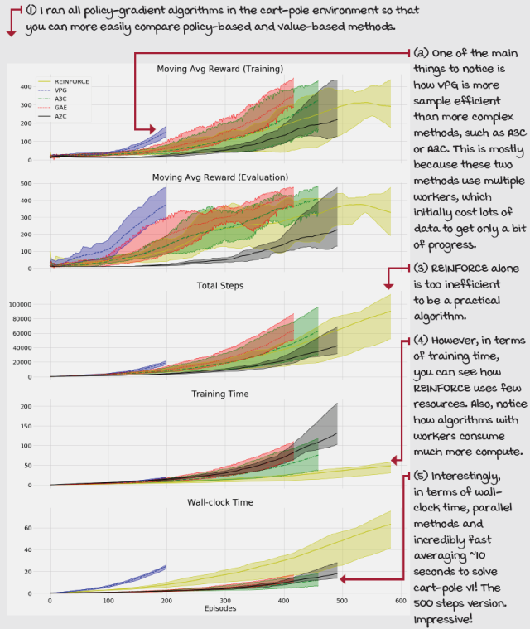
Summary
In this chapter, we surveyed policy-gradient and actor-critic methods. First, we set up the chapter with a few reasons to consider policy-gradient and actor-critic methods. You learned that directly learning a policy is the true objective of reinforcement learning methods. You learned that by learning policies, we could use stochastic policies, which can have better performance than value-based methods in partially observable environments. You learned that even though we typically learn stochastic policies, nothing prevents the neural network from learning a deterministic policy.
You also learned about four algorithms. First, we studied REINFORCE and how it’s a straightforward way of improving a policy. In REINFORCE, we could use either the full return or the reward-to-go as the score for improving the policy.
You then learned about vanilla policy gradient, also known as REINFORCE with baseline. In this algorithm, we learn a value function using Monte Carlo returns as targets. Then, we use the value function as a baseline and not as a critic. We don’t bootstrap in VPG; instead, we use the reward-to-go, such as in REINFORCE, and subtract the learned value function to reduce the variance of the gradient. In other words, we use the advantage function as the policy score.
We also studied the A3C algorithm. In A3C, we bootstrap the value function, both for learning the value function and for scoring the policy. More specifically, we use n-step returns to improve the models. Additionally, we use multiple actor-learners that each roll out the policy, evaluate the returns, and update the policy and value models using a Hogwild! approach. In other words, workers update lock-free models.
We then learned about GAE, and how this is a way for estimating advantages analogous to TD(λ) and the λ-return. GAE uses an exponentially weighted mixture of all n-step advantages for creating a more robust advantage estimate that can be easily tuned to use more bootstrapping and therefore bias, or actual returns and therefore variance.
Finally, we learned about A2C and how removing the asynchronous part of A3C yields a comparable algorithm without the need for implementing custom optimizers.
By now, you
- Understand the main differences between value-based, policy-based, policy-gradient, and actor-critic methods
- Can implement fundamental policy-gradient and actor-critic methods by yourself
- Can tune policy-gradient and actor-critic algorithms to pass a variety of environments
 | Tweetable Feat  Work on your own and share your findings
Here are several ideas on how to take what you’ve learned to the next level. If you’d like, share your results with the rest of the world and make sure to check out what others have done, too. It’s a win-win situation, and hopefully, you'll take advantage of it.
- #gdrl_ch11_tf01: Earlier in this chapter I talked about a fictitious foggy lake environment, but hey, it’s only fictitious because you haven’t implemented it, right? Go ahead and implement a foggy lake and also a foggy frozen lake environment. For this one, make sure the observation passed to the agent is different than the actual internal state of the environment. If the agent is in cell 3, for example, the internal state is kept secret, and the agent is only able to observe that it’s in a foggy cell. In this case, all foggy cells should emit the same observation, so the agent can’t tell where it is. After implementing this environment, test DRL agents that can only learn deterministic policies (such as in previous chapters), and agents that can learn stochastic policies (such as in this chapter). You’ll have to do one-hot encoding of the observations to pass into the neural network. Create a Python package with the environment, and a Notebook with interesting tests and results.
- #gdrl_ch11_tf02: In this chapter, we’re still using the CartPole-v1 environment as a test bed, but you know swapping environments should be straightforward. First, test the same agents in similar environments, such as the LunarLander-v2, or MountainCar-v0. Note what makes it similar is that the observations are low dimensional and continuous, and the actions are low dimensional and discrete. Second, test them in different environments, high dimensional, or continuous observations or actions.
- #gdrl_ch11_tf03: In every chapter, I’m using the final hashtag as a catchall hashtag. Feel free to use this one to discuss anything else that you worked on relevant to this chapter. There is no more exciting homework than that which you create for yourself. Make sure to share what you set yourself to investigate and your results.
Write a tweet with your findings, tag me @mimoralea (I’ll retweet), and use the particular hashtag from the list to help interested folks find your results. There are no right or wrong results; you share your findings and check others’ findings. Take advantage of this to socialize, contribute, and get yourself out there! We’re waiting for you!
Here’s a tweet example:
“Hey, @mimoralea. I created a blog post with a list of resources to study deep reinforcement learning. Check it out at <link>. #gdrl_ch01_tf01”
I’ll make sure to retweet and help others find your work.

