# High-Quality Code Construction – “Minesweeper” Game

Your task is to write an interactive **console-based implementation of the game “Minesweeper”** in which the player tries to **discover all mines** in a matrix of mines and empty cells. The game starts from a **randomly generated matrix of 10 x 5 cells** (5 rows and 10 columns). Initially there are **15 mines** randomly situated in the matrix and all other cells are empty. The player doesn’t know initially where the mines are located and all cells in the matrix are displayed as ‘**?**’. At each turn the player is asked to enter a cell and to **reveal its contents**. If the cell contains a **mine**, the player **loses the game** and all mines are shown. Otherwise the revealed cell is replaced with a number in the range [0…8] indicating how many neighbor cells contain a mine. The figure below shows an example:

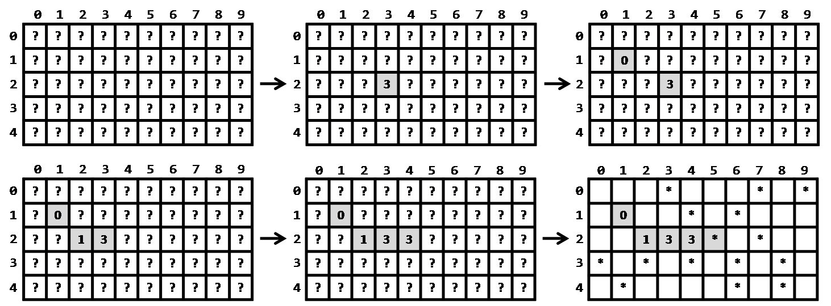

The game finishes either by **revealing all cells** without mines or by revealing a mine. When the game is finished, a new game automatically starts.

The player can request starting a new game by entering the command **'restart'**.

Your program should implement a **local top scoreboard** which keeps the best results and the names of their authors. Initially, at the program start, the scoreboard is empty. It keeps the **top 5 results** sorted in descending order by the number of revealed cells without mines. When a game is finished, the player’s result can enter in the top scoreboard if his or her number of moves is more than some of the other achievements staying in the top scoreboard. When the player’s result enters the scoreboard, the player should enter his or her name or nickname.

The player can request printing the top scoreboard during the game by entering the command **'top'**.

The player can request stopping the game and exiting from the program the command **'exit'**.

## Example Game Session

The player’s input is shown in *italic*:

|  |
| --- |
| **Welcome to the game “Minesweeper”. Try to reveal all cells without mines. Use 'top' to view the scoreboard, 'restart' to start a new game and 'exit' to quit the game.**  **0 1 2 3 4 5 6 7 8 9**  **---------------------**  **0 | ? ? ? ? ? ? ? ? ? ? |**  **1 | ? ? ? ? ? ? ? ? ? ? |**  **2 | ? ? ? ? ? ? ? ? ? ? |**  **3 | ? ? ? ? ? ? ? ? ? ? |**  **4 | ? ? ? ? ? ? ? ? ? ? |**  **---------------------**  **Enter row and column: *2 3***  **0 1 2 3 4 5 6 7 8 9**  **---------------------**  **0 | ? ? ? ? ? ? ? ? ? ? |**  **1 | ? ? ? ? ? ? ? ? ? ? |**  **2 | ? ? ? 3 ? ? ? ? ? ? |**  **3 | ? ? ? ? ? ? ? ? ? ? |**  **4 | ? ? ? ? ? ? ? ? ? ? |**  **---------------------**  **Enter row and column: *2 3***  **Illegal move!**  **Enter row and column: *1 1***  **0 1 2 3 4 5 6 7 8 9**  **---------------------**  **0 | ? ? ? ? ? ? ? ? ? ? |**  **1 | ? 0 ? ? ? ? ? ? ? ? |**  **2 | ? ? ? 3 ? ? ? ? ? ? |**  **3 | ? ? ? ? ? ? ? ? ? ? |**  **4 | ? ? ? ? ? ? ? ? ? ? |**  **---------------------**  **Enter row and column: *2 5***  **0 1 2 3 4 5 6 7 8 9**  **---------------------**  **0 | - - - * - - - * - * |**  **1 | - 0 - - * - * - - - |**  **2 | - - - 3 - * - * - - |**  **3 | * - * - * - * - * - |**  **4 | - * - - - - * - * - |**  **---------------------**  **Booooom! You were killed by a mine. You revealed 2 cells without mines.**  **Please enter your name for the top scoreboard: *Bay Ivan***  **Scoreboard:**  **1. Bay Ivan --> 2 cells**  **Welcome to the game “Minesweeper”. Try to reveal all cells without mines. Use 'top' to view the scoreboard, 'restart' to start a new game and 'exit' to quit the game.**  **0 1 2 3 4 5 6 7 8 9**  **---------------------**  **0 | ? ? ? ? ? ? ? ? ? ? |**  **1 | ? ? ? ? ? ? ? ? ? ? |**  **2 | ? ? ? ? ? ? ? ? ? ? |**  **3 | ? ? ? ? ? ? ? ? ? ? |**  **4 | ? ? ? ? ? ? ? ? ? ? |**  **---------------------**  **Enter row and column: *top***  **Scoreboard:**  **1. Bay Ivan --> 2 cells**  **Enter row and column: *0 0***  **0 1 2 3 4 5 6 7 8 9**  **---------------------**  **0 | 1 ? ? ? ? ? ? ? ? ? |**  **1 | ? ? ? ? ? ? ? ? ? ? |**  **2 | ? ? ? ? ? ? ? ? ? ? |**  **3 | ? ? ? ? ? ? ? ? ? ? |**  **4 | ? ? ? ? ? ? ? ? ? ? |**  **---------------------**  **Enter row and column: *restart***  **Welcome to the game “Minesweeper”. Try to reveal all cells without mines. Use 'top' to view the scoreboard, 'restart' to start a new game and 'exit' to quit the game.**  **0 1 2 3 4 5 6 7 8 9**  **---------------------**  **0 | ? ? ? ? ? ? ? ? ? ? |**  **1 | ? ? ? ? ? ? ? ? ? ? |**  **2 | ? ? ? ? ? ? ? ? ? ? |**  **3 | ? ? ? ? ? ? ? ? ? ? |**  **4 | ? ? ? ? ? ? ? ? ? ? |**  **---------------------**  **Enter row and column: *exit***  **Good bye!** |

Some players could try to cheat by entering illegal moves, so be cautious and **prevent illegal input**.