**linux下libwebsockets编译及实例**

    最近想自己搭建一个webscoket协议的服务器，打算用libwebsockts这个库。

**下载代码编译。**

编写一个shell脚本

#!/bin/sh
*# wget http://git.warmcat.com/cgi-bin/cgit/libwebsockets/snapshot/libwebsockets-1.4-chrome43-firefox-36.tar.gz*
*# tar xvzf libwebsockets-1.4-chrome43-firefox-36.tar.gz*
*#cd libwebsockets-1.4-chrome43-firefox-36*
*# build*
git clone https://github.com/warmcat/libwebsockets.git
cd libwebsockets
documentRoot=`pwd`
mkdir build
cmake ..
make

执行shell脚本就下载编译成功了。

**运行一个例子**

其实在库里面有一些实例的.

cd build
#!/bin/sh
documentRoot=`pwd`
libdir=libwebsockets
cd $libdir/build/bin
./libwebsockets-test-server --resource_path=$documentRoot/test-server

 这样就运行自带的服务器。运行结果.

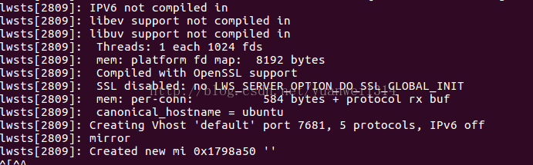

浏览器输入127.0.0.1:7681结果:

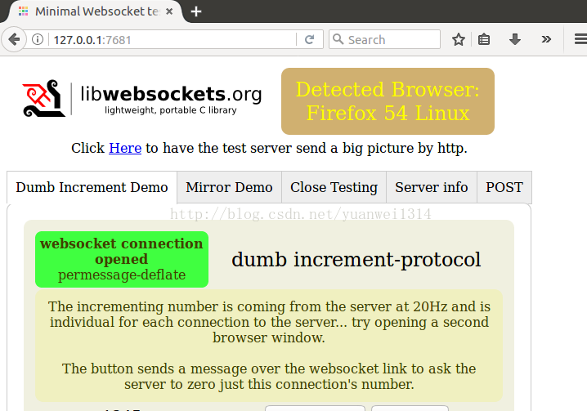

这样就是完整的结果了。

**搭建自己的websocket server**

#include <stdio.h>

#include <stdlib.h>

#include <string.h>

#include <unistd.h>

#include <signal.h>

#include <libwebsockets.h>

#define KGRN "\033[0;32;32m"

#define KCYN "\033[0;36m"

#define KRED "\033[0;32;31m"

#define KYEL "\033[1;33m"

#define KMAG "\033[0;35m"

#define KBLU "\033[0;32;34m"

#define KCYN_L "\033[1;36m"

#define RESET "\033[0m"

static int destroy_flag = 0;

static void INT_HANDLER(int signo) {

destroy_flag = 0;

}

*/* \**

*\* websocket_write_back: write the string data to the destination wsi.*

*\*/*

int websocket_write_back(struct lws *wsi_in, char *str, int str_size_in)

{

if (str == NULL || wsi_in == NULL)

return -1;

int n;

int len;

unsigned char *out = NULL;

if (str_size_in < 1)

len = strlen(str);

else

len = str_size_in;

out = (unsigned char *)malloc(sizeof(unsigned char)*(LWS_SEND_BUFFER_PRE_PADDING + len + LWS_SEND_BUFFER_POST_PADDING));

*//* setup the buffer*/*

memcpy (out + LWS_SEND_BUFFER_PRE_PADDING, str, len );

*//* write out*/*

n = lws_write(wsi_in, out + LWS_SEND_BUFFER_PRE_PADDING, len, LWS_WRITE_TEXT);

printf(KBLU"[websocket_write_back] %s\n"RESET, str);

*//* free the buffer*/*

free(out);

return n;

}

static int ws_service_callback(

struct lws *wsi,

enum lws_callback_reasons reason, void *user,

void *in, size_t len)

{

switch (reason) {

case LWS_CALLBACK_ESTABLISHED:

printf(KYEL"[Main Service] Connection established\n"RESET);

break;

*//* If receive a data from client*/*

case LWS_CALLBACK_RECEIVE:

printf(KCYN_L"[Main Service] Server recvived:%s\n"RESET,(char *)in);

*//* echo back to client*/*

websocket_write_back(wsi ,(char *)in, -1);

break;

case LWS_CALLBACK_CLOSED:

printf(KYEL"[Main Service] Client close.\n"RESET);

break;

default:

break;

}

return 0;

}

struct per_session_data {

int fd;

};

int main(void) {

*// server url will usd port 5000*

int port = 5000;

const char *interface = NULL;

struct lws_context_creation_info info;

struct lws_protocols protocol;

struct lws_context *context;

*// Not using ssl*

const char *cert_path = NULL;

const char *key_path = NULL;

*// no special options*

int opts = 0;

*//* register the signal SIGINT handler */*

struct sigaction act;

act.sa_handler = INT_HANDLER;

act.sa_flags = 0;

sigemptyset(&act.sa_mask);

sigaction( SIGINT, &act, 0);

*//* setup websocket protocol */*

protocol.name = "my-echo-protocol";

protocol.callback = ws_service_callback;

protocol.per_session_data_size=sizeof(struct per_session_data);

protocol.rx_buffer_size = 0;

*//* setup websocket context info*/*

memset(&info, 0, sizeof info);

info.port = port;

info.iface = interface;

info.protocols = &protocol;

info.extensions = lws_get_internal_extensions();

info.ssl_cert_filepath = cert_path;

info.ssl_private_key_filepath = key_path;

info.gid = -1;

info.uid = -1;

info.options = opts;

*//* create libwebsocket context. */*

context = lws_create_context(&info);

if (context == NULL) {

printf(KRED"[Main] Websocket context create error.\n"RESET);

return -1;

}

printf(KGRN"[Main] Websocket context create success.\n"RESET);

*//* websocket service */*

while ( !destroy_flag ) {

lws_service(context, 50);

}

usleep(10);

lws_context_destroy(context);

return 0;

}

执行脚本:

#!/bin/sh
libdir=libwebsockets
g++ -g -o <span style="font-family:Arial, Helvetica, sans-serif;">ws_server </span><span style="font-family:Arial, Helvetica, sans-serif;">test_ws_server.cpp -I$libdir/lib -I$libdir/build -L$libdir/build/lib -lwebsockets</span>

**编写自己的websocket client**

#include <stdio.h>

#include <stdlib.h>

#include <string.h>

#include <unistd.h>

#include <signal.h>

#include <pthread.h>

#include <libwebsockets.h>

#define KGRN "\033[0;32;32m"

#define KCYN "\033[0;36m"

#define KRED "\033[0;32;31m"

#define KYEL "\033[1;33m"

#define KBLU "\033[0;32;34m"

#define KCYN_L "\033[1;36m"

#define KBRN "\033[0;33m"

#define RESET "\033[0m"

static int destroy_flag = 0;

static int connection_flag = 0;

static int writeable_flag = 0;

static void INT_HANDLER(int signo) {

destroy_flag = 0;

}

struct session_data {

int fd;

};

struct pthread_routine_tool {

struct lws_context *context;

struct lws *wsi;

};

static int websocket_write_back(struct lws *wsi_in, char *str, int str_size_in)

{

if (str == NULL || wsi_in == NULL)

return -1;

int n;

int len;

unsigned char *out = NULL;

if (str_size_in < 1)

len = strlen(str);

else

len = str_size_in;

out = (unsigned char *)malloc(sizeof(unsigned char)*(LWS_SEND_BUFFER_PRE_PADDING + len + LWS_SEND_BUFFER_POST_PADDING));

*//* setup the buffer*/*

memcpy (out + LWS_SEND_BUFFER_PRE_PADDING, str, len );

*//* write out*/*

n = lws_write(wsi_in, out + LWS_SEND_BUFFER_PRE_PADDING, len, LWS_WRITE_TEXT);

printf(KBLU"[websocket_write_back] %s\n"RESET, str);

*//* free the buffer*/*

free(out);

return n;

}

static int ws_service_callback(

struct lws *wsi,

enum lws_callback_reasons reason, void *user,

void *in, size_t len)

{

switch (reason) {

case LWS_CALLBACK_CLIENT_ESTABLISHED:

printf(KYEL"[Main Service] Connect with server success.\n"RESET);

connection_flag = 1;

break;

case LWS_CALLBACK_CLIENT_CONNECTION_ERROR:

printf(KRED"[Main Service] Connect with server error.\n"RESET);

destroy_flag = 1;

connection_flag = 0;

break;

case LWS_CALLBACK_CLOSED:

printf(KYEL"[Main Service] LWS_CALLBACK_CLOSED\n"RESET);

destroy_flag = 1;

connection_flag = 0;

break;

case LWS_CALLBACK_CLIENT_RECEIVE:

printf(KCYN_L"[Main Service] Client recvived:%s\n"RESET, (char *)in);

if (writeable_flag)

destroy_flag = 1;

break;

case LWS_CALLBACK_CLIENT_WRITEABLE :

printf(KYEL"[Main Service] On writeable is called. send byebye message\n"RESET);

websocket_write_back(wsi, "Byebye! See you later", -1);

writeable_flag = 1;

break;

default:

break;

}

return 0;

}

static void *pthread_routine(void *tool_in)

{

struct pthread_routine_tool *tool = (struct pthread_routine_tool*)tool_in;

printf(KBRN"[pthread_routine] Good day. This is pthread_routine.\n"RESET);

*//* waiting for connection with server done.*/*

while(!connection_flag)

usleep(1000*20);

*//*Send greeting to server*/*

printf(KBRN"[pthread_routine] Server is ready. send a greeting message to server.\n"RESET);

websocket_write_back(tool->wsi, "Good day", -1);

printf(KBRN"[pthread_routine] sleep 2 seconds then call onWritable\n"RESET);

sleep(1);

printf(KBRN"------------------------------------------------------\n"RESET);

sleep(1);

*//printf(KBRN"[pthread_routine] sleep 2 seconds then call onWritable\n"RESET);*

*//*involked wriable*/*

printf(KBRN"[pthread_routine] call on writable.\n"RESET);

lws_callback_on_writable(tool->wsi);

}

int main(void)

{

*//* register the signal SIGINT handler */*

struct sigaction act;

act.sa_handler = INT_HANDLER;

act.sa_flags = 0;

sigemptyset(&act.sa_mask);

sigaction( SIGINT, &act, 0);

struct lws_context *context = NULL;

struct lws_context_creation_info info;

struct lws *wsi = NULL;

struct lws_protocols protocol;

memset(&info, 0, sizeof info);

info.port = CONTEXT_PORT_NO_LISTEN;

info.iface = NULL;

info.protocols = &protocol;

info.ssl_cert_filepath = NULL;

info.ssl_private_key_filepath = NULL;

info.extensions = lws_get_internal_extensions();

info.gid = -1;

info.uid = -1;

info.options = 0;

protocol.name = "my-echo-protocol";

protocol.callback = &ws_service_callback;

protocol.per_session_data_size = sizeof(struct session_data);

protocol.rx_buffer_size = 0;

protocol.id = 0;

protocol.user = NULL;

context = lws_create_context(&info);

printf(KRED"[Main] context created.\n"RESET);

if (context == NULL) {

printf(KRED"[Main] context is NULL.\n"RESET);

return -1;

}

wsi = lws_client_connect(context, "localhost", 5000, 0,

"/", "localhost:5000", NULL, protocol.name, -1); if (wsi == NULL) { printf(KRED"[Main] wsi create error.\n"RESET); return -1; } printf(KGRN"[Main] wsi create success.\n"RESET); struct pthread_routine_tool tool; tool.wsi = wsi; tool.context = context; pthread_t pid; pthread_create(&pid, NULL, pthread_routine, &tool); pthread_detach(pid); while(!destroy_flag) { lws_service(context, 50); } lws_context_destroy(context); return 0; } 编写脚本:

#!/bin/sh

libdir=libwebsockets

g++ -g -o ws_client test_ws_client.cpp -I$libdir/lib -I$libdir/build -L$libdir/build/lib -lwebsockets -lpthread

**运行结果**

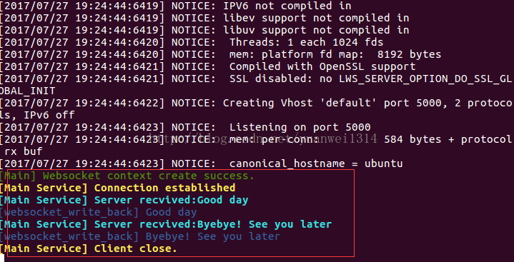

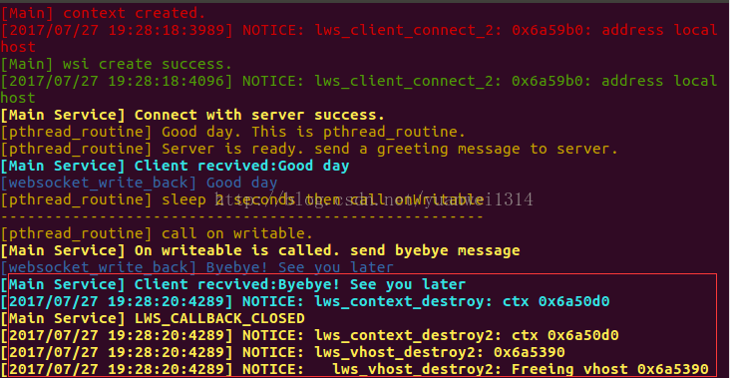

红线部分是交互的结果.这样就是完整的一套逻辑了.