**CSEE5590/490: Web/Mobile Programming (Spring 2019)**

**LAB ASSIGNMENT 3**

**Team ID:- 2**

Boyapati Ramya Class id-4

Manda Aparna Class id – 14

Yenugu Lohitha Class id - 34

YouTube Link: <https://youtu.be/zfSvUeoKYyQ>

Task-1

**Course Registration Application**

**1.Login Page**

Login to the application as existing user

Existing user can view the details of courses and enroll into courses .

On the click of Login button credentials will be validated and user will be navigated to Profile Page

To create a new account click on Sign Up button

**2.SignUp Page**

Enter the details and click on Create Account button..Account will be created and user will be navigated to Profile page.

3.Home Page

In the home page, we are providing a navigation bar on the top to navigate to various pages across the application. The objective behind the UX of this is to enable the user to navigate to any page on the application from any other page. The user can logout of the application from any page by clicking on the signout icon.

By clicking on

1. **‘Profile’**, the user will be navigated to Profile page where all the details of the user are displayed. The user can edit the details by clicking on edit icon and save the details by clicking on save button. The user can delete the account by clicking on delete icon in the profile page.
2. ‘**My** **Enrollments’**, All the enrollments of the user will be displayed and the user can unenroll any course by clicking on the delete icon for that course.
3. ‘**Courses’**, All the courses are displayed. User can enroll into any course by clicking on the enroll button for that course

**Workflow of the Application:**

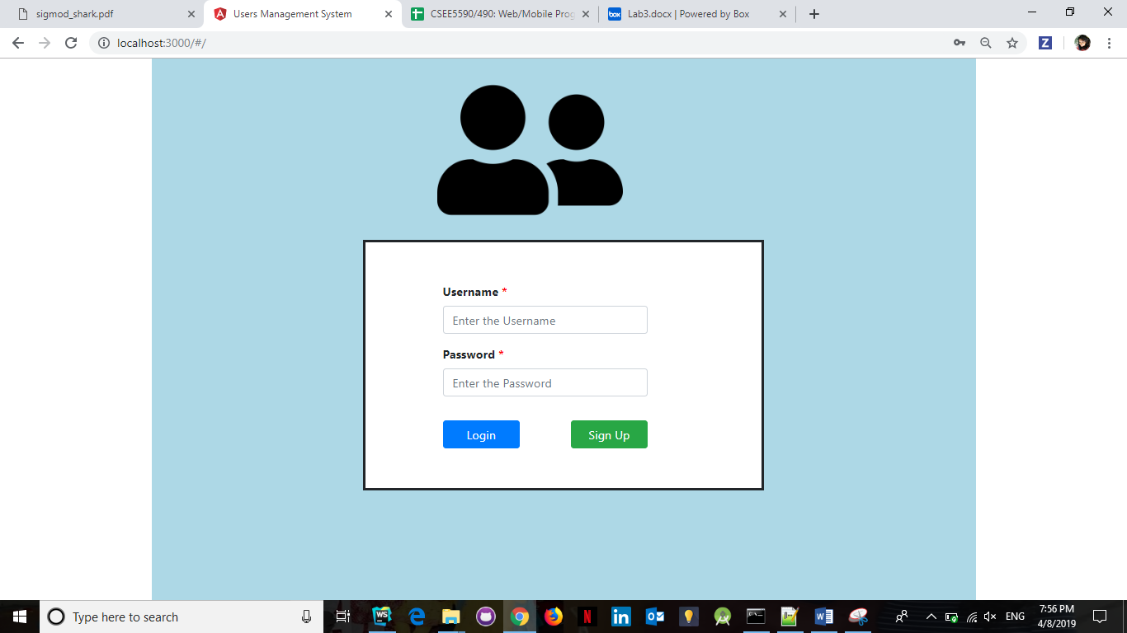

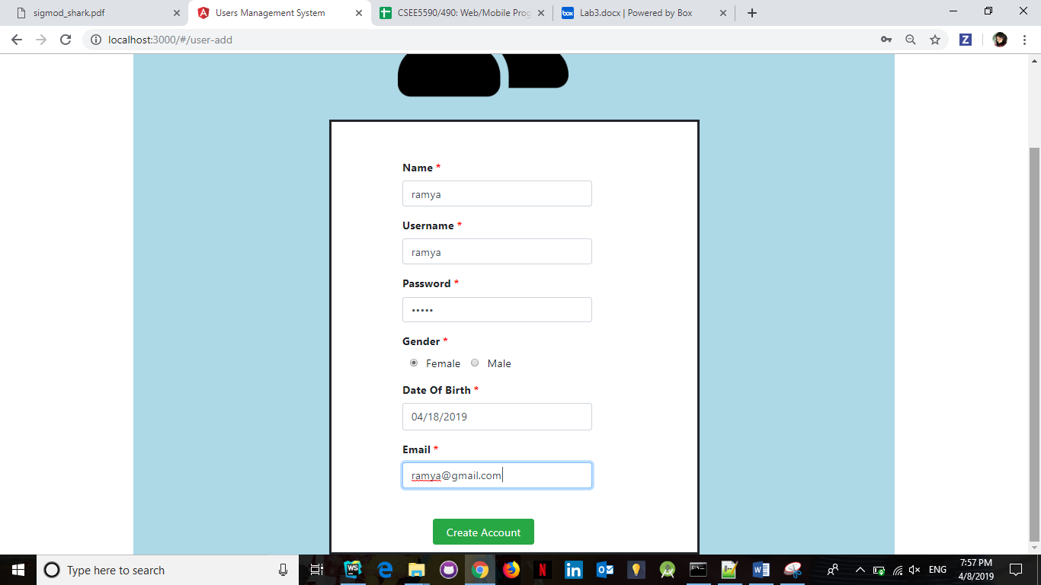

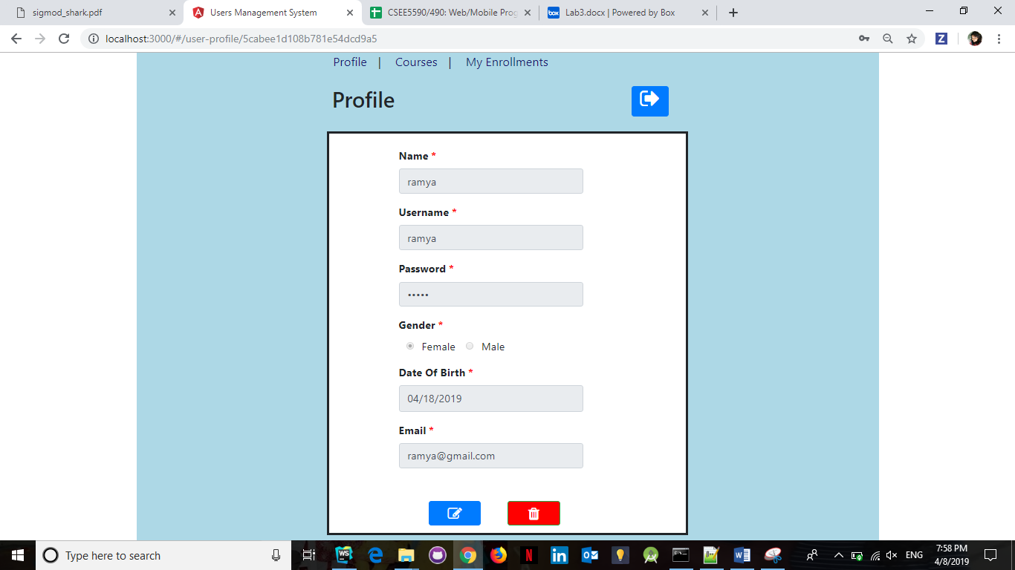

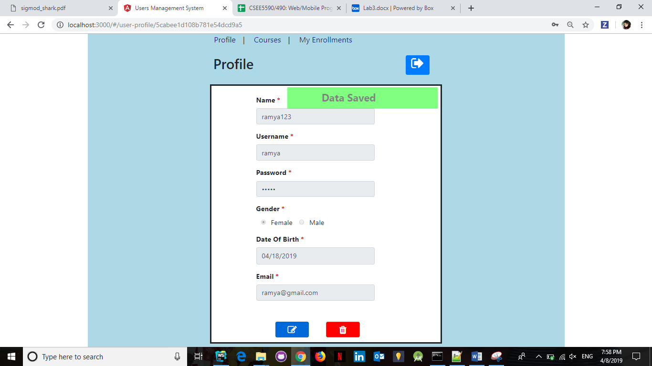

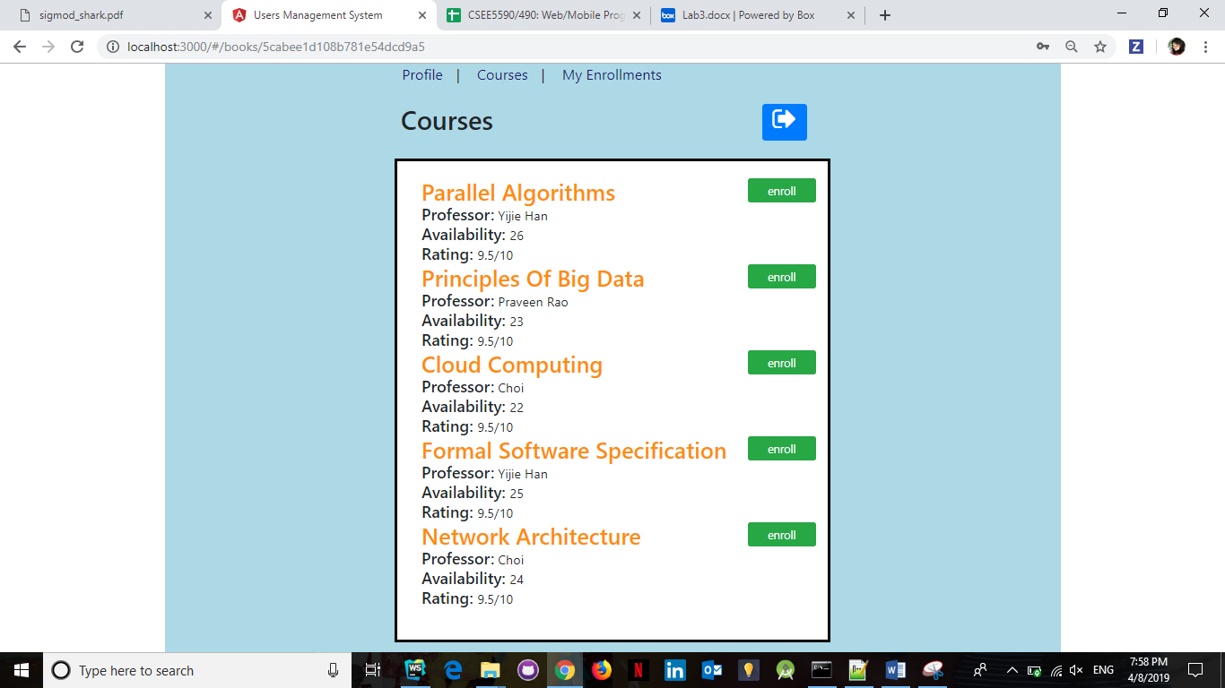

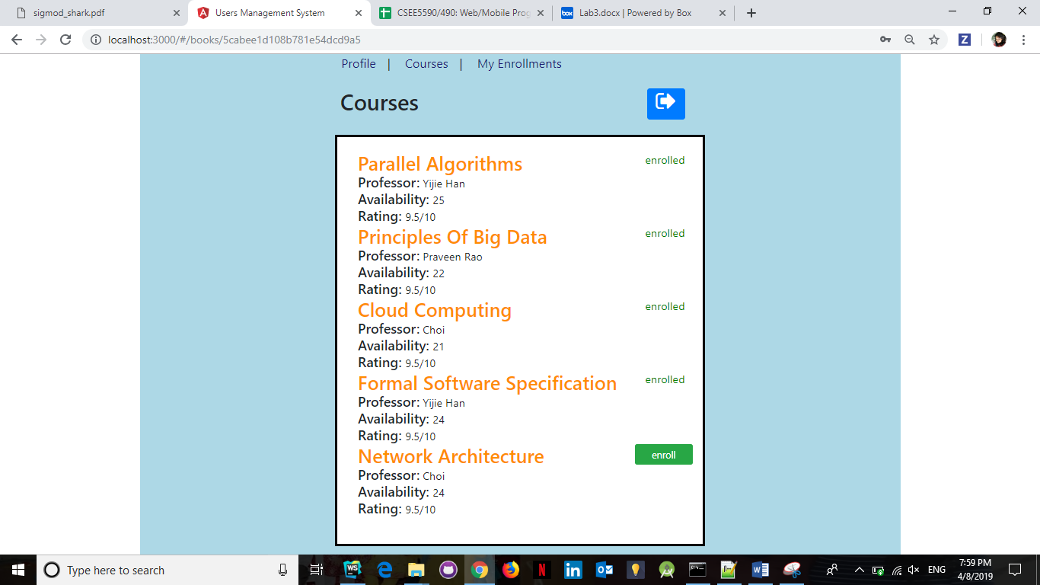

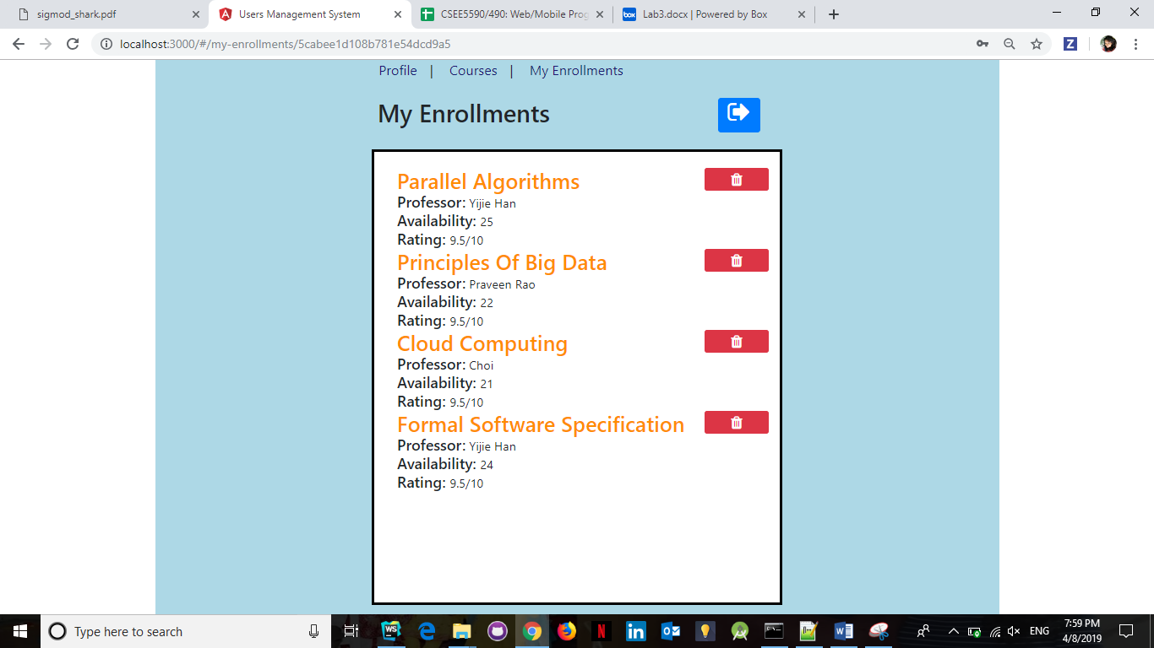

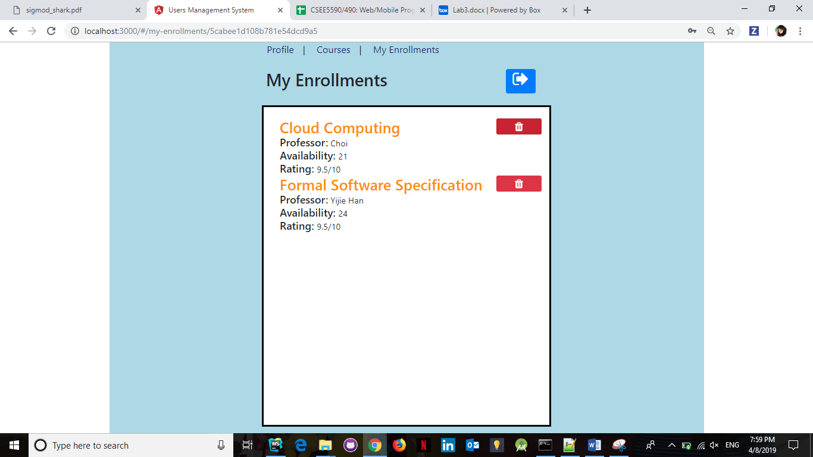



**Task 2: Social Login mobile application**

This android application has two pages.

1.Login page

2.Welcome page

Login Page:

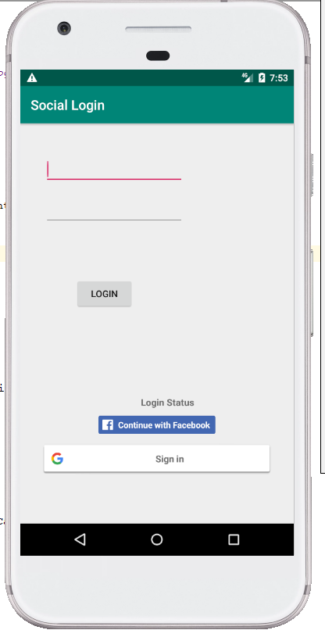

User can login using his application account or via social login i.e., using his facebook or google account.

1.On logging in using application account, user is navigated to the Welcome page displaying user details.

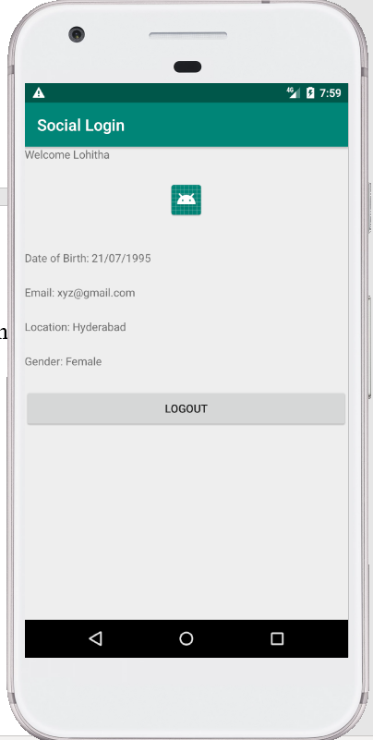

2. On logging in using facebook account, user is navigated to the Welcome page displaying user details from his facebook account

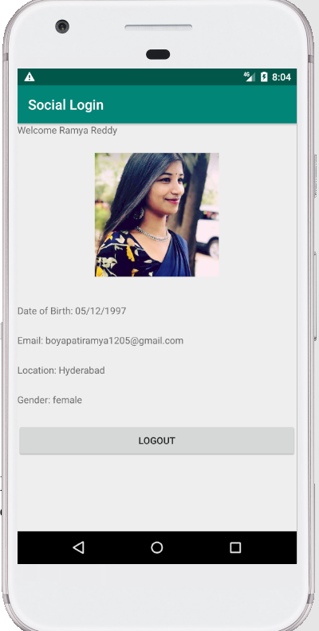

3. On logging in using google account, user is navigated to the Welcome page displaying user details from his google account

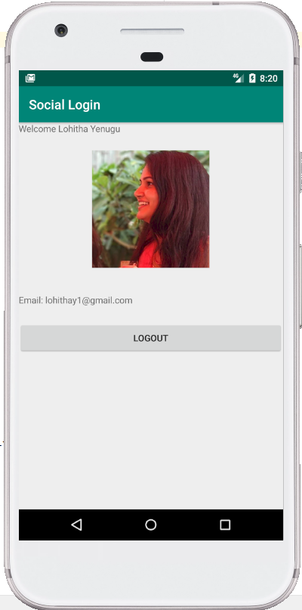

‘LOGOUT’ button logs out user from his logged in(Facebook/Google/Application) account and navigates him back to the login page.