Surface Sound Speed Plotter

# Post Processed Plotting

This tool takes single or multiple HSX files and allows the surface sound speed to be plotted over time as a launch collects data. The output is a geotiff file that may then be overlaid with survey data or charts using another program.

## Processing HSX Files

extractsv.py [-d] file_or_dir output_file.txt

To extract the sound speed values from the HSX files, run the extractsv.py script. As an argument this either takes the filename of a single HSX file or with the –d option, searches a directory for all HSX files. A second argument for the output filename is included after the input file or directory. For example extractsv.py –d H:\OPR-PXXX-RA-YY\HXXXXX\Hypack\2802(RA-5)\DN236\400kHz\ DN236_2802_SVPlot.txt

If you want to create an image with more than one day, these files can be opened in a text editor and concatenated, but make sure to only include the header line once at the top. The index numbers do not need to be sequential. This can be done easily on a UNIX based system with awk 'NR==FNR || FNR>1' *.txt > merged.txt

## Creating a Map Image

svplot.py txtfile.txt utm_zone [stdevs | sv_min sv_max]

To then create an image from the extracted SV file run svplot.py, with the arguments of the text file that was generated in the first step and the utm zone in which the data lies. By default the algorithm bases the color map stretching on limits of a histogram binning of the data. This is because the distribution is often unevenly distributed around the mean. An example is shown below. Display of the histograms may be enabled in the code.

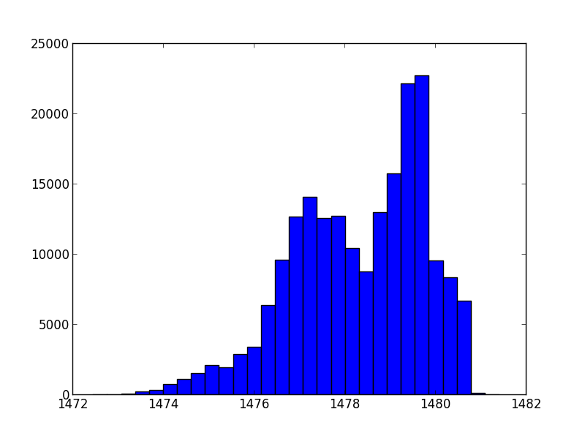

This default scaling usually produces good results. If you want to tweak the limits, a number of standard deviations around the mean can be specified by placing a single number after the utm zone (the sigma bracket desired), or a defined range specified with two numbers.