Create and Insert
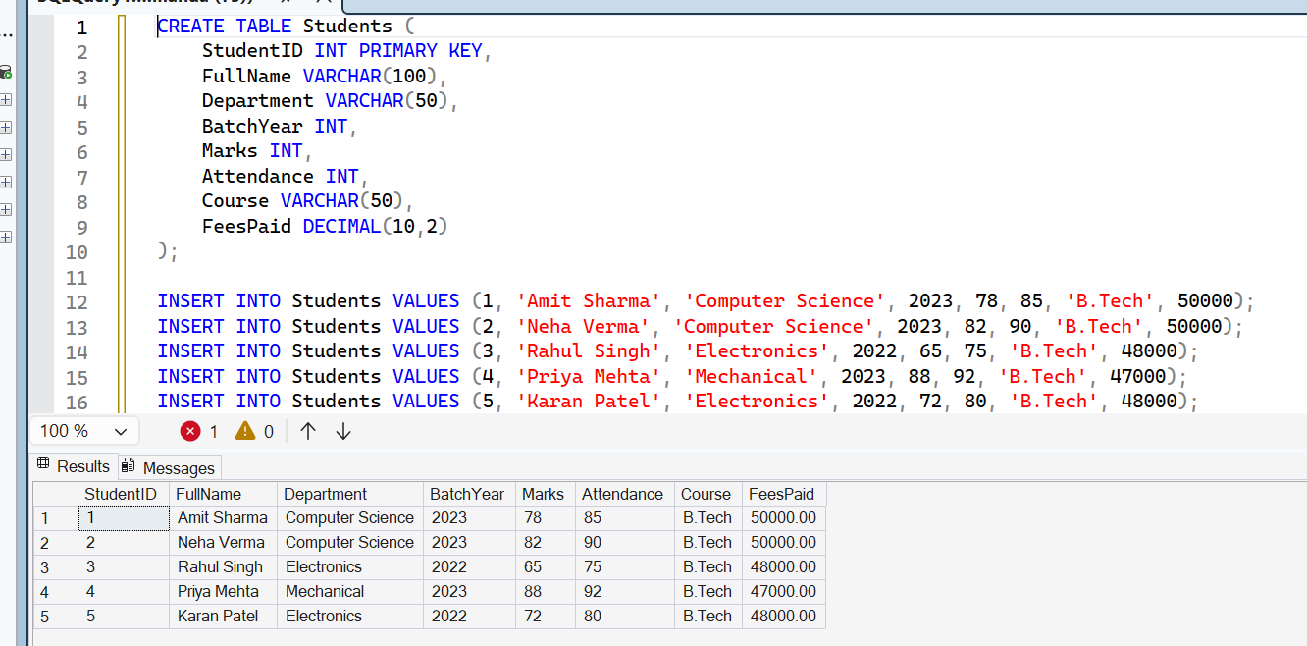

Update
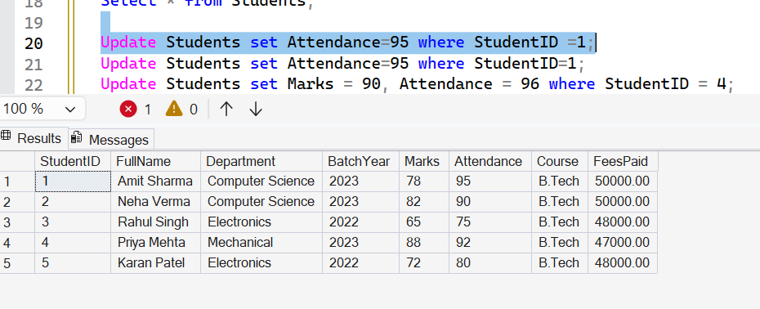
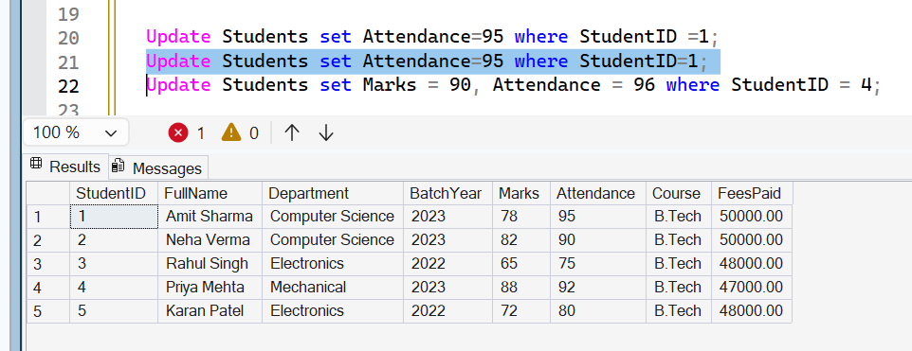
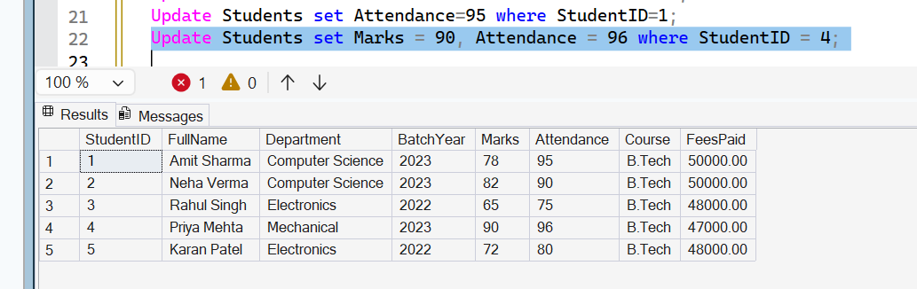
Delete
Before
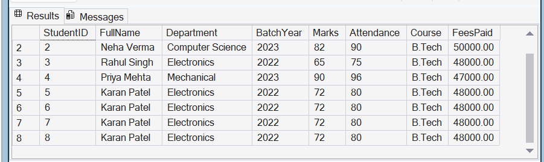
Command:
DELETE FROM Students WHERE StudentID NOT IN (
SELECT MIN(StudentID) FROM Students GROUP BY FullName, Department);
After
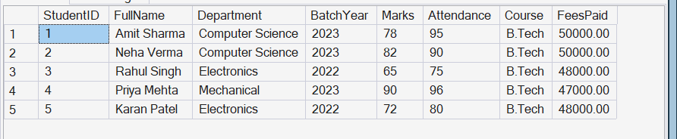

RollBack
Before
Command: UPDATE Students SET Marks = 0;
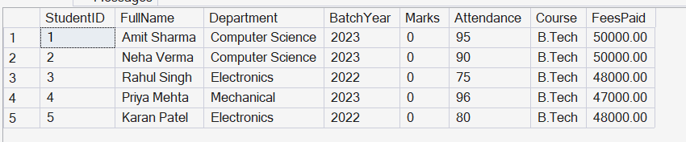
After: RollBack;
