Total Table:
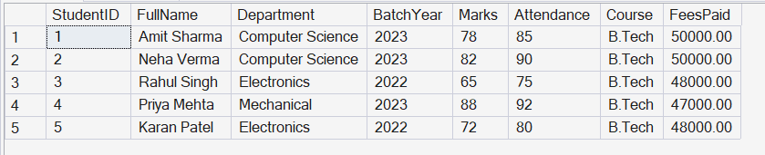
Aggregates
Command: select Department,count(*) as stud_Dept from Students group by Department;
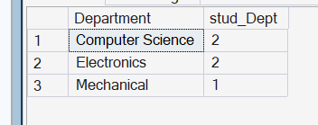
Command: select BatchYear,avg(marks) as avg_Marks from Students group by BatchYear;
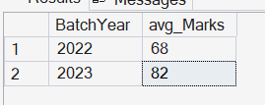
Command: select Course,sum(FeesPaid) as TotalFee from Students group by Course;
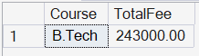
Command: select Department,Avg(marks) as avg_marks from Students group by Department
having avg(marks)>70;
