**INT-335**

**Design Thinking**

**Topic –**

**RAP Academy – EduTech Website**



**Submitted By:**

Abhash Mandal (12102865)

Karukonda Khushi (12104430)

Rahul S Utsahi (12104480)

Atharva Prashant Joshi (12104648)

Kammisetty Likith (12105535)

**Section –** K21CS

School of Computer Science & Engineering

Lovely Professional University – Punjab

**Acknowledgement**

At the very outset of the report, we would like to extend our sincere obligation towards all the personages who have helped us in this endeavour. Without their active guidance, help, cooperation and encouragement, we would not have made headway in the project.

We take this opportunity to present our vote of thanks to all those guideposts who acted as lightning pillars to enlighten our way throughout this project which has led to the successful and satisfactory completion of this project.

We are highly thankful to Dr Navneet Kaur for her active support, valuable time and advice, wholehearted guidance, and sincere cooperation during the completion of the assignment within the time stipulated.

A special acknowledgement goes to our friends and batchmates, who supported us with their valuable feedback and ideas and motivated us throughout the assignment completion.

We would like to extend our sincerest gratitude to all those who contributed towards this project through their insightful interviews.

* Abhash Mandal & Team

**Contents**

|  |  |  |
| --- | --- | --- |
| **SLno.** | **Content** | **Page No.** |
| **1** | Introduction | 1 |
| **2** | Information Gathering | 2 |
| **3** | Problem Analysis & Definition | 4 |
| **4** | Ideation | 6 |
| **5** | Prototyping | 7 |
| **6** | Teams’ Statement | 11 |
| **7** | Critical Evaluation | 18 |

1. **Introduction**

**Design Thinking –**

**• Facilities understanding**

**• Framing problems**

**• Enables creative solutions**

**• Provides fresh perspectives**

Design Thinking is a process that results in a plan of action to improve our situation.

Design Thinking is a skill that incorporates situation awareness and empathy into idea generation.

Design Thinking is a tool that inputs analytical as well as creative thought to solve problems that consider context, stake holder requirements and preferences, issues, and cost.

Design Thinking is a mindset in which ideas are triggered from diverse sources and then built upon to inform progressively better solutions to challenges.

Design Thinking is a series of actions and accumulation of provisional inputs that are structured by a loop in which problems are defined, research and analysis and conducted and then ideas are proposed and subjective to critical feedback and modification which in turn leads to repeating parts of the loop to further refine ideas.

**PHASES OF DESIGN THINKING**

* Information Gathering
* Problem Analysis & Definition
* Ideation
* Prototyping
* Critical Evaluation

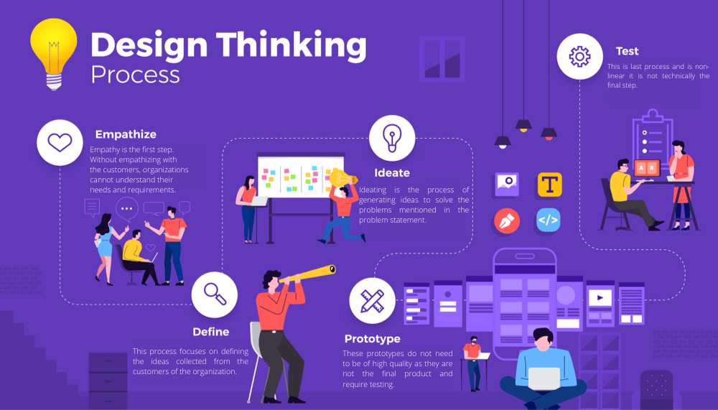

1. **Informationion Gathering**

The first stage of the design thinking process focuses on user-centric research. You want to gain an empathic understanding of the problem you are trying to solve. Consult experts to find out more about the area of concern and conduct observations to engage and empathize with your users. You may also want to immerse yourself in your users’ physical environment to gain a deeper, personal understanding of the issues involved - as well as their experiences and motivations.

* EMPATHY MAPPING

An empathy map is a collaborative visualization used to articulate what we know about a particular type of user. It externalizes knowledge about users in order to

* Create a shared understanding of user needs
* Aid in decision making

In the process of Information Gathering, we did Empathy Mapping by taking interviews of several peoples. As a result, you can see the Empathy Map shown below. After analysing the Empathy maps, we are ready to move on to the next phase of Design Thinking, i.e., Problem Definition.

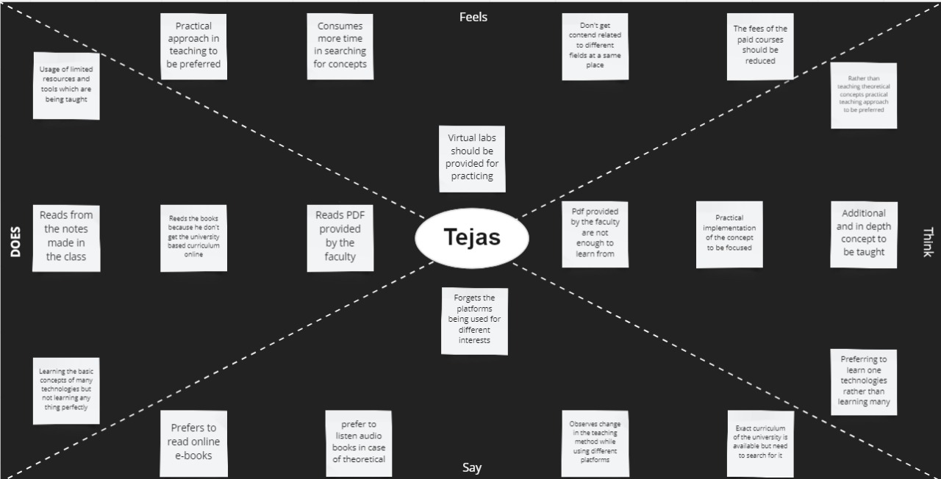

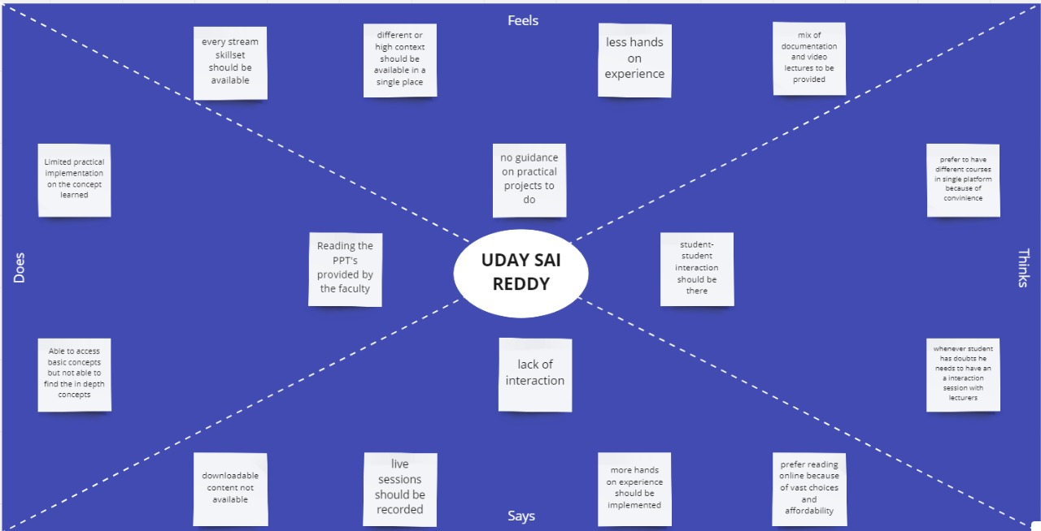

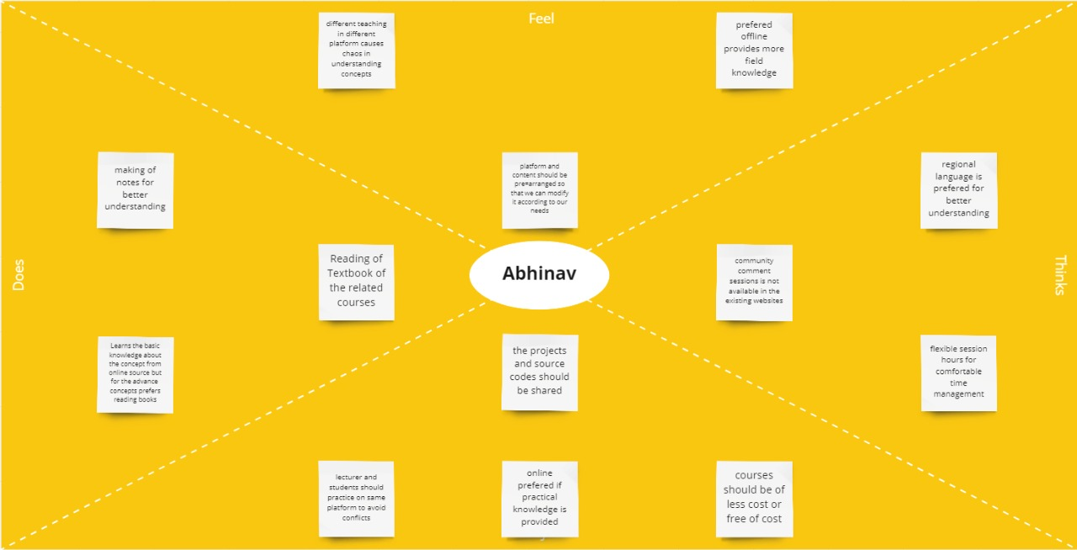

1. **Problem Analysis & Definition**

In the Define stage, you will organize the information you have gathered during the Empathize stage. You will analyze your observations to define the core problems you and your team have identified up to this point. Defining the problem and problem statement must be done in a human–centred manner.

The Define stage will help the design team collect great ideas to establish features, functions, and other elements to solve the problem at hand or, at the very least, allow real users to resolve issues themselves with minimal difficulty. In this stage, you will start to progress to the third stage, the ideation phase, where you ask questions to help you look for solutions.

* **Affinity Diagram**

An affinity diagram is a collection of enormous amounts of data that is organized into groups or themes based on their relationships. The affinity diagram process is great when you want to make sense of insights gathered during research, as well as when you want to organize ideas generated during ideation sessions.

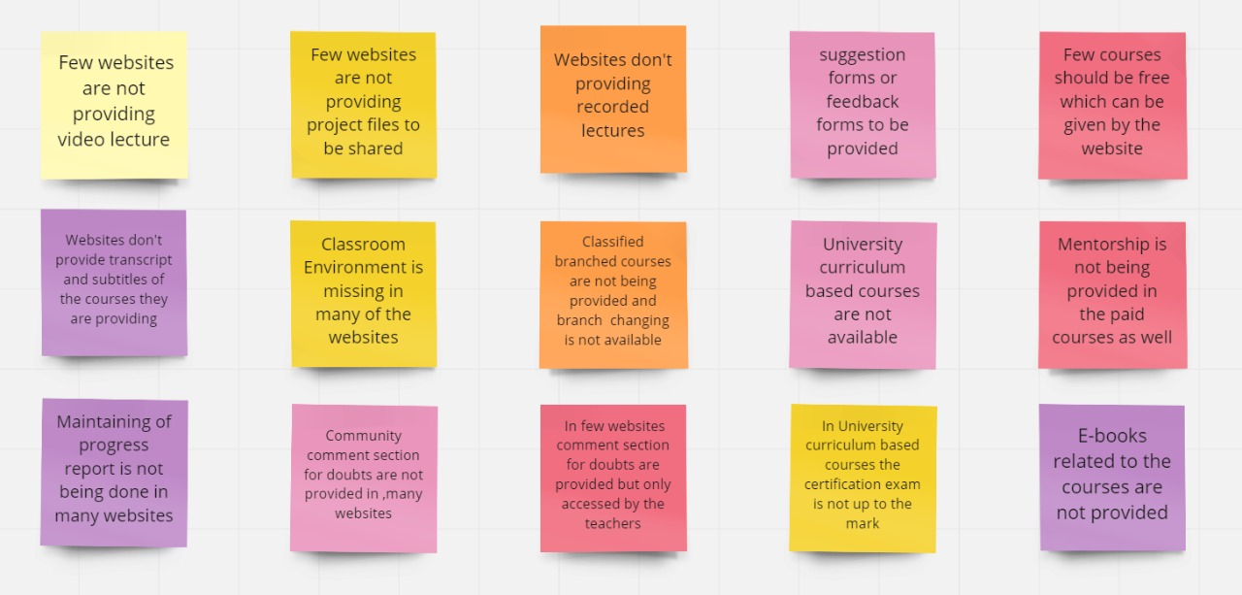

In the process of finding Problem Statement, we are going through Empathy mapping. After studying the Empathy maps, we got to know about many problems faced by the users while accessing different websites for different courses. In few websites, video lectures are not provided due to which students are facing problems, transcriptions and subtitles are not being provided, university-based curriculum courses are not easily found due to which searching for such courses is a waste of time, free courses to be provided that maybe without certification, lack of practicality because of which users are preferring offline content, i.e., books and notes prepared by them and the presentation given by the faculties. Many students have problem with Basic languages like English and Hindi due to which they were not able to grasp the knowledge their professors are providing. Online courses are so high rated that users find it hard to get enrolled in the courses they want. In some website’s courses, there were no projects uploaded for the users for them to practice due to which they never get the practical knowledge of their field. When students have doubts about some topics, there were no contact info of the lecturer shared with the students. Sometimes the concept cleared by the professor of courses is in only one way due to which some users find it difficult to understand. Working towards any goal requires dedication and motivation and, on the face of it, studying online can seem fraught with opportunities to lose these qualities. For one, there is the unlimited distraction of already being on the internet; social media, YouTube and news websites are as present as your next assignment. A lot of valuable study time can pass if you do not monitor your internet usage closely. Given the abstract nature of online learning, motivation in particular can take a hit, especially if you have already spent the day at work in front of a computer screen.

1. **Ideation**

During this third stage of the design thinking process, designers are ready to generate ideas. You have grown to understand your users and their needs in the Empathize stage, and you have analyzed your observations in the Define stage to create a user centric problem statement. With this solid background, you and your team members can start to look at the problem from different perspectives and ideate innovative solutions to your problem statement.

There are hundreds of ideation techniques you can use – such as Brainstorm, SCAMPER, etc. Brainstorm techniques are typically used at the start of the ideation stage to stimulate free thinking and expand the problem space. This allows you to generate as many ideas as possible at the start of ideation. You should pick other ideation techniques towards the end of this stage to help you investigate and evaluate your ideas and choose the best ones to move forward with – either because they solve the problem or provide the elements required to circumvent it.

* **HOW-NOW-WOW Matrix**
* It is an idea selection tool, made popular by Brainstorming.
* It helps groups to Brainstorm, plan ideas and organize their thoughts collaboratively.
* The matrix categorizes ideas based on their originality and the ease of implementation.

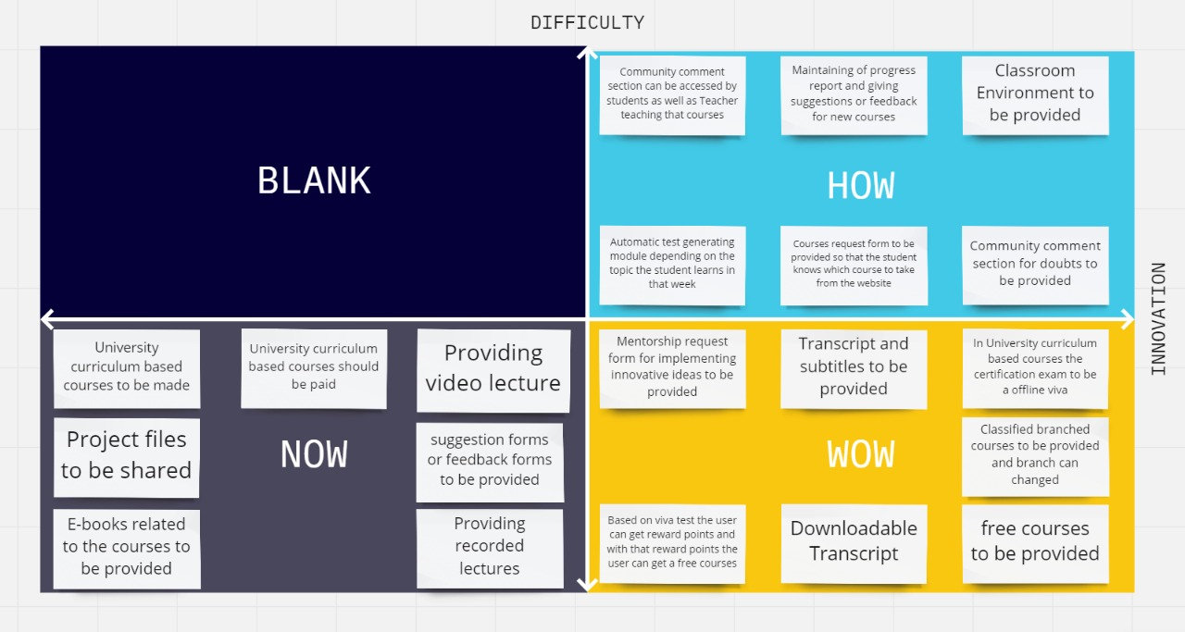

In the stage of Ideation, we need to find the solutions for the problems listed by users. To solve the problem our team started Brainstorming. In Brainstorming, we choose the **HOW-NOW-WOW** matrix. In this matrix, we have classified the ideas into three parts:

* Possible but in current times, we were unable to implement.
* Ideas which can be implemented now.
* Ideas which are innovative and we must implement it.

After the classification of the ideas in the **HOW-NOW-WOW** matrix, we were having a clear understanding of what kind of websites we need to make and now we are good to start our prototype or the next phase which is synthesis through prototyping.

1. **Prototyping**

The design team will now produce several inexpensive, scaled down versions of the product (or specific features found within the product) to investigate the key solutions generated in the ideation phase. These prototypes can be shared and assessed within the team itself, in other departments or on a small group of people outside the design team.

This is an experimental phase, and the aim is to identify the best possible solution for each of the problems identified during the first three stages. The solutions are implemented within the prototypes and, one by one, they are investigated and then accepted, improved, or rejected based on the users’ experiences.

By the end of the Prototype stage, the design team will have a better idea of the product’s limitations and the problems it faces. They will also have a clearer view of how real users would behave, think, and feel when they interact with the end product.

* **Low-Fidelity Prototyping:**

Whether UX designers use paper or digital wireframes, low-fidelity prototyping is the first step in testing design ideas and user flows.

Low-Fidelity prototypes are either hand-drawn or basic digital wireframes without color or content. These low-tech designs allow UX teams to visualize each screen’s layout, test navigation, and experience user flows.

A great example of a digital low-fidelity prototype is a typical eCommerce checkout flow. After creating a wireframe or low-fidelity mockup, UX designers will use buttons or links to connect each screen and create a checkout flow.

Using a low-fidelity prototype, UX designers can experience the checkout flow-ensuring each screen has the correct elements and the user can navigate forwards and backward throughout the flow.

**Types of Low-Fidelity Prototypes:**

• Paper prototypes are the fastest way for teams to create user flows and imagine interactions. Paper prototyping is particularly beneficial during design sprints when teams have limited time to develop flows and iterations. With paper “screens” laid out on the desk or whiteboard, teams can visualize flows together, allowing effective collaboration and idea-sharing. None of the elements are clickable, but paper prototypes enable teams to design screen layouts and flows, reducing the time needed to create initial digital wireframes.

• Clickable wireframes are a low-fidelity digital representation of how screens and flows. Each frame will usually have simple lines and shapes with a prominent CTA for navigation. Modern UX tools like UXPin enable teams to collaborate effectively with comments, replicating the energy and excitement of a paper prototyping session.

|  |  |
| --- | --- |
| **WHEN TO USE** | **WHEN NOT TO USE** |

|  |  |
| --- | --- |
| Low-fidelity prototypes are best for the early stages of the design process. UX teams can use paper prototypes before they even sit down at the PC. These low-tech paper designs are also great for collaboration and exploring lots of ideas at speed-perfect for design sprints!  Digital low-fidelity prototypes help UX teams organize information architecture and user flows before committing to mockups. | Unless you’re testing basic user flows, low-fidelity prototypes do not provide meaningful feedback during usability studies. Users might get distracted by the unfamiliarly of the product and thus focus on the wrong elements. |

* **High-Fidelity Prototyping:**

High-fidelity prototyping is where a product begins to take shape. Using mockups with color and content, designers can create hi-fi prototypes that look and function as close to the final product as possible.

Now designers can add interactions, transitions, and animations to create an immersive user experience—making high-fidelity prototypes perfect for usability studies and presenting to stakeholders.

If we go back to our eCommerce example, designers can include product images and colored CTAs to entice users down a particular flow—like completing a checkout.

UX designers can also add interactions, like an overlay showing the user’s cart when adding a new item. They might also add screen transitions to indicate a user’s movement through the checkout flow.

**Types of High-Fidelity Prototyping:**

* A **high-fidelity prototype using mockups** gives users an accurate sense of how a product will look and function. The designs will include color and content, while every link and button should work as it would in the final product.
* A **high-fidelity prototype using code** takes prototyping one step further. For example, with [UXPin Merge](https://www.uxpin.com/merge), designers can use React or Storybook components to create prototypes that function exactly like the final product. Research teams using prototypes from UXPin Merge get better results from usability studies and testing and cut down time to market.

|  |  |
| --- | --- |
| **WHEN TO USE** | **WHEN NOT TO USE** |

|  |  |
| --- | --- |
| UX teams should only move from lo-fi to hi-fi prototyping once designers have completed mockups to complete at least one user flow for testing.  These mockups must include clickable links and elements, color, and content—but might not require interactions, animations, and transitions for the first round of usability studies.  High-fidelity prototypes are helpful for testing layouts and how page transitions or scrolling might affect content and elements. UX designers can also test how interactions, animations, and transitions affect the user experience.  High-fidelity prototypes should be the last stage of the design process before handing over to engineering. | UX designers must not build high-fidelity prototypes before researchers have thoroughly tested lo-fi prototypes and created mockups with content, and color.  If teams want to test design concepts fast, creating and editing high-fidelity prototypes will severely hamper progress. |

|  |
| --- |
| **TEAMS’ STATEMENT**  **“As this is a Low-Fidelity prototype we have mentioned the courses of CSC only, but we are going to make the sections of the course as Groups.**  **In those groups, the users can select the group they belong to and then they will be able to access the courses not only that there will be a recent section from which they can access the previous courses that they had accessed, and the users will also be able to change the group and access new content of their interests.”** |

**The PROTOTYPES are as follows:**

1. **The User needs to Login into the website to access the content RAP Academy**

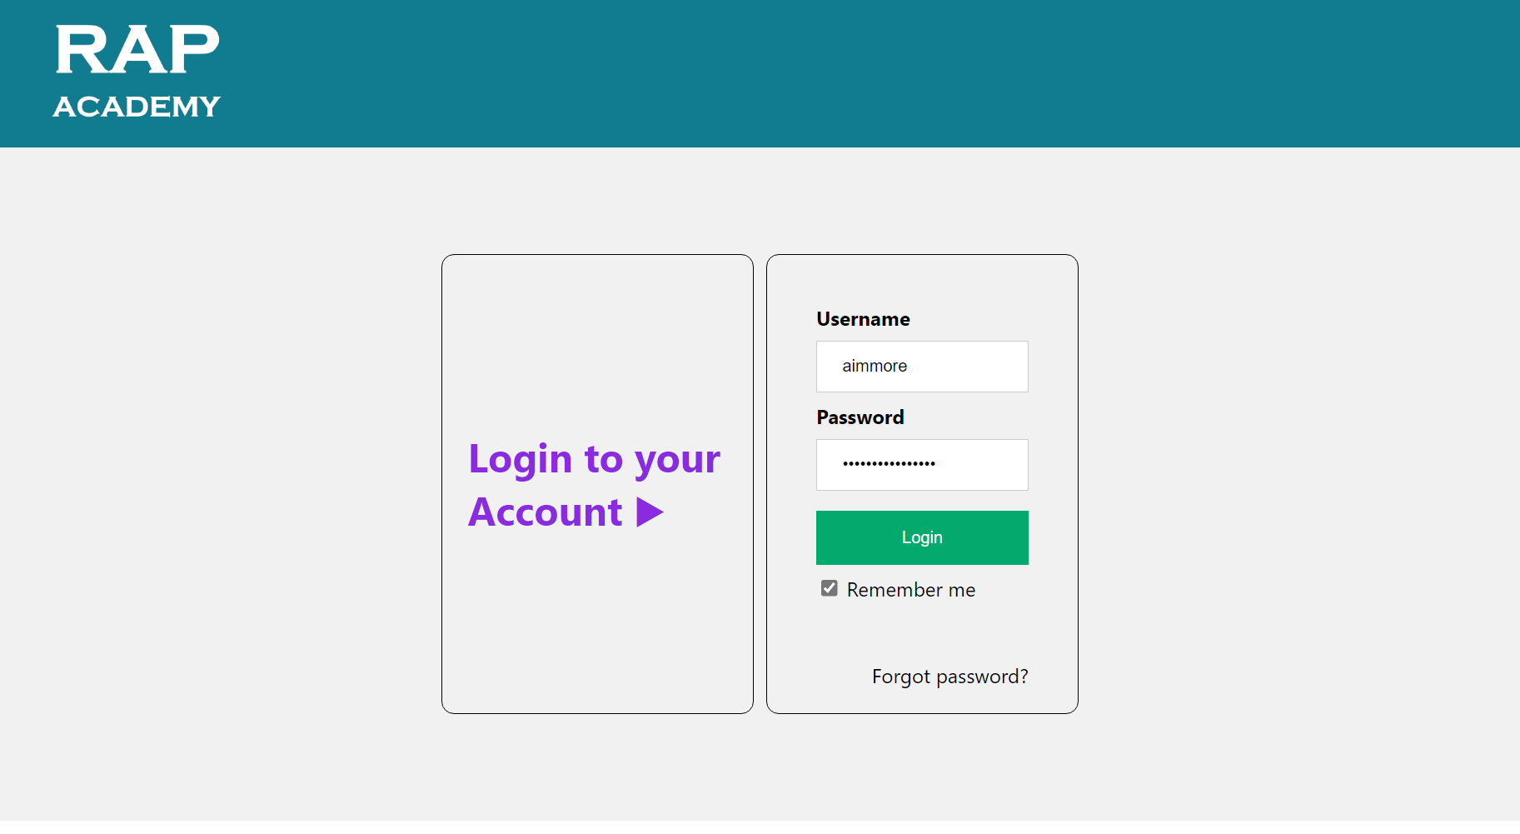

1. **After logging into the account, the user lands on the Home Page of RAP Academy**

* **The user can view his live classes on the current day on the homepage.**
* **Also, the Live Tests, if anyone is available.**
* **Can put an Appointment Request for a Mentor, if he as any doubts in any subjects.**

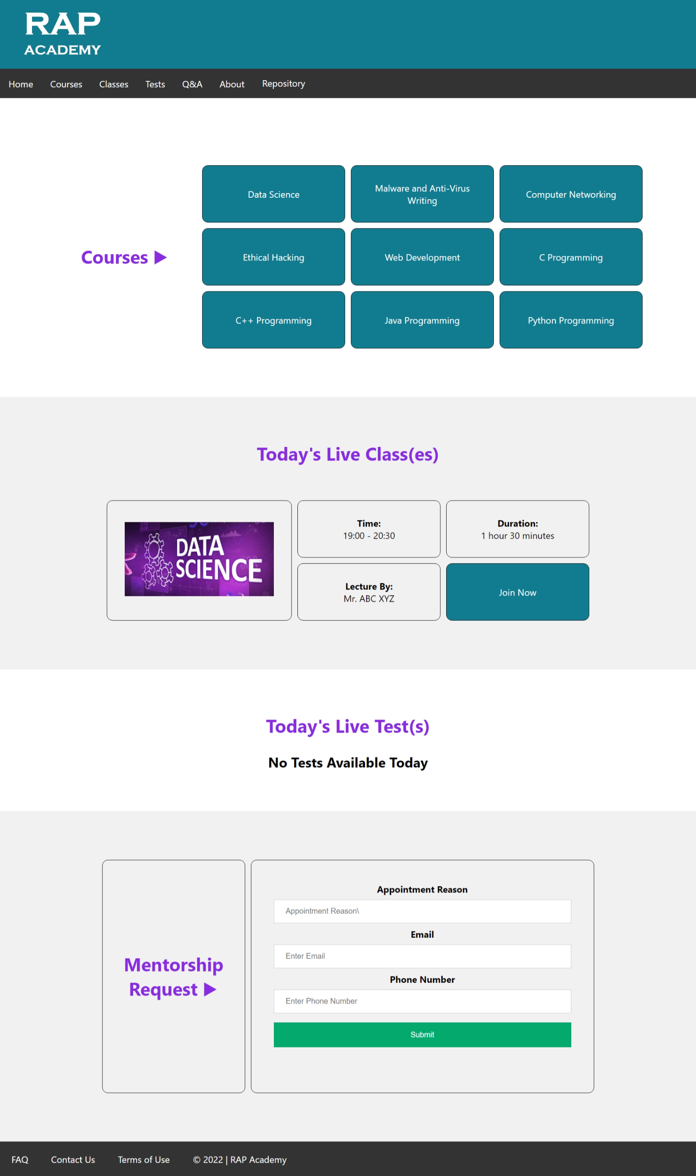

1. **The user can access the study material from the home, like Data Science.**

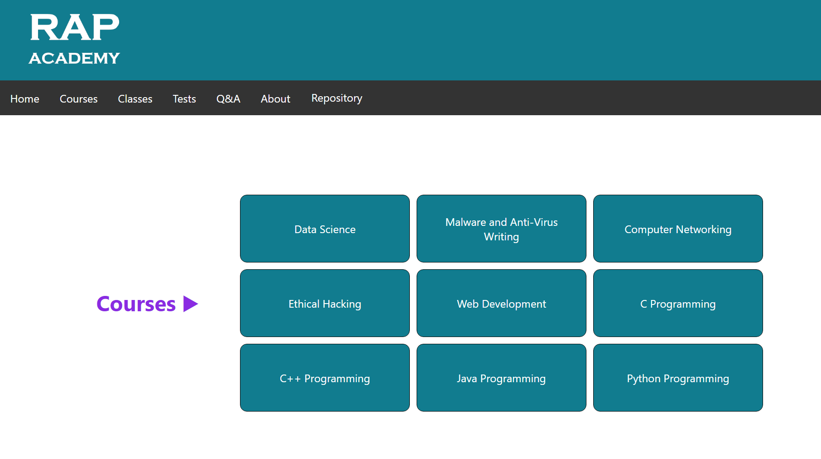

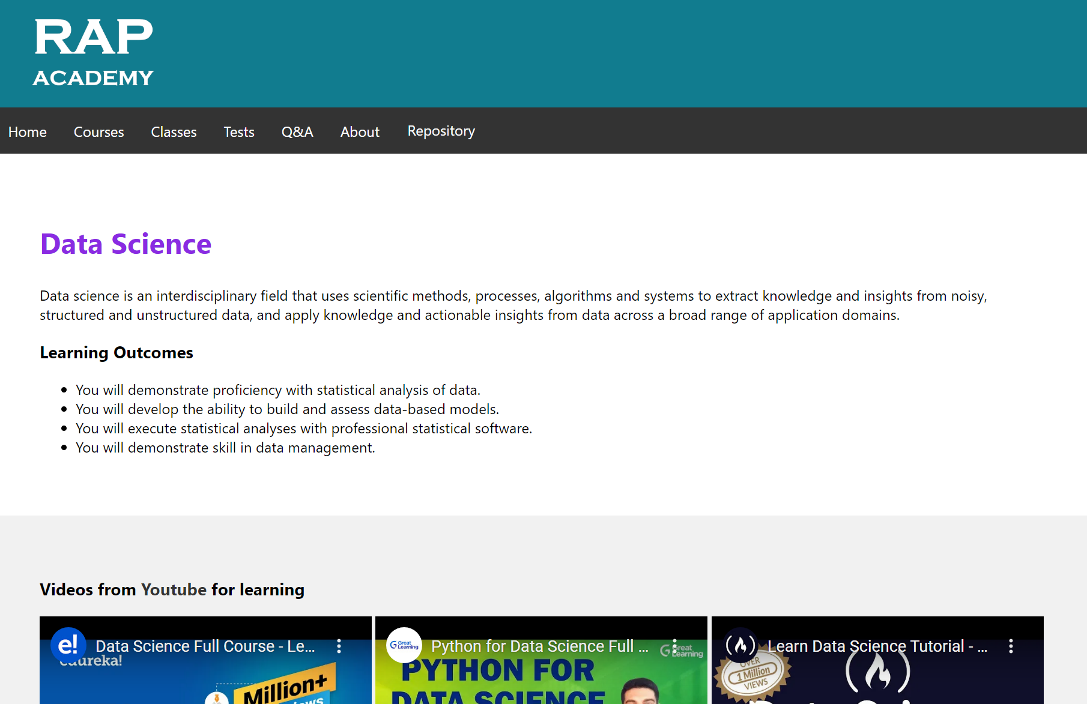

1. **The user can access the classes from the courses available**

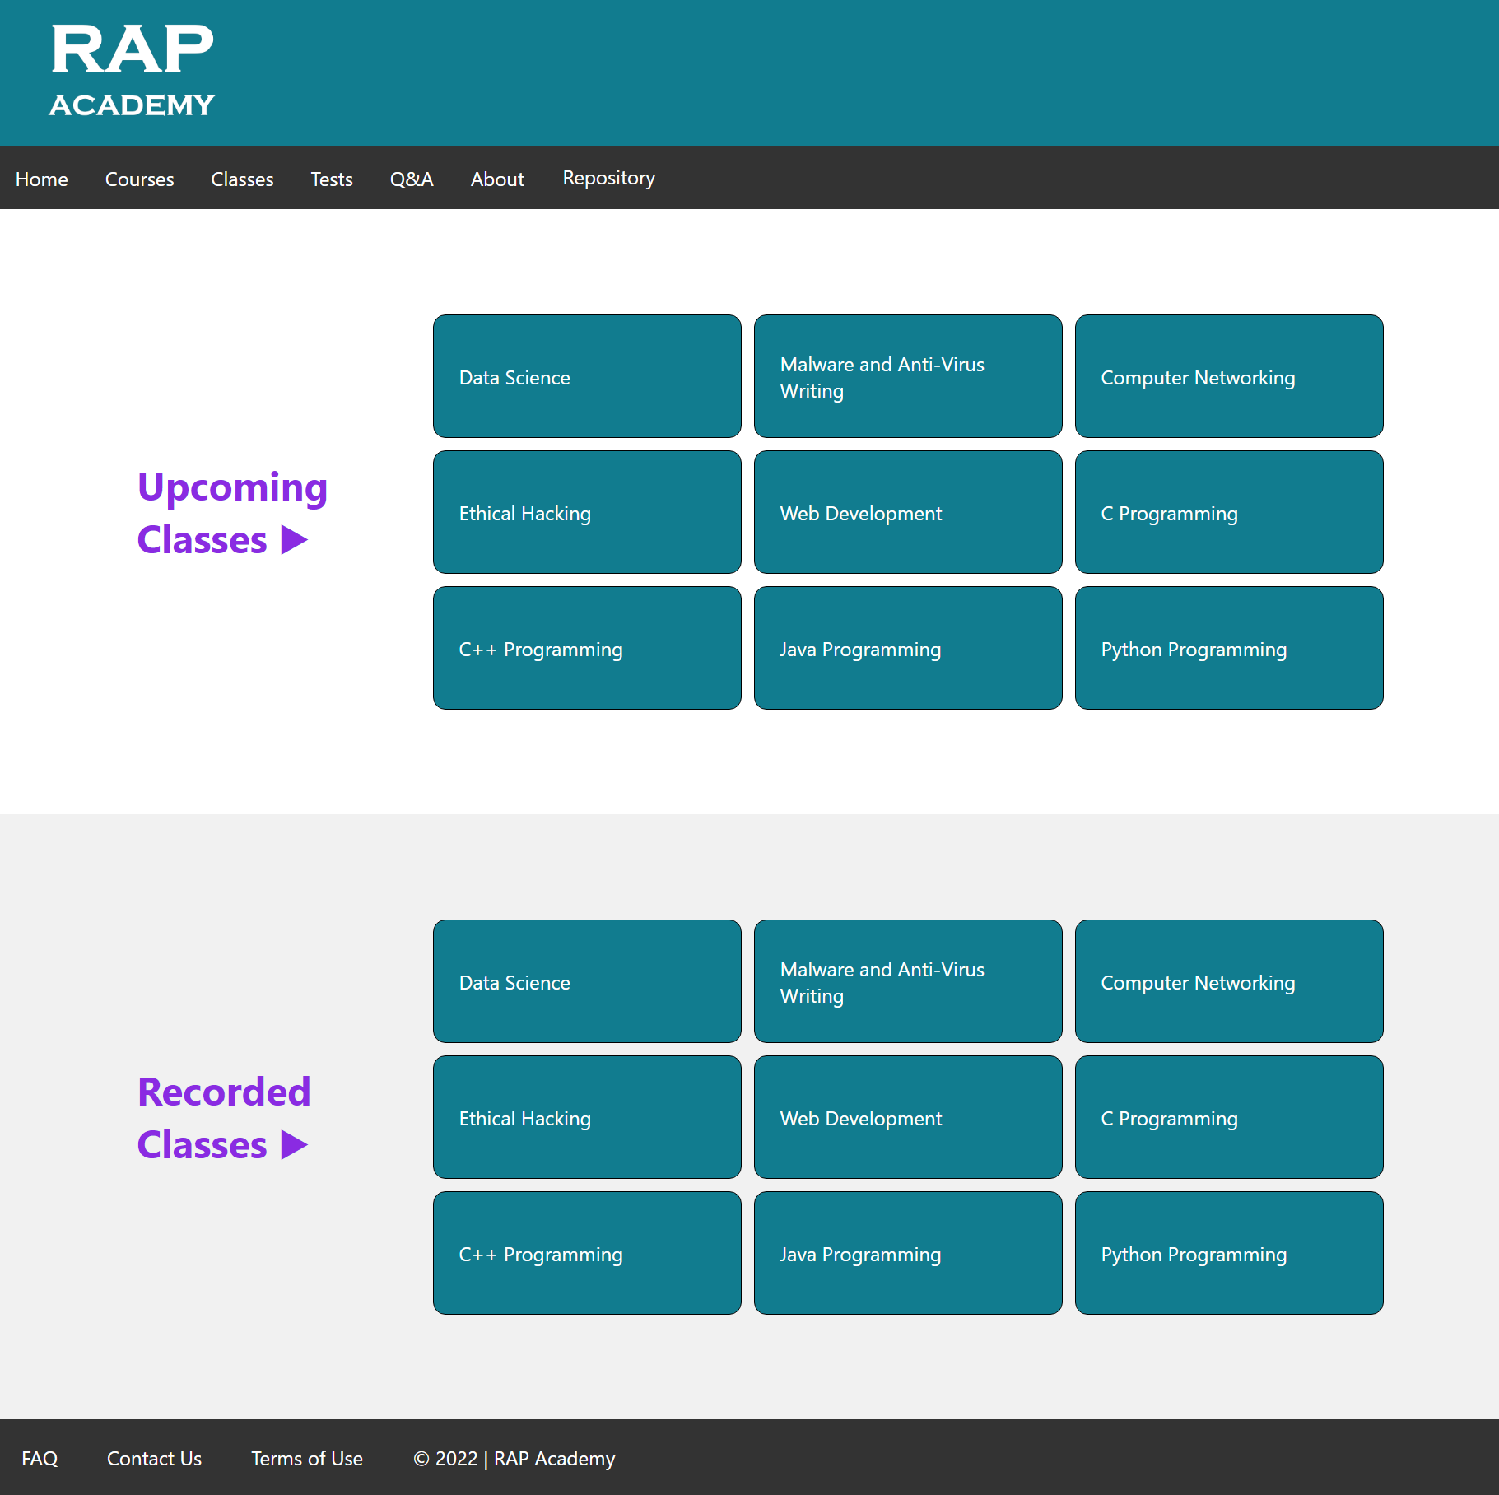

1. **The user can access the schedule of the live classes.**

**`**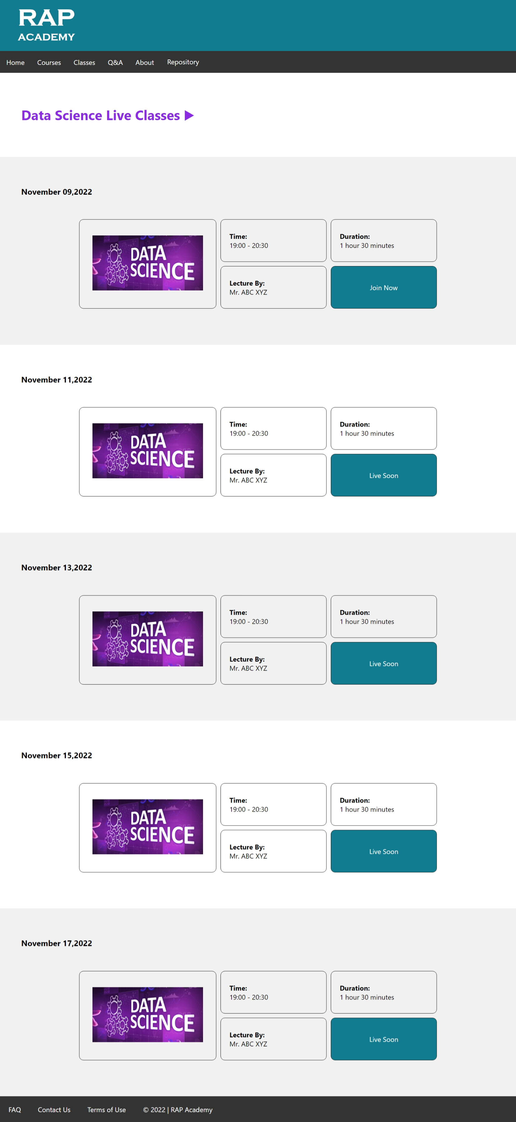

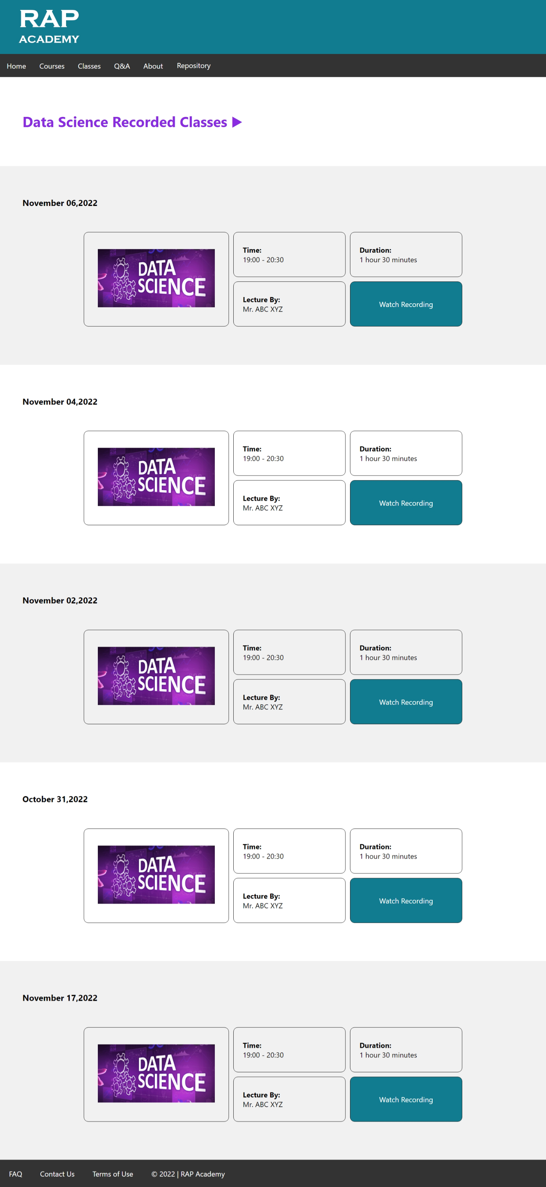

1. **The user can also access the Q&A section, Repositories for accessing E-Books and Projects, that is collected from the user itself on voluntary donation.**

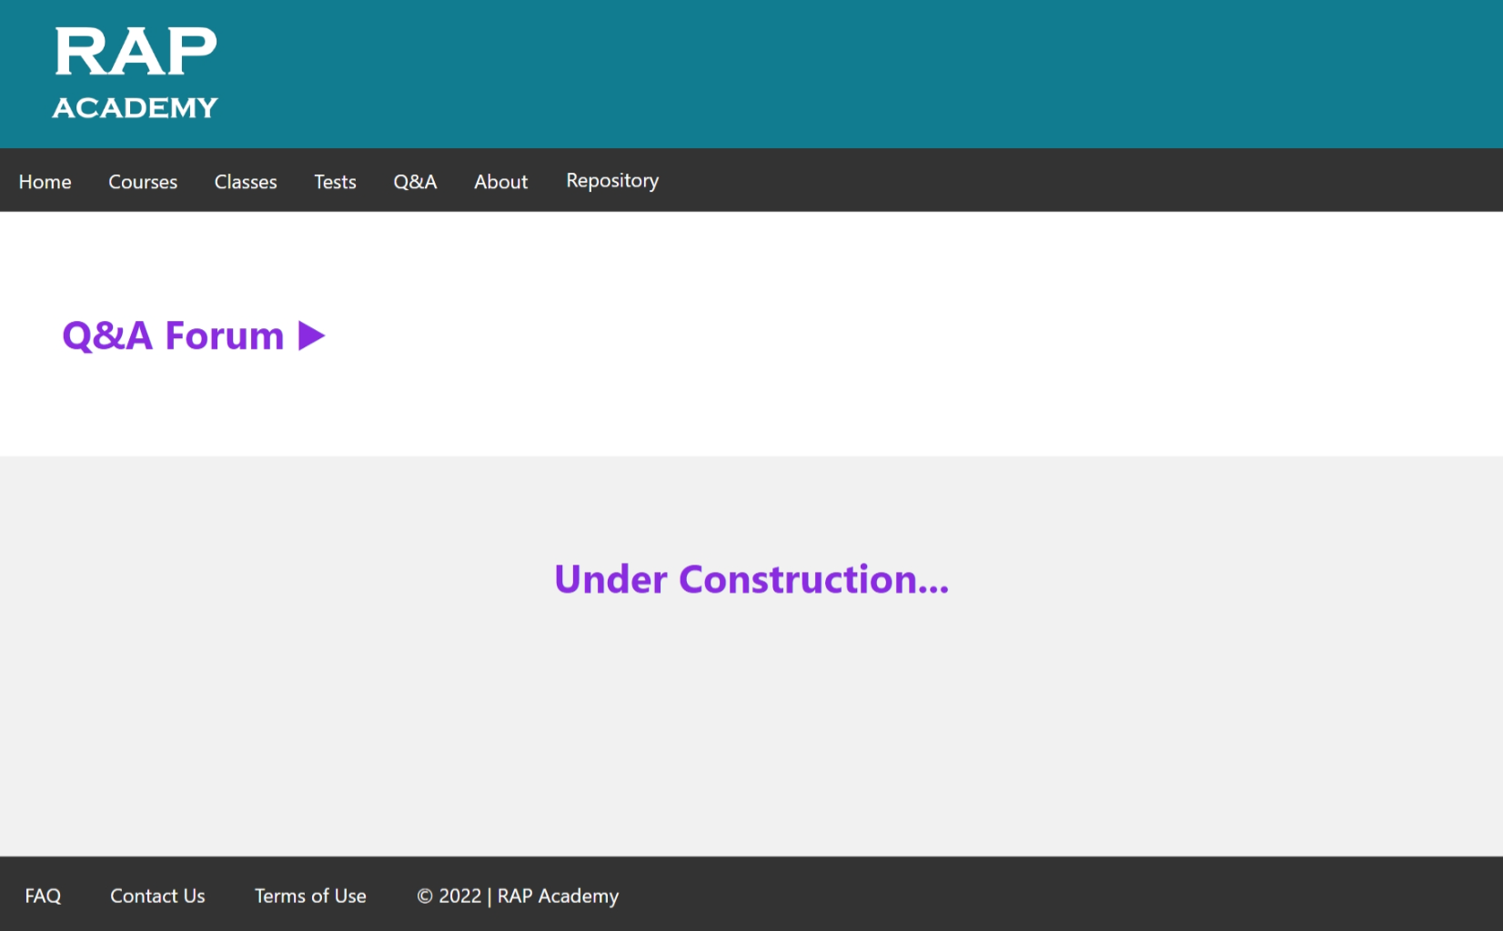

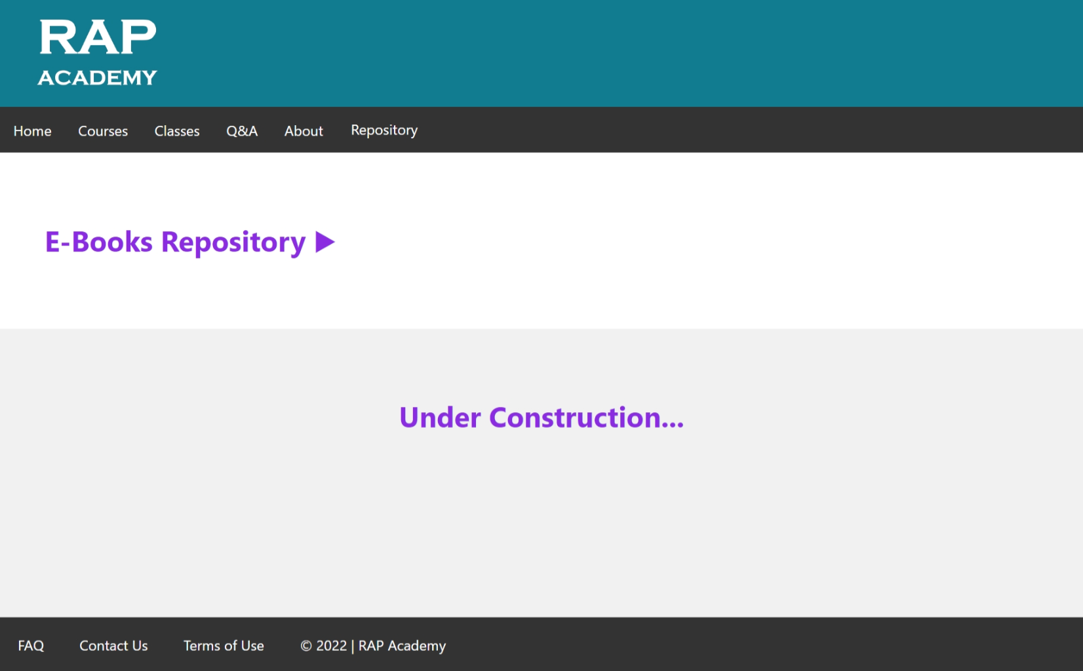

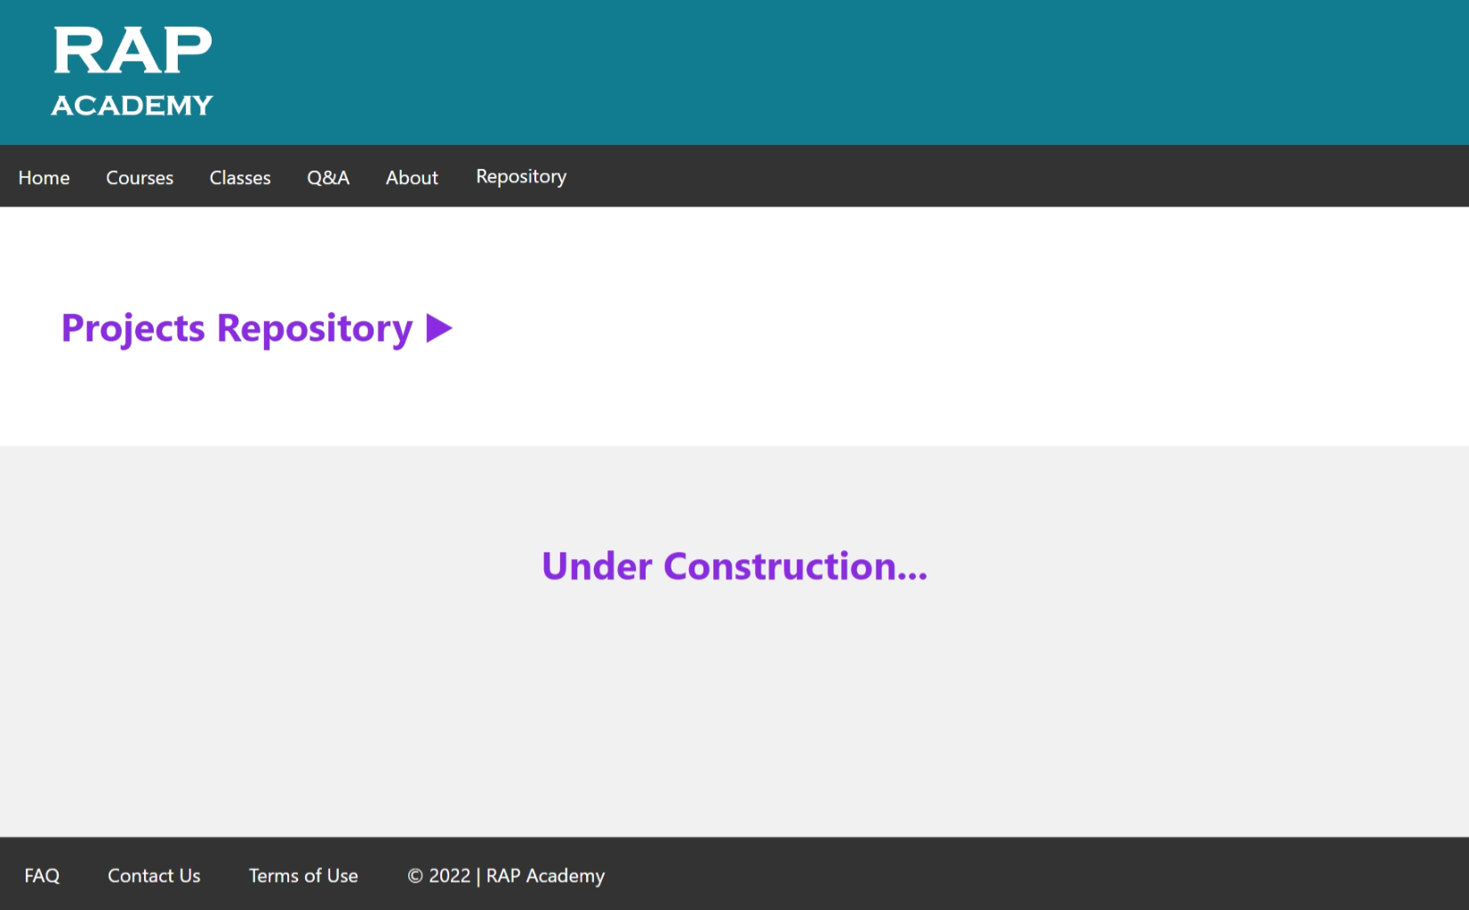

1. **Critical Evaluation**

Designers or evaluators rigorously assess the complete product using the best solutions identified in the Prototype stage. This is the final stage of the five-stage model; however, in an iterative process such as design thinking, the results generated are often used to redefine one or more further problems. This increased level of understanding may help you investigate the conditions of use and how people think, behave, and feel towards the product, and even lead you to loop back to a previous stage in the design thinking process. You can then proceed with further iterations and make alterations and refinements to rule-out alternative solutions. **The ultimate goal is to get as deep an understanding of the product and its users as possible**.

After the process of prototype, we shared the link of our website to many users after that we asked them the feedback about the prototype we made many users were happy after seeing the prototype, but there were few problems observed by the users.

**The problems listed by the users are:**

* The university curriculum-based courses were not made.
* Classroom Environment is not yet provided.
* Suggestion forms or feedback forms are not provided.
* A Limited number of courses are provided need to increase no of courses.
* Courses related to different branches or fields are not provided and there is no classification of branches or fields.