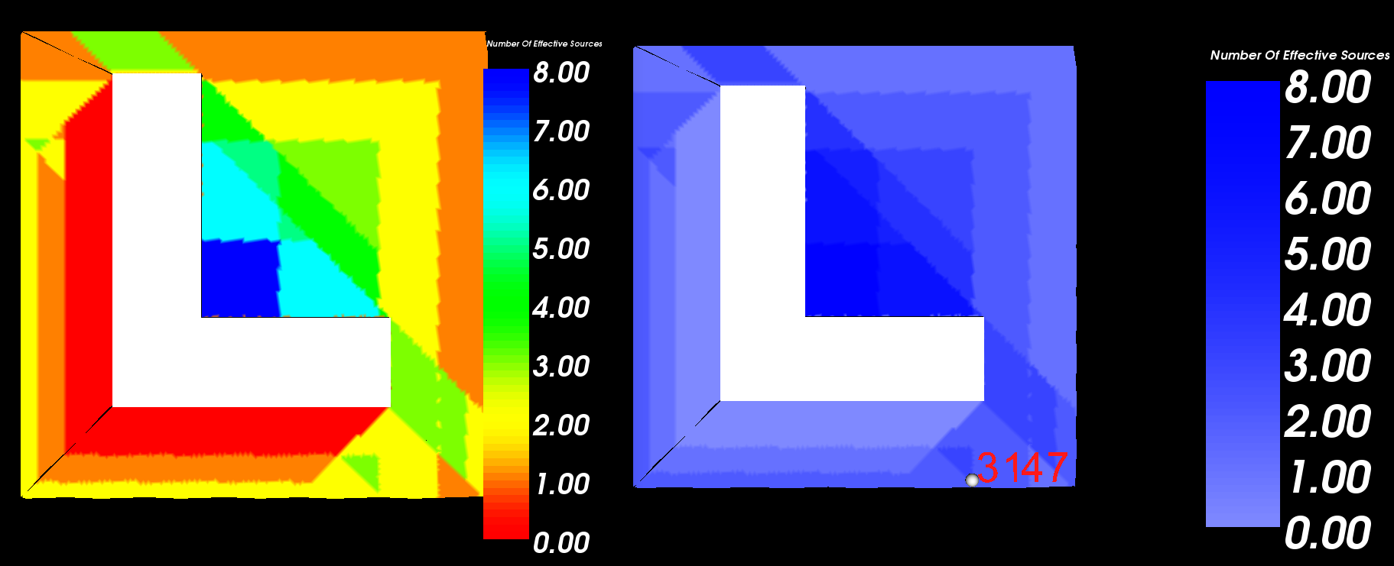Arrival Angles: -45.000000 azimuth, 7.000000 elevation

The 3 sources effective at that point :

SrcNumber: 0

SrcPosition: 210550834339.857039, 210550834339.857006, 36560803021.544243

Order: 0

Strength: 1.000000

MotherSource: 0

MotherWall: 0

SrcNumber: 10

SrcPosition: 210550834339.857039, 210550834339.857006, -36560803021.544239

Order: 1

Strength: 1.000000

MotherSource: 0

MotherWall: 9

SrcNumber: 42

SrcPosition: -210550834315.473044, 210550834339.857006, -36560803021.544243

Order: 2

Strength: 1.000000

MotherSource: 4

MotherWall: 17

WallNumber: 9

FloorPlane: 1

NumberCorners: 6

WallCenter: ( 34.535871, 26.312134, 0.000000)

WallNormal: ( 0.000000, 0.000000, 1.000000)

Corners:

CornerInd[13]=( 51.816000, 51.816000, 0.000000)

CornerInd[7]=( 12.192000, 45.720000, 0.000000)

CornerInd[9]=( 12.192000, 12.192000, 0.000000)

CornerInd[11]=( 38.100000, 12.192000, 0.000000)

CornerInd[0]=( 38.100000, 0.000000, 0.000000)

CornerInd[12]=( 51.816000, -12.954000, 0.000000)

ReflectionCoeff:

SrcNumber: 4

SrcPosition: -210550834315.473044, 210550834339.857006, 36560803021.544243

Order: 1

Strength: 1.000000

MotherSource: 0

MotherWall: 3

ReflectionCoeff:

WallNumber: (17)8

FloorPlane: 0

NumberCorners: 4

WallCenter: ( 27.958058, -1.787671, 0.000000)

WallNormal: ( 0.000000, 0.000000, 1.000000)

Corners:

CornerInd[0]=( 24.383940, -0.000808, -0.000000)

CornerInd[1]=( 29.745299, -0.001131, -0.000000)

CornerInd[2]=( 29.744935, -5.361076, -0.000000)

CornerInd[3]=( 24.383940, -0.000808, -0.000000)

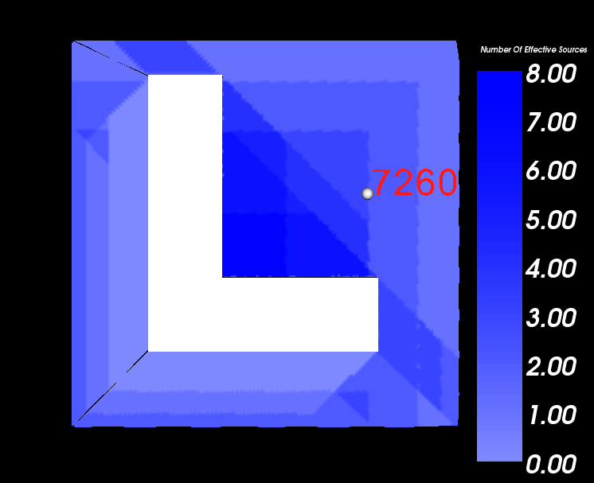

SrcNumber: 0

SrcPosition: 210550834339.857039, 210550834339.857006, 36560803021.544243

Order: 0

Strength: 1.000000

MotherSource: 0

MotherWall: 0

SrcNumber: 10

SrcPosition: 210550834339.857039, 210550834339.857006, -36560803021.544239

Order: 1

Strength: 1.000000

MotherSource: 0

MotherWall: 9

SrcNumber: 164

SrcPosition: -210550834315.473044, -210550834315.473026, -36560803021.544239

Order: 3

Strength: 1.000000

MotherSource: 35

MotherWall: 27