**­­­­­­­PeekAJob: Uncover Opportunities, Elevate Careers**

**A project report submitted to the Jawaharlal Nehru University in partial fulfillment of the requirements**

**for the award of the degree of**

**MASTER**

**OF**

**COMPUTER APPLICATIONS**

**BY**

**LIPSA MANDAL**

**(22/10/JC/043)**



**SCHOOL OF COMPUTER AND SYSTEMS SCIENCES JAWAHARLAL NEHRU UNIVERSITY**

**NEW DELHI – 110067**

**SCHOOL OF COMPUTER AND SYSTEMS SCIENCES JAWAHARLAL NEHRU UNIVERSITY**

**NEW DELHI – 110067**

**DECLARATION**

This is to certify that the project entitled “**PeekAJob”** is being submitted to the School of Computer and Systems Sciences, Jawaharlal Nehru University, New Delhi, in partial fulfillment of the requirements for the award of the degree of **Master of Computer Applications**, is a record of bonafide work carried out by me.

The matter embodied in the dissertation has not been submitted in part or full to any University or Institution for the award of any degree or diploma.

### LIPSA MANDAL

**SCHOOL OF COMPUTER AND SYSTEMS SCIENCES JAWAHARLAL NEHRU UNIVERSITY**

**NEW DELHI – 110067**

**CERTIFICATE**

This is to certify that the project entitled “**PeekAJob”** submitted to the School of Computer and Systems Sciences, Jawaharlal Nehru University, New Delhi, in requirements for the award of the degree of **Master of Computer Applications**, embodies original work carried out atSchool of Computer and Systems Sciencesby “**Lipsa Mandal”.**

**(Mentor)**

**Dr. Karan Singh,**

**SC & SS, JNU, New Delhi**

**ACKNOWLEDGEMENT**

I am deeply grateful to my supervisor, Dr. Karan Singh, from the School of Computer and Systems Sciences, Jawaharlal Nehru University.

Without his assistance and excellent knowledge, this project wouldn't have been completed. He was always there to support me whenever I needed guidance. I would also want to extend my sincere appreciation to everyone who helped me with this project and showed me kindness and support. I wouldn't have done this task without their assistance.

I express my gratitude to the School of Computer and Systems Sciences at JNU for providing me with the chance to work on this project, I will always be indebted to them for that.

**Date: Lipsa Mandal**

**ABSTRACT**

The job market is always changing, and finding a job can be difficult for both job seekers and employers. Traditional ways of job searching and hiring can be slow and unclear. PeekAJob aims to solve these problems by providing an easy-to-use platform for job seekers and employers.

PeekAJob helps job seekers find job more easily as well as search out the right candidate for the company quickly and efficiently

This reduces the time ad efforts as compared to the traditional way.The platform is designed to be user-friendly, helping both job seekers and employers in a straightforward and effective way.

This project demonstrates how PeekAJob can enhance the job search and hiring process by making it more transparent and efficient. By using modern technology, PeekAJob helps job seekers advance their careers and helps employers find the right candidates more easily, leading to a better job market for everyone.

**TABLE OF CONTENTS**

1. Introduction………………………………………………………7-11

1.1Introduction…………………………………………………….7

1.2 Problem Statement & Project Objective…………………8-9

1.3 Motivation…………………………………………………….10

1.4Application…………………………………………………….11

1. Analysis ……………………………………………………..12-15

2.1. Requirement Analysis…………………………………..12-13

2.2. Feasibility Analysis ……………………………………..13-15

1. Design and Implementation……………………………………16-24
   1. Design…………………………………………..............16-18
   2. Modules…………………………………………………19-20
   3. ER Diagram ……………………………………………..21
   4. Data Flow Diagram……………………………………..­­22-24
2. Testing……………………………………………………………..25-27
   1. SystemTesting…………………………………………….25
   2. Unit and Integration Testing……………………………..26
   3. Validation Testing…………………………………………26
   4. Additional Consideration………………………………….27

5. Outputs …………………………………………………………..28-37

6.Conclusion and Future Work……………………………………… .38

**INTRODUCTION Chapter-1**

The job market is always changing and evolving with opportunities arising regularly. Employers and job seekers need to update their skills to keep up. However, the current methods of finding a job often lack efficiency and transparency.

**Challenges for Job Seekers**

* **Limited Job Visibility:** It can be difficult for graduates or those looking for roles to find suitable job openings.
* **Inefficient Application Process:** Traditional recruitment methods are time consuming. May not effectively screen candidates.

**Challenges for Employers**

* **Candidate Search:** Employers face challenges in finding candidates among a sea of applications leading to wasted time.
* **Inefficient Screening Process:** Traditional screening methods may not accurately assess a candidates skills and potential.
* **Limited Candidate Pool:** Finding candidates, for specialized positions can be a challenge through traditional channels.

PeekAJob aims to address these challenges by offering a platform, for both job seekers and employers.PeekAJob is a platform that aims to support job seekers in their career paths by providing a solution. It enables users to find job opportunities, evaluate and enhance their skills and simplify the hiring process. Employers can also use PeekAJob to connect with candidates and make recruitment more efficient.

**PROBLEM STATEMENT**

There is a breakdown in communication between companies and job seekers in the present job market. Getting opportunities that meet their needs can be challenging for many job searchers, especially those who are fresh graduates or seeking for specialised jobs. They can become confused in a pool of worthless postings or lack the resources needed to uncover the hidden gems in the market. The labour market is always evolving, so it's critical to keep your skill set current. Prospective applicants may not be as competitive if they do not have the means or assistance to get the specialised skills required for the positions they are interested in.

**Problem Definition:**

By developing a complete platform that facilitates the job search process for both employers and job seekers, PeekAJob aims to solve these problems. We think the following might be the answer:

• **Matching Job searchers with Relevant possibilities:** By providing a user-friendly search feature gives  job searchers possibilities that suit their interests and skill set

• **Enhancing the Hiring Process:** Employers can use this to find top talent that meets their needs and corporate culture.

PeekAJob seeks to enhance the whole job search process and establish a more effective and interconnected job market by addressing these problems by providing a solution that benefits every individual involved in the job market.

**PROJECT OBJECTIVE**

**For Job Seekers:**

* **Efficient Job Search**: Enable job seekers to easily browse and search for available job listings
* **Streamlined Application Process:** Provide a seamless and straightforward application process, allowing job seekers to apply to desired positions with minimal effort.
* **Access to Application History:** Allow job seekers to track their application history, view submitted resumes, and manage their applications effectively.

**For Employers:**

* Find Top Talent: Draw from PeekAJob's enormous database to field with a greater variety of competent applicants.
* **Conserve Time and Resources:** Utilise a single platform to effectively oversee the whole hiring process. Eliminate the need to go through pointless applications and stop spending time on unfit candidates during interviews.

**MOTIVATION**

Indeed, it can be annoying to look for work. You browse through countless listings for hours on end, but none of them seem like a good fit. Perhaps you are a recent graduate with no idea where to begin, or maybe you want to change careers but need to hone a few skills,  
Businesses also have difficulties! They review applications that are not relevant to their needs for a long time.   
  
To address these issues on both sides of the employment market, PeekAJob has been developed. We support streamlining and improving the effectiveness of the procedure. This is what inspires us on:

Helping You Find The Perfect Job: Our mission is to place you in jobs you'll love to work at! Cut down on time wasted on useless listings. PeekAJob helps you find jobs according to your interests and skill level.

Encouraging Companies: Our goal is to save businesses time and aggravation. Through PeekAJob, they can locate qualified candidates who complement their requirements and corporate culture.

Think of PeekAJob as a go-between for employers and job seekers. It's a platform that assists everyone in making the job market considerably more effective and somewhat less stressful.

**APPLICATION**

There are lots of job opportunities! Companies are finding it difficult to fill open positions with talented individuals searching for chances to grow in their careers. But there are challenges for both sides because there is so much going on. Selecting the ideal job can be extremely challenging. You have to search through a lot of postings and strong competition to find the right fit. Inadequate abilities may also be a barrier if the job market demands that you perform a task that you are not yet proficient in. However, sorting through a vast array of applications requires time and resources. The incapacity of traditional methods to fairly assess a candidate's true skills could lead to poor hiring decisions. Finding qualified candidates for specialized roles can be particularly difficult.

PeekAJob then turns into your go-to solution:

**Concerning Job Seekers**

* **Finding Jobs:** It can be easy for those looking suitable job openings.
* **Simplify the Application Process:** Apply quickly and easily, and receive timely status updates.

**Concerning Employers**

* **Attract Top Talent:** PeekAJob provides you with access to a wider pool of qualified candidates, allowing you to choose the best fit for the needs of your company.
* **Conserve Time and Resources:** Get rid of the application list that never ends! PeekAJob prequalifies candidates in line with your specific needs.

PeekAJob is the perfect solution for the competitive job market of today. It helps companies put together winning teams and helps job seekers land their dream jobs. You can get the competitive edge you need in this market with PeekAJob!

**ANALYSIS Chapter-2**

**Requirement Analysis:**

Requirement analysis comprises determining and keeping track of the needs and specifications of the PeekAJob platform. This study is crucial in order to make sure that the platform meets the expectations of its users and stakeholders. The requirement study for PeekAJob may be classified into three primary domains: user requirements, software requirements, and hardware requirements.

**User Requirements:**

User requirements specify the functionalities and features expected by the users of the PeekAJob platform.

**Job Seekers**

**Registration and Login**: Job seekers need to create an account and log in to access the platform's features.

**Job Search:** The platform should provide a comprehensive search feature with filters for location, industry, job type, salary range

**Job Applications:** Job Seekers are able to apply for the job and can post their application easily

**My Applications:** A dedicated page where job seekers can see their posted application and can also delete the application if they don't want to move forward.

**Security and Privacy:** Ensure that job seekers' data is secure and their applications are not visible to other job seekers.

**Employers**

**Registration and Login:** Employers need to create an account and log in to access the platform's features.

**Job Posting:** Employers should be able to create, update, and manage job postings with detailed descriptions, requirements, salary information, and location.

**Applicants' Applications:** Employer can see applicants applications.

**View Your Jobs:** A page is visible to the employer and contains the posted job of a particular employer and that posted job is not visible too other employer

**Software Requirements :**

These are some software specifications.

**User Interface:** Simple browsing and interaction are made easier with user-friendly interfaces on both mobile and online versions.

**Database Management:** Database frameworks for organising and keeping track of user accounts, job listings, applications, and other relevant data.

**Search Engine:** Utilise powerful search features to refine job postings according to several standards.

**Authentication System:** Safe procedure for registering and logging in, with multi-factor authentication and password recovery.

**Profile Management System:** Streamlined user profile CRUD (Create, Read, Update, Delete) processes.

**Hardware Requirements:**

These are some hardware specifications.

**Server Infrastructure:** Dependable servers to house the database, backend services, and web application. Sufficient storage options for user information, job advertisements, and application materials using databases like MongoDB

**Connectivity:** High-speed internet connectivity is necessary for effortless platform access.

**Security Infrastructure:** Encryption and additional security protocols to safeguard user information and uphold the platform's integrity.

Through the resolution of these hardware, software, and user criteria, PeekAJob hopes to provide a productive platform that improves the hiring and job search process for both businesses and job seekers.

**Feasibility Analysis:**

Feasibility analysis is evaluating PeekAJob's feasibility to make sure it can be created, implemented, and maintained effectively.

**Technical Feasibility:** In order to ensure a project's successful development and execution, technical feasibility analyses if the technology, tools, and resources needed for the project are accessible and able to match the project's needs.

**Platform Development**

**Technology Stack:** Modern web technologies like Node.js for the back-end and React.js for the front-end can be used to construct PeekAJob. It is possible to locate resources and help throughout development because these technologies have solid support systems.

**Database Management:** Utilizing databases using noSQL database like MongoDB

**Security Measures:** Implementing secure authentication methods, data encryption, and regular security audits to protect user data and maintain platform integrity.

**Economic Feasibility:**

A project's profitability is evaluated in terms of its economic feasibility. It assesses if a project's anticipated income and benefits outweigh the expenses and expenditures necessary to complete it, figuring out whether the endeavour is long-term profitable and financially sustainable.

Following are the reasons why it is economically feasible.

**Costs of Development and Operation:**   
PeekAJob's initial development costs will involve expenses related to hiring software developers, designers, and project managers.Investing in the development tools, software licences, and cloud infrastructure setup required to host the application would incur additional expenditures. Continuous development and upgrades, safety measures, customer support, and marketing will all be covered by ongoing operating costs.

**Multiple Revenue Streams:** The platform may make money from a number of different sources, including partnerships, advertising, job posting fees, and membership fees for premium features. A constant flow of revenue is ensured by this diversity.

**High Market Demand:** Employers and job seekers alike have a considerable need for effective job matching services. PeekAJob can draw in plenty of users by addressing significant inefficiencies in the hiring and job seeking processes.

**Operational Efficiency:** PeekAJob are able to preserve minimal operating costs while offering excellent services because to automation and new technology, which improves cost control and profitability.

All things taken into account, these elements support PeekAJob's financial sustainability and help to ensure that its operation will be beneficial and sustainable over time.

**Market Feasibility:**   
  
Market trends, competition, target market demand, and market viability are assessed in order to determine whether or not there is a market for the product or service and ensure that it can be attracted and retained by customers.

**Growing demand:** There's a growing industry of Internet jobs! Job seekers are constantly looking for new ways to find work, and companies have always sought innovative methods of finding skilled workers online. PeekAJob meets this demand by providing a user-friendly platform for both parties. ·

**PeekA stands out from the crowd:** features such as integrated skill tests and access to educational materials differentiate PeekA from the competition. It gives them a distinct advantage over their competitors and provides customers with a more comprehensive experience.

PeekAjob is expected to be a successful and sustainable platform based on the comprehensive requirements, feasibility studies as well as market analyses. PeekAjob is able to meet the needs of jobseekers and employers, guaranteeing a longer period of viability and operating effectiveness through its use of open source tools that address high market demand as well as providing unique financing features.

**DESIGN & IMPLEMENTATION Chapter-3**

Agile development, which emphasises adaptability and continual improvement as part of the development process, will serve as the foundation for the PeekAjob initiative. To guarantee ongoing input and enhancement, the project will utilise an iterative methodology, segmenting the activities into feasible stages. A step-by-step methodology for the PeekAjob development process is provided here:

**System Design:**

In order to ensure that all components work together smoothly for the purposes of meeting the project's requirements and objectives, system design involves drawing up a plan on the structure and functionality of the system. This includes both a high level architecture and detailed designs for individual system components. The system design of PeekAJob will cover the areas as follows:

* **Planning and Requirement Analysis:**
* **Gather Requirements:** Collected detailed requirements for both job seeker and employer
* **Define Objectives:** Clarified the project goals, scope and features.
* **Time Plan:** Scheduled time in following manner

. Planning and Research (1-2 weeks)

. Frontend Development (1month)

. Backend Development (1month)

. Testing and Quality Assurance (2-4 weeks)

. Documentation and Finalization (1 week)

* **Architecture Specification:**

**System Architecture:**

* + - * Define the overall architecture, ensuring smooth interaction between the frontend, backend, and database.

``

**Database Design**:

* + **User Profiles**: Stored user information such as resumes, and login credentials.
  + **Job Listings**: Maintained records of job postings, including job descriptions, requirements, and employer details.
  + **Applications**: Job applications submitted by job seekers with their resume
  + **Database Choice**: Used MongoDB for designing the database.

**User Interface (UI) Design:**

This involves creation of an user-friendly interface which enhance the better experience of both job seeker and employer.

* **User-Centric Design:** Designed a user-centric application for both categories.
* **Unique User Interfaces:** Develop specific interfaces for job seekers and employers to provide a seamless and effective user experience.
* **Development:**
* **Front-End Development**
* **Technology Stack:** Used ReactJS, and CSS to create an interactive and responsive user interface.
* **User Roles:**

**Job Seeker Interface:** Features include apply for jobs that are available according to their interest and role suited for them.They can post their resume in post application form and can view and delete if they don’t want to move further and can log out from the page easily.

**Employer Interface:** Features include viewing all jobs, managing applicant applications, posting new jobs, and viewin or editing their posted job efficiently.

* **Back-End Development**
* **Server-Side Logic:** Used Node.js and Express.js to develop the backend functionality.
* **Features:**

**User Authentication:** Secure login and registration using bcrypt for password hashing and json webtoken for token creation.

**Data Management:** Implement data storing and retrieval with MongoDB using mongoose.Created connection with the database by providing MongoDB URI in config.env file.

**File Uploads:** Used express-fileupload and Cloudinary for handling resume uploads and file handling.

* **Environment Configuration:** Managed environment variables securely by using dotenv. For secretly storing environment variables.
* **CORS Setup:** Established connection between frontend and backend using cors.
* **Middleware:** Implement middlewares for authentication, error handling, and email validation with validator.
* **API Integration:**

**Internal APIs:** Develop and test APIs using Postman to ensure backend services work correctly or not.

**MODULES**

PeekAJob has 3 modules :

* Registration and Authentication Module
* Employer Module
* Job Seeker Module­­
* **Registration and Authentication Module**
* This module contains the authentication part where it shows option for selecting the role. There are two role for the user namely: Employer and Job Seeker.
* If the user is already registered then he/she can log in to their account.According to their role selection respective page will open.Users can securely log out pf their accounts.
* **Employer Module:**

When the user will registered him as employer then the navbar has following option.

* All Jobs: He/She can see all posted jobs that are fetched from the database.
* Applicants Application: Access applicant’s resume for posted job particular to that employer.One employer can’t see the page for other employer.
* Post New Jobs: Employer can post new job listing.
* View Your Jobs: Employer can view, update and delete their posted jobs.
* Log Out: They can easily log out from their account.

* **Job Seeker Module:**

If the user registered as job seeker then the page will show the following.

* All Jobs: Job Seekers can browse and search for available job oenings.They can see the details about the job,location and salary type etc.
* Apply for Jobs: Job Seekers can apply for the job after viewing the job description.They can upload their resume.
* View Applications:Job Seekers view their submitted job applications and can delete it if don’t want to move forward.
* Delete Application: There is also a delete option in the view application page.
* Log out: They can log out easily.

**ER DIAGRAM :**

An ER (Entity-Relationship) diagram visually represents the structure of a database, showing entities, their attributes, and the relationships between them, aiding in database design and organization.

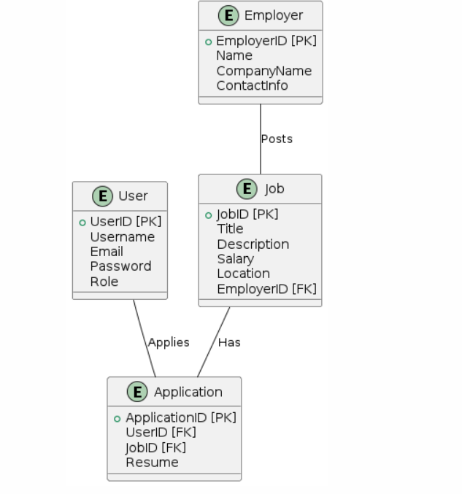

**DATA FLOW DIAGRAM**

A Data Flow Diagram (DFD) visually represents the flow of data within a system, showing how data is processed by depicting inputs, outputs, data stores, and processes.

* 1. **Zero Level DFD :**

A zero-level Data Flow Diagram (DFD) provides a high-level overview of a system, illustrating the main processes, data flows, and external entities without detailing internal processes.

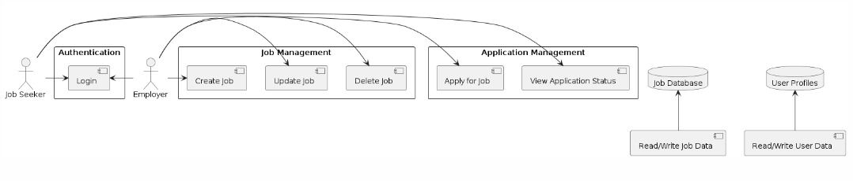

* 1. **One Level DFD :**

A one-level Data Flow Diagram (DFD) expands on the zero-level DFD, detailing the main sub-processes within each major process, showing more specific data flows and interactions within the system.

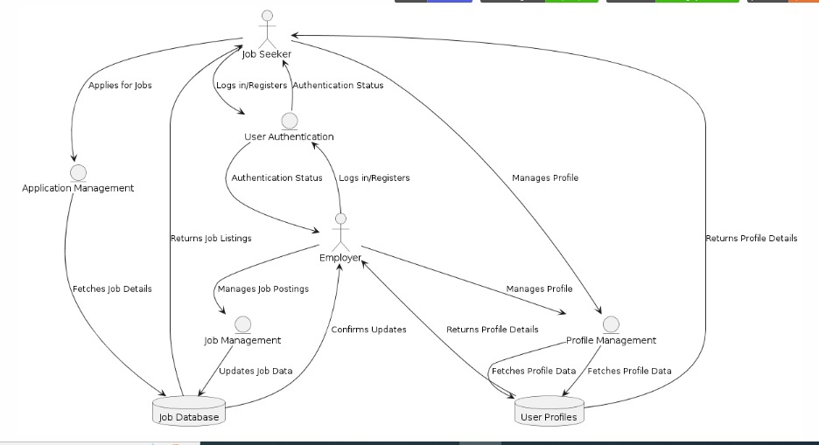

* 1. **Second Level DFD :**

A second-level Data Flow Diagram (DFD) further decomposes the processes from the one-level DFD into more detailed sub-processes, providing an in-depth view of the system's data flows and functional components.

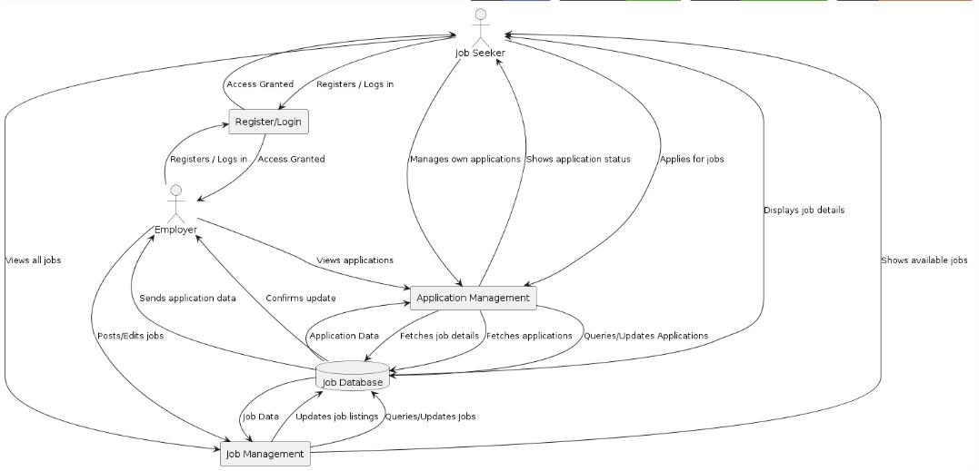

**TESTING Chapter-4**

Testing is evaluating the software and its functionality through checking the bugs. It also means to ensure performance and validate whether it meets the requirements or not.

**System Testing:**

System testing involves testing the entire PeekAJob platform to ensure its functionality and performance. This testing phase validates the system against the specified requirements and objectives.

**End-to-End Testing**

* End-to-End Flow Verification: We verified the complete flow of the system, starting from the user interface developed with ReactJS to the interaction with the Node.js backend and MongoDB database. The testing ensured proper registration, login, job posting, job application, and viewing functionalities.
* User Interactions: We tested the interaction between job seekers and employers, ensuring that job postings can be created, viewed, and applied for, and that application data is correctly stored and retrieved from the database.

**Performance Testing**

* System Performance: We evaluated the system's performance under different loads and scenarios. Measured response times, processing speeds, and resource utilization to ensure the system can handle the expected user traffic efficiently.
* Scalability: We tested the scalability of the platform to ensure it can handle a growing number of users and job listings without degradation in performance.

**Usability Testing**

* User Interface Assessment: To assess the usability of the user interface developed with ReactJS. We conducted user tests to gather feedback on the interface's intuitiveness, ease of use, and overall user experience.

21

* User Feedback: Gathered feedback from both job seekers and employers to identify areas for improvement and ensure that the interface meets their needs effectively.

**Unit and Integration Testing:**

Unit testing and integration testing focus on testing individual components and their integration within the system.

**Unit Testing:**

* UI Components: Tested individual UI components developed with ReactJS to verify that they function correctly. Ensured that form inputs, buttons, and navigation elements perform as expected.
* Backend Functions: Tested server-side functions implemented with Node.js and Express.js to ensure correct data processing, user authentication, and API endpoints.

**Integration Testing:**

* Frontend-Backend Connectivity: Verified the communication between the ReactJS frontend and the Node.js backend. Ensured that data is correctly sent to and received from the server, and that API calls return the expected results.
* Database Integration: Tested the interaction between the backend and MongoDB database. Ensured that user data, job postings, and applications are correctly stored, retrieved, and updated.

**Validation Testing:**

Validation testing ensures that the PeekAJob platform meets the intended requirements and performs as expected.

**Test Against User Requirements**

* Functional Validation: Validated that the system meets the defined user requirements and objectives, such as accurate job posting, job searching, application submission, and profile management.
* Role-Specific Functionalities: Ensured that the functionalities specific to job seekers and employers are correctly implemented and accessible only to the respective roles.

**Validation of Data Privacy and Security**

* Data Handling: Ensured that the system adheres to ethical and legal considerations regarding data privacy and security. Validated that user data is handled securely, with proper encryption and access controls.
* User Consent: Verified that appropriate consent mechanisms are in place for data collection and usage, ensuring compliance with data protection regulations.

By conducting thorough system testing, unit and integration testing, and validation testing, PeekAJob aims to deliver a reliable and efficient platform that meets the needs of job seekers and employers, providing a seamless and secure user experience.

**Output Chapter-5**

**Registration Page**



**Fig-1**

**Log in Page**



**Fig-2**

**Employer’s Dashboard**

**Home Page**

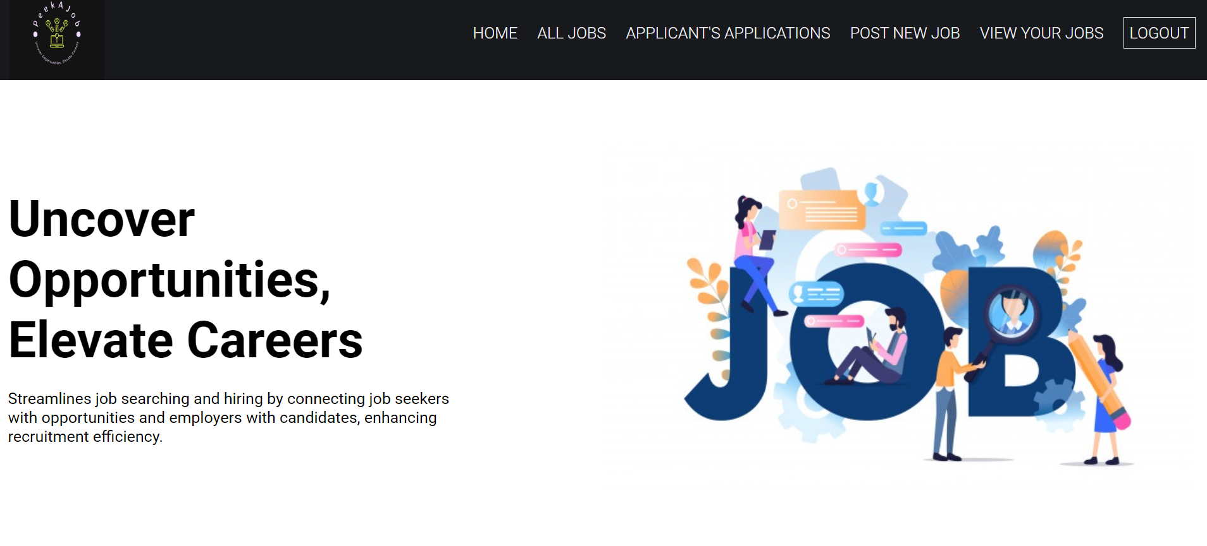

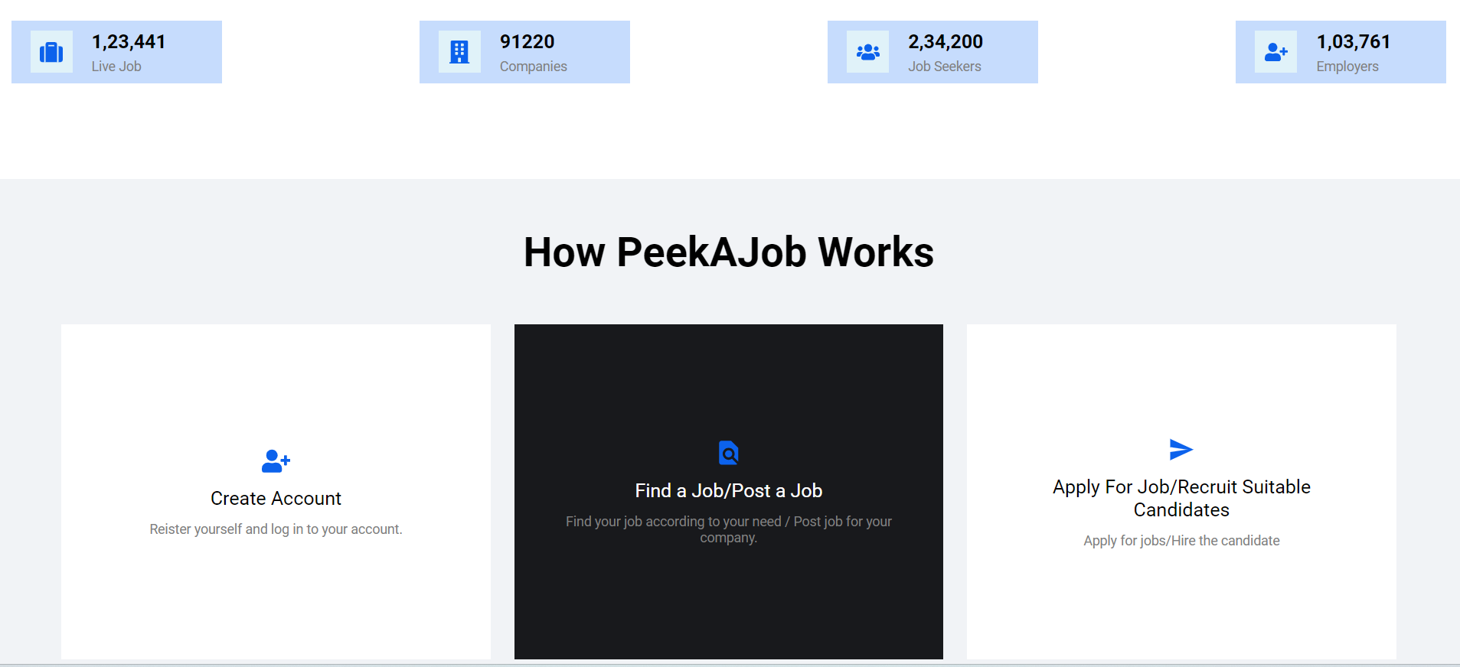

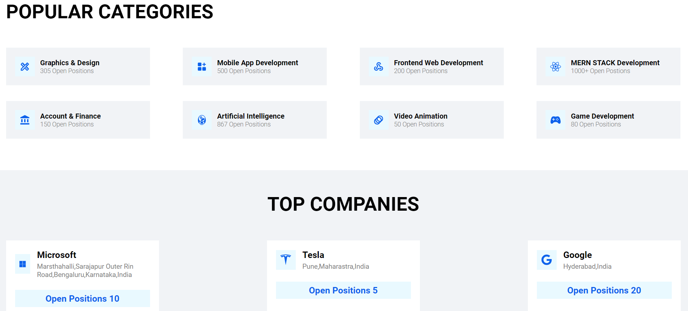

**Fig-3**

**All Jobs**

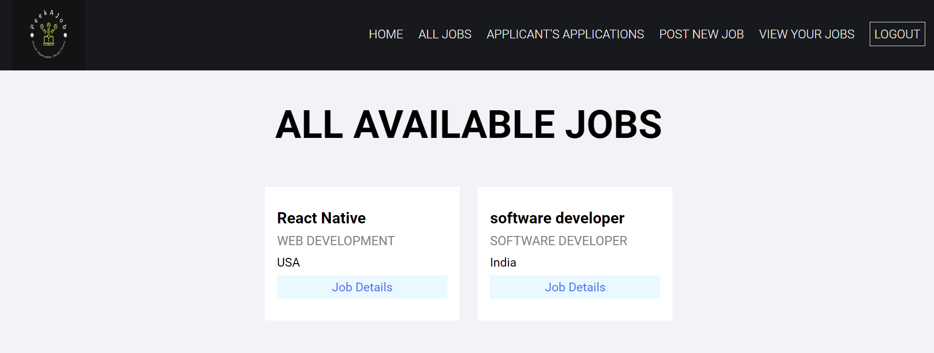

**Fig-4**

**Post new Job:**

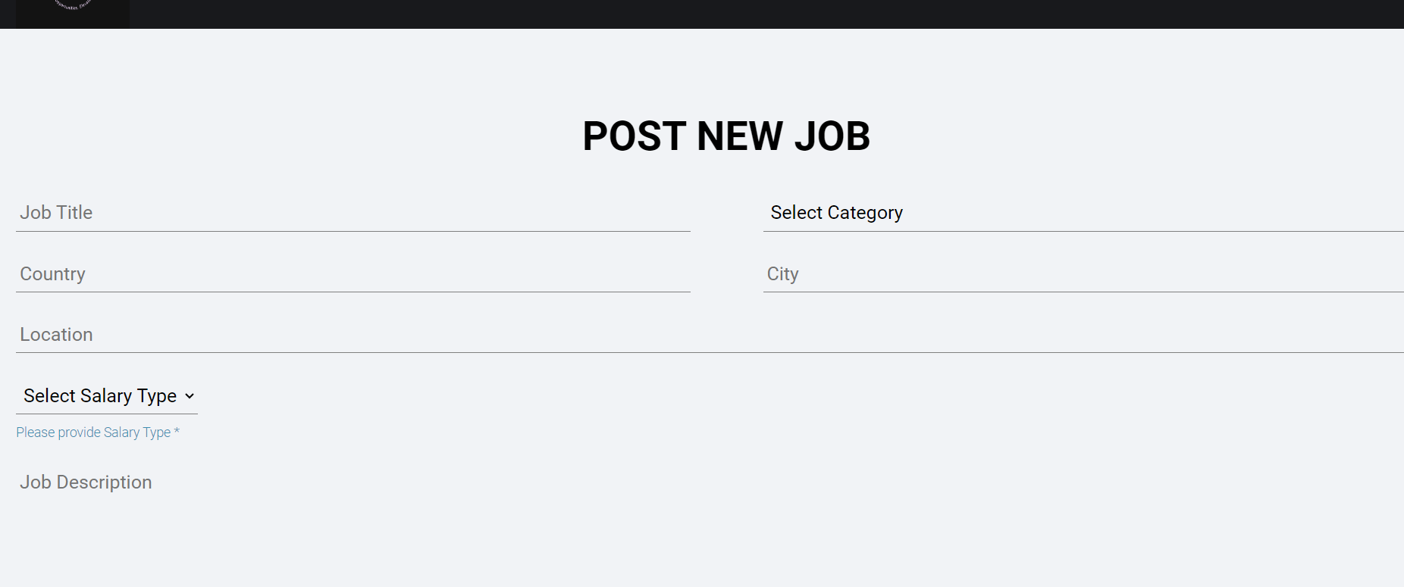

**Fig-5**

**View Your Jobs**

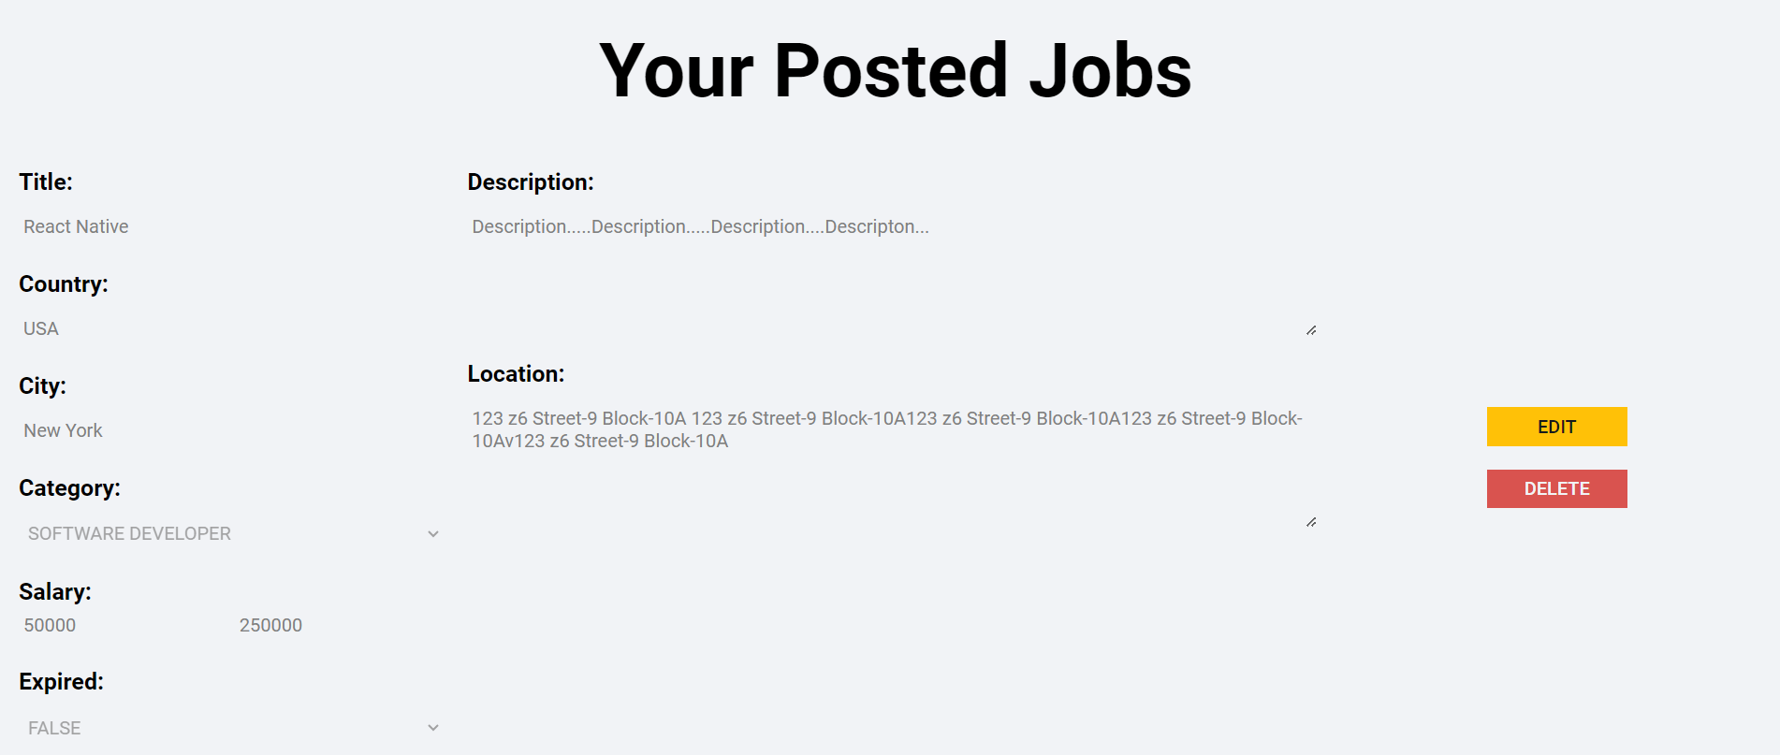

**Fig-6**

Employer can edit the job details easily.

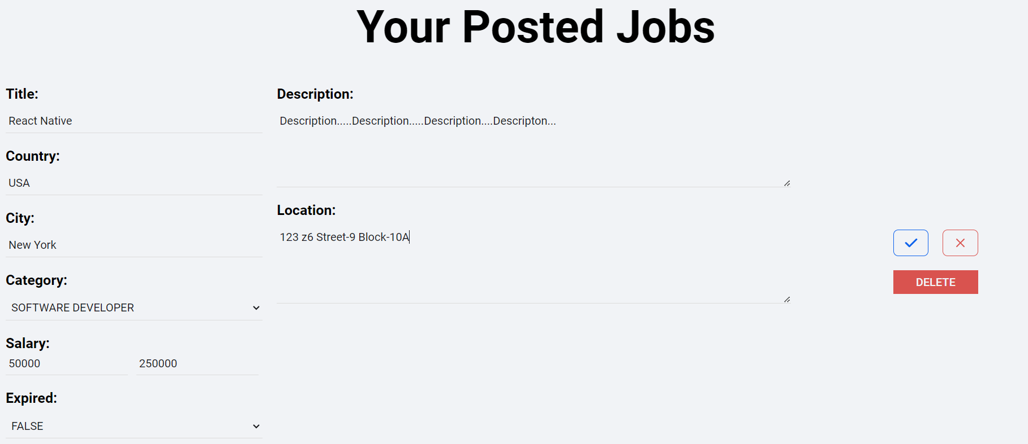

**Fig-7**

**Applicant’s Application**



**Fig-8**

If something which is not valid or any error happen search for then this page will open.



**Fig-9**

**Job Seeker’s Dashboard**

**Home Page**

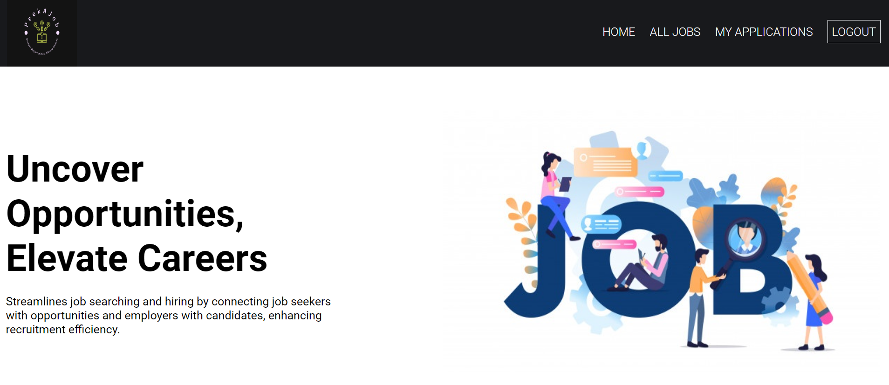

**Fig-10**

**All Jobs:**

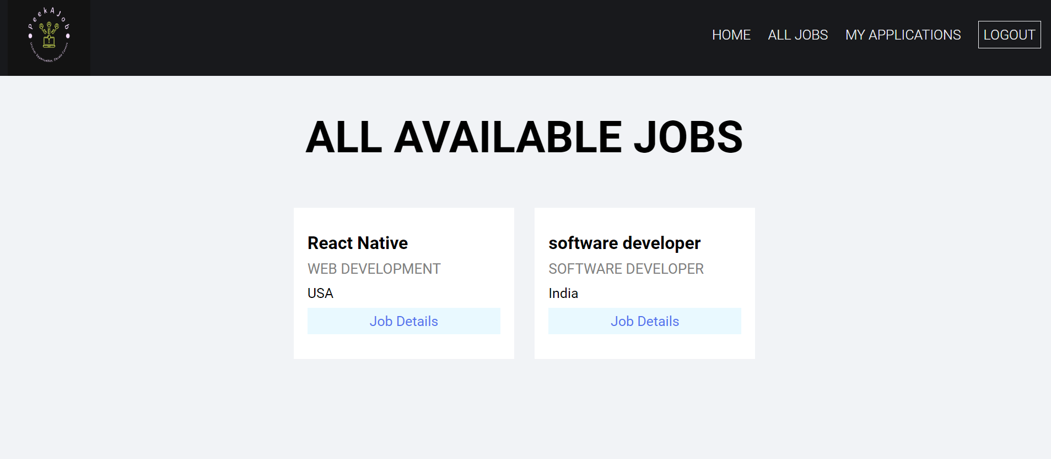

**Fig-11**

**Application form**

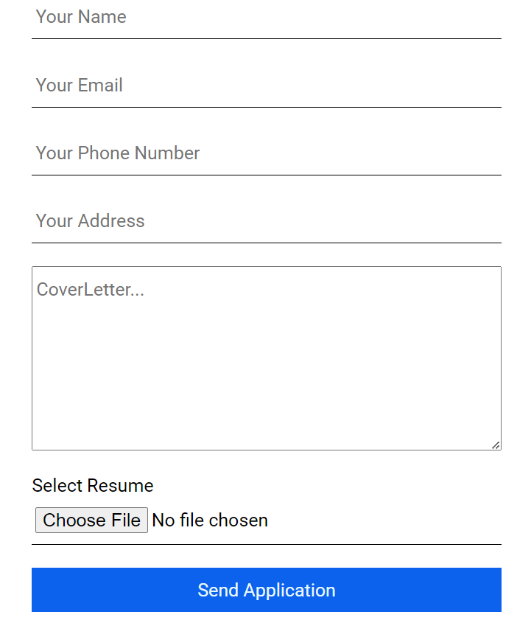

**Fig-12**

**My Application**

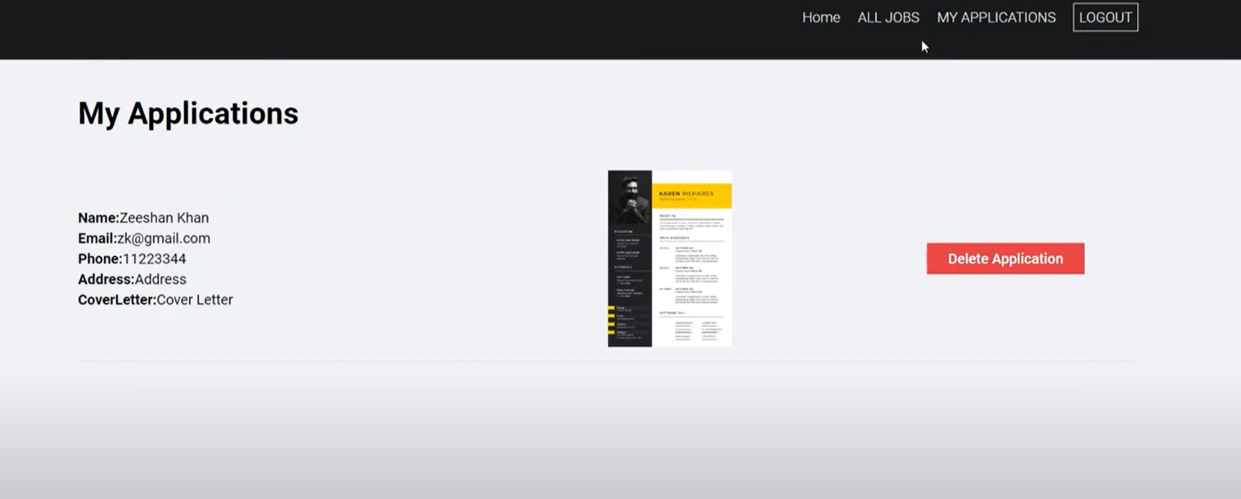

**Fig-33**

**Maintenance and Continuous Improvement**

PeekAJob moves into routine maintenance and ongoing improvement when the testing phase is over.

The platform is continuously observed to maintain its dependability, security, and performance. All-inclusive monitoring systems measure several variables in real-time, which enables us to quickly resolve any problems and provide a steady user experience.

New features and updates are often released in response to developing market trends. Updates on a regular basis fix errors, add new features, and improve already-existing functionality.

Because of our agile development methodology, we can react swiftly to shifting user demands and technology developments, guaranteeing that PeekAJob will always be a dependable, safe, and easy-to-use platform for both businesses and job searchers.

**CONCLUSION AND FUTURE WORK Chapter-6**

**CONCLUSION**

Finally, PeekAjob represents a major step forward in the field of job applications platforms, providing an immediate solution for businesses and jobseekers alike. PeekAjob offers a secure database management system, an intuitive user interface and robust backend features using today's technologies, such as MongoDB, Node.js or React. In order to ensure that this is done. An encrypted database management system, a user-friendly interface, and powerful back-end functions are offered by PeekAJob. We're testing, monitoring, and updating PeekAJob regularly in order to ensure its reliability, safety, and innovation for the navigation of the employment market. In order to revolutionise the job application process and make it more user-friendly for all users, PeekAJob has a unique position due to its emphasis on user inputs, market trends, and adaptability.

**FUTURE WORK**

Several more features may be added to PeekAJob to improve it and provide companies and job searchers more value. Mock exams for skill evaluation might be a significant improvement. Job searchers may use this function to test themselves, determine where they are weak, and get suggestions for resources to help them get better.   
  
AI and machine learning will be used to develop sophisticated job matching algorithms that will more accurately match job searchers with appropriate positions based on their interests and skill sets. The recruiting process may be streamlined by improving employer resources including the ability to evaluate candidates based on their test results, talents, and resumes, as well as by incorporating an interview scheduling system.

To enhance the use and functionality of the platform, we can add a user feedback system. The user experience for both job seekers and employers will be greatly enhanced by adding all of these features, which will make the platform more attractive and useful.