**Automatic Attendance System Using Image Processing**



**Computer Engineering – senior Project Report**

**Advisor :** Tuğba Önal SÜZEK, PhD

Mandana Zooyousefin

Date : 29/1/2023

**A free lecture and meeting attendance recording desktop application with image processing techniques**

Mandana Zooyousefin

Computer Engineering

Muğla Sıtkı Koçman University

**Summary**

Face recognition and detection is an important topic in the field of vision and image processing. Due to the special characteristics of the problem and its various applications, many algorithms have been presented for this purpose. Since each method has a different approach to face detection, it can be hoped that a combined method can provide a much better and more effective solution than the methods presented alone.

In this research, an attempt was made to obtain acceptable results by using a combination of methods such as neural network and PCA (Principal Component Analysis) as a combined approach. Emphasis is placed on the necessity of detecting the face, which forms the basis of face recognition. That is, first the face must be detected and then it must be determined which person this face belongs to.

It is thought that such combined methods can provide better performance in controlling people's entry and exit and participation-enforcement systems.

**Contents**

1. Introduction 4
2. Image Processing 5
   1. Softwares that can be used for image processing 5
      1. OpenCV 5
      2. MATLAB 6
3. Neural Networks 7
   1. Artificial Neural Networks 7
      1. The reason for using neural networks 8
   2. Applications of artificial neural networks 8
4. Graphical user interface design 9
   1. A view of the program’s graphical interface 9
5. References 11

1. **Introduction**

The face is a unique feature in humans. Even two people have slight differences in their faces, despite the similarities. These differences allow us to use faces as a means of identification and recognition. Although no internet connection is available when this tool is a desktop application, it can be used for ID cards, credit cards, identification of criminals, entry to government and military facilities, etc. It can be used in many applications such as.

Face recognition from live and inanimate images by machine is a broad research topic in areas such as image processing, pattern recognition, machine vision and neural networks. Over the last 20 years, a lot of work has been done on various aspects of face detection by physicists and neuroscientists on the one hand, by engineers on the other, and by human and machine.

The first two groups of problems were primarily: uniqueness of faces, face detection in humans, how faces are organized in memory, the inability to accurately invert faces, and the role of the right hemisphere in face detection. Work on facial recognition began in the early 1970s and stalled throughout the 1980s. However, it has increased markedly since the early 1990s. This is due to the increase in research projects in forensic and commercial fields, the emergence of neural networks focused on image processing, the availability of lag-free hardware, and the increasing need for security and surveillance applications.

In the last 5 years, significant progress has been made in facial recognition studies, such as facial segmentation, determining the location of the face in the image, and extracting features such as eyes, eyebrows, mouth and nose. Additionally, great advances have been made in the design of recognition algorithms and neural networks.[1][2]

Programs similar to this project can be mentioned on the following websites:

deputy: It is an attendance platform that also uses video technology to increase accuracy in attendance management. This

The application provides features such as scheduling shifts, sending messages to the team, and analytical reports.[4] ZoomShift:: Shift and attendance feature that uses video technology to record users' attendance

is the management system. This app allows users to easily manage shifts and absences.[5]

TSheets: An online engagement system that uses video technology to manage employee attendance. This application offers a variety of features, including work hours calculation, team management, and detailed reports.[6]

The difference between this program and the examples mentioned above is this:

1) It can be offered free of charge to any company or school that requests it.

2) It can be used as Turkish language.

3) It is a single-purpose and easily usable application.

The purpose of this research is to implement a course or meeting participation-implementation system. This will be accomplished by collecting and classifying a series of images of specific people's faces. Once the system is trained on the collected images, it will have the ability to recognize people in its database and will be able to identify people it knows when it receives a new image.

1. **Image Processing**

Image processing today is mostly called the subject of digital image processing, which is a branch of computer science

It is done by processing the digital signal that represents the images taken with a digital camera or scanned

It is dealt with by the scanner.

In its special sense, image processing is any type of signal processing that is the input of an image, for example

Photos or scenes from a movie. The output of the image processor can be an image or a set of symbols

special or variables related to the image. Most image processing techniques involve dealing with the image as

A two-dimensional signal and using standard signal processing techniques on them. processing

Image often refers to digital image processing, but optical and analog image processing also exist.

* 1. **Softwares that can be used for image processing**
     1. **OpenCV**

One of the problems of visual software developers is performing various calculations on images. Due to the large amount of information, their processing requires optimal programming. Intel company has a project called

OpenCV started to provide optimized libraries for performing real-time visual calculations for the developers of this category of software. It is an open source library with a BSD license for developers of visual and image processing software, which was introduced to the computer world in 2000 by Intel.

Currently, there are different versions of this library, the most famous of which is version 2.4, and the latest is version 3.1, which is considered the latest stable version.

This library is written in C/C++ language, but it is available in almost all popular programming languages, including Python.

* + 1. **MATLAB**

It is a high-level language with an attractive environment, which was originally developed based on the C programming language.

The word MATLAB means both the digital computing environment and the corresponding programming language itself, which is created from the combination of the two words Matrix and Laboratory. This name indicates the matrix-oriented approach of the program, in which even the numbers Individuals are also considered as matrices.

MATLAB has a wide range of applications, including signal and image processing, communications, controller design, test and measurement, financial modeling and analysis, and computational biology. It is also possible to expand the MATLAB environment by adding Toolbox for different purposes.

1. **Neural Networks**

Artificial neural networks are one of the new topics that computer scientists have become interested in, and they spend a lot of time and money on it for the further development of computer science.

This topic was formed by taking the idea from the nervous system of the human body and with the aim of simulating the computer to the human as much as possible, and it has been well developed until now. Among the applications of this discussion, we can mention pattern recognition, image and vision processing, artificial intelligence, robot control and many other things.

* 1. **Artificial Neural Networks**

An artificial neural network (ANN) is an idea for information processing that is inspired by the biological nervous system and processes information like the brain. The key element of this idea is the new structure of the information processing system. This system consists of a large number of processing elements. It is made up of 7 highly interconnected neurons that work together to solve a problem.

ANNs, like humans, learn by example. An ANN is configured to perform specific tasks, such as identifying patterns and classifying information, during a learning process. In biological systems, learning is associated with adjustments in synaptic connections between nerves. This is also the method of ANNs.

* + 1. **The reason for using Neural Network**

Neural networks, with their remarkable ability to infer meanings from complex or ambiguous data,

It can be used to extract patterns and identify methods that are very complex and difficult for humans and other computer techniques to understand. A trained neural network can be considered an expert in the category of information it is given to analyze. This expertise can be used to create new desired situations and answer "what if" questions.

* 1. **Applications of Artificial Neural Networks**

The following can be mentioned from the applications of artificial neural networks:

- Image processing and vision

- Signal processing : including morphology and analysis of signs related to earthquakes and...

- Identify patterns : including facial recognition, fingerprint recognition, voice type recognition and speaking type,handwriting and …

- medical : including the analysis and diagnosis of the symptoms of the heart pacemaker (electrocardiographic),Diagnosis of various diseases and...

1. **Graphical User Interface design**

(Through User Interface) Translation into English: User Interface and abbreviation: UI (an intermediary between human and machine) is a device that allows the user to use the machine. The user interface is a visual and tactile part of the tool with which the user directly interacts. This term can also be translated through user interface, user mediator, and user interface.

Using GUI (Graphical User Interface), we can design a fixed view and layout for our MATLAB project and add control buttons such as pushbuttons, textboxes, axes, and add graphical tools to show various plots.

These controllers are tools that allow the user to communicate with the program using an understandable visual environment rather than entering and reading information as text, which is often difficult and ambiguous. To use the GUI in MATLAB, simply write your own program in the form of functions that trigger a specific event (for example, a button click event or a program launch event).

The graphical view of the program is shown below.

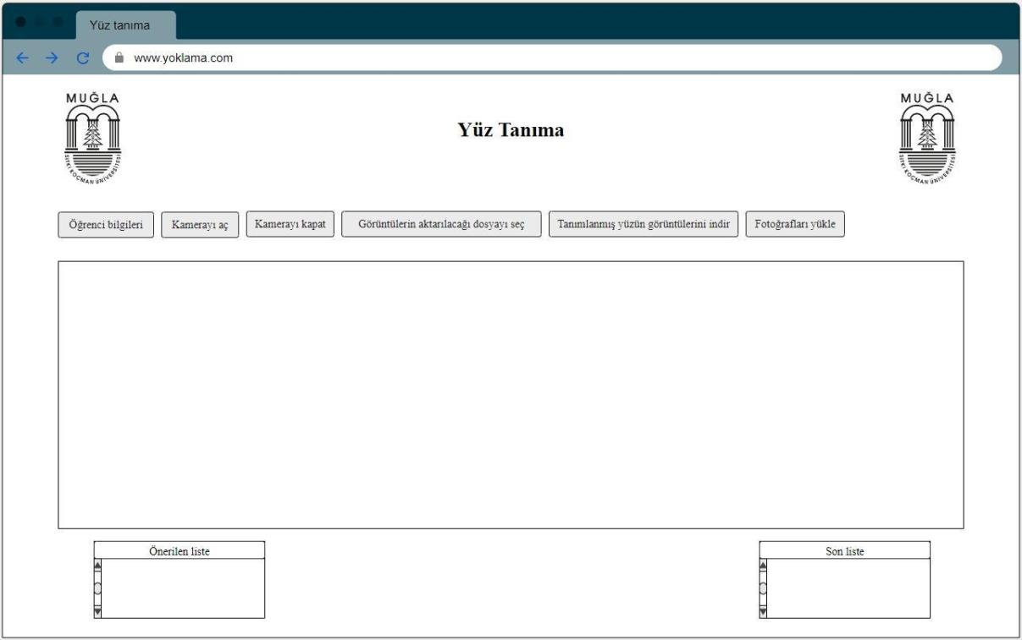

First we need to enter the training data. Training data should include facial images of people in the organization they are members of. Several images are required for each person to be saved in the database as training data. People's images are in their own folder, and all folders are in another folder selected as training data.

After training data entry, the camera is activated by pressing the camera start button and the face detection of each detected person is performed with the Viola-Jones algorithm. By identifying the designated person, a list of identified people is saved in the Excel file. This file is saved by pressing the camera close button and attendance-absence control can be made based on this file.

Additionally, this program has the ability to classify images. That is, an image is given to the system and the faces in the image are identified and detected. Then the program creates a list at the bottom. The user identifies the images in each person's folder by using or editing the list.

At this stage, some pre-processing should be applied to the image because the input image may be a little fuzzy. These pre-treatments are explained in the appendices.[3]

If the organization member wants to register via personal computer, she can use the interface below.

page5image17835776

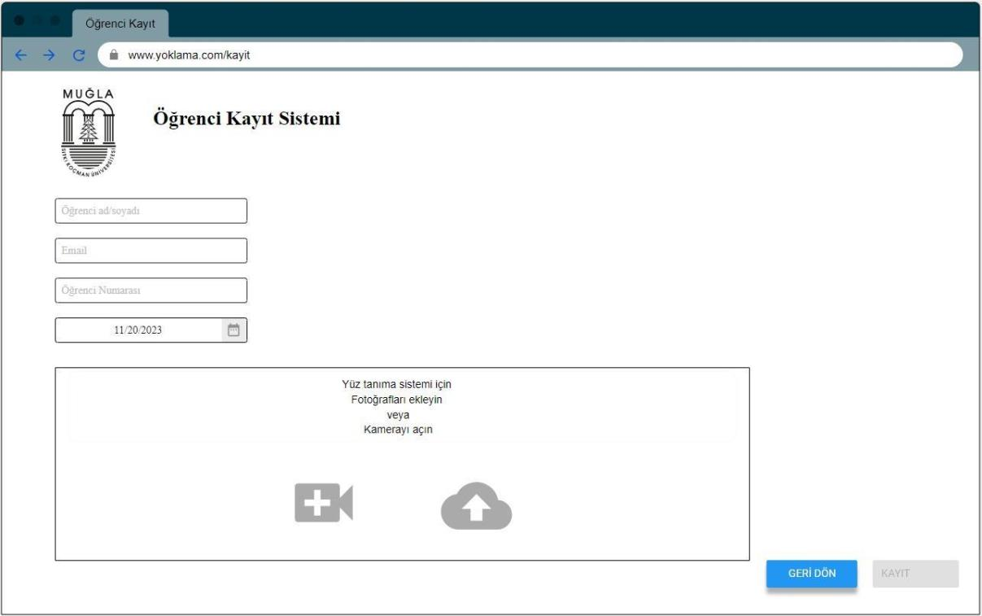

In this way, the student enters her personal information and can then upload and record either via her computer camera or her photo from the file.

Floachart

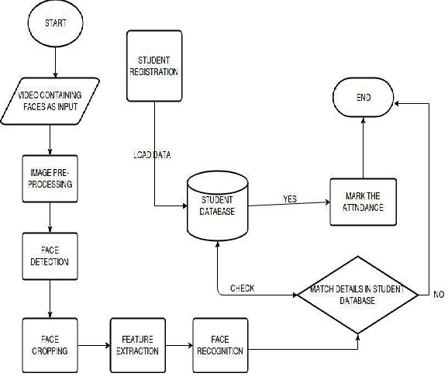

1. **References**

[1] Trahanias, P. E., & Venetsanopoulos, A. N. (1993). Vector directional filters-a new class of multichannel image processing filters. IEEE Transactions on Image Processing, 2(4), 528-534.

[2] Chen, T., Ma, K. K., & Chen, L. H. (1999). Tri-state median filter for image denoising. IEEE Transactions on Image processing, 8(12), 1834-1838.

[3] Chen, T. C., & Chung, K. L. (2001). An efficient randomized algorithm for detecting circles. Computer Vision and Image Understanding, 83(2), 172-191.

[4] https://www.deputy.com  
[5] https://www.zoomshift.com  
[6] https://quickbooks.intuit.com/global/