**Northern Trust Hackathon solution – Team8**

**This is a website which is useful for analyzing stock data.**

**Technology is used: HTML,CSS,JAVASCRIPT, JQUERY**

**RUNNING THE SOLUTION IN LOCAL MACHINE**

* **Add Live-server Extension to the Vs code editor**
* **Open the team8 folder in vscode and run “inder.html” file with live server.**
* **After that you can navigate to any other page.**

**Things which are included in the application.**

**Homepage – Dashboard**

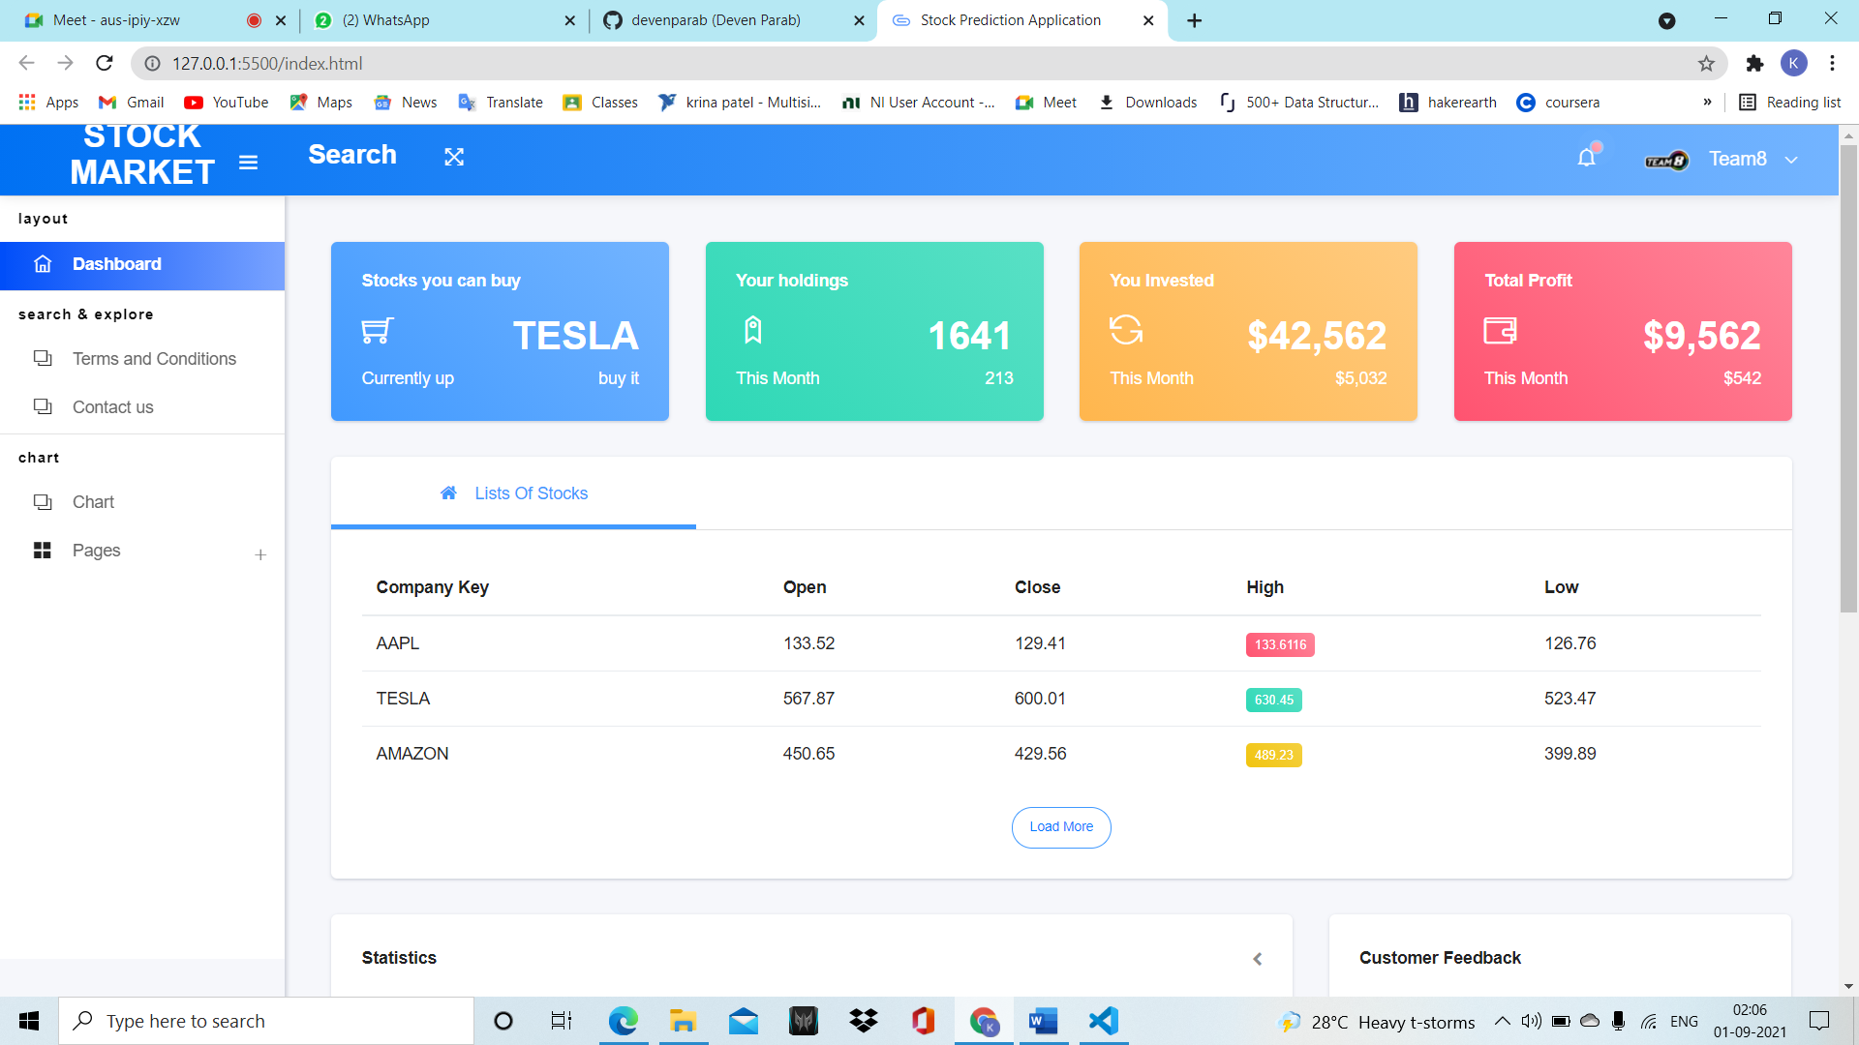

**This is our Homepage.**

**In which we added one navigation bar.**

**When you click on three slipping line logo it will open dashboard which has some options like terms and conditions, contact us, show chart details etc. There Is one another option which is pages, when you click on it ,it gives you option to sign in and register in it.**

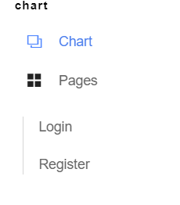

**Now moving on a navigation bar,**

**As when you click on search option it will redirect you to search window.**

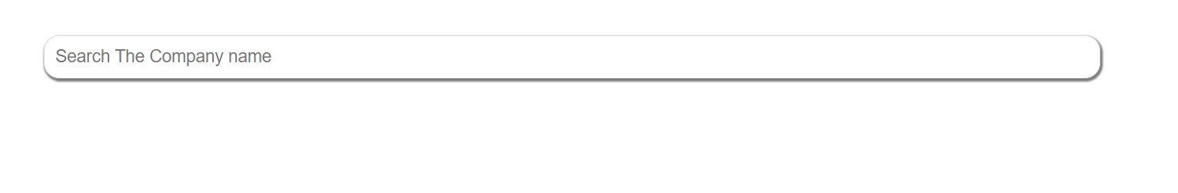

**And here you can search any company name for predicting stocks.**

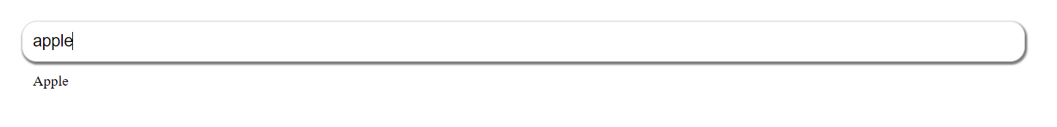

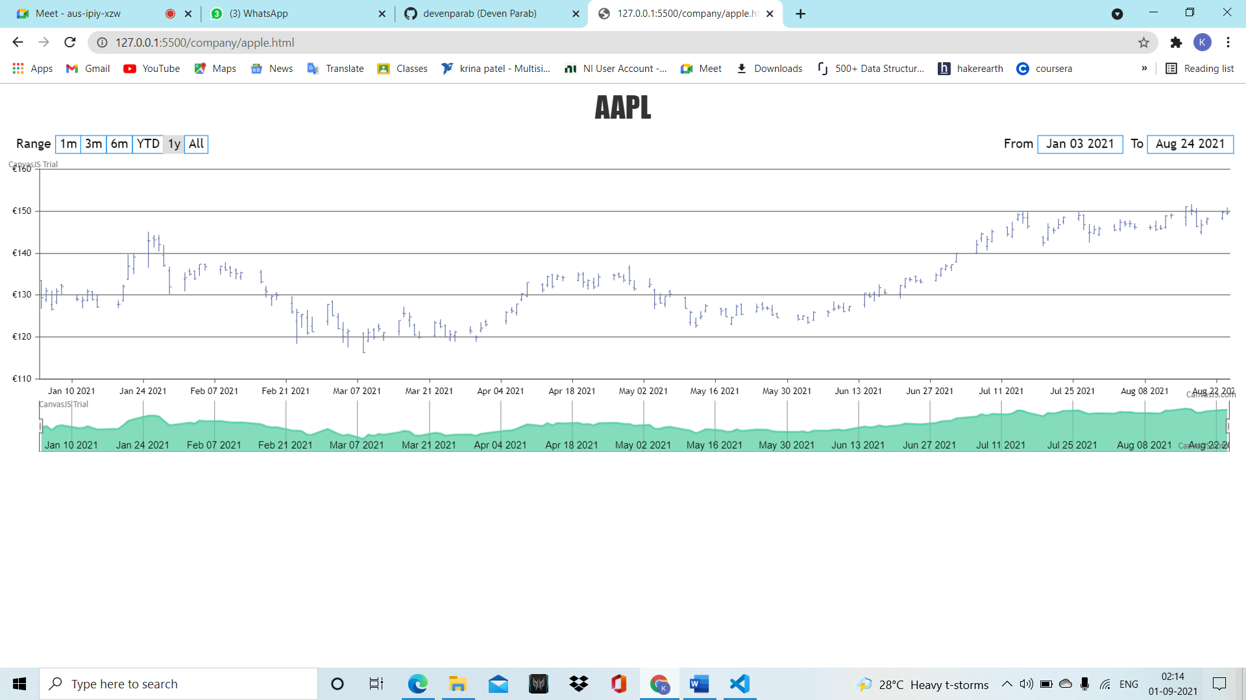

**It will show you the graph of that company stocks.**

**User can filter it will real-time stamp.**

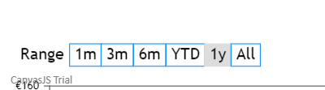

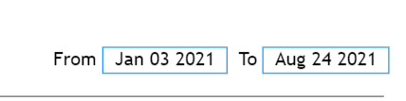

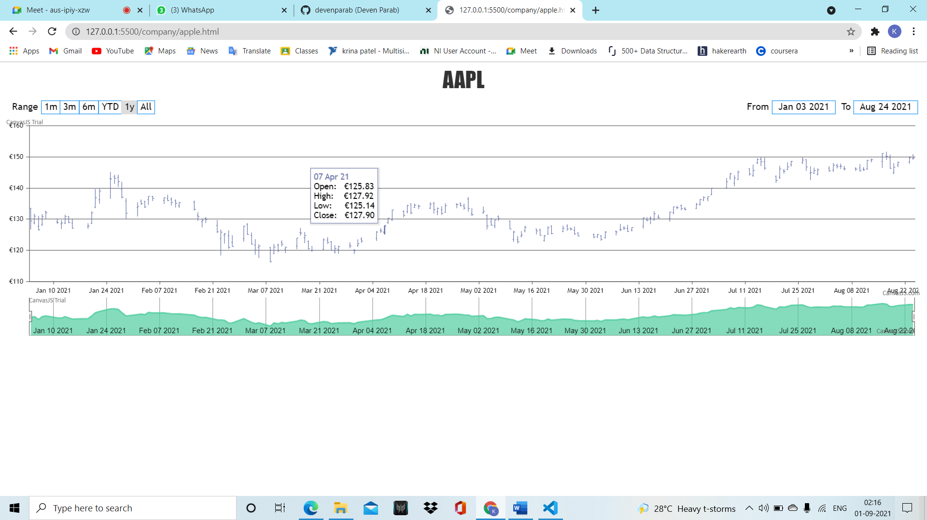

**So using search window user can see any company’s stock performance.**

**Again back to the dashboard ,**

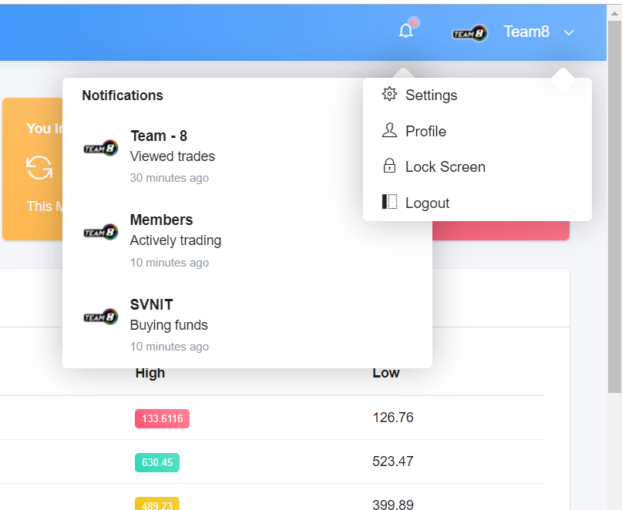

**At right corner, it stores user information.**

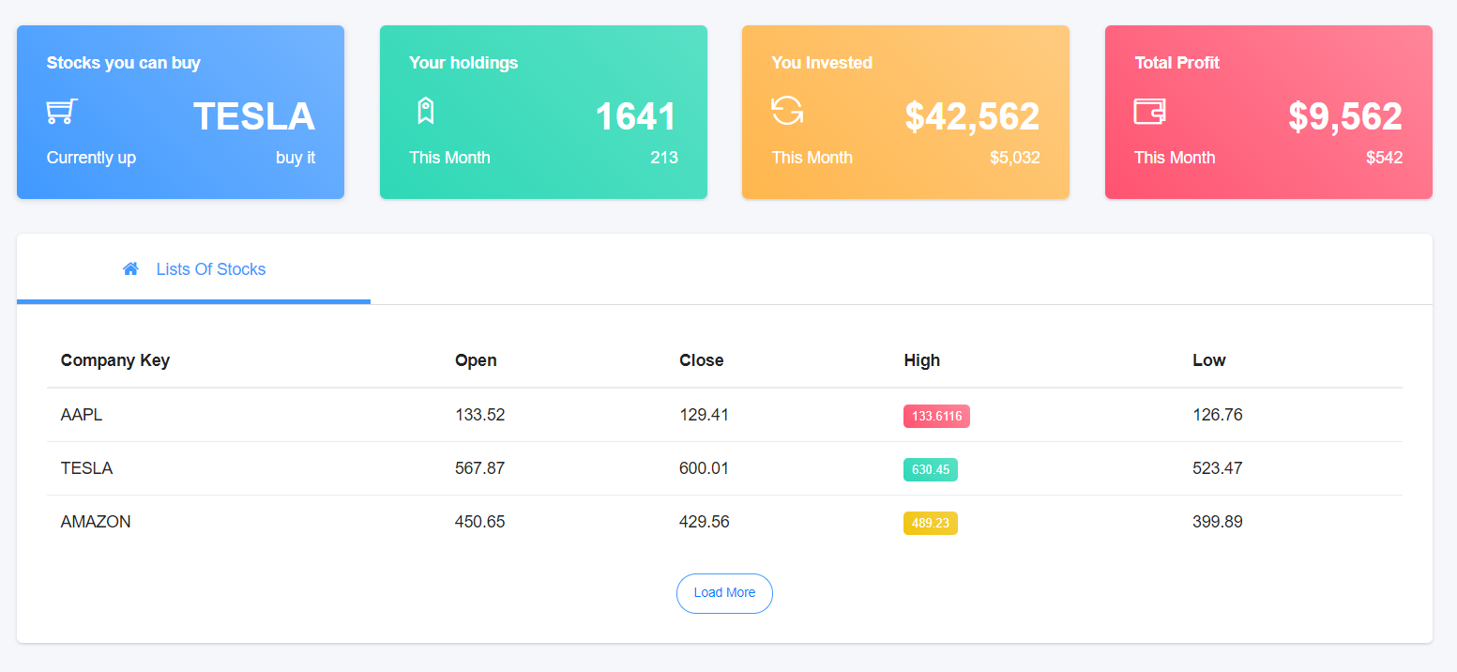

**At the body part, it shows list of stocks, so that user can find**

**Company name for investing in stock.**

**Now, when I got on a search bar it shows me my previous search history as preferences**

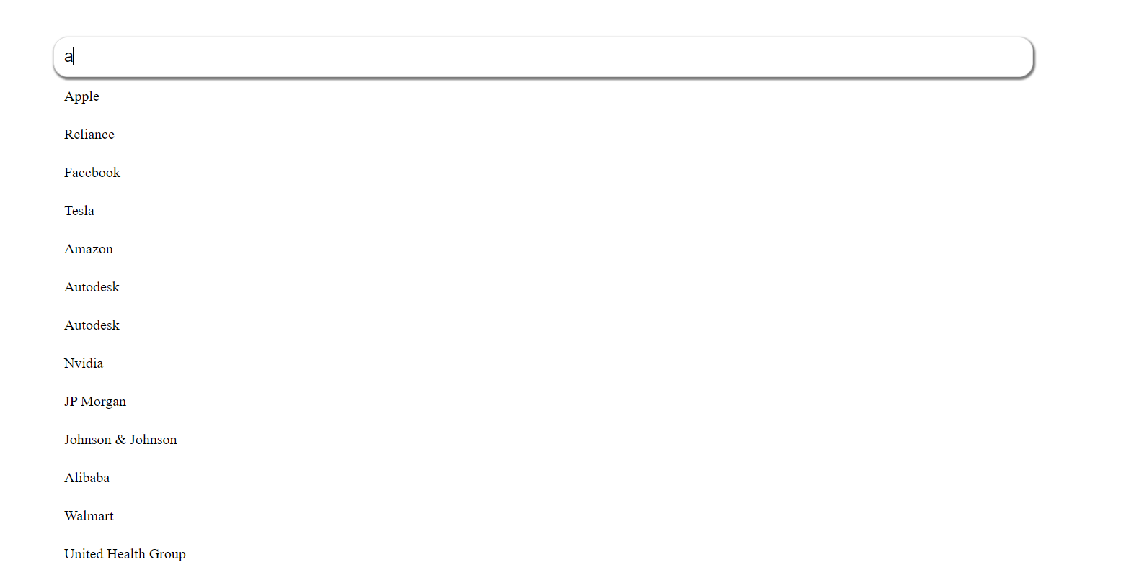

**Now when you click on chart it will direct user in chart guide page**

**In which user can select any chart**

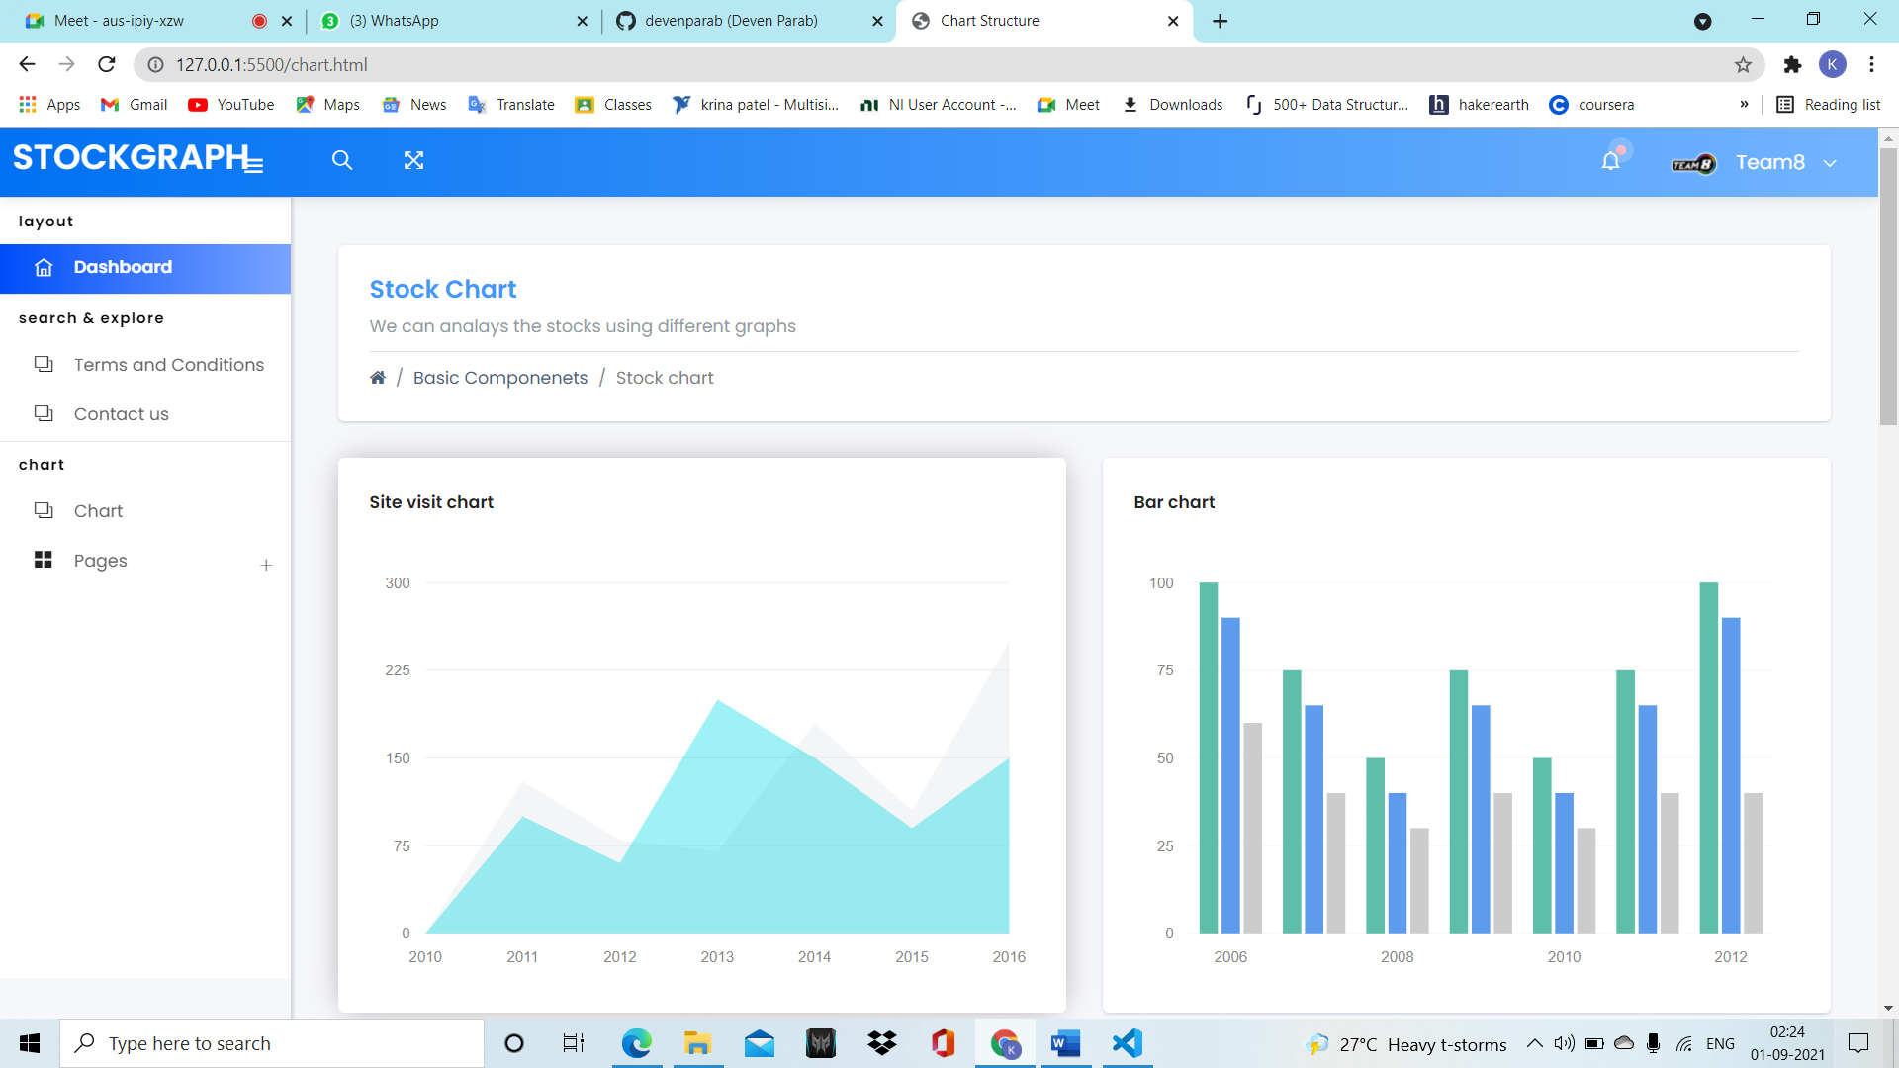

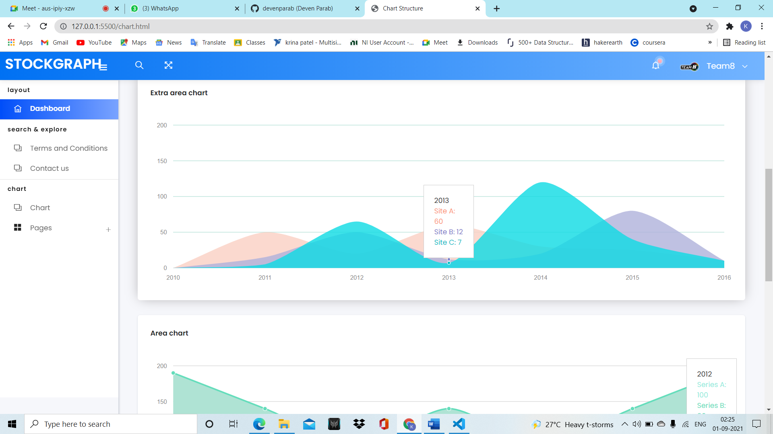

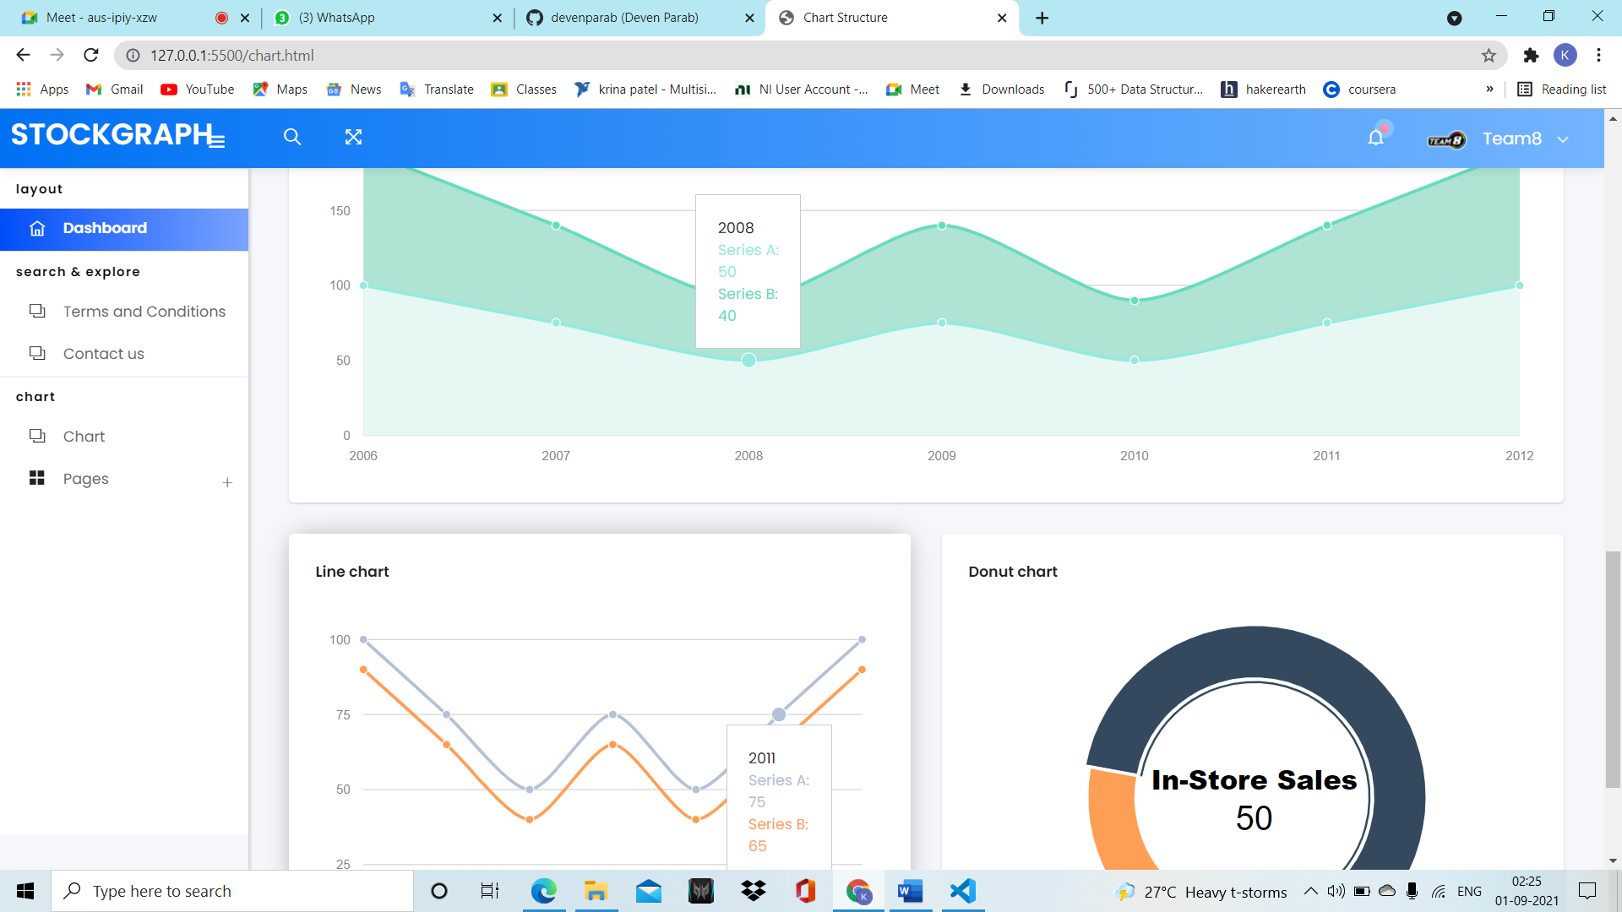

**Additional information**

**Terms and Conditions**

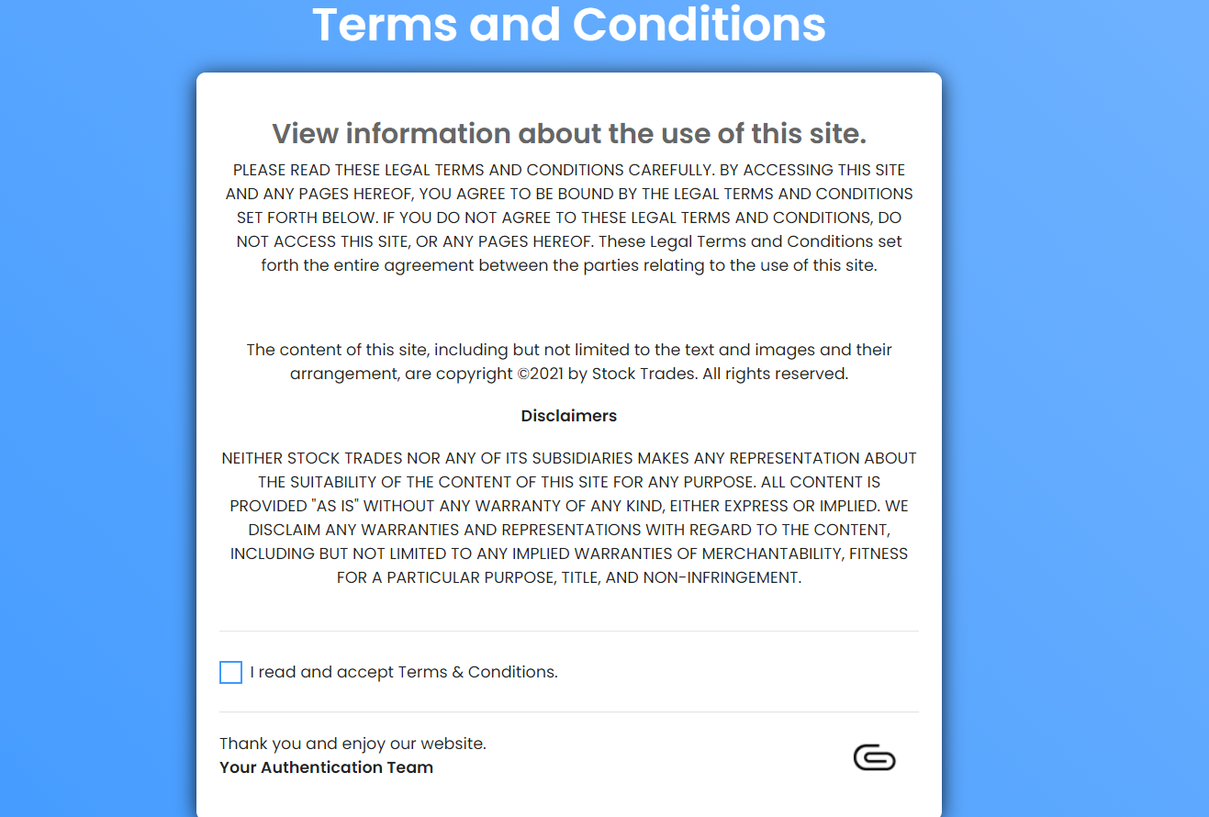

**Contact us**

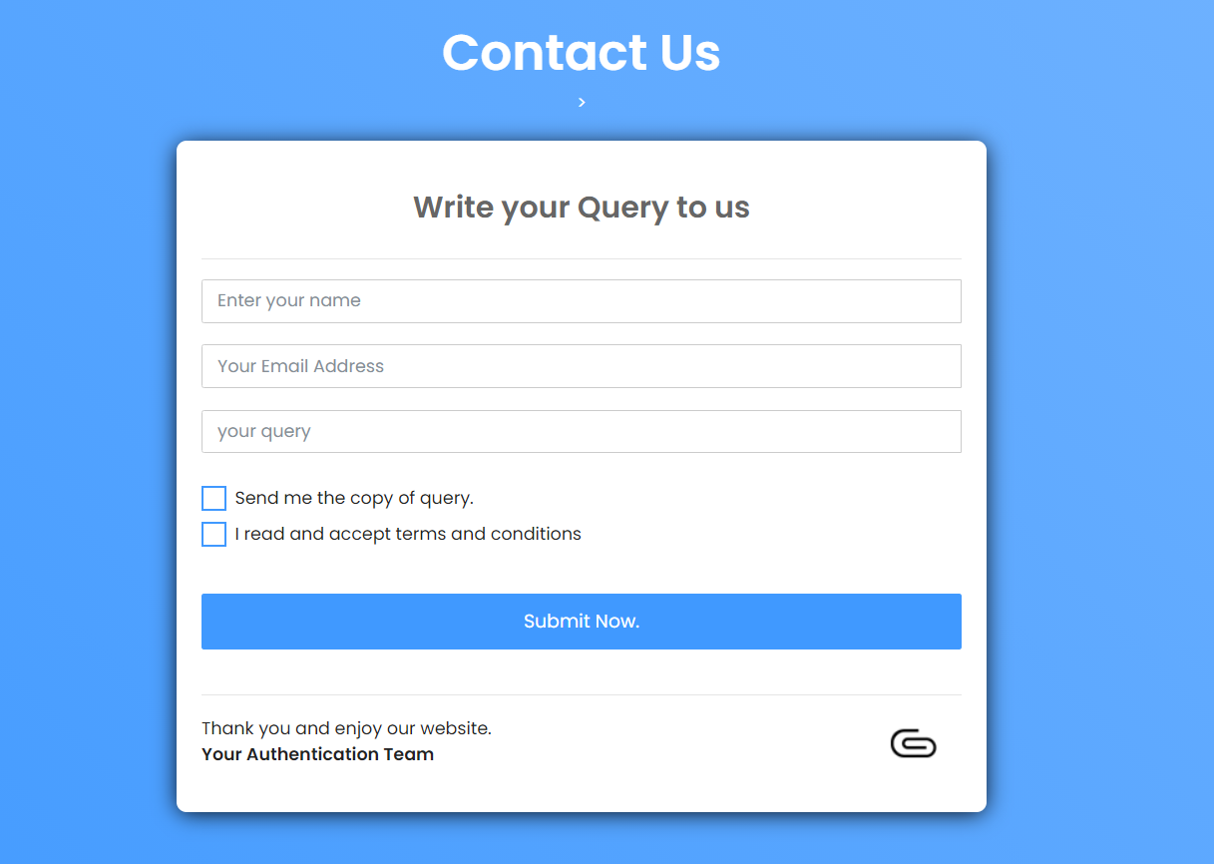

**Sign in**

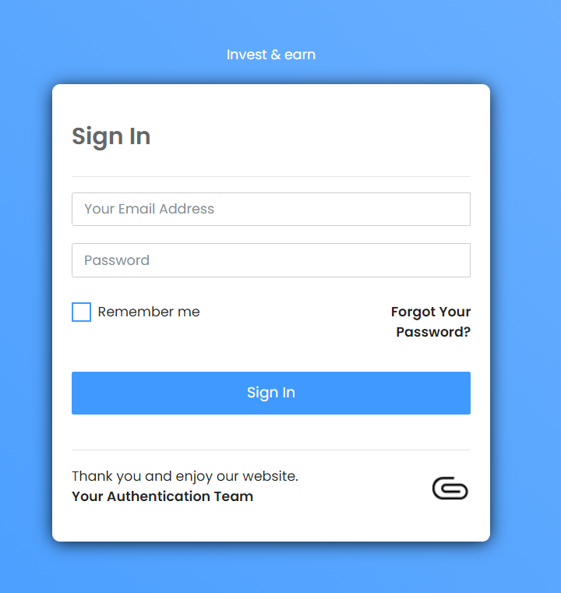

**Sign up**

