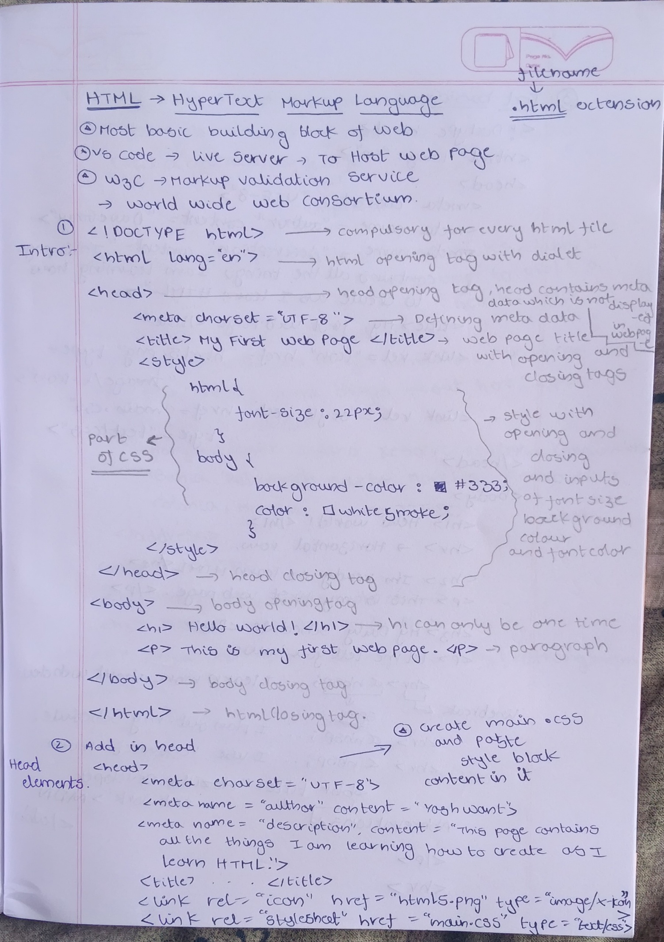
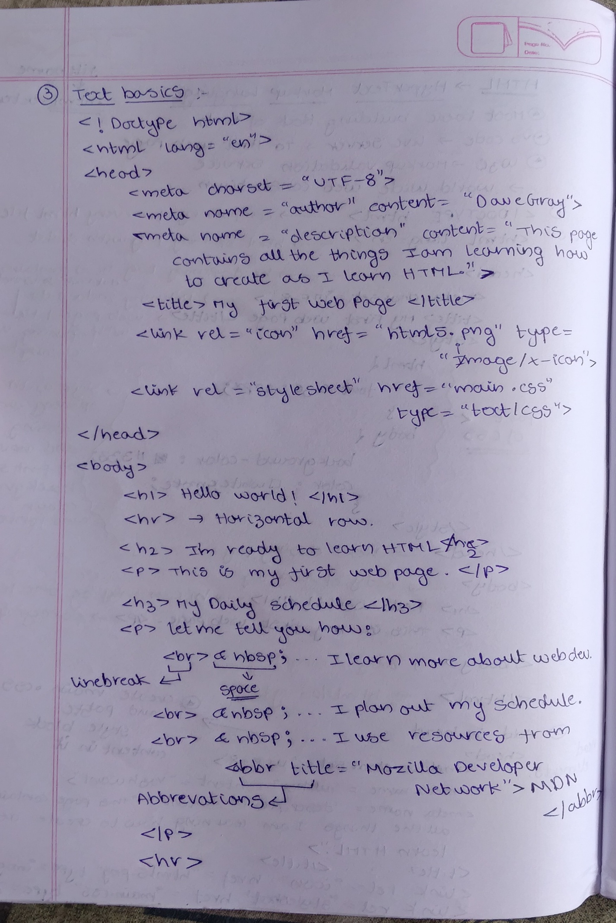
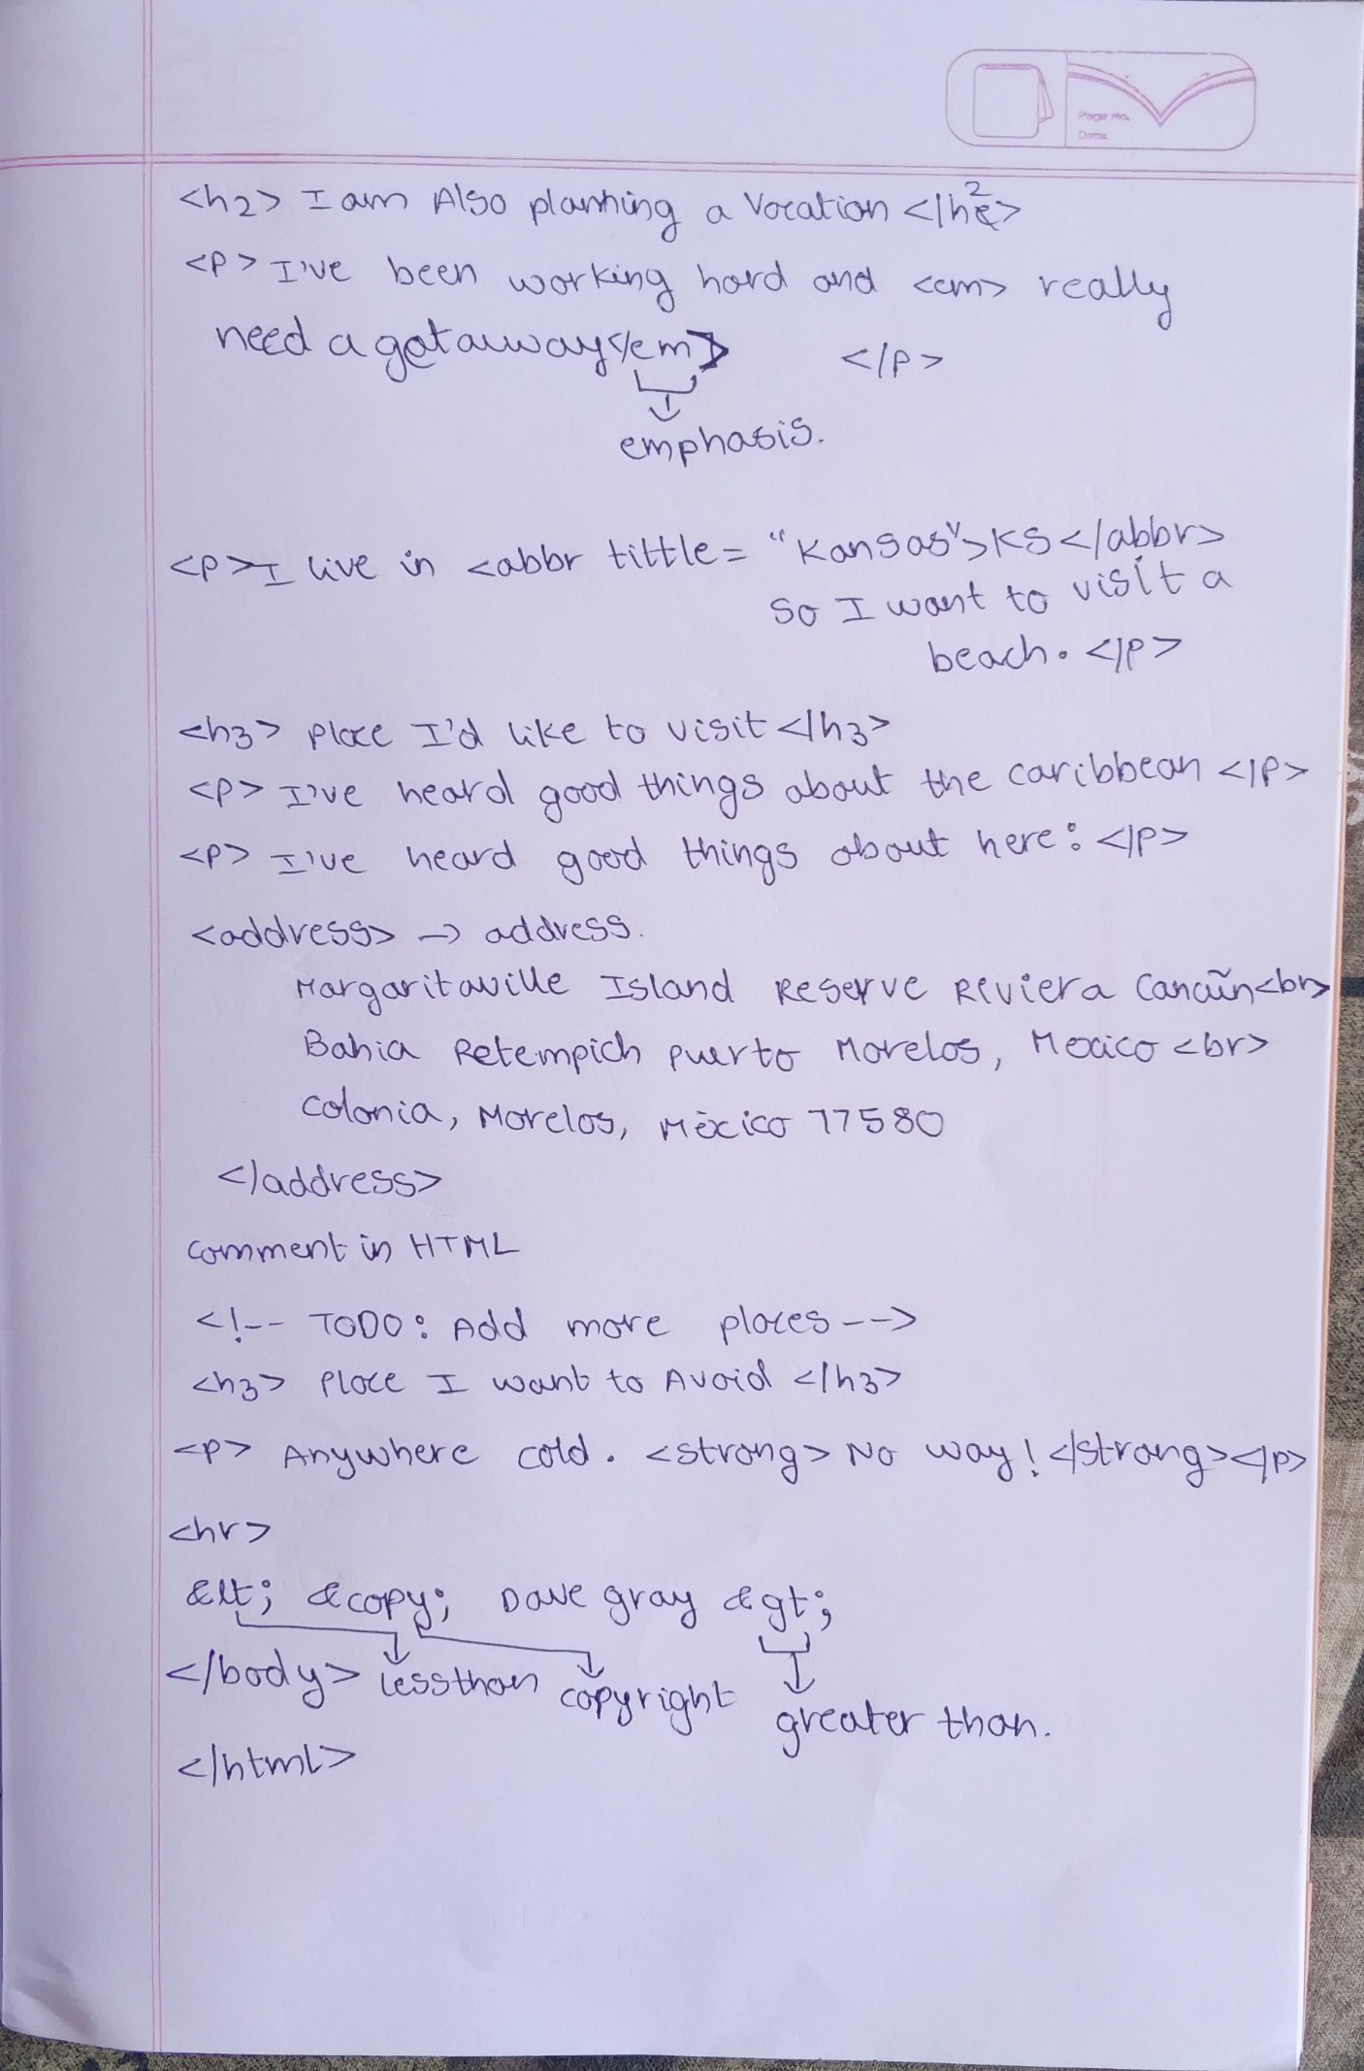

Lists:
1.ordered list<ol></ol> this has numbered items
2.unordered list<ul></ul> this has bullet points
3.descriptive list<dl></dl>
This has two terms:
1.<dt></dt>description term
2.<dd></dd>description details

Adding links:
The CSS file is modified at this lesson for links appearance
<a></a>: anchor tag is used to add links
Relative reference: something in the same server
Absolute reference: not in the same server anywhere in the web
Adding another page link in the home page
Internal reference: link to any section of the same page
<section></section>: to create sections and assign them an Id
<nav></nav>: used to navigate to sections based on their iDs<a href=”#section ID”>name</a>
<a href=”#”>back to top</a>
We can add more links like download, email, phone and external link to any website
<a href="/">Back to home</a>

Adding images:
<image>: this tag is used to add images
Has multiple attributes like scr: source, title, alt: this text appears if the images has problem, height, and width ,loading: loading=”lazy” helps the page load faster
Image tag doesn’t need closing tag
<figure></figure>: adds the image in a figure section as element
Image is not only the figure we can add <code></code> tag also
<figcaption></figcaption>: gives the text below the image
Always use licenced images in the web site
Use placeholders for the image we will get later and edit the images to required format.

Semantic tags: we can’t have any of these more than one in single page if we want to do so we need to name them
<header></header>: heading area with real meaning rather than visual representation
<h1></h1>: main heading
<main></main>: main area of the page which has main content
<footer></footer>: ending area of a page
<nav></nav>: can be named. Using <nav aria-label=”name of the navigation”>
<section></section>: we already know that section tag can be named using ID
<article></article>: used instead of sections bcuz it has a clear topic whereas section is more generic
<aside></aside>: complimentary text not important as the article
<details></details>:this works together with summary tag
<summary></summary>: hide the info and displays when clicked used to display any product display or ask any questions and display answer later
Use <p></p> out of summary for this
<mark></mark>: used to highlight the text
<time datetime=”time/PT3H”></time>: used for assistive technologies to understand time for time and PT3H for duration
<div></div> and <span></span>: avoid these tags bcuz they have no sematic meaning in html but r used in CSS

Create tables: CSS file has been edited for this chapter to create tables
<table></table>: table tag
<tr></tr>: table row
<td></td>: table data
<th></th>: table header
<thead></thead>: table header section for semantics
<caption></caption>: adds table caption
Rowspan and column span can be also used
<tbody></tbody>: table body section for semantics
To add headings to the rows also we need to go to the header section and type
<th>&nbsp;</th> the code in the tag is an html entity
We should give the <th scope=”row/column”> a scope for better semantics

