Diagram Layer 1:
First, the big picture — what actually happens end to end:
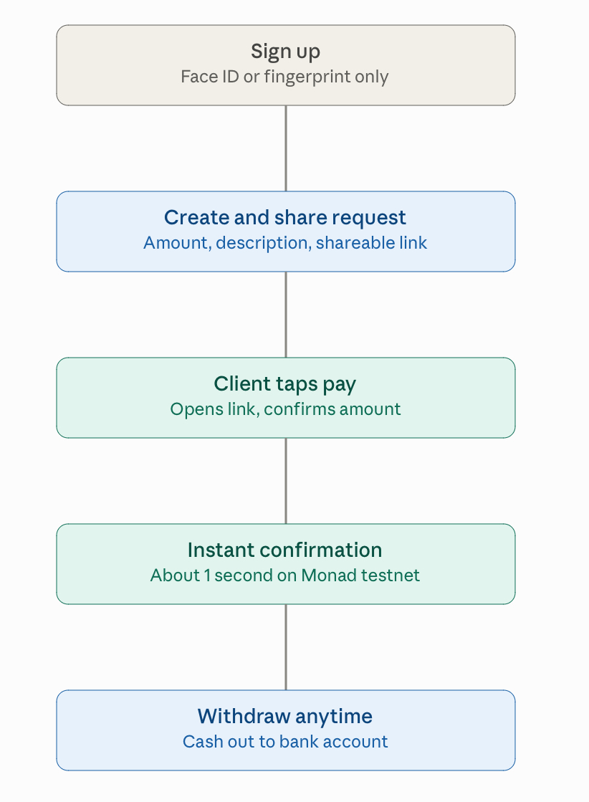

Diagram Layer II:
That's the surface — what your users actually experience. Now let's zoom into the single most important moment in that flow: what really happens, technically, in the second between "client taps Pay" and "confirmed."
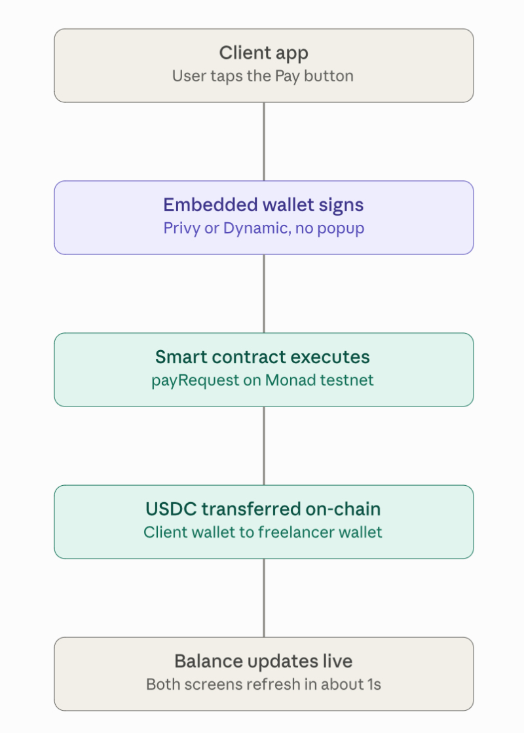
Custody note (resolves a possible reading of the diagram above): "USDC transferred on-chain: client wallet to freelancer wallet" means a direct, non-custodial transfer — the smart contract never holds or escrows the funds itself. `payRequest` calls the USDC contract's transfer function straight from the payer's embedded wallet to the freelancer's embedded wallet in the same transaction. "Balance" on the Home and Wallet screens is simply the freelancer's own USDC token balance (read via `balanceOf`), not an internal ledger inside the payment contract. This keeps the contract stateless with respect to custody and removes an entire class of escrow/reentrancy risk — see the PRD's Smart Contract Scope section, which has been updated to match.

Diagram Layer III:
That's the sequence for one payment. Now zoom out one more level to see how the three big pieces of the system — what the user sees, what your server does, and what the blockchain does — actually sit on top of each other:

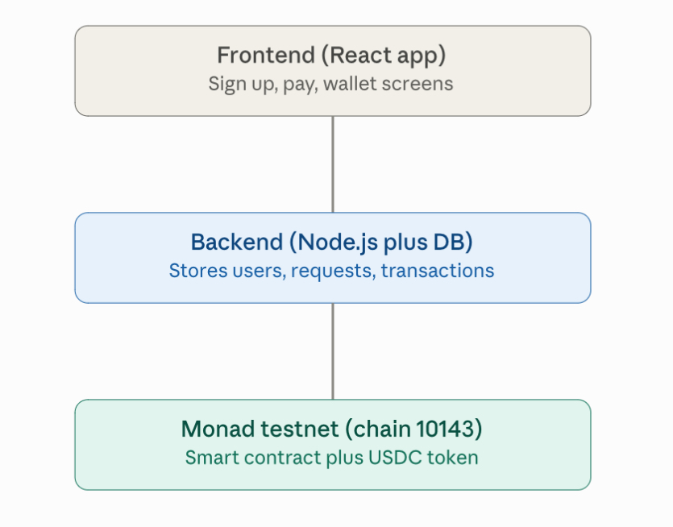
Note on the activity list: since the contract holds no internal ledger, the Wallet screen's chronological activity list (payments, tips, withdrawals) is populated by the backend listening for `Transfer`/`payRequest` events emitted on-chain and reconciling them against the Postgres `Transaction` table — not by a contract-side read. Given the 18-day window, simple short-interval polling of recent blocks for the relevant contract/token addresses is enough; a full indexer is not required for the demo.

