Overview diagram -

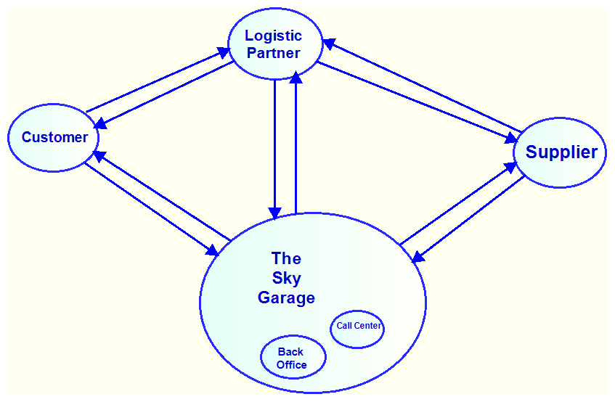
Customer registration via web portal -

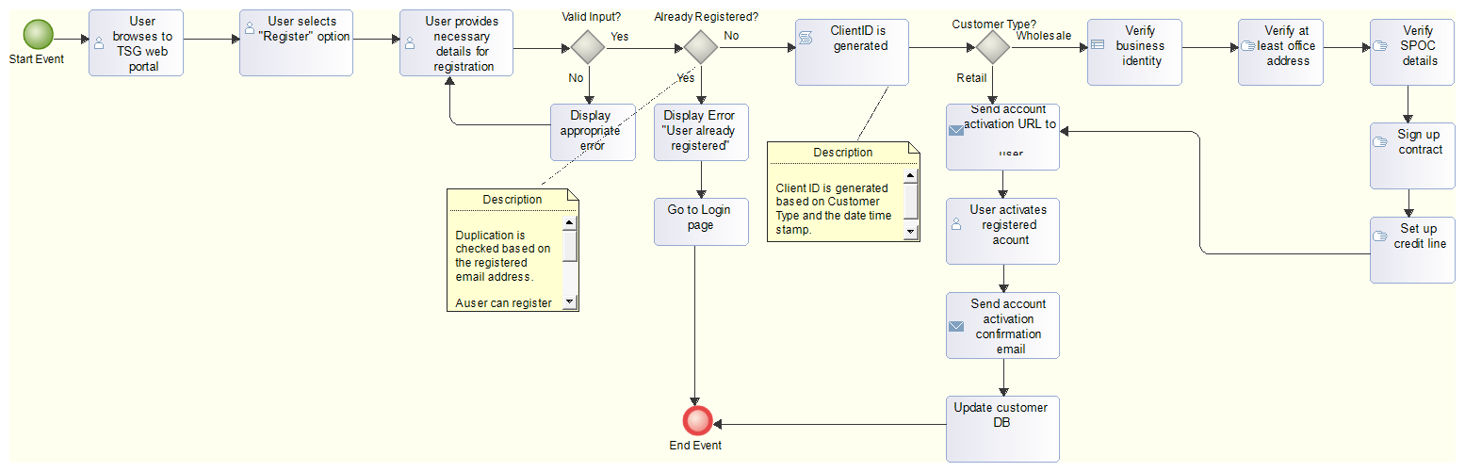

Customer registration via mobile -
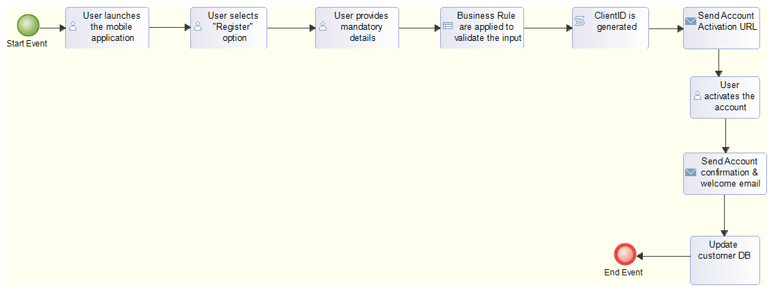

Customer order -
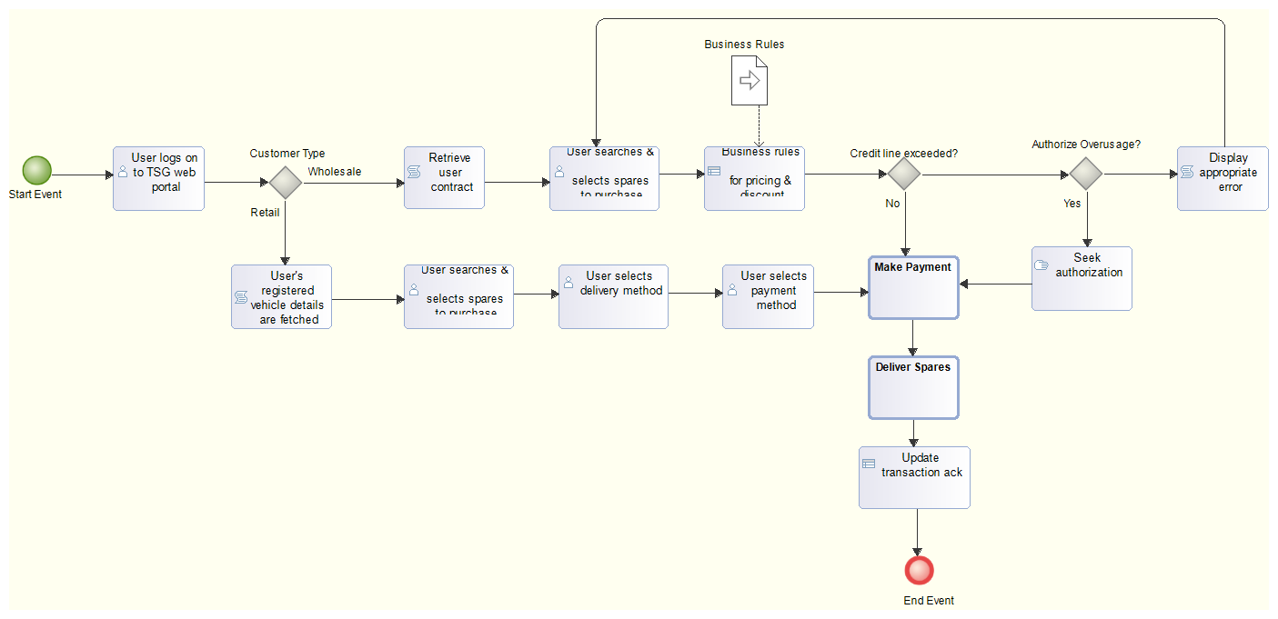

Password reset -
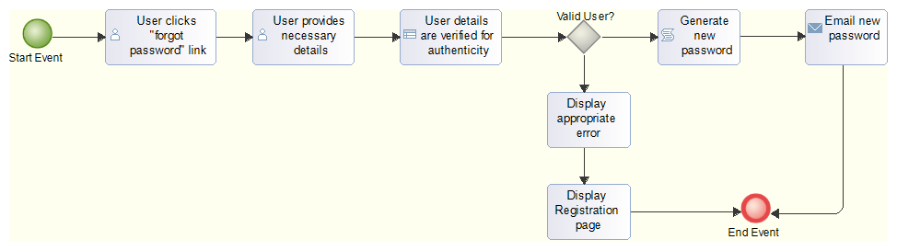
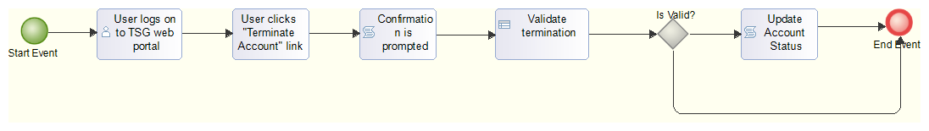
Delete Customer Account -
Update Customer Profile -
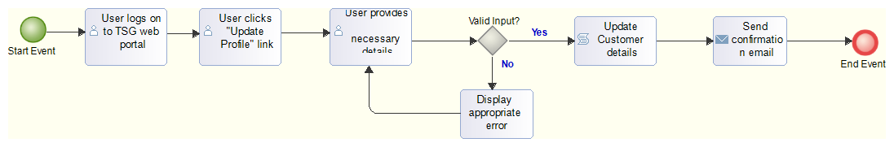

Online Service Booking -

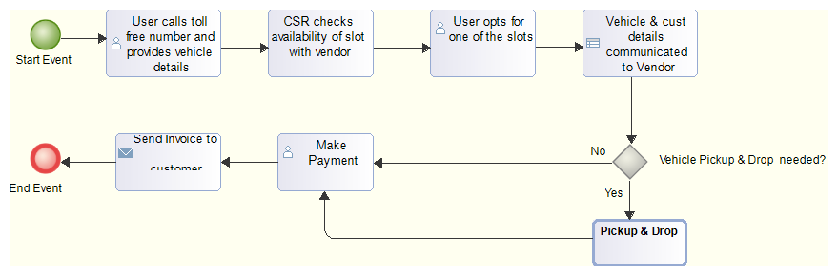

Request for Breakdown Service -

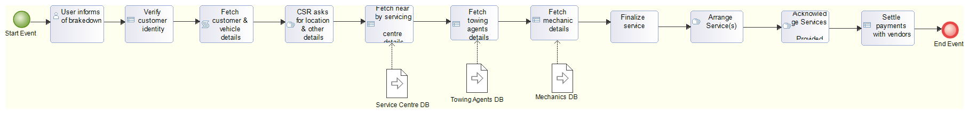
Vendor interactions -

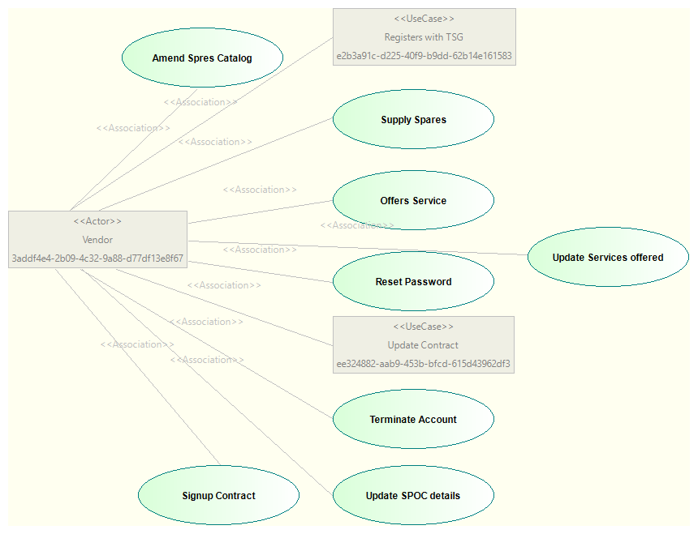
Vendor use cases -Website Administrator's use cases -

