Training Dataset Report

Prepared By – Mandar Vilas Ukrulkar / 24-07-25

Name: dataset_v16v2_200726.clean.jsonl
Model target: Qwen3.5-4B financial-table-structure analyst (LoRA fine-tune, teamspace_uploads_Qwen3.5-4B_v16v2_clean_dataset_220726_3epochs)
Dataset file: dataset_v16v2_200726.clean.jsonl (6,109 records, ~105 MB)
Source corpus: C:\Users\mandar.ukrulkar\Downloads\data_raw_in_out_jsons_200726\output (the exact job-output snapshot used to build the dataset)
Report generated: 2026-07-24

1. Executive summary
Metric | Value
Source documents processed | 249 unique financial-statement documents (+3 re-run twice, +1 non-classification QA job)
Total tables detected by the parser | 19,821
Tables classified as *financial* (candidates for labeling) | 6,260
Tables skipped as non-financial (TOC, prose, boilerplate) | 13,532 (68%)
Labeled input/response pairs found on disk | 6,290 (6,289 with a matching response — the one unmatched input is correctly excluded)
Raw compiled dataset (dataset_v16v2_200726.jsonl) | 6,289 records — exact match to the source corpus
Final clean training dataset (*.clean.jsonl) | 6,109 records
Removed by de-duplication | 180 records (2.9%)
Distinct table_type label strings | 2,232 (long-tail, free-text-ish taxonomy)
Median table shape | 11 rows × 4 columns
Median prompt / completion length | 2,225 / 9,035 characters
Fine-tuning method | LoRA (r=32, alpha=64) on Qwen/Qwen3.5-4B, 1× NVIDIA L4 GPU
Training run | 3 epochs / 384 steps, effective batch 48, ~14.7 hours
Final training loss (epoch 3 mean) | ~0.027 (down from ~4.3 pre-warmup)

The training set is built from real financial-statement tables (10-Ks, 20-Fs, annual reports, insurance/bank filings) extracted and pre-labeled by an Azure LLM pass, then compiled and de-duplicated for supervised fine-tuning of a smaller local model to imitate that labeling.

2. How this report was produced
Two data sources were combined, per explicit instruction to use only these two locations:
- Source job outputs — C:\Users\mandar.ukrulkar\Downloads\data_raw_in_out_jsons_200726\output (253 job folders), each a UUID directory containing one job.json (document metadata) plus one classify_tbl-N_input.json / classify_tbl-N_response.json pair per financial table. This is the exact snapshot dataprep_140726.py compiled from.
- The compiled training files — dataset_v16v2_200726.jsonl (raw, via dataprep_140726.py) and dataset_v16v2_200726.clean.jsonl (de-duplicated, via dataset_clean.py), analyzed directly for the EDA in §5.
Provenance check: the source folder contains 6,290 _input.json files, of which 6,289 have a matching _response.json (the one unmatched input is correctly skipped by dataprep_140726.py's pairing logic) — an exact match to the 6,289-record raw dataset. Unlike an earlier pass of this report (which reconstructed provenance from a different, partially-reorganized pair of folders), §3 below reconciles precisely with the compiled dataset — no representativeness caveat needed this time.

3. Source corpus

3.1 Job-level overview
Total processing jobs | 253
— classification jobs (ai_provider: azure) | 251
— non-classification QA/extraction jobs (no labeling) | 2
Unique source documents | 249 (+3 documents each re-run through the pipeline twice)
Tables per job (table_count) — median / mean / max | 64 / 79.0 / 691
Financial tables per job — median / mean / max | 11.5 / 25.0 / 222

Every classification job used the same pipeline configuration (ai_provider: azure, classified: true). The two non-classification jobs were extraction-only test runs (classify_table: false) against the same QA file and contributed zero labeled tables.

3.2 Documents by number of labeled financial tables
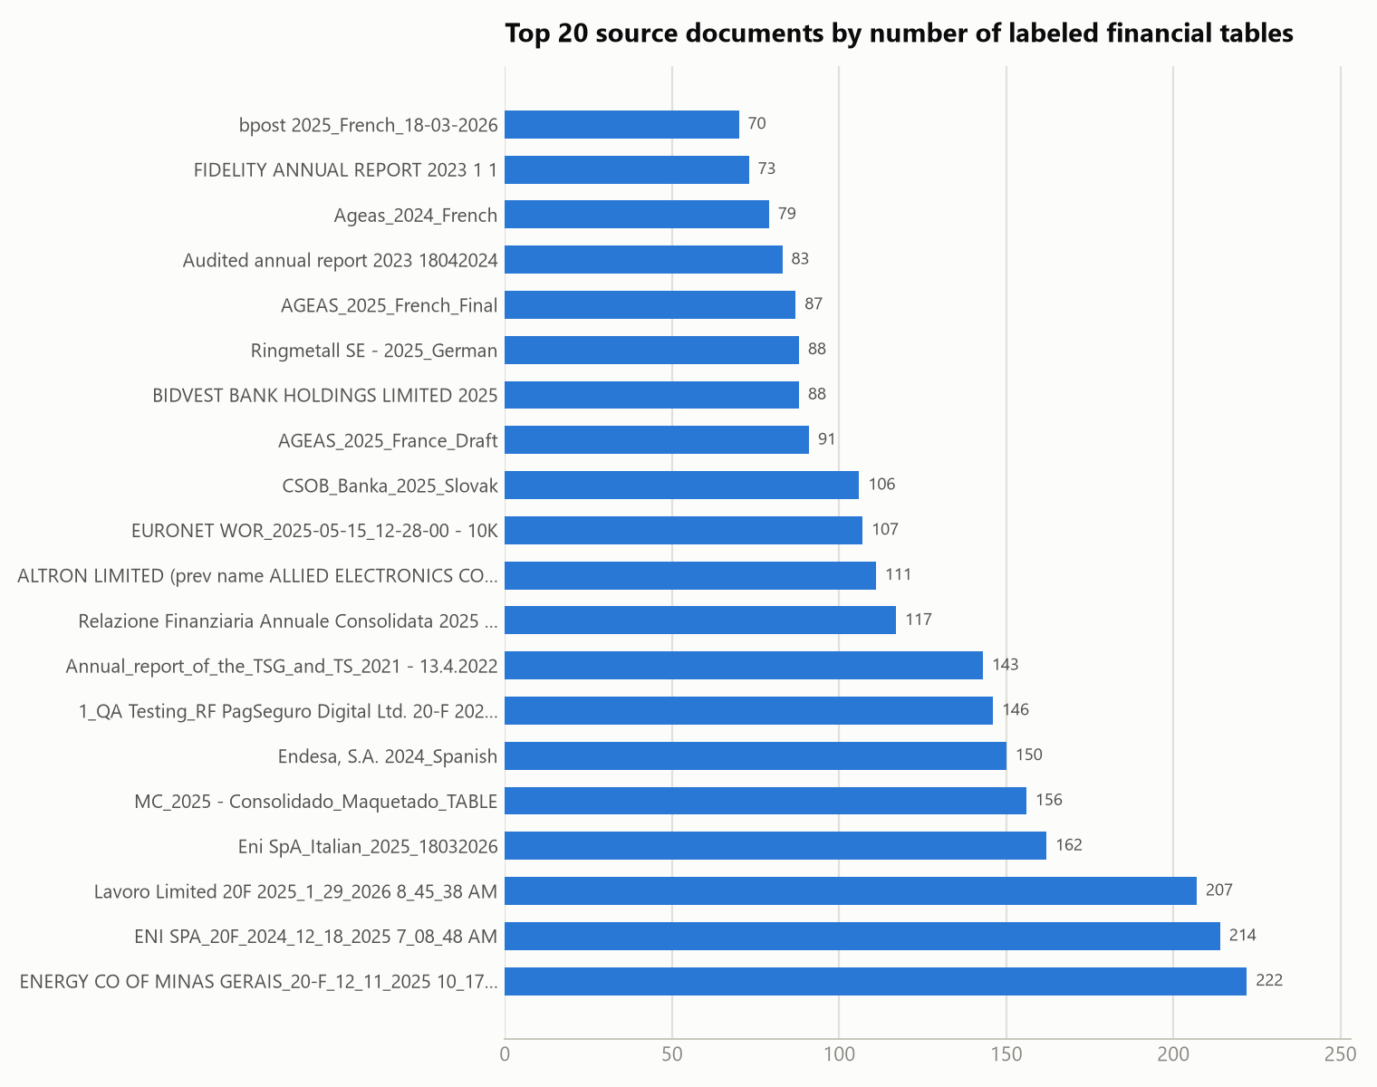
The corpus is dominated by long-form annual filings — 20-F filings and full annual reports (Eni, ENI SPA, Lavoro, Energy Company of Minas Gerais, Endesa, MC Group) each contribute 150–222 tables, an order of magnitude more than a typical single-country statutory filing (~10–30 tables).

3.3 Table-count distribution across the corpus
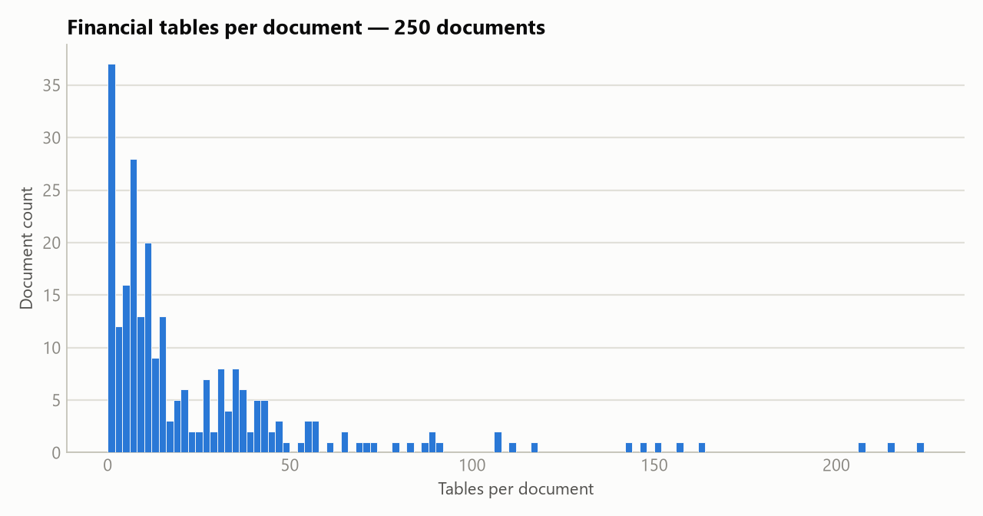
Heavily right-skewed: 62% of documents (156 of 250) contribute fewer than 20 financial tables; a long tail of 12 large multi-jurisdiction filings each contribute 100+.

4. From source tables to training set
Parser output (job dirs) 19,821 tables detected
└─ financial-table filter → 6,260 tables classified as financial
└─ dataprep_140726.py → 6,289 (prompt, completion) records → dataset_v16v2_200726.jsonl
└─ dataset_clean.py (near-duplicate table_type resolution)
└─ 6,109 records → dataset_v16v2_200726.clean.jsonl ← used for training
dataset_clean.py resolves cases where the same underlying table appears twice with conflicting table_type labels (e.g. income tax reconciliation vs IncomeTaxReconciliation), keeping one side by confidence score. This removed 180 records (2.9%) from the raw compiled set. The clean file has a single, consistent completion schema across all 6,109 records: {table_type, rows, columns, cells}.

5. EDA — clean training dataset (6,109 records)

5.1 table_type label distribution
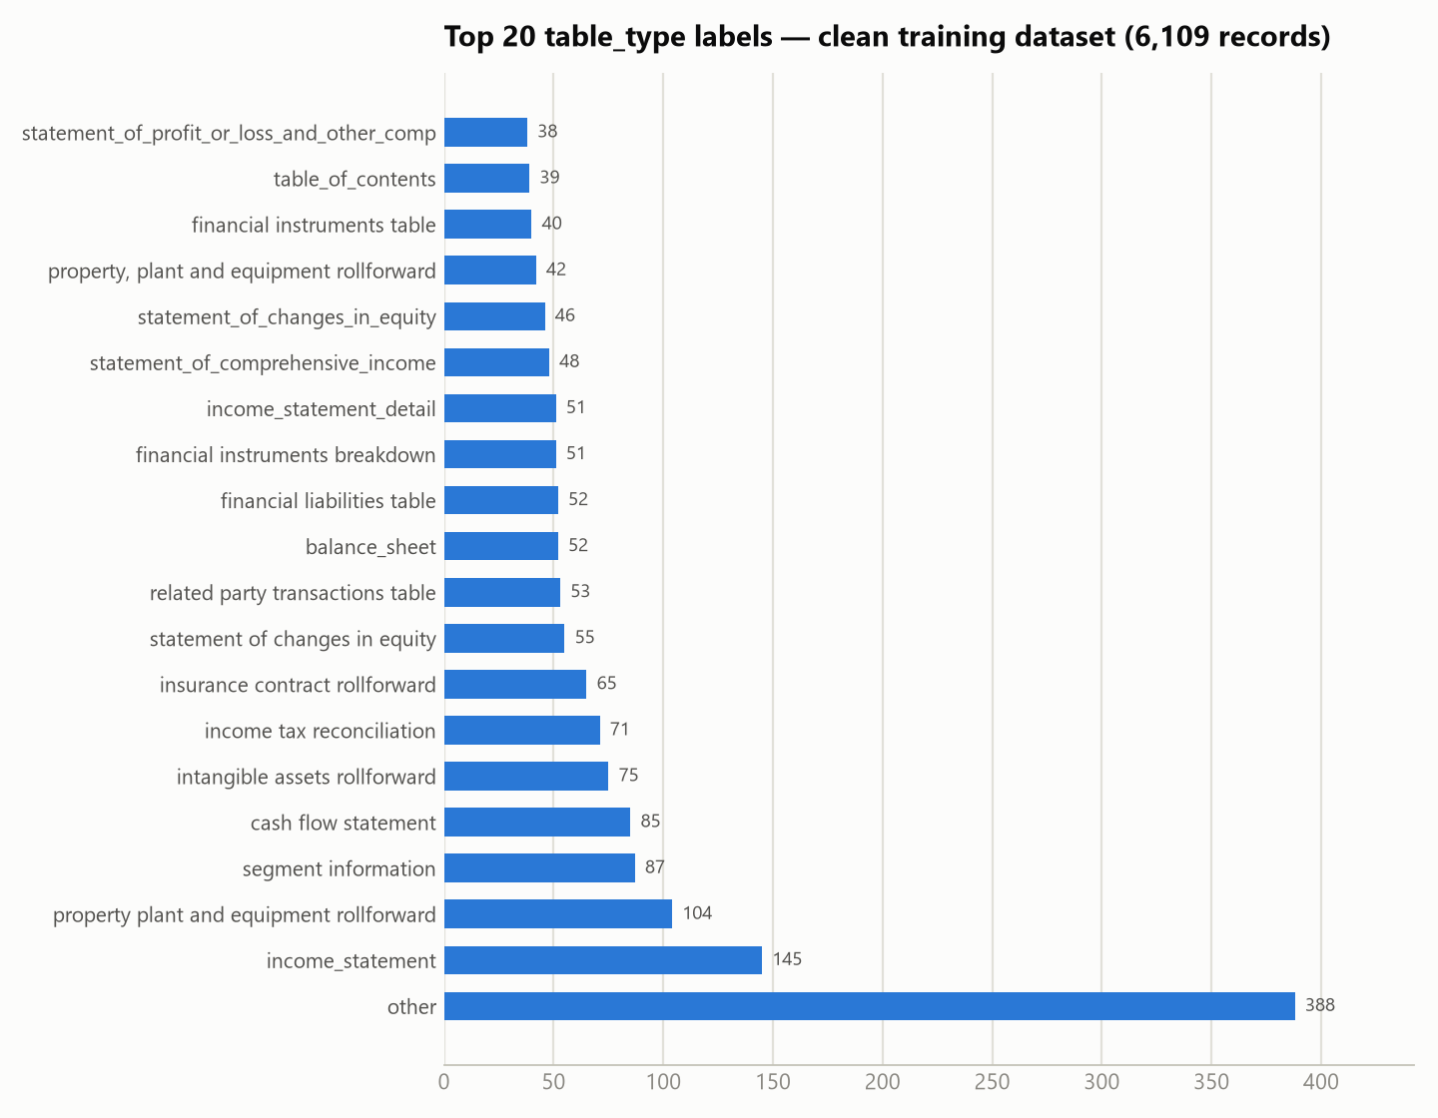
- 2,232 distinct label strings across 6,109 records — the taxonomy is effectively open-vocabulary/free-text rather than a fixed enum (the LLM labeler produces both snake_case and human-readable variants, e.g. both income_statement and income statement occur as separate labels).
- other is the single largest bucket at 388 records (6.4%) — tables the labeler couldn't map to a specific known statement type.
- Beyond the top ~20, the distribution has a very long tail: most distinct labels occur only 1–3 times, meaning the model sees very few examples for the majority of specific table types it's expected to recognize.

5.2 Table shape
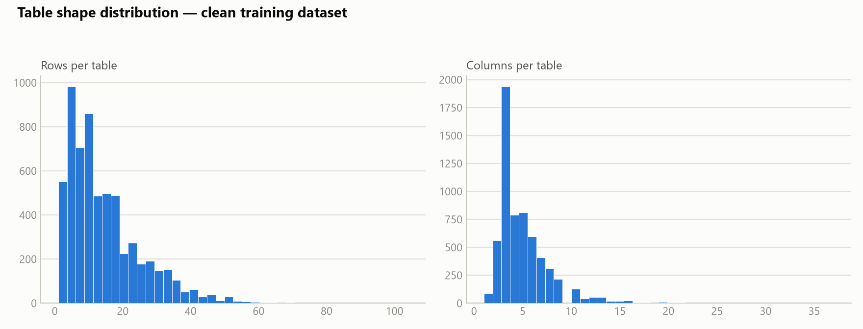
 | min | p25 | median | mean | p75 | p90 | p99 | max
Rows/table | 1 | 6 | 11 | 14.4 | 20 | 30 | 50 | 104
Columns/table | 1 | 3 | 4 | 4.9 | 6 | 8 | 16 | 37
Cells/table | 0 | 12 | 24 | 35.0 | 47 | 82 | 156 | 285

Tables are typically small (median 11×4 = 44 cells), but a long tail of wide/tall tables (segment breakdowns, multi-period rollforwards) reaches into the hundreds of cells — these drive the completion-length tail in §5.4.

5.3 Row and column semantic composition
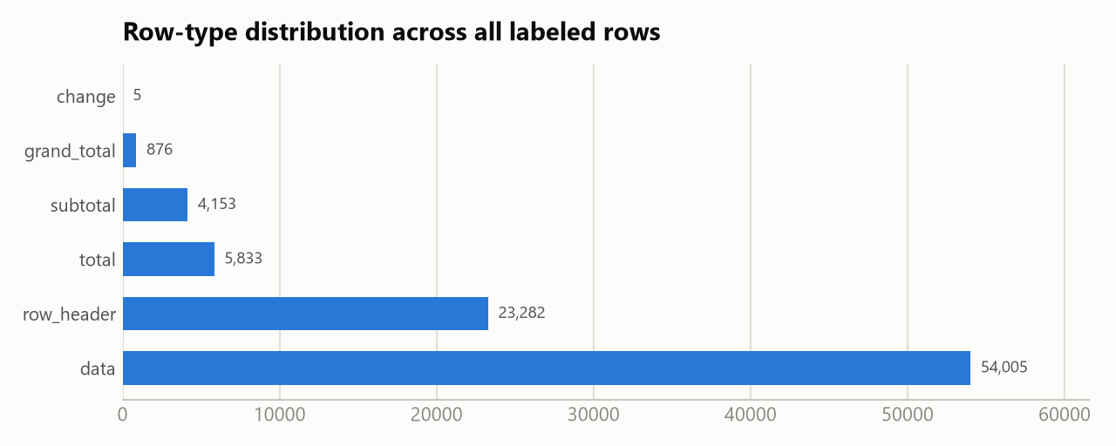
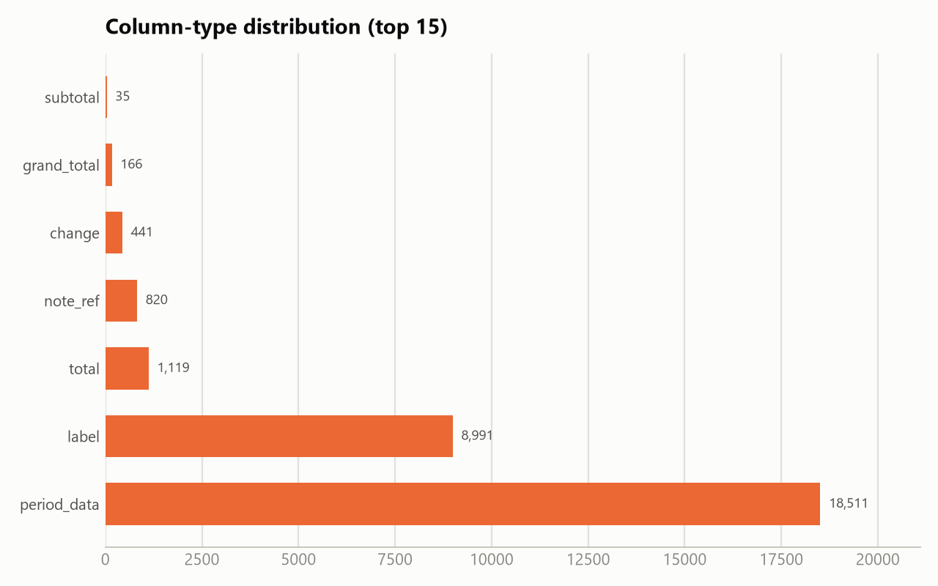
Across all 6,109 tables, labeled rows total ~88,150 and columns ~30,083:
Row type | Count | Share
data | 54,005 | 61.3%
row_header | 23,282 | 26.4%
total | 5,833 | 6.6%
subtotal | 4,153 | 4.7%
grand_total | 876 | 1.0%
change | 5 | <0.1%

Column type | Count | Share
period_data | 18,511 | 61.5%
label | 8,991 | 29.9%
total | 1,119 | 3.7%
note_ref | 820 | 2.7%
change | 441 | 1.5%
grand_total | 166 | 0.6%
subtotal | 35 | 0.1%

Roughly 1 in 8 rows is a subtotal/total/grand-total — this is the structural signal (rollforwards, financial statements with running totals) the model needs to learn to distinguish from plain data rows.

5.4 Prompt / completion length
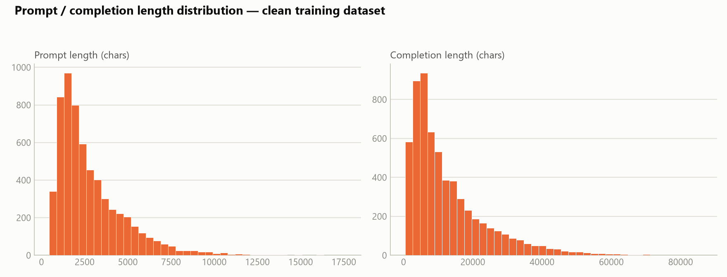
 | min | p25 | median | mean | p75 | p90 | p99 | max
Prompt (chars) | 443 | 1,437 | 2,225 | 2,859 | 3,720 | 5,472 | 10,055 | 17,648
Completion (chars) | 427 | 4,807 | 9,035 | 12,721 | 17,255 | 28,522 | 52,758 | 86,231

Completions run ~4x longer than prompts on median — expected, since the completion re-emits every row/column/cell of the input table plus classification metadata (type, confidence, concept IDs) for each. The p99 completion (~53K chars, ~13–18K tokens) and max (86K chars) are a meaningful tail that drives sequence-length/truncation decisions for training.

5.5 Label richness / confidence
- Cell `concept_id` fill rate: 93.0% — the large majority of cells are tagged with a financial concept (e.g. NoteReference, XBRL-style concepts), meaning the completions carry dense semantic labeling, not just structural typing.
- Row `note_ref_value` fill rate: 7.4% — footnote/note references are comparatively rare, concentrated in a subset of rows.
- `table_type` confidence — median 0.95, mean 0.93, min 0.20. The vast majority of labels carry high labeler confidence; a small tail of low-confidence labels (down to 0.20) exists and is worth spot-checking for label noise.

6. Training run
Adapter: teamspace_uploads_Qwen3.5-4B_v16v2_clean_dataset_220726_3epochs — a LoRA adapter fine-tuned on top of Qwen/Qwen3.5-4B using the clean 6,109-record dataset from §5, later merged into a standalone model via merge_model.py.

6.1 Setup
Base model | Qwen/Qwen3.5-4B
Method | LoRA (PEFT 0.19.1)
LoRA rank / alpha / dropout | r=32, alpha=64, dropout=0.05
LoRA target modules | q_proj, k_proj, v_proj, o_proj, gate_proj, up_proj, down_proj, out_proj, in_proj_qkv, in_proj_a, in_proj_b, in_proj_z
Hardware | 1× NVIDIA L4 GPU
Precision | fp16, gradient checkpointing on
Software | torch 2.8.0+cu128, transformers 5.14.1
Dataset | dataset_v16v2_200726.clean.jsonl, 6,109/6,109 samples used, max sequence length 1,024 tokens
Epochs | 3
Per-device batch size / grad. accumulation | 3 / 16 → effective batch size 48
Optimizer | AdamW (β1=0.9, β2=0.999, ε=1e-8), weight decay 0.01, max grad norm 1.0
LR schedule | 5e-5 peak, cosine decay, 3% warmup
Seed | 42

The LoRA target list includes both standard dense-attention projections (q/k/v/o_proj) and gated-projection names (in_proj_qkv, in_proj_a/b/z) — consistent with Qwen3.5-4B using a hybrid/gated attention block rather than plain multi-head attention, so LoRA adapters were attached to every relevant linear layer, not just the usual four.

6.2 Loss curve
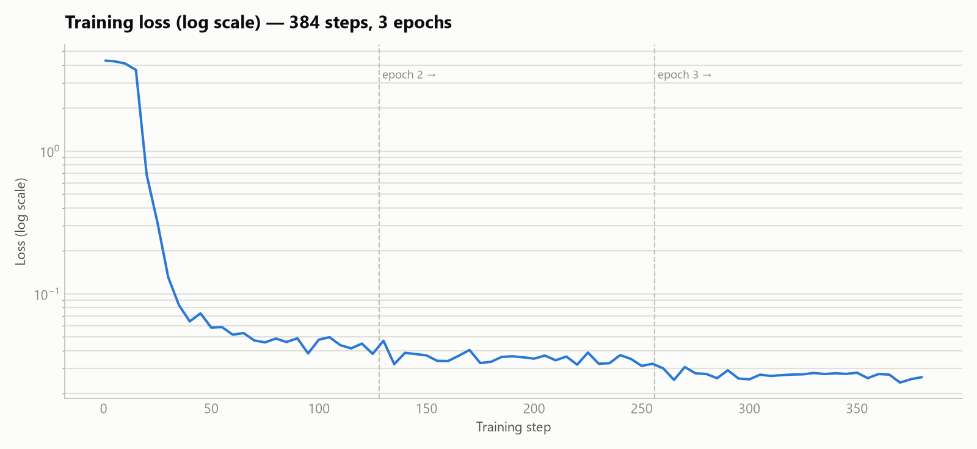
Epoch | Mean loss (logged steps) | Min | Max
1 | 0.71 (skewed by warmup spike) | 0.038 | 4.30
2 | 0.036 | 0.031 | 0.047
3 | 0.027 | 0.024 | 0.031

The first ~15 steps sit inside the warmup window (learning_rate: 0 while it ramps up), during which loss is still near the base model's untrained level (~4.3, grad_norm: NaN). Once the learning rate reaches its 5e-5 peak (~step 20), loss collapses by two orders of magnitude within ~15 steps (4.3 → 0.32 → 0.13 → 0.06) — the model is very quickly learning the rigid JSON output template (keys, nesting, field names) before it has any chance to learn the harder semantic content (correct table_type, row_type, concept_id values). Loss then declines slowly and steadily for the remaining ~2.8 epochs, ending around 0.024–0.03 by the final step. Trainer-reported aggregate train_loss: 0.206 averages in that initial warmup spike and understates how well-converged the final checkpoint actually is — the epoch-3 mean (0.027) is the more representative number.

6.3 Learning-rate schedule
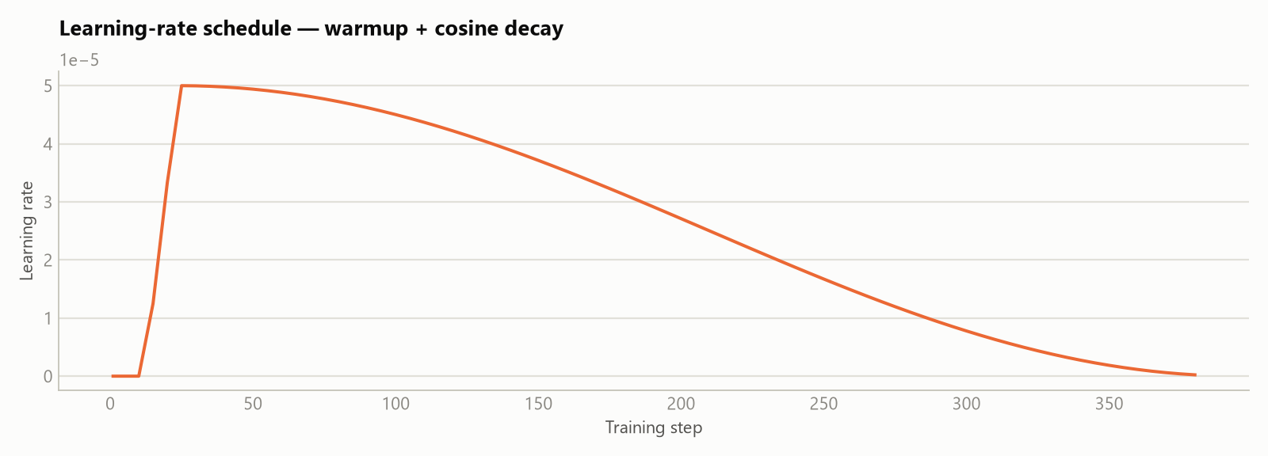
Standard warmup (3% of steps) to a 5e-5 peak, followed by cosine decay to ~0 over the remaining steps — visible directly in the loss curve's soft convergence in epochs 2–3 rather than an abrupt cutoff.

6.4 Compute
Total steps | 384 (128/epoch × 3 epochs)
Total training time | 52,860 s ≈ 14.7 hours
Throughput | 0.347 samples/s, 0.007 steps/s
Total FLOs | 4.09 × 10¹⁷
Checkpointing | every epoch, last 2 kept

A single L4 GPU, fp16 + gradient checkpointing, pushing an effective batch of 48 through 1,024-token sequences for ~14.7 hours to complete 3 epochs over the 6,109-record set — consistent with a modest, single-GPU LoRA fine-tune rather than a large-scale run.

7. Notes and caveats
- Source-to-dataset reconciliation is exact. The source folder's 6,290 _input.json files include exactly one without a matching _response.json; the remaining 6,289 pairs match the raw compiled dataset record-for-record. §3's job/document breakdown can be read as an exact ledger for the raw dataset, not an approximation.
- `job.json`'s declared `financial_table_count` (6,260 total) undercounts the actual labeled files on disk (6,290) by 30. A handful of jobs have more _input.json/_response.json pairs present than their own metadata declares — immaterial to the totals but worth knowing if reconciling job-by-job.
- 3 documents were processed twice (EQUITA Group S.p.A._Italian_2025.docx, Ringmetall SE - 2025_German.docx, and one unnamed job pair) under separate job IDs; their table counts in §3.2/3.3 sum both runs and may mildly overstate unique-table coverage for those three documents specifically. Immaterial to corpus-wide totals.
- 2 jobs are unrelated QA runs (extraction-only, classify_table: false, same PagSeguro 20-F test file) and contribute zero rows to the training set.
- Open-vocabulary `table_type` taxonomy (2,232 distinct strings) means many specific types are represented by only a handful of examples — a candidate area for further label normalization if per-type classification accuracy matters more than overall structure/row-type accuracy.
- Trainer-reported `train_loss` (0.206) is not the converged loss — it's an unweighted average across all logged steps, including the initial warmup spike (loss ~4.3 for the first ~15 steps). The epoch-3 mean of ~0.027 (§6.2) better reflects the final checkpoint's fit to the training data. No held-out evaluation set was used (eval_strategy: no) — all reported loss is training loss, so it speaks to fit, not generalization.
7. Full raw statistics backing this report are in report_assets/stats.json; regenerate with report_assets/analyze.py (corpus + dataset stats), report_assets/chart_gen.py (dataset charts), and report_assets/train_chart_gen.py (training-run charts).

